  + | EUROPEAN COMMISSION - DGXIII  TELEMATICS APPLICATION PROGRAMME  TRANSPORT SECTOR  SAMPLUS TR4023  SYSTEM FOR ADVANCED MANAGEMENT OF  PUBLIC TRANSPORT OPERATIONS PLUS |  | 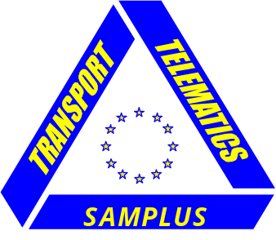
WP08 Results, Recommendations and Guidelines  Document Type: Deliverable  Deliverable Number: D8.1  Deliverable Title: Guidelines for Implementation of a SAMPLUS system: Standards to Adopt and Results to Expect  Work Package WP08 Results, Recommendations and Guidelines  Editor Pekka Eloranta  VIATEK LTD., Tampere  Aleksanterinkatu 21 A  33100 Tampere  FINLAND  Dissemination Level PU  Version 1,0  Circulation SAMPLUS Consortium  CEC DGXIII  Contractual date July 1999  of Delivery  Actual date November 1999  of Delivery  Keywords Recommendations, Conclusions Demonstration, Telematics, Intelligent Transport Systems, Demand Responsive Transport Services, Travel Dispatch Centre, Multi-modal, Public Transport |  | 

Executive Summary

SAMPLUS follows on from the EC funded SAMPO (Systems for the Advanced Management of Public Transport Operations) project 1996-1997. The 19 month SAMPLUS Project started in March 1998. Deliverable D8.1 “Guidelines for Implementation of a SAMPLUS system: Standards to Adopt and Results to Expect” has been developed to provide suggestions for those who wish to plan, develop and implement Demand Responsive Transport (DRT) service concepts. D8.1 takes into account not only issues related to the development and use of Intelligent Transport Systems (ITS) for technical support and management, but also the host environment related to DRT. This has been crucial since the experiences of SAMPLUS have shown that the development of telematics tools and applications cannot be separated from the political, juridical, institutional and organisational issues and frameworks.

The main results of SAMPLUS can be summarised as follows:
- ITS works and is essential element in DRT
- main problems in DRT are organisational
- huge savings in social cost can be obtained, but not always necessarily for the sector who actually pays for the DRT development

Even though D8.1 refers to the previous work packages and deliverables in SAMPLUS, it is not a summary of them, but an independent document providing recommendations and suggestions for those interested in the DRT development. More SAMPLUS information can be obtained from the previous public deliverables:
- D2.2 SAMPLUS Website http://www.europrojects.ie/SAMPLUSmainweb
- D2.4 Business Plan and Market Projection
- D3.1 Requirements of Users of DRT Systems
- D4.1 A Basic System Architecture and Technical Solution for DRT
- D7.1 Evaluation and Verification Plan
- D7.2 Results of the Evaluation and Market Assessment of SAMPLUS technologies

The main goals of SAMPLUS have been:
- to further develop and demonstrate the Demand Responsive Transport (DRT) services and related telematics in Belgium, Finland, Italy, and Sweden
- to carry out feasibility studies in Finland, Ireland and UK for new DRT sites
- to provide extended evaluation to enable confident results to be achieved with regard to the potential for the use of ITS technologies in DRT

SAMPLUS has aimed at developing both the services and the ITS solutions in public transport, and at studying the effects of ITS on the use of DRT services. The results show that DRT is one of the most potential solutions to increase the public transport services that are environmentally friendly, flexible, open for all and taking into account the needs of the special users such as the disabled and the elderly. DRT and related telematics are accepted by dispatchers, operators and end-users and during SAMPLUS in some cases the demonstration systems have gradually been taken into permanent use. The demonstration experiences clearly show that the dispatchers can not provide the DRT services in full scale without telematic applications. Advanced telematic functions are also necessary in order to achieve the efficiency to make DRT services economically viable.

Chapter 1 of this deliverable provides an introduction to SAMPLUS and D8.1. It describes the objectives of SAMPLUS and the relationship between SAMPO and SAMPLUS. The amount of vehicles (buses and taxis) used in public transport in EU Member States is huge. Thus there is also a tremendous market potential for ITS applications in public transport. Even so the implementation of ITS solutions naturally should not be the main objective. The main challenge is in further developing and expanding the public transport services. Through these activities there will be expansion also in ITS in public transport. SAMPLUS has aimed at developing both the traffic concepts and services and the supporting ITS solutions in public transport.

The importance of DRT services is great especially for those users and user groups that for one reason or another have no or limited access to access conventional public transport services. They may be unable to use ordinary services because of special needs for transport services or they may live in areas where there are poor or no services available or where there is a threat of losing the already existing public transport services. The political guidelines urge to develop satisfactory public transport systems and solutions for those millions of Europeans who have to deal, permanently or for some period of their lives, with reduced mobility and who are dependant on the public transport services with moderate costs to help them to live independently. The SAMPLUS results show that DRT is one of the most potential solutions to achieve such goals.

There are many national and European level guidelines and objectives to be considered in the DRT development such as:
- policy related objectives and guidelines (Common European Transport Policy, national transport policies, etc.)
- telematics and transport telematics related objectives
- administrative, organisational and institutional objectives
- juridical and legislative framework
- needs of different users and user categories
- market opportunities

It is necessary to consider financial conditions, expected technological development and current and future needs of special user groups and of the general public.

Chapter 2 describes the role of DRT services in public transport. Attention is paid to the special user groups and their needs. Needs to participate in society activities is seen as being important. However there are large groups of citizens that do not have access to adequate mobility with reasonable costs. There are several reasons for this:
- no access to car
- no proper public transport services available
- public transport services are of low frequency
- public transport services do not serve where the citizens need to go
- the user has impairments that restrict or prevent the use of public transport
- the existing services are not integrated with other transport services

It is evident that the conventional public transport cannot meet these challenges everywhere with reasonable costs.

Chapter 2 gives figures of the expected development of the population, which directly affects to the demand of new public transport services. The future challenges for DRT are directly related to Common Transport Policy such as to make public transport more attractive and usable (for all user groups). On the other hand there are objectives related to the citizens’ participation and independent living which are becoming increasingly important and raising a lot of challenges. These objectives offer hand new possibilities for DRT. Public transport must become more flexible and better suited to meet the needs of its users. Although DRT services and related telematics have considerable potential, it must be remembered that they are usually introduced in areas or low demand periods which have been unable to support conventional services. Thus, the design and operation of the new DRT service concepts must be done carefully. The further development of DRT services offers both challenges and possibilities for the different actors. The public transport industry has possibilities to widen the cost effective integrated services. The telematics suppliers, hardware and software, have new potential markets for their solutions and applications. The authorities can offer new flexible and cost effective public transport and related services for all citizens, including special groups.

Chapter 3 reports the key findings of the SAMPLUS. These are categorised in several issues such as:
- institutional, juridical and organisational
- operational
- technology
- user acceptance
- implementation
- business case and best practises

The SAMPLUS project has identified several key findings related to the development of DRT and ITS. Since there has been several sites and operational environments from rural to urban and from limited areas to larger ones, the results have been reached through collective experience across the sites. These sites have naturally had different environments and reference points. Institutional and organisational issues have proved to be essential and crucial, when creating effective DRT concepts. The juridical framework regulates the operational framework and has to be respected. The SAMPLUS partners have realised that there may in some cases be a need to alter the existing national transport policy and strategies for public transport. It has become clear in the SAMPLUS project that the institutional and organisational barriers are often greater than technological barriers. Thus a lot of preliminary work and negotiations are needed well in advance with all the parties involved before introducing the new DRT concepts.

The rapid technological development creates new opportunities. However in several cases the institutional framework, organisational and juridical issues are not able to match the technological development and opportunities. The following issues should be defined and cleared already in the planning phase:
- juridical status of DRT
- potential operators and competitive situation
- potential buyers of the DRT service (the payers)
- impeding with other public transport modes and services
- pricing issues
- payment and ticket systems
- privacy protection issues
- operational area
- dispatching issues
- compulsory competing
- co-operation with different actors (public-private-partnerships)

Normally the technical issues and problems can be solved rather easily, whereas the institutional and organisational issues are more related to political or social relations. Therefore they contain contradictory aspects and opinions, which sometimes may be rather emotional. SAMPLUS has identified the following main actors whose opinions, objectives and attitudes are important for DRT development work:
- passengers (customers/users of DRT services)
- transport service producers (operators)
- authorities (local, regional, national)
- important (active) destinations, including terminals

These categories may include several groups and subgroups sometimes with conflicting goals and objectives. Thus the identification of institutional, organisational and juridical barriers is extremely important. The contracts of the DRT service between authorities and operators have to be negotiated in time so that the operators can be prepared for future changes. There is a lot of preparatory work to be done and problems to be solved. Chapter 3 includes not only a lot of practical hints but also strategic level information for those interested in the DRT development.

Chapter 4 describes the impacts of DRT services and ITS on different actors. Naturally the impacts differ from each other since the different actors have different perspectives from which they view DRT. DRT services will have quite a lot of impacts to the existing situation. DRT may replace the existing conventional services. In this case the effects are rather big. The users have to learn to use a totally new system, they have to get used to telematics, they have to learn the philosophy of DRT etc. Especially in the multi-modal and multi-operator environment DRT changes the existing public transport significantly. However, in many cases there have been no services available previously. The DRT concepts offer totally new public transport services. In these cases it has normally been easier to introduce DRT, since there has been no other alternatives.

It is very important to assess the expected impacts of DRT services beforehand and to certify that all the needed preparatory arrangements have been taken care of. In multi-operator environment the DRT operators, instead of normal competition, will in several cases co-operate with their normal competitors. The objective is to offer to citizens seamless, integrated public transport services with reasonable price. For DRT the multi-purpose vehicles are far more suitable than normal big buses, since they can use narrow and winding roads and their patronage levels are normally far better than those of big buses on similar routes, especially on the country side. The introduction of DRT means inevitably some level of telematics. The ambition level affects naturally the level of telematics needed. Telematics itself is a tool and tools have to be cost effective. The end-users/passengers are the most important actors in DRT. Without passengers there will be no DRT services. There will be no operational or economical success in DRT, unless the passengers accept the system and trust it. SAMPLUS has shown that after the users have learned the system, found it to be reliable, and acquired the knowledge how to use it (including telematics), then they are rather satisfied with it.

The future plans of enhancing the DRT service concept so that more and more special users could use the service, will require additional and thorough consideration of telematics tools. They are inevitably needed, but they should be easy to understand and use. It is not only question of telematics but also about attitudes and fear of new demanding things. The users should be encouraged to use the systems and services.

The operators and drivers have learned to use radios, mobile phones and on-board units with computers as normal tools. Within a few years there will be a new mobile phone generation that can be effectively used in the DRT services by the operators and the passengers. ITS has also impacts on the TDC personnel. The SAMPLUS project has concentrated on creating easier and better user interfaces for dispatchers. In some cases this has meant that the TDC systems are lighter and smaller than in SAMPO. The dispatchers have been able to define what elements and modules are the crucial ones for the satisfactory dispatching and booking service. One of the questions to be solved is the role of the TDCs. Will they be local, regional or national? Will they be linked with each other creating a service network? Will they be run by public transport operators, authorities, traffic centres or some other actors? It seems that these questions have no single answer today. The TDCs are trying to find their role, if there can be only one. Most likely there will be different types of TDCs. The SAMPLUS results emphasise the importance of co-operation between municipalities and regions. At least if/when the municipalities are small or low demand areas, it is important to have more potential users by combining the efforts and increasing the operational areas.

Chapter 5 presents opinions and ideas for future activities and development of the DRT service concept. On the other hand it reports the risks and barriers in DRT and gives hints how to overcome them. It also includes a section for dissemination and industry awareness, not to forget training and support. A basic future objective for the additional development of DRT among some SAMPLUS participants is to create new additional services and systems that will help especially the different special user groups to live as independently as possible in the environment where they would like to live. In other countries where the needs of the elderly and the disabled are already rather well taken care of there is a need to reduce the costs for such services and at the same time to offer better unrestricted services for all citizens, including these special groups. Obviously the best and most effective way to create these new service concepts is to combine the new services so that the special user services will be integrated with other services. Through development of new DRT related services and using the emerging possibilities of the new Information Society this can be achieved. As mentioned earlier the future development work should be based on EU, national and local transport policy and strategies. On the other hand there may in some cases be a need to alter national transport policy and strategies for public transport.

The organisational barriers are often greater than technological barriers, thus a lot of preliminary work and negotiations are needed well in advance with all the parties involved before introducing the new concepts.

The contribution of the future DRT development to European Community social objectives means improved accessibility of services for all citizens, increased quality and user orientation of the social services such as health and home care, decreasing the isolation and withdrawal of special users such as the elderly and the disabled, increasing the possibilities for all citizens to participate and not be dependant on the social group/situation, etc. The future work should aim at finding and developing new logistics solutions (people and goods), advanced service concepts and systems to help special user groups to stay and to live actively in their homes instead of being forced to move to old-age home or hospital. The objective is to create, for the citizens, services that can easily be implemented European wide. New technologies should be used and new services should be developed to provide new concepts and policies to enhanced transport, mobility, and participation of the citizens. It has become obvious in that there is a growing need to enhance the user-friendliness of the information society.

Chapter 6 provides a comprehensive checklist for the DRT service development. It gives an overview of the DRT development process and goes through all the frameworks and issues affecting the DRT development. A lot of comments, hints etc. are given to the users to be taken into account in the future development of DRT service concept. Perhaps one of the most challenging and important issues in chapter 6 is the description of the contractual issues that should be taken into account. The issues that are to be taken into account and cleared include:
- the amount of public transport operators in DRT services (one vs. several)
- the operational environment (free competition vs. totally regulated services)
- transport modes for DRT services (one vs. several modes)
- the level of subsidies (subsidised vs. commercially profitable)
- the modes and treatment of subsidy (subsidy may be used for operator to cover operator costs or to offer cheaper tickets and fares, subsidy can be channelled via selected operator/operators or via authority to all eligible)
- the party responsible for the public transport service and operations (local, regional, national authority, private operator/operators, no responsible party at all)
- juridical framework and factors concerning traffic and public transport
- financing instruments of DRT (who buys the services, who pays the subsidies)
- payment and ticket systems, clearing procedures
- operator contracts

Chapter 7 summarises the conclusions and recommendations resulting from the SAMPLUS project.

For further information contact:

The Project Co-ordinating Office at: Transport and Travel Research Ltd,
6 Bridgford Road, West Bridgford, Nottingham, NG2 6AB, UK
Tel: +44 115 945 5950; Fax: +44 115 945 5665; E-mail: TTR_Nottingham@compuserve.com

The Editor at: Tampereen Viatek Oy,
Aleksanterinkatu 21 A, P.O.Box 718, FIN-33101, Tampere Finland
Tel: +358 3 237 1783; Fax: +358 3 237 1777; E-mail:pekka.eloranta@viatek.fi

TABLE OF CONTENTS
Executive Summary 1
1 INTRODUCTION 8
1.1 General 8
1.2 The relationship between the SAMPO and SAMPLUS projects 13
1.3 WP08 –Guidelines for Implementation of a SAMPLUS System 13
2 DRT Services – needs, opportunities and challenges 16
2.1 DRT services in the domain of public transport 16
2.2 Special user groups – mobility and participation 18
2.3 The need for new services 20
2.4 Challenges and opportunities in providing DRT services 21
3 Key Findings 23
3.1 Juridical, institutional and organisational issues 24
3.2 Operational issues 31
3.3 Technology issues 38
3.4 User acceptance 41
3.5 Implementation issues 42
3.6 Business Case, best practises 44
4 Impacts OF DRT and its 47
4.1 Impacts of DRT services 47
4.2 Impacts of ITS on passengers 48
4.3 Impacts of ITS on operators 49
4.4 Impacts of ITS on authorities 50
5 Needs for future actions 52
5.1 Further development of the service concept 52
5.2 Overcoming risks and barriers 55
5.3 Dissemination and industry awareness 56
5.4 Training and support 57
6 Checklist for the DRT service development 59
6.1 Basic Frameworks 61
6.2 Organisation and Structure of Public Transport and Related Services 62
6.3 Provision of Subsidies 63
6.4 Socio-Economic Issues 64
6.5 Operational Issues 65
6.6 Technology Issues 69
6.7 Implementation Issues 72
6.8 Contractual issues 73
7 Conclusions and recommendations 79
ANNEX A: SAMPLUS sites 81
ANNEX B: User needs review 95
ANNEX C: Evaluation review 115
ANNEX D: Summary of the Finnish Service Line Study 148
ANNEX D: DRT experiences from Prince William County and cities of Manassas
and Manassas Park, USA 161
ANNEX E: References 167

INTRODUCTION

Chapter 1 presents the SAMPLUS project and its objectives, the countries and sites involved, the contributors and the work carried out within the scope of SAMPLUS.

SAMPLUS is an acronym for Systems for the Advanced Management of Public Transport Operations Plus. SAMPLUS is continuing the development work of the EC/DG XIII funded SAMPO (Systems for the Advanced Management of Public Transport Operations) project. The main goals of SAMPLUS have been:
- to further develop and demonstrate the Demand Responsive Transport (DRT) services and related telematics in Belgium, Finland, Italy, and Sweden
- to carry out feasibility studies in Finland, Ireland and UK for new DRT sites
- to provide extensive evaluation to enable confident results to be achieved with regard to the potential for the use of ITS technologies in DRT

General

The amount of vehicles (buses and taxis) in public transport in EU Member States is huge, being several hundreds of thousand units. There is also a tremendous market potential for Intelligent Transport System (ITS) applications in public transport. Even though the market for both ITS and for vehicles can be very significant across Europe, the increase of the ITS solutions in public transport naturally should not be the main objective.

The main challenge is in further developing and expanding the public transport services. Through these activities there will be expansion also in ITS in public transport. SAMPLUS has aimed at developing both the services and the ITS solutions in public transport at studying the effects of ITS on the use of DRT services.

The public transport services can be divided into several categories as shown in the Table 1. As seen in the table DRT is an essential part of public transport services.

Service | Schedule | Route | Start/End of route | Origin/ Destination  Fixed stations or on demand | Individual service/ Mass ser-vice | Locate passengers origin and destination when booking | Suitability for special groups
Regular public transport | Fixed | Fixed | Fixed | Fixed or on demand | Mass service | No | In minor scale only
DRT | Fixed but on demand, or on demand (may be adjusted to meet other the needs of other passengers) | Fixed but on demand, or on demand (may be adjusted to meet other the needs of other passengers) | Fixed or variable | Fixed or on demand | Individual (may be adjusted to meet other the needs of other passengers) | Yes, both exactly | For most special groups
Taxi | On demand | On demand | Variable | On demand | Individual | In great scale | For many special groups
Line taxi | On demand | Fixed or variable | Other end fixed | Fixed or on demand | Individual | In most cases passenger is responsible | In minor scale only
Invataxi  (specially equipped taxis for disabled) | On demand | On demand | Variable | On demand | Individual | At least one end | For most special groups

Table 1: Public transport types

The importance of DRT services is great especially for those users and user groups that for one reason or another have no possibilities to access and use conventional public transport services. They may be unable to use ordinary services because of special needs for transport services that conventional public transport cannot provide, or they may live in areas where there are poor or no services available or where there is a threat of losing the already existing public transport services. The Common European Transport Policy and European Commission’s Green Paper “The Citizens’ Networks” urge to develop satisfactory public transport systems and solutions for those millions of European citizens who have to deal, permanently or for some period of their lives, with reduced mobility and who are dependant on the public transport services with moderate costs to help them to live independently. The SAMPLUS results show that DRT is one of the most potential solutions to increase the public transport services that are environmentally friendly, flexible, open for all and taking into account the needs of the special users.

The SAMPO and SAMPLUS result clearly show that DRT and related telematics applications and technologies are accepted by dispatchers, operators and end-users and during the SAMPLUS project in very many cases the demonstration systems have gradually been taken into full use. In most cases the could no longer have provided the demanded DRT services needed without the related ITS applications. As a matter of fact the demonstration experiences clearly show that the dispatchers can not provide the DRT services in full scale without telematic DRT applications.

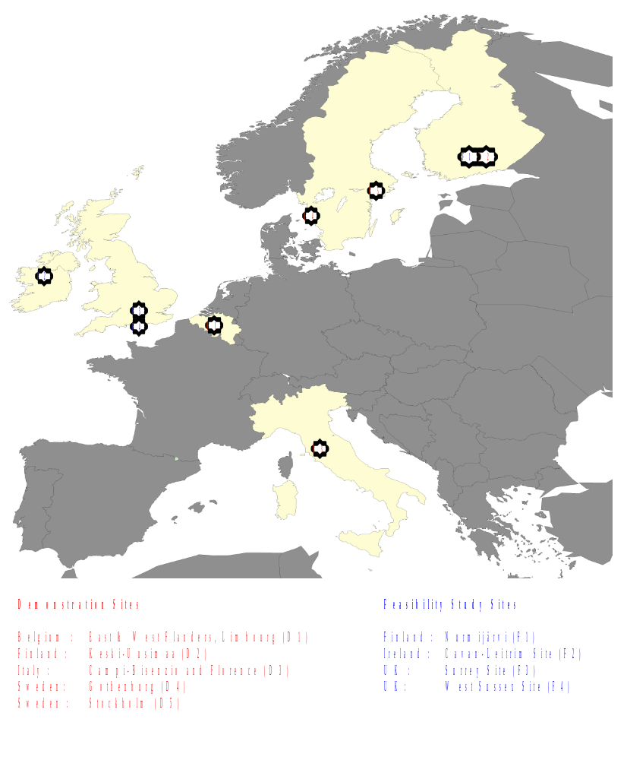
In SAMPLUS organisations from four countries; Belgium, Finland, Italy and Sweden have further studied, demonstrated and evaluated the DRT services and solutions. In three countries; Finland, Ireland and UK there have been feasibility sites, where the needs of the different user categories have been studied, ideas for DRT service concepts and systems have been developed and solutions and implementation plans have been made.
Figure 1: The SAMPLUS sites
The characteristics of the DRT and the journey patterns at the SAMPLUS sites are described in the following table and figure.

Category | Type of Service | Schedule | Route | Pickup / Setdown | Client Base | SAMPO/ SAMPLUS Examples | Other  Examples
Scheduled | Conventional no individual needs | Fixed | Fixed | Stations / Stops | General Public |  | Most scheduled rail and bus services
 | Hail and Ride, pickup, setdown variations | Fixed | Fixed | Anywhere along a route | General Public |  | Numerous examples (e.g. UK, Australia)
DRT | Semi fixed, deviations within area/zone/ corridor | Fixed intermediate points | Flexible but with some fixed points | Designated Stops and/or at home | Special Groups only | No SAMPLUS example
 |  |  |  |  | General public | Marsta (Sweden)
 | Flexible | No fixed intermediate points | Flexible between end points | Designated Stops and/or at home | General public | Porta Romana (Italy), Limbourg, W & E Flanders (Belgium)
 |  |  |  |  | Special Groups only | Gothenburg (Sweden)
 | Virtual flexible (limited service area) | On-Demand | No fixed route | At home or designated stops | General Public | Keski-Uusimaa  (Finland), Campi (Italy) | Treintaxi (Netherlands)
 |  |  |  |  | Special Groups only | Florence (Italy)
 | Virtual flexible (unlimited service area) Shared Ride / Multihire, individual needs accepted | On-Demand | No fixed route | Anywhere in response to booking | Special Groups |  | Many paratransit services (eg US)
 |  | On –Demand | No route | From Designated Stops | General Public |  | Maxitaxi services (Aust)
 |  | On-Demand | No route | Door-Door (booked) | General Public
Taxi | Virtual flexible (unlimited service area) Single Hire, all individual needs accepted | On-Demand | No Route | Door-Door (booked) or ranks or hailed from street | General Public |  | Most taxi services world wide

Table 2: DRT types

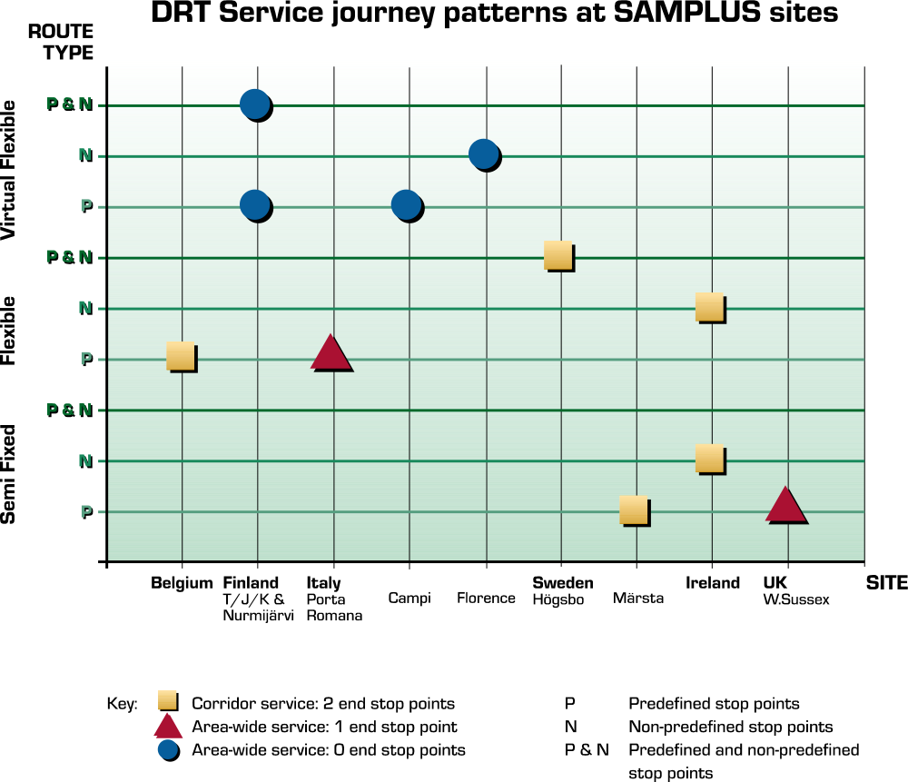
Figure 2: The SAMPLUS Journey Patterns

There are several actors in SAMPLUS countries that have participated and contributed to the SAMPLUS work such as:
- authorities (municipalities, provinces, ministries, institutes)
- public transport associations (bus and taxi sector)
- public transport operators (bus, taxi, invataxi and train)
- technology providers (hardware and software)
- universities
- telematics and transport consultants and engineers
- users and user groups

The SAMPO and SAMPLUS projects have shown that ITS based DRT service is feasible and viable. Therefore it should be accepted and taken seriously as a public transport mode. Having said that, it can be stated that there are many areas where DRT can still be enhanced (i.e. more attractive or usable) or optimised (more cost effective), etc. Each of these areas needs research in itself. The collective impact of these improvements will be to move DRT into being a very strong, if diffuse, element of the overall transport service supply.

Even though the results of DRT trials are extremely promising the actual DRT development work has only just started. Projects like SAMPO and SAMPLUS have clearly demonstrated the viability of DRT, and the real need of DRT utilising ITS. But there is a clear need to improve the optimisation process, to be able to integrate DRT better with other modes and other sub-systems, to enhance the interface with the users, to widen the scale of services and to advance the technology platform on which the DRT services are provided.

Annex A describes more details of the SAMPLUS demonstration and feasibility sites. Additional information can also be obtained from the SAMPLUS home page. The address is http://www.europrojects.ie/SAMPLUSmainweb/.

The relationship between the SAMPO and SAMPLUS projects

The main goal of the previous SAMPO project was to assess the potential and effectiveness of introducing ITS technologies to DRT services. This goal was evaluated in a European demonstration project, developed at test sites in four European Union member states. The SAMPO project clearly established the feasibility and benefits of such technologies. The SAMPLUS project builds on the results of SAMPO and further develops them. One of the main ideas in SAMPLUS has been find out, whether it is possible to move towards actual business cases - “from charity to business”. However it seems that in most countries the DRT services will always need subsidies.

The SAMPLUS project has continued the SAMPO work and provided a set of DRT technologies and operations that have been fully demonstrated on urban and rural test sites across Europe. In the SAMPO project the demonstration period was sufficient to test the ITS, but it was far too short to get reliable data concerning the changes in the passenger behaviour patterns. After SAMPLUS the DRT systems developed will be ready to be taken into use in other markets, with guidelines for application and the presence of decision support. These technologies will provide a new opportunity to meet the needs of the Common European Transport Policy by addressing EU strategies on social cohesion and the avoidance of marginalisation, thereby providing greater travel opportunities for European citizens.

WP08 –Guidelines for Implementation of a SAMPLUS System

WP08 summarises the results of the SAMPLUS project. All the previous work packages contribute to WP08 and D8.1. as shown in the Figure 3.

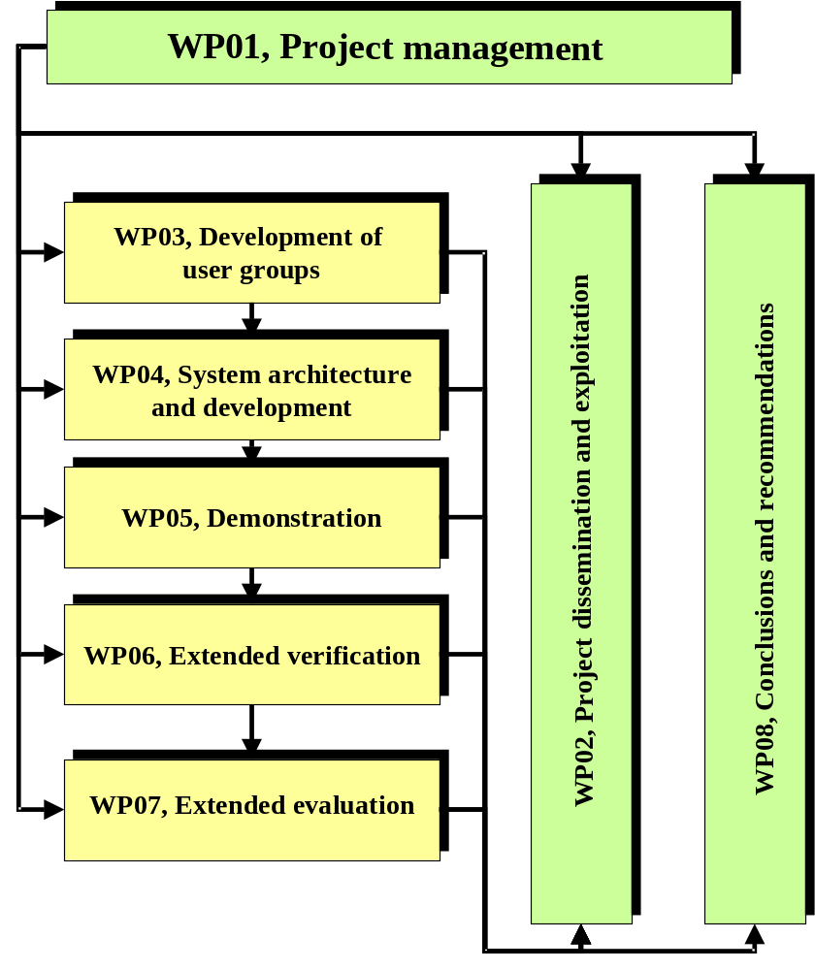
Figure 3: SAMPLUS work packages

The main objective of the Work Package 08 – “Guidelines for Implementation of a SAMPLUS system: Standards to Adopt and Results to Expect” has been to produce guidelines which will be used by operators and local authorities in different European countries/sites when planning, designing and implementing DRT systems and services.

WP08 brings the results of the SAMPLUS project and provides general conclusions and guidelines on the Consortium, Programme and European level. The key objectives of the work package are:
- to analyse the results of the SAMPLUS Demonstration and Extended Evaluation,
- to make conclusions from operator's, end-user's and administration's point of views,
- to make recommendations on the SAMPLUS results,
- to provide a “Best Practice Guide” and
- to produce deliverable D8.1 (on SAMPLUS-website).

It is to be noted that in WP08, in addition to the feedback and input from the SAMPLUS project itself, there are national and European level guidelines and objectives to be noticed in WP08 such as:
- political and transport policy related objectives and guidelines (Common European Transport Policy, national transport policies, etc.)
- telematics and transport telematics related objectives and guidelines
- administrative, organisational and institutional objectives and guidelines
- juridical and legislative framework and objectives
- needs of different users and user categories
- market opportunities
- financial framework
- expected technological development
- the future needs of special user groups and general public
- possible input from other projects

The conclusions and recommendations should be in line with the main political, institutional and technological trends, otherwise they may be difficult to carry through. One of the main objectives of WP08 is to disseminate the results, recommendations and conclusions using website media to inform the potential DRT actors:
- public transport industry and operators,
- the SAMPLUS Consortium,
- potential DRT service users,
- national and local authorities and municipalities,
- Directorates General (DG) VII and XIII,
- those involved with the TAP (Telematics Application Programme)
- technology providers and
- those interested in the development activities on the field of public transport telematics and/or demand responsive services.

In addition to SAMPLUS results D8.1 also presents the results of the Finnish Service Line Study in Annex D and the DRT-experiences from Prince William County and cities of Manassas and Manassas Park in USA in Annex D.

DRT Services – needs, opportunities and challenges

Chapter 2 describes the needs, opportunities and challenges for DRT services and related ITS. It includes the following parts:
- DRT services in the domain of public transport
- Special user groups – mobility and participation
- The need for new services
- Challenges and opportunities in providing DRT services

DRT services in the domain of public transport

Sufficient public transport services are essential in all levels of society all over Europe. The services allow citizens to participate actively and in some cases also to live independently. The awareness of environmental problems, changes in attitudes towards public transport, political decisions and financial reasons have affected the development of public transport services.

New and improved public transport services and systems have been created to satisfy the changing needs. DRT services have lately been one of the most interesting development areas of public transport both in the SAMPLUS countries and elsewhere such as in Germany, France, Netherlands, USA and Australia.

In Europe there are a lot of citizens that do not have access to adequate transportation systems with reasonable costs. There are several reasons for this. Some of them can be listed here:
- no access to car
- no proper public transport services available
- public transport services are of low frequency
- public transport services do not serve where the citizens need to go
- the user has disadvantages that restrict or prevent the use of public transport
- the existing services are not integrated with other transport services

As shown in the figure 4 there is a need to develop new kind of low cost, flexible services between conventional public transport and taxis.

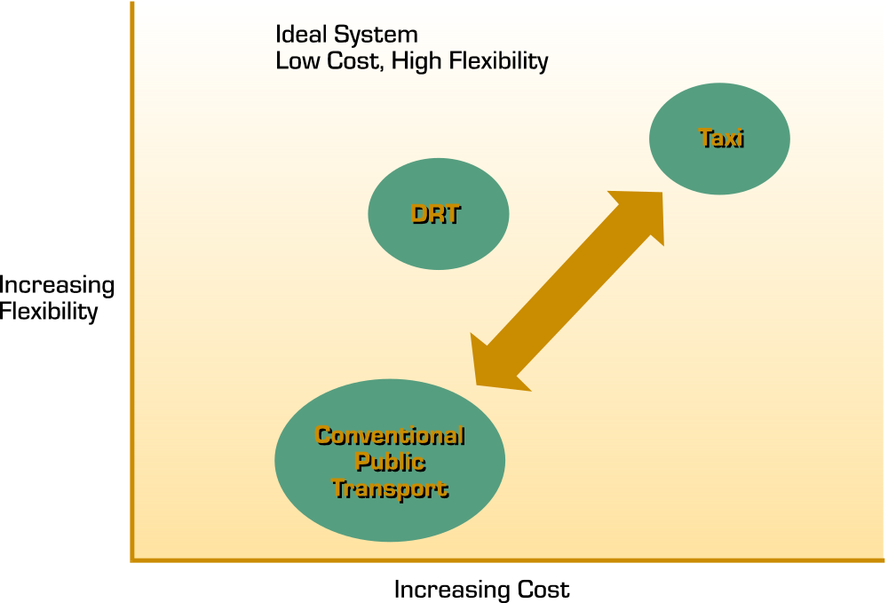

Figure 4: Improving the trade-off between flexibility and cost

It is evident that the conventional public transport cannot meet these challenges everywhere with reasonable costs. Thus there is a threat of a vicious circle as shown in the Figure 5.

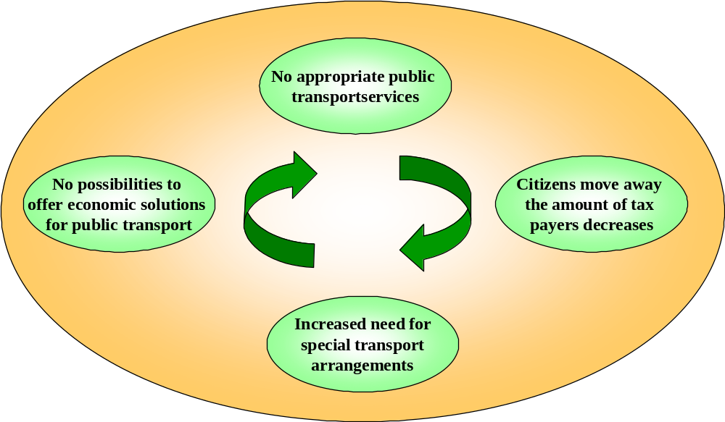
Figure 5: Vicious circle of public transport services

On the other hand the authorities have become aware of the increasing transport costs. In those countries where, in search of equality, transport services for special users that are totally or mostly paid by the authorities the costs tend to be very high and increasing. There is a parallel need to decrease the transport costs and still to offer proper transport services for the users. Here the DRT services have proven to be very effective.

It seems that DRT has come to stay in public transport. One evidence of this is the fact that there will be legislative efforts in SAMPLUS countries aiming to define the role and status of DRT services as an essential element of public transport. SAMPLUS has made it a target to forward this legislative work.

DRT is very important for special users such as the disabled and the elderly people. However DRT services are very important also for “ordinary“ people such as home-based women (especially those with children), teenagers, low-waged or unemployed, students etc. All of these have typically no access to a car and are dependent on lifts or inadequate public transport. This reduces their mobility and their possibilities for social participation.

Special user groups – mobility and participation

The development and evaluation work of the DRT services and related ITS applications in SAMPLUS has shown that there is a need to further develop the service concepts of the demand responsive transport and to add new service areas to the existing service concepts. Mobility services, home and personal care, deliveries, communication, possibilities for improved access for services and greater participation in society are important issues in the future. This is especially important and urgent for special groups such as the disabled and the elderly.

The disabled and elderly very often have health and other problems that tend to weaken their possibilities to move and participate. This may also lead to social withdrawal and isolation. On the other hand the decreasing possibilities to move and to participate and to live independently increase the need for institutional care, old-age homes etc. Very often the elderly and the disabled cannot live where they would like – at home. The studies in Finland for instance show that the elderly do like to participate on the equal terms with other members of society. The members of the special user groups want to increase their mobility with the help of new systems and services that take into account their needs and physical restrictions. This applies also to other SAMPLUS countries. Thus there is a social need for advanced DRT service concepts.

The results of SAMPLUS have been remarkably good. However they also show that there should be further development aiming at improving the quality of life of the elderly and the disabled. It is essential for the mental well-being of a person to be able to take care of his/her errands independently. The elderly and the disabled will be able to live full-blooded life and live longer at their own homes without institutional care but with the help of high-level transport, home care and other services.

The amount of ageing people will grow in the near future all over Europe. For instance in Finland there will be a remarkable growth in the number of the elderly people. In the year 2030 the estimated amount of people over 65 years old will be some 26 % of the population while now it is about 15 %. This trend is more or less the same in all European Union Member States.

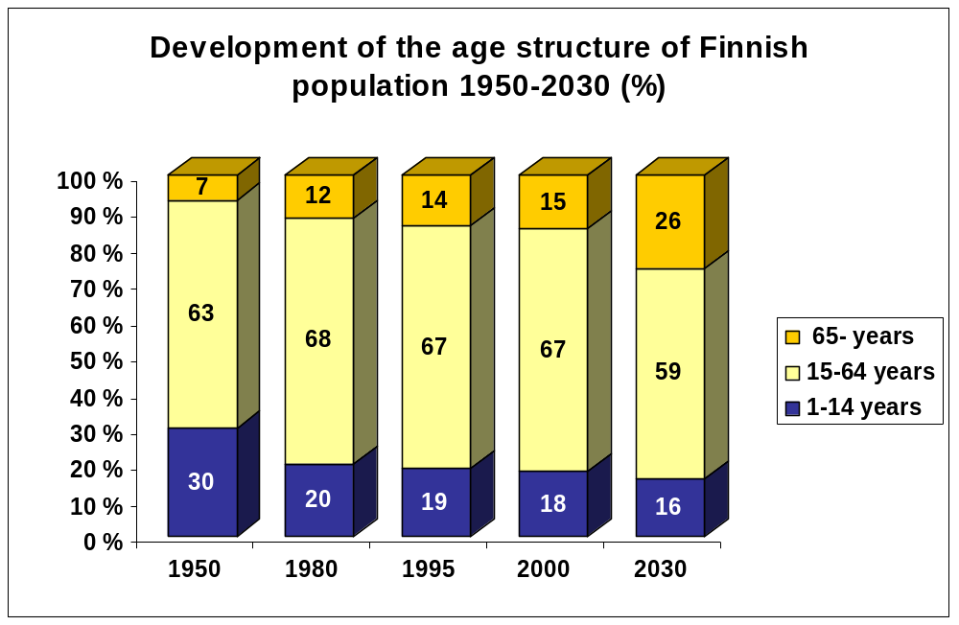

Figure 6: Development of the population age structure in Finland

As the amount of retired people in Europe is expected to almost double by the year 2025, the amount of working citizens (15 to 64) is expected to decrease by 4 % and the under-20s age group is expected to decrease by 11 %. A declining workforce will be required to bear the medical and special service costs of an increasingly numerous elderly population. This forms a massive challenge to society. A welfare state has to take care of the needs of its weakest members: the children, the elderly and the disabled. It ensures their possibilities to participate in social and community activities by introducing suitable legislation.

One of the ways to improve the participation and independent living possibilities of the elderly and the disabled have been special transport and other services that make it possible for them to travel independently. Most of those transport services are nowadays individually tailor-made for each user and paid by society. However very often there is no real need for the expensive individual transport and the same service could be provided with DRT.

The growth of the number of people needing special services and the decrease of the number of people who pay indirectly for these services with their income tax mean that individual transport services serving only one person at time can not be maintained for long. Society wants to maintain and further develop the high-level services for the disabled and the elderly but the current individual transport services need to be further developed and/or replaced with new ones serving several people at the same time. Combining the transport demand and serving several people at time according to their individual needs will ensure that the elderly and the mobility impaired people can have high-level, satisfactory transport services and possibilities to fully participate in society. To make all this to come true there is an immense need for efficient tools (telematic and other) to assist in providing adequate public transport and related services with reasonable costs.

The need for new services

So far the DRT development work has been active in the fields of telematics and service concepts. SAMPO and SAMPLUS have been able to demonstrate co-operation between bus and taxi industries which normally compete of the same markets. This has made it possible to offer high quality and flexible public transport services with reasonable price. Especially areas where there has been existing public transport services available at least in minor scale have had very promising results so far and the patronage levels have been growing steadily.

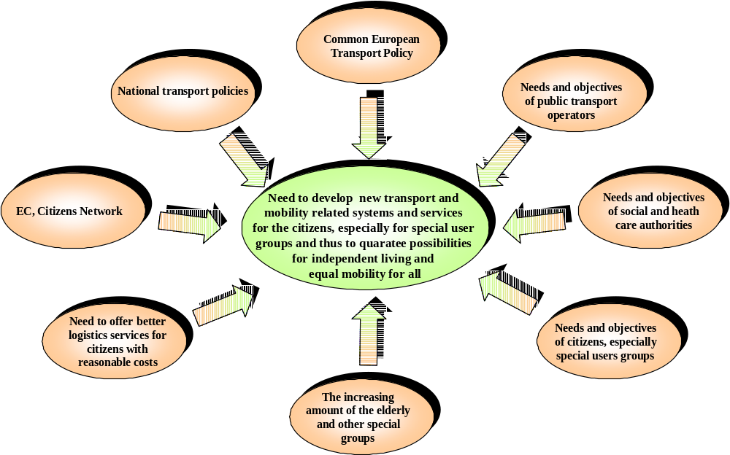
However as shown in the Figure 7 there are several issues and objectives emphasising the need to enhance the DRT service concepts and to further develop and utilise the ITS tools especially to meet the needs of the special users.

Figure 7: Needs and justification for the further development of DRT and related ITS

Although the individual transport services for the disabled are of high quality in most European countries there are a lot of people who have mobility impairment and for this reason can not use the traditional public transport services, but on the other hand do not belong to the community aid system. Also for these people new transport systems such as DRT services are a longed-for possibility to travel independently.

The social intercourse has been noticed to be very active in the above mentioned transport systems and it brings both mental and physical stimulation to the passengers. Society gets savings through the reduction of the need for institutional care. Also for the transport operators the service modes give an enhanced possibility to achieve new client groups that have not been able to use public transport before. The SAMPLUS results show that here the development work of DRT services as a part of the public transport system offers huge challenges but at the same time enormous potential for savings, if planned and carried out thoroughly.

Challenges and opportunities in providing DRT services

It has become obvious in the SAMPLUS countries that there is a growing need to enhance the user-friendliness of the information society and to further develop the DRT services by adding new elements to the existing service concepts and by developing totally new concepts. European Commission’s Green Paper “The Citizens’ Networks” summarises the potential challenges that can be affected by the enhanced DRT services. There are some 80 million European citizens who, permanently or for some periods of their lives, have to deal with reduced mobility. There are about 100 million elderly people of whom 50 % do not have access to private cars. For these users it is essential to develop and offer new services.

The future challenges for DRT are directly related to Common Transport Policy such as to make public transport more attractive and usable (for all user groups). On the other hand there are objectives related to the citizens’ participation and independent living which are becoming increasingly important and raising a lot of challenges. These objectives offer brand new possibilities for DRT. Public transport must become more flexible and better suited to meet the needs of its users. Although DRT services and systems have considerable potential, it must be remembered that they are usually introduced in areas or low demand periods which have been unable to support conventional services (at least within acceptable financial support levels). Thus, the design and operation of the new DRT concepts must be done carefully. This also applies to the use of ITS in DRT services.

Based on the results of SAMPLUS, it can be said that the further development of DRT services offers both challenges and possibilities for the different actors. The public transport industry has possibilities to widen the cost effective integrated services.

The telematics suppliers, both hardware and software, have new potential markets for advanced solutions and applications. The municipalities and other authorities can offer new flexible and cost effective public transport and related services for all citizens, including special groups. The following table shows the opportunities of different organisations, when developing and implementing new advanced and innovative DRT services and related ITS applications.

Organisation | Opportunities
transport operators & and other service providers | - new flexible multi-modal public transport services for areas of relatively low demand  - new innovative services for citizens, especially for the special user groups (= new customers & users of service)  - integrated public transport, information and other services for citizens and especially for special groups (the disabled, the elderly etc.)  - new modes of service to increase attractiveness of public transport operations  - interoperability and co-operation between different kind of operators and service providers e.g. seamless service for passengers from the origin to the destination  - new dispatch and service centres to enhance the effectiveness of operations  - increased employment  - increasing patronage and revenue by tapping into new markets
industry and suppliers | - integrated dispatching and service provision applications  - personal home and public terminals (especially for the elderly & the disabled)  - route optimisation, monitoring and service provision management applications  - geographic information systems (GIS) for services to citizens and new user interfaces with advanced technologies  - user friendly ordering, booking and payment systems (smart cards etc.)  - adaptation of generic tools and applications to meet the needs of new services for the citizens  - new kinds of vehicles
municipalities authorities, etc. | - cost-effective and flexible transport and other services for citizens (also for special groups)  - health and home care systems for special users  - delivery and pick-up services for small goods and parcels  - new transportation related services for visitors and tourists  - savings or extinction of the growth in transport, social and health care costs  - increased vertical and horizontal co-operation between municipal sectors  - new kinds of vehicles to meet the needs of citizens (also the special groups)
universities,  research centres, engineering offices | - scientific RTD in the areas of new services for citizens and related telematic applications  - validation and evaluation of new services for citizens and their influence on the independent living and participation  - simulation studies of new services relating to the Common European Transport Policy

Table 3: Opportunities for different actors, when developing advanced DRT services

Key Findings

Chapter 3 reports the key findings of the SAMPLUS project. These findings can be categorised into the following issues:
- juridical, institutional and organisational
- operational
- technical/technology
- user acceptance
- implementation
- business case

The SAMPLUS project has identified several key findings related to the development of DRT and ITS. Since there has been several sites in SAMPLUS in different countries and operational environments from rural to urban and from limited areas to larger ones, the results have been reached through collective experience across the sites. These sites have naturally had different environments and reference points. Several meetings, discussions etc. have been organised to provide the findings. Especially important was the SAMPLUS Work Shop in Brussels in January 1999. Figure 8 illustrates how the technological development, juridical framework, institutional, organisational issues and naturally the needs of the users all have effects on the operational framework and should be taken into account in the DRT development work.
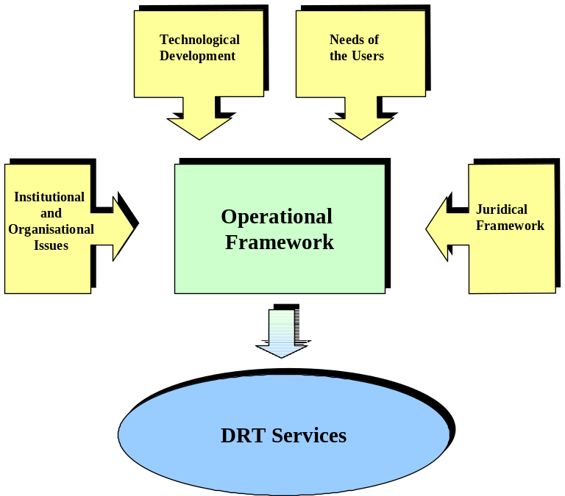

Figure 8: The issues affecting the development of the DRT services

Juridical, institutional and organisational issues

The development work of DRT services and systems should be based on EU, national and local transport policy and strategies. On the other hand, the SAMPLUS partners have realised that there may in some cases be a need to alter the existing national transport policy and strategies for public transport. It has become clear in the SAMPLUS project that the institutional and organisational barriers are often greater than technological barriers. Thus a lot of preliminary work and negotiations are needed well in advance with all the parties involved before introducing the new DRT concepts. Institutional and organisational issues have proved to be essential and crucial, when creating effective DRT concepts. The experiences of SAMPO and SAMPLUS show that the technological issues and problems are relatively easy to solve, but the institutional and organisational barriers and problems are often very difficult to solve and eliminate, and affect directly the operational framework. The juridical framework regulates the operational framework and has to be respected. For site details see the SAMPLUS Deliverable 7.2 Section 8.7 and Annexes 1 to 8 and see Annex C Section 8.5 in this deliverable.

The rapid technological development creates opportunities for DRT services. However in several cases the juridical framework, institutional and organisational issues are not able to follow the technological development and opportunities. These issues will be described more thoroughly in Chapter 6. The following organisational and institutional issues should be defined and cleared already in the planning phase:
- juridical status of DRT
- potential operators
- potential buyers of the DRT service (the payers)
- impeding with other public transport modes and services
- pricing issues
- payment and ticket systems
- privacy protection issues
- operational area
- status of the TDC
- dispatching issues
- compulsory competing
- co-operation with different actors

Since DRT is a rather new service and includes several “strange“ features compared to the conventional public transport, there are several questions to be asked and answered and prejudices to overcome. When just demonstrating and piloting new services and concepts these questions and issues can in several cases be forgotten, but when the DRT service concepts and systems are taken into full scale use, they must be solved carefully beforehand. For instance the following issues are essential from the viewpoint of the proper DRT service:
- the amount of public transport operators in DRT services (one vs. several)
- the operational environment (free competition vs. totally regulated services)
- transport modes for DRT services (one vs. several modes)
- the level of subsidies (subsidised vs. commercially profitable)
- the modes and treatment of subsidy (subsidy may be used for operator to cover operator costs or to offer cheaper tickets and fares, subsidy can be channelled via selected operator/operators or via authority to all eligible)
- the party responsible for the public transport service and operations (local, regional, national authority, private operator/operators, no responsible party at all)
- juridical framework and factors concerning traffic and public transport
- financing instruments of DRT (who buys the services, who pays the subsidies)
- payment and ticket systems, clearing procedures
- operator contracts

Normally the technical issues and problems can be solved rather easily with tests, development work and calculations whereas the institutional and organisational issues are more related to political or social relations. Therefore they contain many kinds of contradictory aspects and opinions, which sometimes may be rather emotional. From the institutional, organisational and juridical points of view, there are a few main categories whose opinions, objectives and attitudes are important for DRT:
- passengers (clients/users of DRT services)
- transport service producers (public transport operators)
- authority (local, regional, national)
- important (active) destinations, including terminals

Within these categories there may be several groups and subgroups sometimes also with opposite goals and objectives. Thus the identification of institutional, organisational and juridical barriers is extremely important. The contracts of the DRT service between authorities and operators have to be negotiated in time so that the operators can be prepared for future changes. It is not only a question of starting the service and driving the vehicles. There is a lot of preparatory work to be done and problems to be solved. The contractual issues are described more detailed in Chapter 6.

The operators are in a competitive situation in many ways. The major competition is the competition with other modes such as private car, two-wheelers and walking. This causes institutional problems especially, when it is a question of sustainable traffic. Walking and bicycling are in many ways healthier than any public transport mode. On very sparsely populated areas a (private) car is in many cases more sustainable than any public transport mode. Also the competition between operators may cause institutional and organisational problems.

Recognised problems and issues to be solved

1. Impeding the existing public transport services
There may, in some cases and in some countries be a law or other regulation which tells that the new service (new bus line, DRT service etc.) may not impede the existing public transport service. Normally this has been the question of negotiations between the public transport operators and authorities. In most countries there is so far no special legislation for DRT.

When the public transport operators are in competitive situation they tend to protect their actual or assumed rights very actively. However, the most crucial issue is to attract the potential passengers. If the public transport service concept is not good and attractive enough, the potential passengers may change the mode, in most cases to a private car, bicycle or walking.

2. Fare level and other customer costs
There are two main aspects and point of views in this issue. The first is the goal to create commercially profitable (self supporting) public transport concepts and the other one is the legal responsibility of the authorities to provide transport services to several special groups with a moderate fare level. In some cases the authority obligations are so demanding and strong that they overrule the objective of commercial profitability.

The DRT fare may be the ticket price only, or the ticket price plus the extra fare of telephone calls, special services needed etc. The extra price for telephone calls is often justified, because the TDC normally deals with and provides information on normal public transport services. This information is normally chargeable to the users, at least outside big cities.

The extra price for telephone call can be seen as a TDC support price. With this money it is possible to reduce the trip fare. On the other hand the public transport passengers are not accustomed to extra or additional fares in normal public transport. Therefore in most SAMPLUS sites no extra fare is used at the moment.

When it comes to the fare level there are two main opinions that were also noticed in the fare discussions within the SAMPLUS Consortium. One opinion was that the fare should be equal with normal public transport fares and the other opinion was that DRT offers higher level of service, has higher service costs and therefore the fare level should be higher (for instance 30 %) than in normal public transport. These issues should be free for the individual implementation to choose; however, if the legislation specifically prevents from charging a higher fare, then it (the legislation) should be changed.

The fares absolutely need to be agreed locally before implementation. In many countries public transport is subsidised. Several levels and sources of subsidies in public transport may naturally have some effects on the fare levels, too. It is likely that if DRT is successful, it will eventually spread from small area-specific services covering a limited region to city-wide services. While simple fixed-fare systems may be appropriate when services only cater for very short trips, this is unsustainable if passengers begin making longer trips. This issue could also be raised up front. Ideally a distance-based fare structure similar to that of a taxi (but at a proportion of the single-hire taxi cost) could be used from the outset, or an equivalent based on zones.

The sustainability principle and common health care principles suggest that short distances should be walked or biked. Too low fares and tariffs attract citizens from those modes. Naturally the incapability to walk or to bike allows for an exception. This is one aspect to be taken into the consideration when planning the DRT tariff.

In many cases with small-demand systems and purely manual systems the cost of operators required to take the bookings and dispatch vehicles can approximate the fare revenues. Hence if DRT is to be successfully expanded beyond small-scale pilot schemes, it is imperative that automatic booking options (by both telephone and internet) be developed, as this will allow bookings to be made much more cheaply for the operator, and more quickly for the customer once they are used to the system. This issue is raised again in TDCs, where the identification of origin and destination by the customer are crucial issues. In this context, a proposal for using a standard stop numbering system is currently under consideration in the International Standards Office (Working Group 8). The rapid uptake of mobile phones and the Internet, and the apparent growing acceptance even among older people for these options (see experience in Gothenberg) could perhaps be mentioned.

A further point with regard to despatch centres is the spread of the GDF standard for geographic databases, and the likelihood that GDF compliant maps will be produced as a matter of course for use in in-vehicle navigation systems. This means that public transport operators and dispatch centres should be encouraged to specify dispatching and tracking systems which utilise such databases, since otherwise the cost of maintaining separate and specific up-to-date road maps is likely to be prohibitive.

3. Payment methods and ticket systems
DRT services should be seen as an essential part of public transport. Also the taxi-industry is becoming an active operator in DRT. These issues together mean that:
- the DRT ticket system should be an essential part of the conventional public transport ticket system, or at least as near to it as possible
- the payment method should not be a monopoly of some operator or transport mode
- the ticket system must not require extra equipment or processing costs, or needs for special skills for drivers or transport operators, although, if the operators don’t have any good system at present, this could be a positive motivation to introduce one
- for each trip there must be a real ticket available on paper or in electronic form
- the integration of DRT ticket system with other ticket systems of other transport modes (for instance rail) may cause problems, if the standardisation is not complete and thorough
- data should be collected concerning each trip or validation transaction, to assist revenue support (subsidy), sharing of revenue among operators, and service planning
- the clearing system has to be developed and agreed upon between the DRT actors

4. The operational area of DRT services
The definition of operational geographical area needs a lot of consideration. The following issues should be cleared:
- what is economically the best area size?
- what are the real factors influencing the operational area decisions?
- if the traffic is offered/bought by one or more municipalities, are the rules similar within and outside those municipalities?
- when the passengers feel that the service is economic, service quality is satisfactory, the concept is easy to use etc, there are demands to widen the operational area
- if national social security organisations (or similar) are among the subsidising organisations, there will be demands to widen the operational area to cover origins and destinations of subsidised trips outside the municipality borders too.
- the amount of paying customers (end-users) must be considerably high before the fare box revenue could cover the real costs outside the municipal area.

5. Travel Dispatch Centre (TDC)
It is very important to decide what is the principal role of the TDC. Is it a "broker" of trips as taxi dispatch centres in so cases, is it a combined trip designer and integrator, is it the information centre for public transport or is it perhaps something else? If the TDC is situated in the premises and run by one of the many potential effective operators, the question of objectivity and equality will arise immediately.

The selection of vehicles to provide the service needs accurate and clear rules. On the other hand there should be guidelines and instructions, how to manage the situation, when the existing and approved rules conflict with the real world. The dispatchers should be able to know, how much flexibility they can have in dispatching and how “creative” they are allowed to be.

The main target is to guarantee the service. If the TDC is a separate (objective) organisation, it may be difficult to find and set real and measurable economical and operational objectives and indicators for the TDC to be used. On the other hand separate, independent TDC’s may have difficulties in extracting the knowledge and managing all the different operational and service related issues and factors.

One of the big questions concerning TDC’s is how to specify the origin and destination of a passenger's journey quickly and accurately. The geographical location of the TDC affects this a lot, since the more familiar the dispatchers are with the area the better service they can offer. When the dispatcher is familiar with the operational area, he/she can avoid conflicts with the existing public transport services.

The experiences so far have shown that this kind of knowledge is very hard to computerise at the moment. The databases for this would be very often extremely difficult and expensive to keep up to date. This is especially the case in areas/countries where public transport operators (there may be several of them) have little interest in publishing and maintaining uniform timetable information. Naturally if there is only one public transport operator in the operational area the situation is easier. It was not the objective of the SAMPLUS project to harmonise the timetable information. This large-scale work should perhaps be done in future projects to support the creation of integrated public transport concepts that also include DRT services.

The use of GIS systems has been tested in locating origins and destination and the results show that even though GIS offers some level of assistance, still there seems to be a need for skilled dispatchers that really know the operational area and its special geographical nature. Time will show whether the GIS systems will be developed so that they will replace the personal geographic familiarity with quick and comprehensive databases and user interfaces. The development of the GIS systems requires also standardisation efforts.

There are some major decisions that affect the role and operation of the TDCs such as:
- should the TDC give only addresses to drivers, or should it also give an exact route?
- if the route is given, who is responsible for the road network data updates?
- are the operational parameters for all vehicles equal?
- how can these parameters be determined?

What comes to telematics, it is obvious that with low-cost equipment it is impossible at the moment to have an acknowledgement of completed transport (trip) to the TDC. However the development of new standardised telematics tools (new generation mobile phones etc.) will ease the situation in the near future (in 2-3 years).

6. The juridical status of DRT
As long as DRT does not have equal juridical status with other (conventional) public transport, the whole potential benefit that DRT services could offer, cannot be acquired. The juridical framework and regulations should not only cover technical issues, but also issues related to subsidies, responsibilities, existing regulations etc. It is worth noticing that very often this may be rather difficult. For example there are cases, where the legal position is unclear and the authorities may be unwilling to discuss the juridical issues with operators. Thus there is a risk that at some point in the future another authority may block/prevent the developments. It has become obvious in SAMPLUS that if there is no official basis for DRT services there is a risk that the services can be brutally shut down very quickly, even where the services are established and providing real benefits..

7. Competition and tendering
It is not necessary to have tendering in fully regulated countries. However there are several countries, where the tendering process is obligatory. Before any calls for tenders to operate DRT services can be launched, there must be a generic model/framework, defining the structure and contents of the tenders so that they can be compared. Before it is possible to have a proper working model/framework, most of the institutional and organisational question should be solved and agreed upon. Secondly, a true tendering process needs at least two potential and independent contractors/service provider candidates.

For the potential contractors there must be possible to establish economically effective consortiums. However, in many cases it may be very difficult to find two or more potential consortiums to submit tenders and to compete. Also it is important to remember that in European Union Members States there are regulations for public domain procurements. Thus the calls for tenders to create/develop the DRT system and to operate DRT services have to planned carefully and send out in good time. The calls for tenders have to be clear and informative so that the tenders received can easily be compared.

8. Area wide operational models
The effective DRT service covers either a very small area or a bigger economic zone, crossing the municipality borders. If the organisation responsible for public transport services is a municipality, the proper running of DRT services requires an area wide (covering several municipalities) operational model. Without an area wide operational model all decisions should be done in each municipality at the same time and in the same form.

There are questions to be solved related to the operational area. For instance, if only one municipality is paying for DRT services, but the natural catchment area extends beyond the municipal boundaries, does the municipality then only pay for the portion of a trip within their area? Indeed, does the municipality refuse to pay for any part of a trip that has an element outside their area? Does it restrict the benefits to its’ own citizens only? These kind of questions have to be answered already in the planning phase.

9. The role of the authorities paying for the DRT services
In many cases the authorities have taken the role of a payer for the DRT services (for instance in Finland the Social Insurance Institution is the biggest organisation paying for the personal transport services). It seems that there is a need for the authorities to move from a passive role (“only paying for the services”) to an active role (“actively determining the transport activities and thus also the amount of money paid for the services”). In fact the authorities have started to be more active and aware of the money used for the services.

10. Unions
The workers' and labour unions as well as the operators' unions may have methods and rules which do identify and take into account the operational model of DRT services. This may cause the fact that some transport modes lose their market position in DRT service development.

Traditionally the unions have not been very flexible in certain countries when it comes to work practices. They have demanded that everything is specified and negotiated, and don’t like flexible practices. For DRT in rural areas, the times of starting and finishing the service may vary from day to day during the week, and there are also many other factors varying and thus being more suitable for the owner-drivers (who are the beneficiaries of the incomes from the operations) than for the employees (who receive salary). In some cases the unions work very strongly against any official involvement of the private sector, and would be willing to prevent new mobility services rather than allow the private sector to have any commercial position/role.

11. The question of privacy and sensitive information protection
To be able to run the DRT services effectively, certain levels of information concerning special customers needs to be stored in the TDC databases. In many cases this has caused rather complicated situations, since the information needed is often considered to be sensitive and protected. Therefore many authorities have the opinion that it is not allowed to store this kind of information into any database, especially not in the TDC databases without a special permission for each separate case. Since this data is anyway needed to be able to operate effectively and since using the data must not violate or cause any inconvenient situations in any way to any person, this type of data should be allowed to be stored in the TDC databases.

12. Information
The DRT services are new for nearly everybody. Therefore there is a need for an effective and smart touch on information, marketing and advertising. The information must be provided through several channels with their own content of information. General public, potential passengers, operators, the TDC, drivers, authorities should all have tailored information to satisfy their needs. Regular discussions, formal and informal, between different actors is essential

The ordinary people/citizens are rather conservative, when it is a question of public transport. To change these attitudes, a lot more information and marketing is needed compared to other “conventional” transport modes.

Operational issues

The juridical, institutional and organisational issues directly affect the operational issues and in several cases they may be difficult to separate.

1. The service concept description
The DRT service concept has to be defined properly and in common understanding between the different actors in DRT, including the different users. When the operational rules for the service concept are known by all actors, it seems, based on the SAMPLUS experiences, that supply and demand of DRT services meet and the expectations of the DRT users are realistic.

In the SAMPO project the service concepts and operational rules were not yet settled and stable enough whereas in SAMPLUS the expectations of the users and service providers match and are realistic. Obviously it takes more than a year to reach the stable situation in DRT services.

When talking about demand responsive services it is essential that the service required is provided reliably and quickly according to the agreed rules. In several sites the service concepts, operational rules and ITS applications were further developed after the SAMPO project in the course of the SAMPLUS project.

In SAMPLUS it also became clear that it is rather easy to define the rules for the service provision and concept in exceptional environments (i.e. in the demonstration scenario). However, when in SAMPLUS the demonstrators were upgraded to full scale systems, the service concept rules become extremely important as mentioned before.

To be able to guarantee proper DRT services telematics is absolutely important. However SAMPLUS has shown that the level of telematics has to be adapted to the needs and possibilities of the DRT service environment. If the objective is to create DRT services with reasonable cost-benefit ratio, the telematics level should not be too high, but on the other hand not too low either. This optimal level should be determined case by case (see also sections 3.3 and 3.6).

If the DRT service is open for all, a huge increase in passenger amounts is possiible, especially after the potential passengers come upon the new transport mode and start to trust its service ability. SAMPLUS was able to show significant increase in the number of passengers in most sites. When the passenger amounts and patronage level increase heavily both the transport fleet and ITS solutions to be used must be easy to upgrade.

The main objective of the telematics tools and applications is to confirm that the public transport operators (DRT service providers) can offer effective and efficient service to the users with reasonable costs. From the users viewpoint telematics is not so important, but the service is.

The objective of the DRT service development is to offer new flexible solutions that together with existing public transport (fixed line) services can be integrated into a seamless public transport system. This includes the service, the payment systems, the fares, the information activities etc. This kind of integrated system can combine existing services into effective travel chains.

The proper DRT service concepts cannot be developed without co-operation of different actors in the field of public transport and co-ordination of the different initiatives in the spirit of the Citizen’s Networks. Most likely, new Public Private Partnerships can offer also solutions for the development of DRT services. At least SAMPLUS results indicate this.

2. The role of DRT service providers
From the users point of view the main service providers are the dispatchers in the TDC and the drivers of the DRT vehicles. The SAMPLUS project experiences and results of several national studies for instance in SAMPLUS countries show that these two groups need to be very motivated for the work. Results of the Finnish Service Line Study are summarised in Annex D. There are several requirements for both good dispatchers and drivers:
- they should have understanding of the DRT concept
- they should be motivated and customer oriented
- they should be friendly to the end users
- they should know the needs that the special groups have
- they should know the conditions and geography of the operational area
- they should know how to use the telematic equipment and applications
- they should be able to solve unexpected problems without causing drawbacks in DRT service
- they should be co-operative

The SAMPLUS results show, that if the dispatchers and drivers have time enough to get acquainted with the DRT service concept and ITS applications and time enough to prepare, it is possible to find very good DRT service providers. However all the drivers are not suitable for the work. Also the dispatchers need to be selected properly. The end-users can tolerate some mistakes, but they hate arrogance.

An interesting thing is that in one case two community partnerships have concluded that it is much more important (and more likely to be successful) to get a “caring person” and to teach them how to drive a minibus, than to take a bus driver and to teach them how to be a caring person. They know that many of their customers need either some assistance, or just some courtesy and friendliness. These community partnerships have made the provision in their budget for driver-training skills.

Compared to SAMPO, in SAMPLUS there was not very much unintentional misuse of the system by the dispatchers and drivers. Obviously the further development of the telematics applications has been successful in SAMPLUS and the users are more familiar with the systems than in SAMPO. On the other hand the systems and their user interfaces have been developed so that in SAMPLUS they have become easier to understand and to use, even for new DRT sites without background knowledge of SAMPO and SAMPLUS.

As mentioned before the dispatchers and the drivers should be as familiar with operational area as possible. The experiences of using TDCs that are situated far away from operational area were partly unsatisfactory. It seems that to some degree the use of advanced telematics as GIS is useful. An extremely effective system is however needed to update and maintain the geographical database. The updating costs are too high for DRT services alone. It is possible to perform the needed updates also in a cheaper way, “internally”, but then the new edition of the map used needs to be constantly updated to meet the needs of DRT.

On the other hand there are situations where GIS, information of existing fixed line services (time schedules) etc. is not enough. SAMPLUS revealed the importance of the combination of intelligent telematics systems and intelligent dispatchers and drivers. It became apparent that the regular meetings and discussions between the dispatchers and the drivers have been welcome and extremely useful. Several prejudices have disappeared and the understanding of each others problems has increased. This has been especially important in the sites where buses and taxis have been working together. During the SAMPO project there still could be seen prejudices and protectionism, but SAMPLUS has been able to eliminate most of these disadvantages.

In SAMPLUS the training of the drivers and dispatchers was a lot easier than in SAMPO. Most dispatchers and drivers had previous experiences of DRT. In addition to that the service concept and the ITS applications were developed and new modules/tools were added so that their feedback was taken into account and used. Thus the training phase was relatively easy. This experience can be passed on to the new sites, which will gain a satisfactory performance more quickly than was possible in the SAMPO/SAMPLUS sites.

3. Marketing and information activities
In SAMPLUS it has become apparent that proper marketing is needed and the lack of information has very often been one of the main reasons for not using DRT services. The evaluation of SAMPLUS results show that the DRT concept has been accepted by those users that know the concept and use it. However the marketing is a very delicate issue. As a matter of fact sufficient budget for marketing should be built already into any proposed pilot project.

Over-active marketing may cause the situation, where the demand grows too rapidly and the dispatcher and vehicle capacity simply is not enough. For instance in one case, when the interest to DRT grew during the SAMPLUS project dramatically and there was a decision not to put too much effort to marketing before the resources for the service provision could be guaranteed.

In addition to the direct marketing there is naturally a need to affect the attitudes so that both public transport and DRT will have an increasingly positive image. The marketing and information activities should be a continuous process. The information activities should be interactive, if possible, so that the feedback from the various user categories could be taken into account. It is especially important to target the marketing and information activities to special users and thus support the objectives of Green Paper “The Citizens’ Networks” and to add citizens’ possibilities for independent living and participation.

4. Integration with the existing fixed line services
Already during the SAMPO project the importance of utilising and not impeding the existing fixed line services was clear. Thus SAMPLUS has developed solutions, where the existing services will be utilised, if/where possible. However, it has not yet been possible to solve the problems and meet the challenges of managing real-time time-table information in a competitive multi-operator environment and to combine this management with effective and quick dispatching and booking.

In SAMPLUS the time table management system has not been the core issue and it has not been solved in the project. However, since the existing service has to be taken into account there have been other solutions. For instance the dispatchers may know very well the operational area and the existing fixed lines (and their schedules). Thus the dispatchers have avoided the impeding problems. On the other hand, when the DRT service/operation areas grow, the dispatchers need advanced systems for the time table management.

It seems that it is very important to solve these problems at least locally and nationally. To build a comprehensive real–time time-table management system is a huge challenge, especially if/when all existing regular services and connections are included in the time-table database.

This challenge should be answered, and indeed there are already national initiatives in SAMPLUS countries aiming at comprehensive time-table management systems. Whilst integration is complicated in fully regulated markets with only one operator, it is very difficult in competitive environments

5. Booking the trips
For the end-users the ease of booking the trip (and return trip) is extremely important. If the booking requires special skills/knowledge or if it takes too long to book, the users are not satisfied. Based on the results of the SAMPO project, the SAMPLUS sites have developed the booking procedures to better satisfy the requirements of the end-users. Naturally the users first have to accept the idea of advance booking. However SAMPO was able to introduce the idea of advance booking in DRT and thus SAMPLUS had no major problems in persuading the users to make the booking calls.

It is the dispatchers’ responsibility to ask all the questions and to get all the information needed in booking from the customer. Since the SAMPLUS dispatchers have been rather experienced they have not had any major problems in getting the information needed from the users. Naturally the dispatching system controls that all the basic questions will be asked. Basically the booking made with the TDC works well on all SAMPLUS sites. The main problems encountered are in return trip bookings, where there are still improvement and development to be done.

In the future the special users will be one of the main focus groups. It is likely that there will be new problems and challenges, when the amount of special users such as the disabled and the elderly increases. These users may not be familiar with telematics, they may be afraid to call and they may have also difficulties to make themselves understood.

It is obvious that new ways and technologies to assist booking are needed. Especially, when there is a need to book quickly the next possible trip back home, smart cards, magnetic cards and other automatic data carriers could be used. In these cases the assumption is that the user will take the next vehicle from the booking point to the “home stop”. Naturally, if the service is totally demand responsive, with no time-schedule, there has to be a way to inform the user of the actual time when the vehicle is coming.

As mentioned in 3.1, precisely defining the location of departure and especially destination points is often rather difficult, especially if the operational area is large and the passengers cannot exactly describe the destination. In these cases it is very important that the dispatcher knows the operational environment and geography. Naturally the use of a proper GIS database will help in defining the location.

It seems to be natural that the possibilities of Internet will be used in the future also in DRT. The results of SAMPLUS show that Internet is a potential tool, especially when the new generation of mobile phones will be introduced in the near future. Sometimes, however, the time the message needs to move from dispatcher to client or vice versa varies too much. Figures 9 and 10 show the penetration rates of mobile phones in SAMPLUS countries and the increase of the Internet connections in Europe. The figures clearly show that the telematics tools are becoming more and more common.

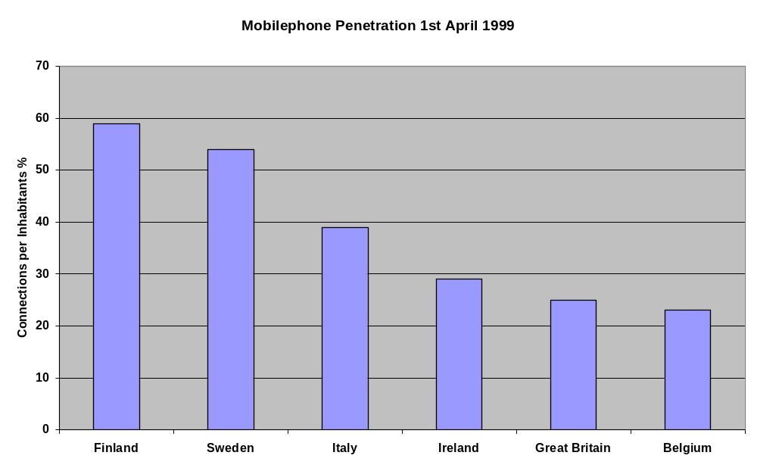

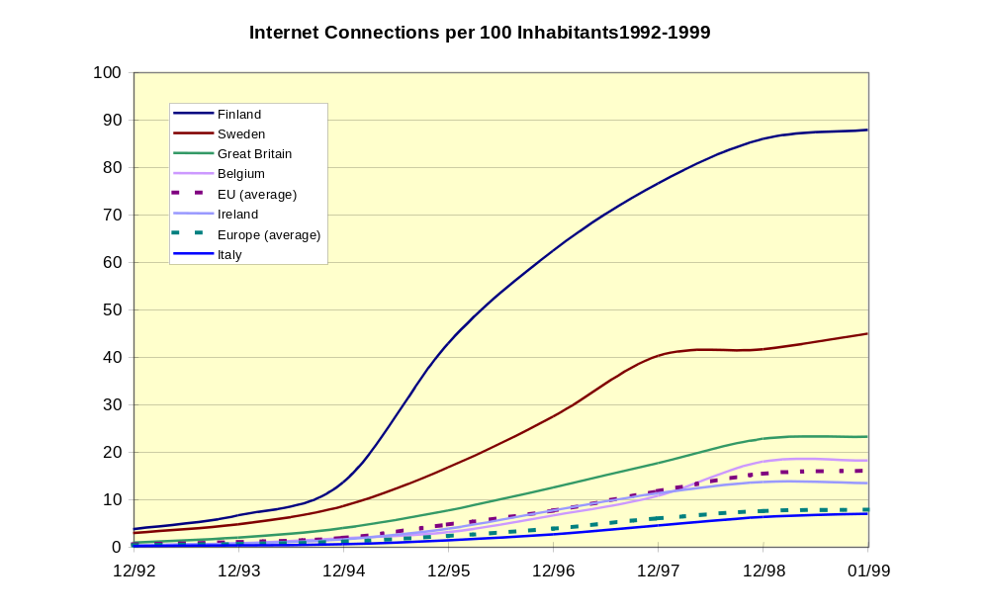Figure 9: The mobile phone penetration in SAMPLUS countries

Figure10: The Internet connection development

6. Fares
As mentioned in the 3.1 the fares should be carefully defined to make DRT an attractive public transport alternative and at the same time keeping in mind that DRT offers good service, normally far better than conventional public transport. On the other hand the users have to know and understand that there is a reason for higher fees. Too short trips far from the depot that cannot be combined with other trips heavily and rapidly increase the operational costs. Therefore the tariff/fee may include elements which favour walking or biking when the trips are short.

There are also cases where the fares are the same as in conventional public transport. Here DRT is seen as a seamless element of the total public transport concept. Sometimes there has also been a political decision to replace the conventional public transport with DRT services and since the users have not any other alternative for public transport, the fare has been kept the same as before. The fare questions have to be solved case by case. The main issue is however to offer and provide better quality trips than in conventional public transport with much cheaper fares than in taxis.

7. Special Users
In SAMPLUS the needs of the special user categories have been taken into account as fully as possible. In SAMPO it became clear that these users should not be forced to use DRT services, if it is not possible to take into account their personal needs. The needs for savings will force the municipalities for instance to find new innovative concepts such as DRT to be used by the special users. Very often it may mean that the special users’ attitudes are sceptical. Thus there is a need for motivation based on the positive effects of DRT.

DRT service could be marketed to the special users as a social mode of transport where you can meet people and where you will have good service from friendly and helpful drivers. The results of SAMPLUS,“The Citizens’ Networks” and the objectives of the 5th framework programme clearly show that there is a need for additional development of DRT concepts so that they will help the special users to participate society, to live independently and to obtain several new services. These could be provided with a new concept Integrated Demand Responsive Services for Citizens, IDRSC based on the SAMPLUS work and ideas and their further development.

8. Operation
DRT aims operationally to provide satisfactory services using the existing resources as effectively as possible. The co-operation between different actors in DRT is essential. The need to further develop the DRT services based on the SAMPLUS experiences will require in many cases multi-purpose vehicles that can also take into account the needs of the special users (the disabled, the elderly etc.) These vehicles should have easy access, low floors, possibilities to take in wheelchairs etc. It is also important that the operational environment and the DRT solutions (vehicles, stops etc.) are in harmony. The experiences show that vehicles can be reasonably cheap even though they are specially equipped, if they are based on generally accepted and used (‘standard’) solutions.

If the passenger amount is greater or there are part time contracts with operators, the fleet may consist of several types of vehicles. The fleet may consist of ordinary low floor minibuses, special equipped vehicles (for the disabled) and standard person cars as taxis, and buses.

Technology issues

As partly mentioned already earlier DRT services are increasingly regarded as an adequate response to the demand of mobility in a number of situations. These include, e.g., providing efficient response to travel needs of special user categories (the elderly, the disabled, the students, the workers, etc.), coping with transport requirements in low demand areas (peri-urban areas, rural areas, mountain communities, etc.) or during particular time periods (e.g. night services), the provision of complementary PT services (e.g. feeder services for conventional bus network, etc.). The number of the elderly people within the community, living in both urban and rural areas, is increasing in both absolute terms and as a percentage of the population. Their mobility needs cannot easily be met with conventional transport services, and thus they have a higher requirement for flexible, user-oriented transport.

Whilst the use of simple manual systems may be appropriate in some situations, it is expected that the rapid decline in cost for telematics hardware and software means that the main constraint in using more sophisticated approaches will be the technical capability of the operators. For example many bus operators are not familiar with either AVL or the concept of computerised despatching and booking, whereas these are familiar to most taxi operators.

Both SAMPO and SAMPLUS projects have shown that it is rather difficult to develop properly working DRT service concepts without developing respectively telematics solutions and technologies. It has also become apparent that, when SAMPO was very ambitiously developing comprehensive and large telematics systems for DRT, in SAMPLUS the development was more focused to the users’ and dispatchers’ needs so that development work was concentrated on the issues that really were relevant and important from DRT service point of view. This meant that even though the results of SAMPO demonstrators exceeded the expectations, the SAMPLUS project selected the very best telematics solutions and modules to be further developed. The emphasis has been in the core needs of the dispatchers, drivers and end-users.

In SAMPLUS it was agreed that the institutional, organisational and juridical issues will be taken more thoroughly into account than in SAMPO, where it was not possible to concentrate on these issues. This was important since some of the SAMPLUS sites were moving gradually from demonstrations towards the full scale use of DRT, where the technologies have to be compact and not too expensive and the institutional and organisational issues have to bee agreed upon so that there will no unexpected drawbacks in the full scale use.

In SAMPLUS the use of technology as a tool for DRT service provision was emphasised. The effects of the juridical, institutional and organisational issues on the telematics applications were thoroughly taken into account. The telematics applications were seen not only as tools to be demonstrated but also as potential solutions to be implemented for the full scale use.

The technological development in SAMPLUS was determined and rather focused since the service providers and users had rather good understanding of their needs and objectives, thanks to the SAMPO projects efforts. It became clear that even though there is a lot of promising technologies (GPS positioning and navigation, Internet, different communication network, on-board units, portable terminals, real time booking modules, optimisation modules, dispatching software, GIS systems etc.) offering huge visions, it is not a target in itself to use them all at the same time. The nature of the DRT service varies site by site and the same goes with the technological solutions. It is obvious that in the full scale use there has to be some compromises between the most advanced technologies and low cost tools that support DRT service provision.

The SAMPLUS project went well in the time schedule also technologically. One of the reasons for this was the fact that when the project started the different actors had already experiences both of the DRT systems and related technologies. Thus new ideas of using technologies were relatively easy to adapt in SAMPLUS. The users could tell what they wanted and the technology providers were able to answer to most of the users’ needs. This is very important for the success of the DRT systems and ITS – the solutions must be derived from the users needs.

The telecommunication problems that existed during the SAMPO demonstrations were eliminated in the SAMPLUS demonstration. The future communication possibilities will in the coming 2-3 years develop tremendously, when for instance the new generation mobile phones will be introduced. The speed and the capacity of the communications will increase dramatically and the future DRT applications will have totally new services available. The problems of shadow areas and quality of communications will hopefully be history.

During the SAMPLUS project several improvements to dispatching systems in TDC’s were made. This has been important since moving from demonstrations to full scale use the systems have to be real integrated tools not only good pilots. In full scale use the public transport operators need to have reliable, economical and comprehensive tools. One of the SAMPLUS operators summarised his ideas and objectives, when moving from demonstration into full use that: “We are moving from charity to business”. This was very well said since it describes the objectives of committed public transport operators. If DRT and related telematics will be considered to be seriously taken, all the unnecessary “nice to have” telematics have to be abandoned.

Human machine interfaces have to be simple and clear so that the booking can take place rapidly. GIS systems with illustrative digital maps are useful, especially when the operational area is large. However the dispatcher should be familiar with the area. The vehicle equipment should also be working with proven technology. In the near future, as mentioned, also the vehicle equipment will be developed tremendously. The on-board units can, in addition to DRT use, be used for several other purposes. Traffic information, weather information, RDS-TMC messages etc. will be possible in the near future.

Based on what has been said before, the viability of DRT systems/services has been successfully proven in SAMPO and SAMPLUS projects through local demonstrators. A number of requirements emerged from such demonstrators which strongly emphasise the needs of enhancement and further development of the technologies and “intelligent infrastructures” supporting implementation and operation of DRT services.

In the framework of the Ten-Telecom project SIPTS (Services for Intelligent Public Transport Systems) new solutions are being searched to replace conventional, ineffective, public transport services. For this a standard based, modular DRT-software will be extended to special needs of different areas (different user needs). These address different levels and provide the overall context for the needed future RTD and demonstration work related to technological issues:
- technological infrastructure supporting the implementation and operation of DRT services (e.g. improved user access to the DRT service, dedicated in-vehicle terminals, improved vehicle location and communication systems, etc.)
- standardisation and interoperability of technical systems to improve integration of DRT systems within the overall infrastructure for the management of collective transport and mobility services
- functional and operational capabilities of the resulting DRT service management infrastructure (e.g. service management and optimisation criteria, multi-site multi-operator, etc.)
- evolution of the DRT concept towards the integration and flexible management of other transport modes and services; i.e. development of a multi-modal, multi-service, multi-operator flexible Travel Dispatch Centre integrating management of several services including demand-responsive bus services, collective taxi services, etc.

The results of SIPTS and SAMPLUS support each other and both are aiming towards standardised DRT systems. Therefore there has been co-operation and change of ideas between these two projects. DRT needs standard modules both in the terms of technology and service concept. Development of modular solutions should be encouraged.

Although the level of demonstration achieved through SAMPO and SAMPLUS projects proved the viability and the market potentials of the DRT approach, there is considerable scope for further RTD actions to consolidate both the technology as well as the service models, as a further step to prepare large scale operation of flexible and integrated public transport services. It seems that during demonstration the passengers are willing to accept more service faults without complaint than in full scale use, and therefore the technology must be possible to be upgraded.

There is a need to demonstrate the full market potential and the business case for these technologies. The collective research effort has brought some of the technologies to the market place, but the public transport sector does not yet fully understand the operational and economic potential of the DRT services supported by advanced telematics. Equally, the supplier industry does not yet have a complete understanding of the range of environments within which their systems may need to operate, nor of the full range of operational requirements or system constraints. However, on the Finnish demonstration site, after the demonstration has moved to full scale use, the DRT has nearly 10 % share of all rural public transport trips. It is interesting to notice that in this case most of the passengers are totally new from other modes, thus adding the use of public transport. The potential market share is even bigger. This is a real wake-up indicator.

The technologies should be directed towards applications in the domain of local and flexible transport. This has traditionally been viewed as a small, niche market. As a result, research and industrial programs have considered the domain to be a very low priority. However, research within SAMPLUS has shown that the market has been seriously underestimated, mostly because of the higher profile given to the mass urban passenger transport systems of Europe’s large cities which were at the forefront of the research, development and dissemination effort. For a detailed discussion of the potential impact of DRT services in varying economic and market conditions and service locations within and beyond Europe, see the SAMPLUS Deliverable 7.2 Chapter 9.

User acceptance

The evaluation results and the rapidly growing passenger figures show that the users have been satisfied with the SAMPLUS systems. One of the main reasons for this is that the normal teething problems were mostly suffered already during the SAMPO project and SAMPLUS could continue the good work done. From the beginning of the SAMPLUS project, the users had already an idea of what is coming and they also new what they wanted. This indicates that the introduction of DRT needs lengthy background preparation and it will take several years to become established before a judgement about its success can be made.

There could have been even more passengers during SAMPLUS, if there had been enough capacity to serve all the potential users. As a matter of fact in many cases the term “user acceptance” could be changed to “user demand” since there is in some SAMPLUS sites a strong need to enhance the operational area and to add new kind of services and customers to the DRT service concept. The lack of information is not anymore as big a reason for not using DRT as during SAMPO.

The demonstration and the evaluation have shown that the users have generally accepted the SAMPLUS concepts, the technologies used and found booking easy. It seems that the DRT service is nowadays seen as an essential part of the public transport system at the sites.

It is however evident, and the SAMPLUS results show it on some sites clearly, that during a piloting (demonstration) phase, the users accept far greater deficiencies than in the full scale use. The possibility of deficiencies selects the passengers, too. Therefore the piloting phase does not reveal all user needs and in the case of service unreliability the potential amount of passengers remains hidden, too.

The evaluation results clearly show that the users have accepted the new system and the DRT service. Speed, comfort, price, reliability, safety and security have ranked mostly very good or good in all SAMPLUS sites. Annex C contains a summary of the main evaluation results. More information can be obtained from the SAMPLUS Deliverable 7.2 (Chapters 4 to 6 and Section 8.1) for a comprehensive guide and comparison of results at the demonstration sites.

Most of the DRT service providers (public transport operators) involved with the project have been satisfied with the SAMPLUS results and contributed actively to the project. The technological problems compared to SAMPO have decreased. The telematics systems have been more reliable that in SAMPO and the drivers have been mostly motivated.

Discussions, negotiations etc. between the dispatchers and drivers have been very useful and eliminated potential problems already beforehand. The public transport operators have been very active in developing both preconditions and DRT services themselves. They have spent huge amount of work and money to support the development of DRT services.

The passengers have been much more satisfied during SAMPLUS than during SAMPO. One of the reasons for this is the fact the DRT concepts and telematics application have been more mature and a lot of developments and improvements have been done to the telematics applications. It seems that the users want to keep the existing DRT services. Even those who have not used the DRT services think that they are needed and should stay.

As mentioned before SAMPO could not deal with the institutional and organisational issues as much as needed. In SAMPLUS the situation was different even though there still remains some issues that are open from institutional, organisational and juridical point of view. However, the most important thing for the end-user is the quality of the delivered service. If the service is not good, the users think that the DRT concept and telematics tools are not working well, even though the reason may be elsewhere than in telematics and dispatching systems.

The telephone call fee has been somewhat problematic. The TDC gives service that normally is chargeable, but surveys and focus groups have shown that users are usually not very willing to call, if there is a telephone call fee in addition to the fee for fare. The booking systems has still to be further developed and fine tuned, especially if/when there will be more special users in the future than in SAMPLUS.

However, in some rural areas where there is little or no available local service, and a high dependency on lift-giving, people are already used to having to phone someone (relative, neighbour), when they need to travel. In these situations, they see that it is natural to pay for the call themselves to a booking point.

Implementation issues

An assessment of the European market indicates that the collective size of the local and inter-urban passenger transport industry in Europe exceeds 300,000 bus units, and that there is an even larger number of taxi and minibus units. The number of bus units alone for this sector is estimated to be about 50% greater than the combined bus supply of all of Europe’s cities. However, because they are diffuse and the operator size is typically very much smaller, they have not been given much attention. Research in prior projects have indicated that there has been virtually no penetration of ITS into the inter-urban or the local bus sectors, whereas in the taxi sector there was typically radio communication with more or less sophisticated on-board units supported by taxi dispatch centres.

The requirements for DRT systems are actually more complex than for conventional operation, so that an operator that equips vehicles and depots for DRT participation should not need to make further investments for participation in conventional services. It is estimated that the investment for communication, location, in-vehicle displays, payment devices, and depot support systems is approximately from 5.000 to 10.000 Euro per vehicle.

This means that the total market in Europe for ITS for DRT is about 150 million Euro for local and inter-urban buses alone, and of a similar amount for taxis and minibuses engaged in local transport. These units will have a typical average life of 3-5 years, giving an annual potential market of 60-100 million Euro for the bus, minibus and taxi sectors combined. Naturally there is connection with the AVL/AVM (automatic vehicle location and monitoring) market also. Thus the market potential is remarkable.

The investment cost mentioned above is not excessive for the bus operator. As a percentage of total expenditure for the operator’s services, it is probably about 1-3% over the useful lifecycle of the equipment. Therefore, if the combined telematics can achieve even small increases in business, or efficiencies, they are likely to have a very rapid payback period. The important thing is that the TDC and the other operators also make the investment, so that the value-added services and management are implemented, and that the systems are compatible within the operating environment.

As mentioned earlier it seems that the operators regard DRT as a future mode of public transport and have invested a remarkable amount of their own money and efforts to the DRT concepts developed within SAMPLUS. The DRT concepts have started to move from demonstrators and pilot applications towards systems that are rather close to the full scale systems. It is interesting to notice that the SAMPO project aimed at full scale implementations that could take place 2-3 years after the project and that by the end of year 1999 (two years after SAMPO) SAMPLUS has been able to create systems for the full scale use. This could not have happened without the operators acceptance and contribution.

SAMPLUS has been in a very good position regarding to the implementation issues. SAMPO made a lot of preparatory work, which was the continued in SAMPLUS. When the SAMPO demonstration and evaluation were finished there were already a lot of test results and ideas for the further development of the demonstrators. SAMPLUS could base partly its work on these results and was able to create demonstrators that were rather close to final products to be implemented by the sites.

The SAMPO and SAMPLUS projects were piloted in the environment where the customers were real end-users in real environments. This was rather demanding and sometimes risky. On the other hand it really gave feedback immediately, if something went wrong or anything exceptional happened. Most likely the results of SAMPLUS could not have been implemented and taken into full operational use, if the demonstrations would not have taken place with real users.

Implementation activities of the full scale system in SAMPLUS have taken place only when the verification and demonstration phases have taken care of and proved that all pieces of the concept are working reliably according to the specifications. The implementation phase should include proper information and training of all actors involved with DRT services, either service providers, users or payers of the service.

During the demonstration there should be time and resources enough for preparatory activities. The demonstrators should be followed closely and evaluated properly so that the needed adjustments can be done before the full scale implementation. The feedback from the different actors is essential.

The first implementation and full-scale use started already during the SAMPLUS project. Looking back to SAMPO expectations in the beginning of 1996, it can be stated that this happened earlier than expected during the SAMPO project. It is also worth noticing that the some of first full scale implementations took place in the most challenging multi-modal and multi-operator environment.

Business Case, best practises

It was not easy to determine the economic or financial results of the SAMPO project on a wider scale, because of the limited time available and because of the reason that SAMPO was pilot/demonstration project with limited connections to the real competitive environment. Further the economic assessment consists of at least three aspects. The first is operational, the variable and fixed costs versus fare-box revenue. However this kind of cost calculation reveals only a small part of the economies or benefits associated with DRT. The second is authority costs and savings. The third is sustainable costs calculation. Other than for operator costs and savings calculations, the difficulty is in the fact that the costs tend to accrue to the operator or service purchaser and the savings to other authority or society sectors. These kind of savings are nearly impossible to obtain from school, social and health care sectors/authorities even in the cases where they are working together with voluntary organisations on local, regional and state level simultaneously.

It is important to remember that each coutry has its own cost tructure e.g. fuel costs, staff costs, maintenance costs vary considerably. Thus the only really useful financial comparison is before and after at each site. However SAMPO and SAMPLUS have shown there is potential business in DRT, especially when the mandatory special transports have imposed a lot of costs for municipalities. Based on the findings in SAMPLUS DRT could induce remarkable savings especially in these special transports.

When the authorities purchase the services as turn-key-systems, or some major elements of the service, the presented operating costs do not reveal the real cost, since they are the results of the tendering process. The non-direct revenues in authority revenues are many times greater than the direct operational or fare revenues. The last is the case in Finland. In other SAMPLUS countries the operating cost are true operator’s costs. The sustainable development calculation was not possible in any country because of extent of work.

The experiences from Finnish SAMPO & SAMPLUS demonstrations and from the full scale can be summarised as follows:
- running costs of the TDC vary from 1,3 Euro to 10 Euro per trip (it is evident that when the demand rises to some hundred trips per day, the running costs may in well functioning TDC be as low as 1 Euro/passenger trip)
- the price/cost of a single trip is in Finland now at the level 10,5 Euro for the purchaser (municipality) including the TDC costs (half of the DRT trips are run by taxis with normal taxi prices, the price is quite sure profitable for the operator)
- The operator receives subsidies for every taxi drive some 15 Euro and for every minibus drive some 47 Euro from the municipalities.
- the direct costs of one DRT taxi trip (excluding the fare-box revenue share) are approximately on the level 11 Euro + TDC costs for the operator and the direct costs of one DRT minibus trip approximately 34 Euro + TDC costs.

The economical result will radically change, when it is a question of the special transports, or of the public transport in low demand areas with equal level of service than elsewhere. The average authority cost of a special transport person trip in Keski-Uusimaa was 15,5 Euro before the DRT demonstrations.

Before the SAMPO and SAMPLUS demonstrations the social sector of each municipality granted a certain number of subsidised trips for each eligible person in the municipality. The social sector had the obligation to follow the number of trips and the justification of invoices concerning the trips. The social sector costs for the special transports reduced in Tuusula and Järvenpää nearly as much as the SAMPO and SAMPLUS authority costs were the totally during the same time period. Kerava was not using SAMPO/SAMPLUS for the special transports and the authority costs in Kerava social sector increased substantially following the general trend in similar municipalities in the whole country. These experiences have in some cases encouraged the municipalities to replace the existing and expensive fixed line public transport services with DRT services, where the service level is higher than in conventional public transport and the costs for municipalities are lower than they previously had been. In addition the service providers can offer the services effectively and profitably.

In Belgium DRT services are fulfilling a major role in the restructured PT network in each of the 3 provinces, where the classic city services, the fast, interregional connection services and the functional service routes need to be supported in areas with low population, errand travel patterns and dispersed service centres. This lowest level of public transport fails to be performed with the classical regular lines, running expensive full-sized vehicles via twisted schedules through all the villages and quarters. DRT services perform the lowest level of public mobility in these difficult PT-areas. So the cost savings compared with the older network, are clearly present, although very difficult to measure due to the scale of data collection: previous lines are redirected and more lucrative than before, other lines previously serving parts of current DRT areas are abandoned, and so on. Therefore it is almost impossible to pinpoint any savings or cost-reductions related to a specific DRT service.

Moreover, DRT offers other improvements that are only measurable in a qualitative way, without any financial assessment. In this context we need to validate the improved level of flexibility towards the customer, his increased mobility potential, the improved accessibility for elderly and disabled, a more personalised treatment of the passenger, the improved relationship between the operator and the local communities and such. In short, one must conclude that the improved image of the operator has to be taken in mind when analysing the pure and naked cost-economical efficiency index.

The operating cost per passenger in Belgium is much higher than the fare that the passenger pays, which shows clearly one objective and social relevance of public transport, guaranteeing a base level of mobility for the so-called less mobile or captive users. In Belgium the DRT Services are a part of the total public transport concept and the fare (based on tariff zones) is the same as in conventional public transport. DRT is introduced in many cases to replace former classic and inefficient services. The fare has been kept the same since people have no alternative for former public transport services that have been abandoned. The only difference is that the customer has to pay a phone call for the DRT Service (always zone tariff).

In Italy there has been several activities related to the expansion of the DRT services:
- in 1998 more than 5 systems (SAMPLUS/PERSONALBus) were sold and will be operated this year
- ome calls for tenders were launched 1998 by different transport companies for AVL/AVM systems including also the request of functions/modules for DRT service
- at least 3 regions have prepared calls for tenders for DRT service/system to be operated in low demand zones (mountain communities, etc.)

All these initiatives are pushed by a local authority (city or region level) or by a public transport operator. Naturally the potential business case is easier to determine if there is a proper before-after situation and analysis. This means that the demonstration time has to be long enough. In those sites where SAMPLUS has directly continued SAMPO work by developing the SAMPO DRT concepts and applications, there has been a possibility for longer period of before-after studies.

A remarkable finding is that the passenger amounts have increased dramatically. On the other hand, since the fare level is very moderate, it is most likely that the fare box revenue will still not be enough to make the concept profitable in the full scale use, unless there is a proper contract between the municipalities and the public transport operators. Naturally, if the fares were higher there would be more incomes, but then the passenger amounts might also decrease. However it seems to be important to have at least some level of authority support to make DRT profitable business. The support has of course to be in line with EU regulations and laws.

SAMPO estimated that at least two years of operation will be needed to make the business conclusions. SAMPLUS can now after two years confirm the assumptions of SAMPO that there is good economic potential in DRT, when the geographical area is chosen correctly, the information activities are taken care of, the institutional and organisational barriers are eliminated and telematics for DRT is developed and used wisely. The integration of DRT services with other public transport modes is essential from the business case point of view. The challenging objective is to offer users a seamless public transport concept, where all the different DRT systems and existing public transport services (all modes) could be used as one system with simple ticket and payment systems. Thus one could talk about real travel chains and their management.

Impacts OF DRT and its

Chapter 4 describes the impacts of DRT services and telematics applications on different actors including SAMPLUS passengers, public transport operators and authorities.

The SAMPLUS demonstrations were better able than the SAMPO demonstrators to provide experiences of the different actors in DRT and to assess the impacts of DRT systems on different actors. Since there are several actors with different objectives, it is only natural that also the impacts differ from each other. The main actors that have been analysed are:
- passengers
- public transport operators
- authorities

Impacts of DRT services

DRT services will have quite a lot of impacts to the existing situation. DRT may replace the existing conventional services. Naturally in this case the effects are rather big. The users have to learn to use a totally new system. They have to get used to telematics, they have to learn the philosophy of DRT etc. When replacing the existing services it is essential to make all the preparatory arrangements carefully. Especially in the multi-modal and multi-operator environment DRT changes the existing public transport significantly, not only on the end user level, but also on the operator level.

However, in many cases there have been no services available previously. The DRT concepts offer totally new public transport services for citizens. In these cases it has normally been easier to introduce DRT, because there has been no other alternatives.

Whatever the previous situation may have been, it is very important to assess the impacts of DRT services beforehand and to certify that all the needed preparatory arrangements have taken care of. As mentioned already before the institutional and organisational issues, including the legislative framework and regulations have to be carefully studied and modified, if necessary, to meet the challenges set by DRT. This was noticed in SAMPO and has become even more important in SAMPLUS, when the implementation is phase is approaching.

In multi-operator environment the DRT operators, instead of normal competition, will in several cases co-operate with their normal competitors. The objective is to offer to citizens seamless, integrated public transport services with reasonable price. The vehicles used very often differ from conventional public transport vehicles. Based on the users feedback the multi-purpose vehicles (minibuses) have been very good in DRT. In some sites also normal taxis or specially equipped taxis (so called invataxis) have been used, when they have suited better. For DRT these multi-purpose vehicles are far more suitable than normal big buses, since they can use narrow and winding roads and their patronage levels are normally far better than those of big buses, especially on the country side.

The findings from SAMPLUS and other related projects show that the users, once they have got acquainted with the new DRT concept have been very satisfied. Suspicion and negative attitudes have rather soon turned to positive, if the system has worked properly and reliably. It can offer social contacts and relaxing chatting opportunities with the fellow passengers and the driver. However these positive attitudes cannot be reached without thorough and proper preparatory work, information and marketing.

The introduction of DRT means inevitably some level of telematics. The ambition level of the concept and services affects naturally the level of telematics needed. It is worth noting that telematics itself is a tool and tools have to be cost effective. SAMPLUS experiences have been able to show that moderate level of well-chosen telematics can be useful, but over-specification in the functionality, amount and level of telematics will decrease the cost benefit-ratio. Naturally the user’s (operators, passengers, dispatchers, authorities etc.) point of view is crucial here. The proper and clear human machine interface, the ease of use, flexibility of the system etc. are absolute requirements for proper DRT telematics. Naturally the communication between the TDC, drivers and passengers has to be reliable and effective. It seems that here SAMPLUS has been very successfully developing the SAMPO results to better need the users’ requirements. Therefore, telematics will not be the major bottleneck in providing DRT services.

Impacts of ITS on passengers

The end-users/passengers are the most important actors in DRT. Without passengers there will be no DRT services. There will be no operational or economical success in DRT, unless the passengers accept the system and trust it. SAMPLUS has shown that after the users have learned the system, found it to be reliable, and acquired the knowledge how to use it (including telematics), then they are rather satisfied with it.

The passengers need also objective information of the possibilities, effects, fares, additional services and requirements etc. The SAMPLUS results show that if/when the passengers understand the idea and philosophy of DRT, the importance of booking calls, the importance of clear information of departure and arrival points, the role of dispatchers etc, they accept the DRT and are willing to use this new public transport service and related telematics tools.

The user interface of the passengers with the DRT systems is normally the (telephone) calls to (and from) the TDC. From the passengers point of view advanced telematics and technologies are not important. On the contrary it could be said that the less telematics the passengers knowingly have to use, the better. During the SAMPO project several technologies were tested. Most of them proved to be effective and properly working. However there were some technologies which either did not satisfy the users or were not yet ready to be taken into use. For instance the experiences of voice responsive systems in automatic bookings and booking confirmations were not too good in SAMPO but were much better in SAMPLUS. Also the use of smart cards in payments was not very successful. However the smart card development was not in the scope of SAMPO, only the use of possible working smart card solutions.

In SAMPLUS some technological solutions were further developed and some were not used at all. The main idea was to make the system easier for the users. Mostly this was done successfully in SAMPLUS.

The future plans of enhancing the DRT service concept so that more and more special users could use the service, will require additional and thorough consideration of telematics tools. They are inevitably needed, but they should be easy to understand and use. It is not only question of telematics but also about attitudes and fear of new demanding things. The users should be encouraged to use the systems and services. One good argument for using DRT services is the idea of not only a trip, but also of a social event. During the trip you will meet friends, talk about important issues etc. This should not be undermined.

Impacts of ITS on operators

The SAMPO project was very good from the operators point of view. In most cases they learned what to do, what not to do, and how to further develop the services and related telematics. SAMPLUS has been able to take into account most of the findings of the operators, when further developing the DRT systems.

The operators/drivers have learned how to use different telematics tools. SAMPLUS has concentrated very strongly on eliminating the problems encountered in SAMPO. This work has been rather successful. The operators and drivers have learned to use radios, mobile phones and on-board units with computers as normal tools. Based the SAMPO and SAMPLUS experiences, one DRT test site outside the SAMPLUS project took hand-held terminals into use as a low cost message transmitting tool. The results seem to be rather promising on low demand areas.

Within a few years there will be a new mobile phone generation that can be effectively used in the DRT services by the operators and the passengers. This new generation will combine the possibilities of phones and computers and it will eliminate the communication problems, caused by the unclear verbal (spoken) messages, the shadow areas etc. more effectively than today’s terminals and mobile phones. The quality of data and voice will be improved and most likely the speech synthesisers will be far better than they are now. Hopefully, there will be no more communication problems and misunderstandings caused by them. In one of the test-sites the SAMPLUS results was the main stimulus that the change of the local taxi dispatch computer system was accelerated.

ITS has also impacts on the TDC personnel. The SAMPLUS project has concentrated on creating easier and better user interfaces for dispatchers. In some cases this has meant that the TDC systems are lighter and smaller than in SAMPO. The dispatchers have been able to define what elements and modules are the crucial ones for the satisfactory dispatching and booking service. Naturally, when the initiatives have come from the dispatchers, the new modified DRT systems satisfy better the dispatchers. As already mentioned the emerging new generation of mobile phones with new technologies and communication speed that is dramatically faster and much more reliable than today will create totally new possibilities for DRT.

While DRT projects to date have been relatively small scale, such projects are likely to move towards the model increasingly adopted in the taxi industry following introduction of computerised dispatching, advanced booking and vehicle tracking systems. This involves fewer TDC’s, able to control in some cases several thousand vehicles. For example Taxi Combined in Sydney handles over 1.500 taxis, Computercab in London track and despatch a fleet of up to 2.700 taxis, while the Comfort Taxi Company system in Singapore despatches over 10.000 taxis. While such a model may not be appropriate for rural villages, it is likely to be appropriate to larger urban areas when several hundred or even several thousand, DRT vehicles are operating.

Furthermore close integration with the sophisticated passenger information systems being developed by rail and bus operators is also likely to occur. If DRT is not properly integrated with mainstream public transport and with taxi operations, then the benefits for the public will not be maximised and DRT will remain a small-scale niche operation.

One of the questions to be solved is the role of the TDCs. Will they be local, regional or national? Will they be linked with each other creating a service network? Will they be run by public transport operators, authorities, traffic centres or some other actors? It seems that these questions have no single answer today. The TDCs are trying to find their role. Most likely there will be different types of TDCs.

Deliverable 7.2 Section 8.6 looks at the potential effect of market environment upon operators introducing DRT.

Impacts of ITS on authorities

It seems that the different administrative sectors (social, health care, school, technical, etc.) in SAMPLUS countries have realised that DRT can provide a powerful tool. However there is a real need also to further develop DRT and to find new service concepts and systems that make it possible to offer better services for citizens and at the same time to control the growing authority costs. This can be done through development of new services and using the emerging possibilities of the ITS these objectives can be reached.

It seems that administrators, authorities municipalities, provinces etc. in SAMPLUS countries have accepted the philosophy and possibilities of DRT services. DRT has proved to be able to create at the same time satisfactory and economical public transport services for the citizens. Naturally this could not have happened without proper telematics tools. These tools - software and hardware - have generated a lot of interest. The sites have been contacted and visited by authorities from other potential DRT sites that are interested in SAMPLUS experiences.

The experiences from SAMPLUS inevitably emphasise that organisations like National Social Insurance Institution (NSII) in Finland paying huge sums of money for special transports should actively participate the DRT development work. It seems that this kind of organisations will become more and more aware of the fact that they could have an active role in DRT and thus both save taxpayers money and provide the transport services needed.

Even though SAMPLUS and the ITS-support systems have been able to show that there are a lot of savings to be achieved, the authorities are not willing to use huge amount of money for ITS, mostly because the financial situation is not very good. When moving towards full scale use the telematics systems have to be simple, reliable and robust. If the ITS (software & hardware) needed for DRT is/should be bought by the authorities, the step may be too big to be taken. Therefore the alternative, where the public transport operator “sells the whole packet” including the ITS needed, may be a good solution. For this kind of service, there should be basic framework or guidelines for the DRT service contracts. However the decisions of how to arrange the DRT service should be made case by case.

The SAMPLUS results emphasise the importance of co-operation between municipalities and regions. At least when the municipalities are small or low demand areas, it is important to have more potential users by combining the efforts and increasing the operational areas.

Needs for future actions

Chapter 5 presents opinions and ideas for future activities the further development of the service concept, risks and barriers, dissemination and industry awareness and training and support related to DRT.

Further development of the service concept

The basic future objective for the additional development of DRT among SAMPLUS participants is to create new additional services and systems that will help especially the different special user groups to live as independently as possible in the environment where they would like to live. On the other hand there is a need to offer better unrestricted services for all citizens, including these special groups. Obviously the best and most effective way to create these new service concepts is to combine the new services so that the special user services will be integrated with other services. Thus all citizens will be served equally and all groups, especially the disabled and elderly will be taken into account. All these objectives developed within the SAMPLUS project support the EC’s policies.

The future development work of DRT services must be in line with the EU and national policies. This is the key for successful implementation of new services, systems, applications, technologies etc. The further development of DRT services should aim towards sustainable development and enhanced services for the citizens. There is a strong need to combine the EU policies with new innovative service concepts, systems and technologies, to develop solutions that support the policy objectives and at the same time create services for all citizens including special user groups. One of the main cornerstones of the work done and the future plans has been European Commission’s Green Paper “The Citizens’ Networks”. Together with the Communication “Developing the Citizens’ Network” it forms one of the main guidelines for the further development of DRT services. Generally taken the Common European Transport Policy that also inspires “The Citizens’ Networks” is very strongly guiding the further development of the SAMPLUS results and ideas.

The future work should aims at DRT services, systems and applications that could be disseminated and taken into use and implemented European wide. As mentioned in chapter 4, it seems that the different administrative sectors (social, health care, school, technical, NSII, etc.) have realised that there is a real need to find new service concept and systems that make it possible to offer better services for citizens and at the same time to control the growing authority costs. Through development of new DRT related services and using the emerging possibilities of the new Information Society this can be achieved.

As stated in the chapter 2, it has become apparent that there is a strong need to enhance the service concepts and to further develop and utilise the telematics tools. EU/EC policies form a platform for the future development work of SAMPLUS results and ideas. The future work should give valuable information, feedback concerning the political guidelines, suggestions and best practise examples for the political decision makers.

The future development work should be based on EU, national and local transport policy and strategies. On the other hand there may in some cases be a need to alter national transport policy and strategies for public transport. In the SAMPO and SAMPLUS projects it became clear that the organisational barriers are often greater than technological barriers, thus a lot of preliminary work and negotiations are needed well in advance with all the parties involved before introducing the new concepts.

Although the individual transport services for the disabled are well-developed in many European countries, there are a lot of people who have mobility impairment and for this reason can not use the traditional public transport services but on the other hand do not belong to the community aid system. Also for these people new transport systems such as service lines (lines with loose time schedule and possibility for route deviations, help and assistance needed is given by the driver) and demand responsive transport services are a longed-for possibility to travel independently. The social intercourse has been noticed to be very active in the above mentioned transport systems and it brings both mental and physical stimulation to the passengers. Society gets savings through the reduction of the need for institutional care. Also for the transport operators the service lines give a new possibility to achieve completely new client groups that have not been able to utilise public transport before.

Special attention should be paid to the many people in rural areas without cars. They are the life-blood of the community, but may be suppressed or leave. There is a need to communicate the social crisis that is faced. This is made worse by the difference in mobility, opportunity and lifestyle between those that have adequate transport, and those that don’t. This is a core difference compared to one or two previous generations. In addition, many facilities are concentrated in towns, and local facilities shut down, while new communities are planned on the basis of universal mobility, and then exclude many people. If regions, authorities and services want to consolidate their facilities, then they must provide the real mobility options.

The contribution of the future DRT development to European Community social objectives means improved accessibility of services for all citizens, increased quality and user orientation of the social services such as health and home care, decreasing the isolation and withdrawal of special users such as the elderly and the disabled, increasing the possibilities for all citizens to participate and not be dependant on the social group/situation, etc. The future work should aim at finding and developing new logistics solutions (people and goods), advanced service concepts and systems to help special user groups to stay and to live actively in their homes instead of being forced to move to old-age home or hospital. The objective is to create, for the citizens, services that can easily be implemented European wide.

The social and healthcare sectors in different SAMPLUS municipalities have been very actively creating and developing new ideas for DRT services. The SAMPLUS project has given good results and now the social and health sectors in SAMPLUS municipalities want to continue the development work. There is an urgent need to create new services and concepts that will help especially the different special user groups to live as independently as possible in the environment where they would like to live. On the other hand there is a need to offer better open-for-all services for all citizens, including these special groups. The social objectives should be in the first priority. Increased participation and decreased isolation are very important issues. Socially it is important that all citizens will be served equally and all should be taken into account.

New technologies should be used and new services should be developed to provide new concepts and policies to enhanced transport, mobility, and participation of the citizens. It has become obvious that there is a growing need to enhance the user-friendliness of the information society.

At the moment the supply of telematics applications for the needed service concept is very limited. This is especially the case in social services. Transport, mobility, health care, home care and other services should be designed bearing in mind those millions of European citizens who have to deal with reduced mobility and who are dependent on public transport services. The fact is that these new service concepts cannot be created on a wider scale without advanced telematics systems. The systems to be developed will integrate the demand and supply of not only transport services but also social services related to home care, health care, deliveries etc. Naturally the systems and technologies should be as standard as possible. Indeed the SAMPLUS sites have been able to use several standard modules, elements and equipment. However so far there are no standard DRT systems to cover the whole service concepts. SAMPLUS has used and further developed the open architecture specifications introduced by the SAMPO project.

Although most DRT trials to date have started from making bus services more flexible or special taxi services more economic, it is hopefully the case that they will move towards fully flexible multihire “anywhere-anywhere” services which:
- allow people to travel from anywhere to anywhere if desired, for the appropriate fare, rather than limiting such services to specific zones or sectors
- use the new types of vehicles currently emerging, which combine the low running cost and manoeuvrability of the taxi with low floor, easy access, comfortable seating, and a seating layout allowing friendly interaction with the driver.
- are open for the general public to use (with special groups receiving appropriate subsidies based on a percentage of the fare)

This will widen choice for all, and provide affordable accessibility for the many people who, for economic, social, demographic or other reasons, do not have access to a car. However such services are only likely to be developed on a large scale in urban areas if:
- appropriate cost-based fare structures are adopted
- subsidies are restricted to specific target groups of the population, rather than made available generally
- modern technology is used to minimise cost of taking bookings and despatching vehicles

In rural areas it will be difficult to operate such services on a pure cost – recovery basis, and some on-going subsidy of a general nature is likely to be required (in addition to specific user-side subsidies). This is where local municipalities in particular become vital (as well as health care organisations etc).

It seems unnecessary for several different DRS operators in one city (except perhaps large cities) unless two or more distinctly different DRS services (in terms of service quality) are offered under different price structures. One option would be to let tenders for the provision of DRS services, with both taxi and bus operators to bid. The nature of the service(s), fare structures etc would need to be determined in advance. Ideally, tenders should be let separately for the provision of integrated booking and information service covering all modes, with all operators (taxi, bus, rail, tram, DRT etc) required over time to provide information on their services in a standardised format. This would allow the public to make the best choice of option or options for any given trip.

Overcoming risks and barriers

SAMPLUS has shown, as described in chapter 3, that the major risks and barriers are not technological, but more juridical, institutional and organisational. DRT is a new concept, even though it has been tested and piloted for some years now, for instance in SAMPO and SAMPLUS. When moving from demonstrations towards full scale use of DRT systems there are several issues that have to defined and agreed upon.

These issues were not that important during the pilot phases, since the one could always say that “it is only a pilot – not a real thing”. Now after SAMPLUS many sites are moving towards real full scale use and all the potential risks and barriers have to be considered. It may be so that they are not really major problems, but this has to be made clear in advance.

Fair competition should be guaranteed, where possible. Very often DRT services cannot be operated on fare box revenue and thus the level of subsidies has to be determined in advance. The ideal situation is a seamless public transport system, where DRT is one essential element. However there has to be clear rules and instructions both for the tendering process, contacts and operation of DRT.

Responsible actors for each element in the DRT service concept should be literally defined. There should be also a juridical framework for DRT. In many cases DRT is not recognised within the national legislation, which makes it difficult to arrange DRT services in wider scale. The demonstrations are normally run in “exceptional circumstances”. The tariffs and fares should also be set right. Too-high fares most likely will not attract the users and too-low fares may cause capacity problems.

There are no major risks and barriers in technical issues and most problems can be solved rather easily. The emphasis should be in the institutional and organisational issues and political or social relations. These issues should not be underestimated. For instance in multi-operator, multi-modal environment the risks and barriers were remarkable in the SAMPO project. Many of them could not be solved before SAMPO was over. The SAMPLUS project was very successful in eliminating the risks and barriers as the evaluation results show. The co-operation between transport modes and operators in DRT should be encouraged. This is challenging for instance in situations where DRT replaces existing services.

SAMPLUS has shown that the operational contracts of DRT service provision are very important and they have to prepared thoroughly and early enough. The should be no open questions by the time the DRT service starts. There should also be only one party responsible for the specific service provision. This party can naturally then use subcontractors in the service provision..

The DRT service should follow not only the national juridical and conceptual guidelines, but also the EU level regulations and framework. However this has unfortunately not been the case in all SAMPLUS countries. By following European level suggestions and guidelines, the systems will be open and have European level value and interest.

It is important that the European level and national transport policies support each other and make it possible to develop DRT services. The European level transport policy sets the basic framework and guidelines of the national policies. The policy makers should start the process, where the policies will be harmonised. SAMPLUS has experienced that even though it has been involved with telematics, the whole development process of DRT requires also transport policy related decision and guidelines. Equally important as co-operation between different operators and transport modes is co-operation between different authorities. The roles on different authority levels should be literally defined. The co-operation between different municipalities is needed, especially where the municipalities are small and density of population is low.

The SAMPO experiences showed that the reliability of the TDC software and communication links between the TDC and vehicles/drivers may form a risk that has to seriously be taken into account. However SAMPLUS was able to remove most of the technology problems. Here the technological development and the development of applications based on the users’ needs played important roles. SAMPO showed also that the geographical location of the TDC is very important. The dispatchers should be familiar with the DRT service area. GIS systems can be used to some extent to compensate for the lack of geographical knowledge. However not even advanced GIS system can be replace the knowledge of the dispatchers.

During SAMPO there were people (both service providers and users) with attitudes against DRT. However during SAMPLUS the situation was better and the attitudes were much more positive. As expected, it will take more than six months (the SAMPO demonstration period) to make the system accepted.

Dissemination and industry awareness

Decisions about the procurement of telematics based systems will be made by user organisations and user categories. It is obvious that there is an increasing market both for the new services for citizens and for the applications and technologies. It seems that the industry awareness is growing and the market potential for DRT is growing

The basic idea of the dissemination and industry awareness is to ensure that the SAMPLUS results can be and will be used in the future to assists the further development and deployment of the results of different pilots/demonstrators. The target is to facilitate the services and applications of the SAMPLUS results to future users at other sites both nationally and internationally; and to disseminate the results across the EU and the rest of Europe. It is natural that the DRT service concepts have to be modified and fine tuned case by case based on opinions and needs of all user categories in the operational area. Public-private partnerships seem to be rather promising from the dissemination point of view.

The results of SAMPLUS should be disseminated to representatives of the public transport industry actively in works shops and seminars. Several national and international conferences have already been organised by the SAMPLUS partners.

The dissemination and exploitation target actors consist of national/regional authorities, local communities, citizens, special user categories, public transport operators and other service providers. The new DRT services and applications should be based on the integration and further development of existing applications and technologies, and thus the price of both equipment and of support services can be set at reasonable levels which are affordable to the users. Generic solutions and existing application technologies will be employed as much as possible to ensure that end user prices and the prices for services remain reasonable.

The results of SAMPLUS have been/will be disseminated in the following way:
- deliverables, media exposure, publications, web-site
- seminars, and workshops at the administration and commercial levels, informational events etc. to convince the users of the commercial benefits of the use of the results
- development of links with interested users
- utilisation of evaluation and acceptance results as a means of promoting the services and systems
- provision of results to selected users of the system for their user evaluation and assessment
- information to worker and organisations.

See also the SAMPLUS Deliverable 7.2 S3ection 8.5 for further development of the use of DRT contacts in SAMPLUS.

Training and support

It became clear in SAMPO that DRT requires a lot more training and support for all the actors than originally anticipated. SAMPLUS was, however, able to continue from SAMPO work and thus the training and support was much easier to arrange and the different target groups were reached. On the other hand the attitudes had turned more positive towards DRT and thus the training was easier.

However the same basic principles were present in SAMPO and SAMPLUS:
- each actor needs specially tailored information, training and support
- proper verification decreases the amount of problems and the need for special training
- special user groups need special training that has been very well prepared
- it is useful to arrange events to which all the potential users are invited
- the dispatchers and the drivers should arrange meetings where different issues can be discussed
- the dispatchers have to be able to reach for help immediately, when problems occur
- the end-users need much more information than anticipated
- the end-users should have a feedback possibility (telephone number etc.)
- special user groups need special training that has been very well prepared
- introduction of new telematics equipment and applications requires more preparatory efforts than normally assumed.

Checklist for the DRT service development

Chapter 6 presents a list of frameworks and issues that should be considered and taken into account, when planning and developing the integrated DRT service concepts.

There are a lot of issues to be taken into account, when developing the DRT service concept and related applications. Figure 11 describes principles of the DRT development process. Even though the figure is simplified, it shows how there are many several steps and issues that have to be taken into account, when developing DRT. It is also worth noticing that to develop an effective and working DRT service concept takes quite a long time, usually not less than some two years.
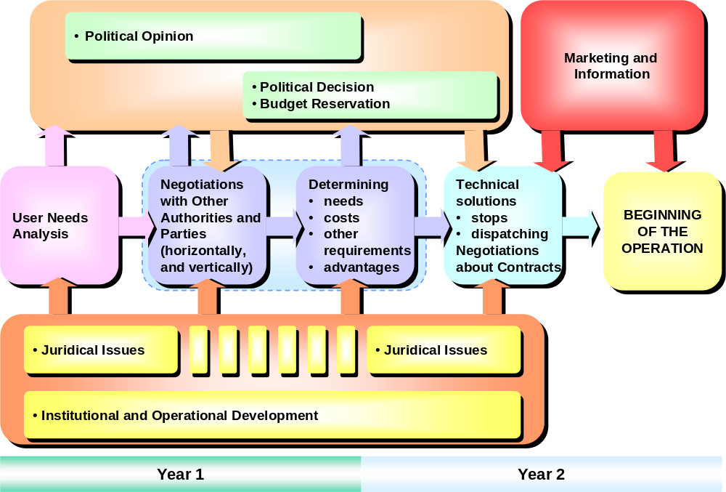

Figure 11: Development of DRT services in municipalities

It is important that all the steps described in Figure 11 are taken. Based on the experiences it can be said that during the DRT development process the technological and telematics possibilities and tools develop very quickly faster and it would be important to follow this technological and telematics development and to utilise new opportunities when making political, juridical and operational decisions. The steps cannot be taken without financing. Thus in the very early stages of the DRT development it is absolutely important to arrange the financial issues so that there will be no unexpected financial fox holes. In SAMPLUS the financial instruments and sources varied quite a lot from country to country.

As mentioned in Chapter 3 the technological development, juridical framework, institutional and organisational issues all have effects on the operational framework and should be taken into account in the DRT development work. Thus the development of DRT is affected by several external factors, frameworks and issues. It cannot be isolated from the social frame of reference. On the other hand there are several issues that have to be taken into account and decided internally during the development process. Figure 12 summarises these frameworks and issues.
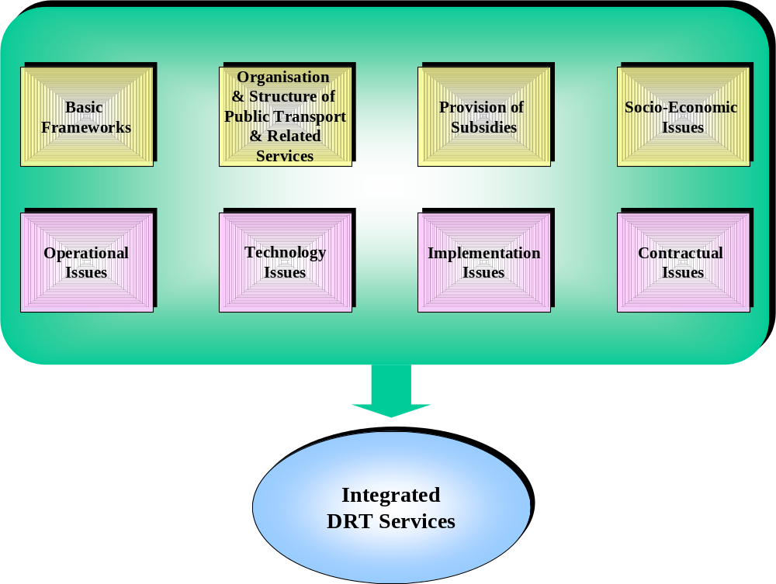

Figure 12: Frameworks and issues affecting DRT development

When planning the DRT service concepts it seems to be important that both public and private organisations are involved and work together. On the other hand there is a need to listen to the end users. The following actors should participate the DRT planning:
- authorities
- community groups
- public transport operators and associations
- end users and their representatives (associations etc.)
- software and hardware specialists
To be able to run DRT service properly in a reasonably large scale telematics is essential. Manually the operations and the service cannot be controlled. All the telematics functions should be integrated together.

Basic Frameworks

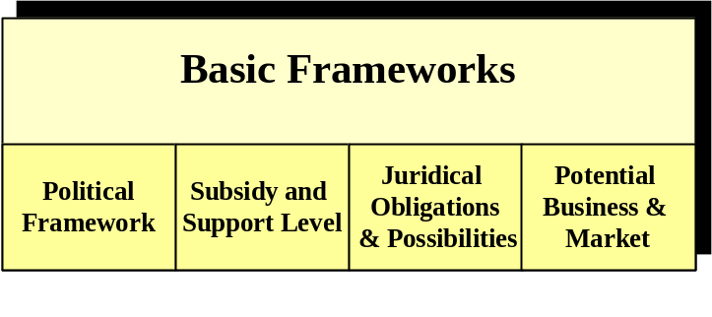
Figure 13: Basic Frameworks in DRT development

Before starting the actual development work of DRT concept and services it is essential to ensure that all the information concerning the basic frameworks affecting the DRT development work is available. If the basic factors are unclear or they have not been taken into account, then the DRT concept, however advanced operationally and telematically, may face serious problems when taking it into full scale use.

Political framework

The political framework for the DRT service concept must be cleared. This political framework varies quite a lot in different European countries, even though the national transport policies of the Member States should follow and respect the Common European Transport Policy. Thus the political framework may offer totally different possibilities for the development and operation of DRT services. If there is no political support for the DRT service concept the development and implementation work will be very difficult. Naturally it is important to try to foresee whether there might be changes in the political framework in the future. Perhaps it may even be possible to try to actively speed up changes needed. In most SAMPLUS countries there is a political support for the DRT development.

Subsidy and support level

Subsidy and support possibilities and mechanisms to public transport and DRT especially should be checked. In many cases the DRT service will not be self supporting and thus there is a need for subsidies and support to develop and run the DRT service concepts. Very often subsidies and support are closely related to the political framework.

Legal and juridical issues

The DRT service concept cannot be developed and run, if the legal framework prevents it. Thus the juridical obligations and possibilities for DRT must be checked. In most countries there is no legislation for DRT, however it seems, partly because of the SAMPO and SAMPLUS projects that in some countries the development work to create the DRT legislation has started. This legislation will determine the DRT concept, obligations and possibilities for DRT. If there is no legislation for DRT, there should be efforts to create it. The DRT services need to have a juridical status to be run in full scale and real environment. The pilots and demonstrations can normally be run without any special juridical framework, but after that there should be an officials status. It is also very important to check, whether there are regulations dealing with the competition with other public transport modes and with violating existing public transport services.

Potential business and markets

Naturally the DRT service concept is worth creating, if there are potential markets and business for it. On the other hand it may also be a political decision to develop the DRT service even though there are no potential markets and business. This is however not very advisable or desirable. The DRT service concept should have real potential and markets. DRT can be either commercially profitable business or a new public transport mode that enables potential for society and authorities to offer statutory transport services more economically and effectively than earlier. It is also important to notice that without integration with existing public transport services DRT is not very likely succeed. In any case the concept should have potential for high benefit-cost ratio taking into account all the social benefits and costs.

Organisation and Structure of Public Transport and Related Services

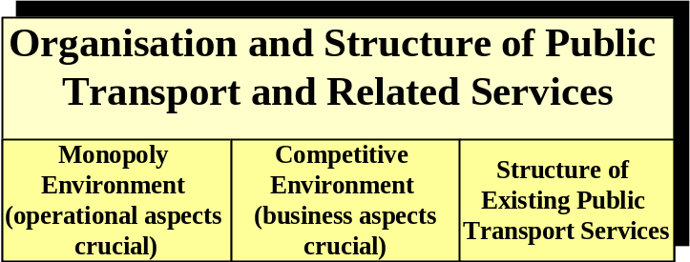
Figure 14: Organisation and Structure of Public Transport and Related Services in DRT development

Structure of existing public transport services

To develop a working DRT concept it is crucial to be familiar with the organisation of the existing public transport services. Also the structure of existing public transport and related services have to be studied.

If there are no existing public transport traditions and services it may be rather easy to start a DRT service by using semi-fixed route services with route deviations where requested. In cases where there is quite good public transport between towns/cities, but almost no services in rural and low demand areas, the flexible service with fixed end stop points might be the best. If the public transport has quite a comprehensive and wide network, but very low frequency and all the lines are directed to the nearest main centre, the best DRT alternative might be the virtual flexible routes.

Monopoly environment

The situation may vary from country to country or from region to region. There may be a monopoly environment, where the business and competition is not that crucial. However the operational issues have more emphasis in the monopoly environment. According to Common European Transport Policy there has to be good arguments for the monopoly environment..

Competitive environment

In competitive environment the importance of business aspects is crucial. The competitive environment forces the public transport operators to develop better and more innovative services than the competitors, although problems of co-operation are common and can deter the introduction of DRT services. Off road competition is more likely to promote DRT service than on road competition.

Provision of Subsidies

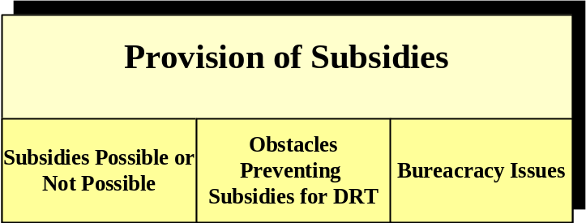
Figure 15: Provision of Subsidies for DRT

As mentioned already in the Basic Frameworks, the subsidy issues are important. If there are possibilities for subsidies and support the mechanisms are to be cleared out well in advance. If there are subsidies available in public transport, it is also very important to clarify, if there are obstacles preventing the subsidies for DRT. This is very important since very often DRT services cannot be operated on fare box revenue and there is a need for some kind of support and subsidies. There should be no major questions open concerning subsidies and support, when planning the DRT service concept. Therefore all the bureaucracy issues related to subsidies have to be clear before starting the DRT operation.

Socio-Economic Issues

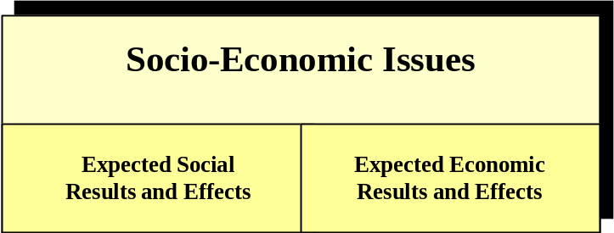
Figure 16: Socio-Economic Issues in DRT development

Expected social results and effects

The socio-economic issues are very important, when evaluating the DRT service concept. There should be clear picture of expected social results and effect for the DRT service. Therefore it is crucial to gather beforehand all the needed information for the before-after analysis. Most likely DRT service concept will affect many social issues. This is obvious since in many cases the planned DRT areas and users of the DRT service differ from normal environment and users. The areas may have no or limited amount of public transport services and there may be special users and user groups such as the disabled and the elderly.

Expected economic results and effects

On the other hand there should also be clear expectations for economic results and effects. In DRT there is the costs tend to cumulate to the public transport sector, but the benefits to social and other “soft” administrative sectors. Therefore, if economical results are expected, it is essential to collect data related to transport costs before and during DRT service. The SAMPO and SAMPLUS evaluation plans and reports have presented sets of measurable indicators for social and economic evaluation and assessment. Naturally they always have to be adapted case by case. See the SAMPLUS Deliverable 7.2 Annexes 9 to 12 for more detail.

Operational Issues

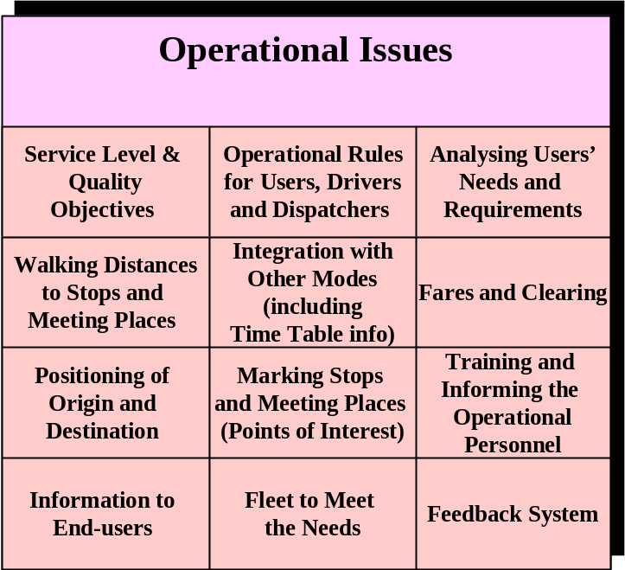
Figure 17: Operational Issues in DRT development

The operational issues and decisions form the basis of the DRT service. They have to be clear, practical and justified. They have to be defined so that all the parties involved with the development and operation of DRT can approve them.

They also have to measurable, if just possible. The service concept should be planned based on the users’ needs and there should be discussions, planning sessions etc, where the service characteristics are defined. The decisions of the service concept should cover issues like:
- type of service
- service area
- service hours & time tables
- routes, if any
- ordering procedures
- stops & meeting places

Working examples of such service decisions are given in the SAMPLUS Deliverable 7.2 Annexes 1 to 8.

Service level and quality objectives

The DRT concept needs clear and measurable service level and quality objectives that can be used, when assessing and evaluating the service level and quality of DRT. It is also important to plan how the service and quality assessment and evaluation will be carried out in practise.

Operational rules

The DRT service cannot be provided, if there are no rules for the DRT operation. All the different actors; end-users, authorities, drivers, dispatchers etc. need to have rules and instructions how to behave in different situations. The responsibilities and rights have to be defined. The rules have to be written and they have to be clear and easy to understand. Based on the experiences from the SAMPO and SAMPLUS projects, it requires a lot work and discussions to create these rules. Especially in a multi-operator, multi-modal environment the rules may be rather complicated. On the other hand, the use of common sense should not be forgotten. It is also important to decide what kind of users will be transported from door to door.

Analysing users’ needs and requirements

Naturally the DRT service is not a service for itself, but for the users. It is important to analyse and to define all the different users, user groups and user categories (both direct and indirect users) and to analyse their needs and requirements. Even though it is possible to learn from previous exercises, the user needs and requirements analysis needs to be done always, when there are plans to introduce DRT on a new area. (It also provides a very good awareness-raising activity, and identifies potential support from the community in establishing and maximising the use of the services). It is crucial to take into account the needs and requirements. There are several issues and steps that have to be taken into account iwhen definend the user requirements. The following figure shows the different steps of the user needs/requirement analysis.
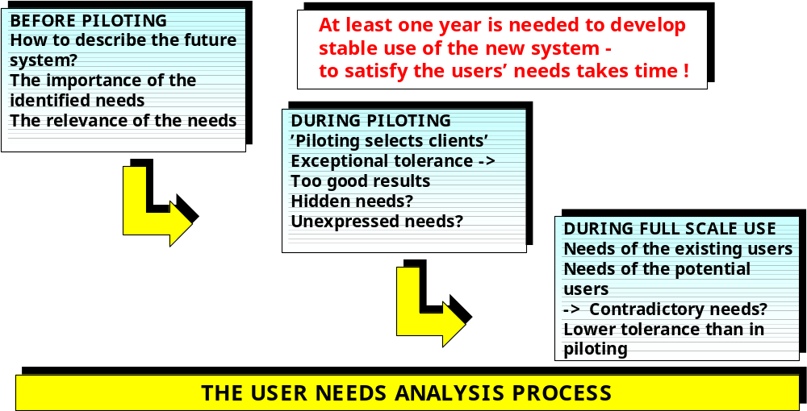

Figure 18: The structure of user needs analysis

Walking distances to stops and meeting places

The operational environment of the DRT may vary a lot for instance from urban to rural. Therefore it is important to define the walking distances to DRT stops and meeting places, taking into account the operational environment. In most cases there are also users that are justified to be picked from their homes and thus for them there is no walking distance. Especially in competitive multi-operator, multi-modal environment it sometimes is rather complicated to define the distances since the competing operators may have contradictory opinions.

Integration with other modes

The idea of seamless public transport public is becoming more and more popular. However to achieve the objective the different public transport services and modes should be integrated. DRT should be seen as an essential element in the total public transport chain and thus it should be integrated with other modes. The integration of the public transport time table/schedule information would require a comprehensive and up-to-date time schedule database with very short response times. So far this kind of database has not been created, though there are projects that are aiming at doing it.

Fares and clearing

The decisions of DRT fares and clearing systems are to be made. The DRT fee may be the same as in normal public transport. However very often the DRT fee is a bit higher than the ordinary public transport fee. In SAMPO and SAMPLUS there were both sites with the same fee than in the normal public transport and sites with slightly higher fee than in normal public transport. If there is more than one mode and operator involved with the DRT service, it is very important to create and agree upon an effective and impartial clearing system, as well as the rules for sharing the revenue.

Positioning of origin and destination

Very often in DRT there are no routes or timetables, but the service is provided by the request of the user. Since the user normally informs the dispatcher the origin and the destination, it should be very easy. There should be an easy way to inform the dispatcher about the origin and the destination. This has been one of the most challenging issues in SAMPO and SAMPLUS. The origin is normally easier to tell, but the destination is often open to various interpretations. Naming and numbering the meeting places and using stickers on the phone (telling the name and number of the nearest stop) have been used, but they have not eliminated all the problems. What it comes to vehicles the positioning technologies ( if they will be used) have to be defined also in good time before the operation starts. The use of standardised ssolution is recommended.

Marking stops and meeting places

The stops and meeting places have to be marked and their co-ordinates should be in the dispatching system. The markings should be clear and visible containing at least name, number and the telephone number of the TDC. The points of interest (POI) should be in the TDC-database, but they normally are not marked. Often there is a need for totally new stops for DRT and thus the marking work should be started in good time.

Training and informing the operational personnel

All the people involved with the DRT operations and service should be provided with proper information and training. This training should be planned carefully and there should be enough time for the operational personnel to get acquainted with the DRT service concept and its requirements. When the operational personnel has been informed, trained and discussed with early enough, the threat of lack of motivation and negative attitudes decreases strongly. It is also important to bring together the operational personnel and discuss with them about the coming DRT service. The dispatchers, driver and other personnel should learn to know and talk to each other.

Information to end users

Experiences show that the informational activities targeted to the different end-users are never too much. To provide the information for the users articles in newspapers, brochures, discussions, seminars, radio and if possible also should be used. The information should be carefully planned and it should be very easy to understand. If the users do not know what they are offered, they most likely will not use the service. There should also be a contact person to answer the questions the (potential) end-users may have.

Fleet

The user needs analysis and naturally all other DRT-related information should be utilised, when planning and preparing the fleet to meet the needs of the users. The vehicles should be suitable for the DRT operational area, they should be especially equipped for the special users (if the services are targeted to these users), they should be telematically equipped (to be able to communicate reliably with the TDC). The amount of vehicles should also be estimated carefully. Especially in the multi-operator multi-modal environment the fleet decisions are of great importance. The SAMPLUS experiences show that the buses must have reasonable accessibility. It would be could if they could be wheelchair accessible. The buses should have flow floors, if possible and they should be mini-bus sized. The noise level should not be too high. The feedback from the users shows that they like the “dance floor” seating, where the passengers can sit in a half circle and easily to talk to each other. The conventional layout is however safer and thus perhaps should be preferred.

Feedback system

Since the best way to develop the DRT service concept is to listen to the operational personnel and the different users of the system, there should be a good follow-up and feedback system which not only gathers the feedback, but also actively stimulates the operational personnel and the users to provide feedback related to the system. All the feedback should be recorded and it should be used for evaluation and further development.

Technology Issues

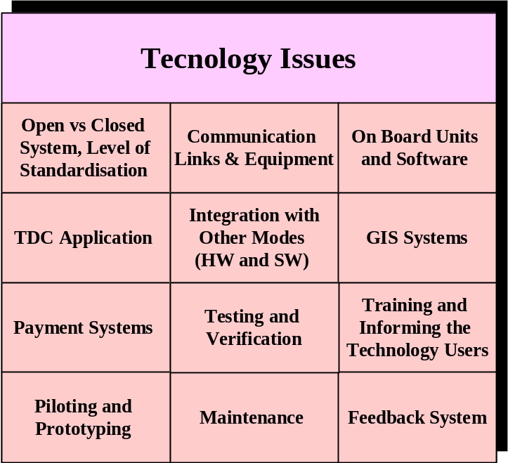

Figure 19: Technology Issues in DRT development

Open vs. closed system, the level of standardisation

One of the main technological decisions concerning DRT is the decision of the openness of the technologies and applications to be used. The closed technologies may sometimes be cheaper and easier to introduce. However if the objective is to develop a DRT system that can be integrated with other public transport systems, the only answer is standard open architecture and standard open systems. Naturally since the standardisation work of several telematics tools, equipment and applications is not yet finished, it sometimes may be difficult to make the technological decisions. However perhaps the most important thing is to confirm the openness of the DRT system (hardware and software) by using as standardised user interfaces as possible. It is also important to try to foresee the possible functional links.

Communication links and equipment

The communication links and equipment to be used should be both quick (short response times) and reliable (no breakdowns or errors). The positive thing here is that the telematic development is so rapid that the telematic tools are not causing major problems, if the background issues are taken care of.

The new generation mobile phones for instance will offer huge possibilities for the communications in the DRT service concepts. Also positioning technologies for vehicles are developing quickly and at the same time the hardware costs are decreasing. Here the openness and standard solutions mean reliability.

On-board units and software

The on-board units and software to be used have to be considered also carefully. As with communication links and equipment the technological development of on-board units is very rapid. The new generation mobile phones, portable computers etc. offer a wide range of good alternatives. The results of SAMPO and SAMPLUS show that the data communication is more reliable and effective than voice communication to vehicles. Also the possibility to print the messages, instructions etc. has been regarded as a good characteristic. It is worth noticing that the draft standard for the on-board-units in the buses is available.

TDC application

The TDC application is the most challenging element in the DRT system. The dispatching system has to be easy to use, quick, reliable and integrated with other public transport systems (if possible). It has to contain at least some level of route/time/etc. optimisation, if there are several departures and arrivals during one trip. The use of digital maps have been proved to be illustrative and useful, especially, if the operational area is large. A lot of effort should be put into planning and development of the proper TDC system. Here it is useful to study the experiences of the previous TDC system development projects and their results. The SAMPLUS results show that the time required to make a booking (call time) has been some 2 minutes or less. This has been accepted by the users generally. However the time should be shorter than 2 minutes.

Integration with other modes

If possible, the DRT software and hardware should be integrated with the systems of other modes and other operators. This naturally requires open systems and solutions as mentioned above. It would be also very useful to integrate the DRT system with timetable information applications. However at the moment there seems to be very limited amount, if any, of reliable, up-to-date, timetable information systems and databases. However the integration requires discussions and negotiations with other modes and other operators, which may also be competitors. This may be complicated, but for instance the SAMPLUS experiences show that it is possible. One of the major reasons for this at least in SAMPLUS was the fact that in DRT there were two competing modes which both had new customers.

GIS systems

As mentioned above the proper GIS system is useful, especially when the geographic are is large and the amount of data is big. When using GIS it is important in addition to the stops and meeting places to include all relevant points of interest, public offices and buildings, agencies, local names etc. in the GIS database. When using GIS in DRT, it is crucial to plan the updating routines so that the GIS system is reliable. However in many cases this is a huge and challenging work.

Payment systems

Payment systems can be used to make it easier and faster to pay, to gather follow-up information, to provide information for the clearing activities. The agreed clearing system is essential, if there is more than one operator providing the DRT service. The payment methods may be cash, magnetic cards, smart cards etc. The payment system has to be planned and developed carefully since the cash flow is always important for the operators.

Testing and verification

The DRT systems - hardware and software - must be properly tested and verified before piloting, prototyping and implementation. The testing and verification should be done to all parts and modules of the DRT system and the followed by the integration testing and verification to make sure that the different modules also work together. The testing and verification should be planned carefully.

Training and informing the users

Proper training and sufficient information is to be given to the technology users. Experiences show that the informational activities targeted to the technology users are seldom too massive. Work shops and training sessions are essential for the technology users. The training and information should be carefully planned and very easy to understand.

Piloting and prototyping

The DRT systems should be taken into use through demonstration, where a limited amount of vehicles and limited amount of users will test that the system, even though bench-tested and verified in advance, also works in practise. There should be a proper demonstration plan including the pilot period (start date, end date), feedback instructions, information collection procedures (for evaluation) etc.

The demonstration of the system should last preferably at least six months. If the demonstration period is shorter, the users most likely will not learn to use the DRT service concept before the pilot period is over. After a successful pilot period and modifications needed the DRT system can be implemented and taken into full use.

Maintenance

It is important to plan and develop a maintenance system to confirm that the DRT service concept will be continuously supported by the working technologies, hardware and software.

Feedback system

There must be a feedback system that gathers the feedback from different users and actors. The feedback system should encourage all the users and to provide feedback, suggestions, experiences etc. related to the technological issues. All the feedback should be recorded and it should be used for evaluation and further development.

Implementation Issues

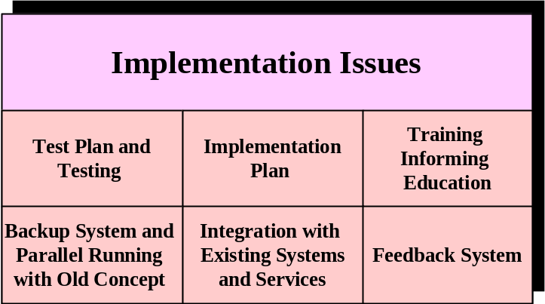

Figure 20: Implementation Issues in DRT development

Test plan, testing and implementation plan

The implementation of the DRT service concept and related hardware and software has to be planned and carried out according to proper testing and implementation plans. There may be two implementations: the implementation of the pilot and the implementation of the full scale DRT system. Both implementations are important, however the implementation of the full scale system always requires more than the implementation of the pilot.

Normally the full scale system to be implemented is not the same as the pilot system. There may have been improvements, changes and modifications. Thus the system to be implemented has to be tested very thoroughly. It cannot be emphasised too much that the system must not have any unsolved operational or technological problems left in the implementation phase.

Training, informing and education

There has to be time and efforts enough for training and education in the during the implementation phase. All parties must be aware of what is going to happen and what is required from them.

Backup system and Parallel running with the old concept

It is essential to exercise great care and sensitivity when replacing existing services with DRT services. To make sure that there will be no major problems, it is advisable to run the old system (if there has been one) and the new system in parallel for some time so that there is always a possibility to take the old system into use, if needed. However in case something happens there has to be a backup system to be taken into use, when needed.
Integration with the existing systems and services

To get the best results out of DRT service it should be integrated with the existing systems and services. This integration has to be planned thoroughly and in good time so that there will be no unexpected integration problems. The experiences show that the proper integration requires very much efforts.

Feedback system

To make sure that the implementation has been carried out according to the plans there has to be an easy to use feedback system for all the parties involved. The feedback system will provide valuable information not concerning only the implementation but also the DRT service concept as a whole. All the feedback should be recorded and it should be used for evaluation and further development.

Contractual issues

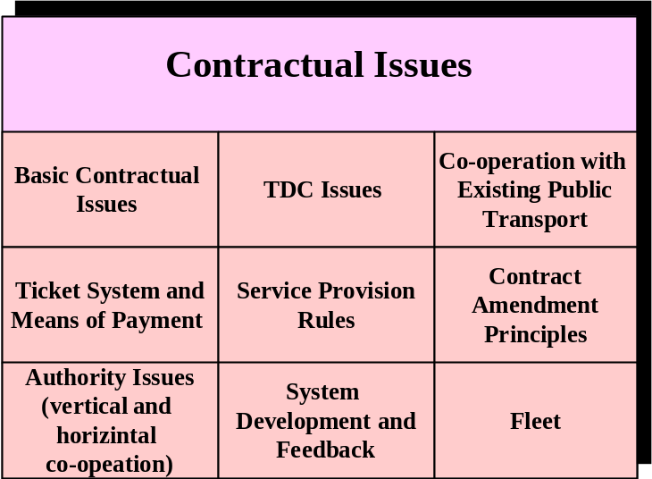
Figure 21: Contractual Issues in DRT development

Basic contractual issues

The operation and running of the DRT services naturally needs, as any other transport operation, a proper and thoroughly planned contract. The contractual issues are especially crucial when the DRT service is provided by an external transport service provider. If the DRT operator belongs to the organisation paying for the DRT services, the need for a detailed contract is less than in the case where some or all of the DRT operations are contracted. The DRT operation contract must include the standard elements and parts of every public transport contract.

The operational area, defined and agreed upon in the contract, affects much on the DRT operation. If the area is too big, the TDC may have difficulties in locating the origin and destination addresses. If the area is flexible, there may be difficulties with fleet management and economical operation of the service.

The contract period is crucial for a private operator. If the period time is short, it is difficult to learn the new DRT system, impossible to amortise special vehicles and equipment needed in the operation, and to find motivation for the continuous development of the concept, which is essential for DRT services. If the contract period is too long, there may be erroneous estimates of the DRT system or its economy in the beginning. There may also be difficulties to adapt new operation models. The contract period
for instance in Finland/Keski-Uusimaa is four years.

Sometimes the ideas and practices on which the contract is based change or turn out to be erroneous. Therefore the contract must contain terms of cancellation – a method to cancel or terminate the contract within a given time (for instance in some months) and the basis to agree any recompense. The DRT service operation time (operating hours) is an essential part of the contract. The daily operationg hours have an affect on the possibilities and motivations to use DRT services. If the daily operating time is too short, the DRT service will not ‘find its place’ and remains as a special service for special groups.

Because the DRT service often consists of several operations which are at least partly connected with each other in a new way, the responsibilities of each operation must be clear. This includes the definitions of the service concepts and especially the links between separate parts/elements of the service chain. If there are many operators and especially many public transport modes, the definition of all service aspects and elements must be done. It is typical that different operators and modes have slightly different meaning on the terms, or some terms may not be in use at all. Thus it is very important to agree upon the terminology.

The agreement upon the management of DRT operations is an essential part of the contract. Because DRT is under continuous development, the management board typically is a mixture of purchasers and operators. This will ensure that both the economical and the operational aspects are taken into account. The contract fee is one of the important issues affecting the future development of DRT. The contract fee must stimulate and encourage the future development of the DRT service concept. This is extremely most important. The contract fee does not necessarily have to cover all the costs related to DRT, if the operator estimates that the future market potential and possibilities may lead to substantial downstream benefits. The contract fee may be based on fleet size, number of passengers, operation time etc, or a combination of these factors. The fare box revenue can form one part of contract fee.

Proper and active marketing is an essential element for all new systems. This is the case with DRT services, too. New ways of thinking in public transport may need years to become accepted, and before the penetration level is high enough. Indeed, it may require quite a long time to stabilise the DRT system as an essential element of the public transport concept.

The methods of solving disagreements or disputes have to be described in the contract. The same goes with reporting on the disagreements and/or mistakes. The reporting has many levels and objectives. It should be defined at least for operational, development, purchaser and authority purposes.

TDC issues

The TDC itself needs a specific, detailed section in contract. The TDC may be part of the DRT operator’s own organisation, or a separate body outside the DRT operator. On the other hand it may belong to the purchaser’s organisation or some other organisation which incorporates TDC operations. If the TDC is not a part of operator’s organisation, special attention must be paid to the services (information, queries etc.) given and received.

The communication and information transfer responsibilities have to be properly defined. To prevent the TDC to start behave independently without a proper relationship to operations in the field, the operation contract should include indicators for economical effectiveness which tightly tie together the TDC operations with total effectiveness of DRT services.

The TDC may perform the route optimisation. The route optimisation seems not so necessary for small and medium sized operation areas, if the drivers are familiar with area. If route optimisation is used, it is important to define who collects the start-time situation and who updates the road network information.

If DRT co-operates with other public transport, the good practise is that the TDC is well informed of existing public transport. How the information is used, and whether it is available for everybody, is a policy decision. If the TDC is a source for common public transport information, the price of telephone calls must be taken into consideration. The TDC can not be a competitor for business based information services.

The TDC is dependent on data transfer. Therefore the data transfer methods and responsibilities of correct data transfer must be clear in contract. On the other hand the data transfer is one if the fastest changing areas in technology, and therefore the content of contract must be flexible.

The reporting for service improvement, economical relations, authority needs as etc. must be an essential part of everyday operations in the TDC. Reporting will be for operational, development, purchaser and authority purposes.

Many TDC operations are totally dependent on the real time knowledge of the operational area. Therefore the map information as names of locations, blocks, roads, buildings etc, roads, public transport routes and terminals including usual stops., road network, addresses are a vital part of the TDC information and therefore the purchase and update of this kind of data(bases) must be clear from the beginning of the TDC work

In SAMPLUS approximately fifteen types of DRT service scenarios are recognised. The possible scenarios depend on the type and organisation of existing public transport services, on the general transport policy, on the policy etc. The selected scenario(s) have a great influence on the TDC operations.

Co-operation with existing public transport

The crucial question in the co-operation between DRT and existing public transport is the openness of DRT services. If DRT is meant for some minor special groups, there are no or only limited amount of co-operation questions to be solved. On the other hand, if DRT is open for all, all the public transport operators, including taxis, call buses etc. are potential partners in co-operation.

The introduction of open DRT in areas where there is existing public transport causes adaptation of new and old public transport to each other, at least in the long run. If the DRT is not open for all, the adaptation on the other public transport's side may be unnoticeable. Because DRT in general and in principle is more expensive than normal public transport, the authority-purchased DRT normally avoids the violation of other public transport. The best is a co-operation with other public transport from the start of DRT. If other public transport operators receive information all the time, the suspicious attitudes diminish considerably. Working with the taxi industry is the hardest part, because in many cases the taxi assumes that DRT lie on the same market with taxis. The co-operation is not one-sided. Normally the adaptation causes on the existing public transports side at least some reduction on most uneconomical lines. There is the good practice to estimate possible conflicts and create rules to avoid illegal and unnecessary conflicts. In the same process it is good to negotiate the feeder service principles.

Ticket system and means of payment

An other cause is the DRT's adaptation to public transport ticket system(s). Because DRT normally is the minor part of public transport, DRT must adapt more than other public transport. At the same time solutions must be found for the ticket system and make the decision on the means of payment. Because other operators may be sub-contractors, the use and extent of sub-contractors is good to appear in the basic contract. DRT may have a separate ticket, because the price may differ from the price of ordinary public transport. If a smart card is in use, the part time vehicles or supplementary vehicles may not have the necessary equipment and skill. The ticket price is at the new DRT contract a flexible element. Therefore the contract must include ticket price change methods. With ticket price, it is possible to impact on demand and revenue. Because of a new system the change of price can not be as rigid as in other public transport.

Some legal issues may restrict the ticket price. For example in Finland the ticket price must be "moderate in the area", if the clients are for social reasons eligible for subsidised transport. The payment method(s) definition(s) must consider that there may be customers with vouchers. The clearing of vouchers may include bureaucratic difficulties. Who pays the bureaucracy costs?

In many cases the local public transport may long-established means of settling the ticket receipts and allocating the revenue. There are many aspects to be taken into account in the contract
- what are valid tickets?
- adaptation of the DRT system to existing systems and methods
- own tickets of DRT
- transfer tickets
- use of smart card
- clearing system.

Service provision rules

It is always important to describe the service concept in details. Especially this is the case in DRT, because most operators and TDC personnel are not familiar with the service concept in the beginning. On the other hand there must be an easy way to modify the operational rules, if they cause unsatisfactory service or economic disaster in real life. For the passenger one of the most important things in DRT is way and time of booking the trip. Another important issue is the possible boarding and egress locations. It is important to make attitude surveys and studies during the DRT operation. If the attitude studies report needs for changes, there have to be agreed rules for the process.

It is also important to define the service quality objectives and measures. The contarct has to contain the agreed quality levels to be fulfilled and define procedures and sanctions in case of non satisfactory quality.

If the TDC is a separate body, and there are many separate operators to carry out the passenger transport, the vehicle selection rules are of very high importance. In the TDC the vehicle and route optimisation needs a lot of parameters. To avoid suspicion among competing operators, the parameters and selection process should be open. The optimisation can involve factors of suitability, economy, policy, etc. The TDC must beforehand have a list of questions and all statistics needed for all reporting.

For the driver some rules are needed. How much help for the customer is included in the service, waiting for client etc. When the service is being introduced, the procedures for how to respond when there are difficulties or unsuccessful service in either the TDC or in the field are important.

In special transport a sensitive common-sense approach is highly and desirable. No rules can replace a sensitive and helpful driver and TDC-personnel.

Contract amendment principles

In DRT the system elements have very separate development periods. On the technical side stops and other traffic environment are quite stable. The vehicles may considerably change over a period of years, the machinery in the TDC and in vehicles change totally over some years, the data communication may have major changes in months, as may the software in all machinery. Due to these different cycles, and because the whole DRT concept is under development, longer period contracts must include short ways of contract amendments. The content must be able to adapt to new solutions and situations, and clauses which may be affected by under development to ensure smooth running of the system must allow for this possibility. The tariff changes must be quite simple, if the price is not fixed on a common public transport ticket price. Contract amendments may have some ways to influence the demand, and not only following the changes in general public transport.

Authority issues

DRT is a new concept and therefore the national authorities may have great interest on DRT. At the beginning the national authorities may be willing to subsidise the concept and therefore be a party to the contract. The regional authorities are a natural participant in DRT. The deal between local and regional authorities highly depends on the national models and therefore there is nothing to express on the EU-level. A successful DRT needs, however, a tight co-operation between local and regional authorities - vertical co-operation. Because the DRT impacts on several other sectors as well as on technical aspects, the horizontal co-operation of authorities is extremely important. The horizontal co-operation must include at least the technical (public transport), social, health and education authorities. Some of those are authorities utilising the system, however being but outside the contract. Therefore there must be rules for the services offered to these authorities, future options and restrictions for the oversized use of the DRT concept.

System development and feedback

If DRT is not totally ready, a continuous follow-up, reporting and feedback is needed and is an essential part of contract. In the contract there must be a readiness for change on both sides (purchaser, operator). The marketing of the system is a part of development, but must be targeted towards specific user groups. General marketing has difficulties to reach special groups.

Fleet

The passenger volume in DRT may change considerably. This means that the fleet size question is a sensitive part of contract. The running of the system may include a principle of capacity restrictions and thus a fixed number of vehicles. Some questions which are essential to handle before such decisions are: All day capacity, part-time vehicles (as taxi). Fleet quality aspects and definition. Response to demand. Fleet size flexibility. Fleet type flexibility. In the competitive environment in Finland the use of taxis as part time operator and as supplementary fleet has been successful.

Conclusions and recommendations

The SAMPLUS project has been developing and enhancing a wide range of transport opportunities. These are particularly relevant to those areas where public transport services are not satisfactory. These areas may be rural, urban or suburban, where the lack of access to services and to proper transportation facilities reduces the ability of communities to develop and function in a proper manner. In addition, citizens who are disabled, elderly, or whose mobility is restricted have great potential to benefit from the SAMPLUS project work. The main impacts that will be experienced are:
- integration of services into a network provide greater transport cohesion in districts
- flexible routing services allow access throughout an area rather than on corridors
- improved access to local services, and to some extent to larger centres
- improved mobility will generally increase the level of economic activity in the locality, either rural or suburban, and improve the sense of identity
- improved mobility for disabled and elderly – or other socially excluded groups - will allow them to participate more fully in their communities and reduce barriers to being treated on an equal basis with other citizens
- improved mobility and access to services will help retain people, especially young people and families, in areas of declining population.
- the cost-effectiveness of the services will encourage increased service provision, increased usage, and create a sustainable environment for improvements.
- for locations with strong tourist dimension, improved, flexible public transport will encourage tourism without cars, assisting tourism growth in a sustainable fashion.

The experiences of the SAMPLUS project have shown that the development of telematics tools and applications cannot be separated from the political, juridical, institutional and organisational frameworks. On the contrary the main problems and barriers related to DRT are not technological. This deliverable can be used both as a strategic guide for the development and implementation of DRT service concept and as a practical development guide with concrete suggestions. Even though D8.1 refers to the previous work packages and deliverables in SAMPLUS, it is not a summary of them, but an independent document providing recommendations and suggestions for those interested in the DRT development. More information concerning SAMPLUS can be obtained from the previous deliverables that are publicly available:
- D2.2 SAMPLUS Website http://www.europrojects.ie/SAMPLUSmainweb
- D2.4 Business Plan and Market Projection
- D3.1 Requirements of Users of DRT Systems
- D4.1 A Basic System Architecture and Technical Solution for DRT
- D7.1 Evaluation and Verification Plan
- D7.2 Results of the Evaluation and Market Assessment of SAMPLUS technologies

The main goals of SAMPLUS have been:
- to further develop and demonstrate the Demand Responsive Transport (DRT) services in Belgium, Finland, Italy, and Sweden
- to carry out feasibility studies in Finland, Ireland and UK for new DRT sites
- to provide extensive evaluation to enable confident results to be achieved with regard to the potential for the use of ITS technologies in DRT

SAMPLUS has aimed at developing both the services and the ITS solutions in public transport, and at studying the effects of ITS on the use of DRT services. The SAMPLUS results show that DRT is one of the most high-potential solutions to increase the public transport services that are environmentally friendly, flexible, open for all and taking into account the needs of the special users such as the disabled and the elderly. DRT and related telematics applications and technologies are accepted by dispatchers, operators and end-users and during the SAMPLUS project in very many cases the demonstration systems have gradually been taken into full use. In most cases the dispatchers could no longer have provided the demanded DRT services needed without the related ITS applications. As a matter of fact the demonstration experiences clearly show that the dispatchers can not provide the DRT services in full scale without telematic DRT applications.

Extensive evaluation of the SAMPLUS results have been done and the results show that DRT services will offer a new mode that can be integrated with the existing public transport services. The DRT services are flexible and user friendly and have been accepted by the users. The DRT concept needs advanced telematics to be run properly. The rapid technological development during the SAMPLUS project and in the future plans of technology providers have shown that the telematics tools will be no bottleneck in DRT service provision. There are however several institutional, juridical and operational issues and questions that have to be cleared before the full scale DRT system can be implemented.In many cases the fare box revenue cannot cover the DRT service provision costs. This is natural especially in the low demand areas, where no public transport service or mode is self supporting. However DRT services have proved to be very cost effective, when it comes to the statutory transport services provided/paid by the municipalities. Remarkable savings can be reported here.

The following list summarises the main findings and experiences of SAMPLUS:
- the development of DRT tools and applications cannot be separated from the surrounding political, legal and institutional frameworks
- technological problems are often easier than institutional and organisational ones
- DRT concepts should be based on the users’ needs, especially the needs of the special users should be further studied and services developed
- the passengers have accepted the DRT concept
- TDC relating far away from the operational area has not been the best solution
- the real-time time table information is a huge challenge for integrated public transport
- in many cases some level of authority support is needed to make DRT profitable
- the DRT services have been very cost effective what it comes to the services paid by the authorities
- the introduction of DRT means inevitably also some level of telematics
- standard solutions for DRT should be developed and used
- there is a need for legislative work for DRT
- fair competition should be guaranteed
- the DRT development cannot be done without committed responsible actors

ANNEX A: SAMPLUS sites

Site description

- Demonstration sites

1.1 Belgium

Market environment

In Belgium the market is regulated (highly planned). The size and location of routes are protected from other operators: De Lijn has a monopoly for operating public transport in the area and it is the only operator that receives subsidies. Routes are allocated by the public authorities for the three provinces of Limbourg, West and East Flanders : De Lijn makes up a dossier (map showing the routes) which the Minister signs. In effect, de Lijn has a legal/historical entitlement to route(s). Fares are regulated, being fixed by a Ministerial Order.

The Demonstration Area

The DRT demonstration in Belgium continued directly from the SAMPO demonstration and the basic DRT system was similar to that used in SAMPO. The number of lines offered was increased substantially, DRT services now being available throughout the three provinces, a total area of 8,596 km² with a population density of 378 to 527 persons/km².

Service characteristics

The DRT service provides a partial feeder service to conventional public transport trunk lines, thereby meeting the demand for local errand based customer requirements. 29 services are available, 21 of which are in Limbourg. Patronage ranges from 30-40 per service in Limbourg rising to 50-70 per service in east Flanders, and less than 30 per service in West Flanders. The corridor-type routes are all fully flexible between the two end stop points, calling at predefined stop points. The services and the three TDCs (one per province) are all operated by the state operator, de Lijn, using a total of 27 vehicles.

There are no restrictions on the type of service users, who can expect to find stop points every 500 metres in built up areas, and approximately every kilometre in rural areas. Service frequency, hours and days vary between the provinces, e.g. only East Flanders offers a Sunday service and it generally has the longest operating hours (14½ hours, Monday to Friday); whereas in West Flanders services are less frequent (2 of the 6 services only run 3 days per week for 12½ hours Monday to Friday); and in Limbourg all services operate at least 13½ hours Monday to Friday. Saturday services in Limbourg and West Flanders cease one or two hours earlier than Monday to Friday.

Reservations with operators are only possible Monday to Saturday in all provinces, the pattern of opening hours in relation to service operating hours being varied, i.e. sometimes the TDC opens before the service operation commences (Limbourg and West Flanders, but not in East Flanders) and sometimes it closes after the service operation finishes (West Flanders, but not East Flanders and Limbourg). Services are less frequent in West Flanders (every 2 hours) than in the other provinces, where they are hourly.

Customers need to book at least one hour in advance, except in East Flanders, where it is two hours. At all sites the notification of collection time occurs at the time of booking, i.e. there is no call back system. There is an expected stop point wait time of +/-5 minutes. Payment is by cash or a bus card.

Operational features

Pick-up time is considered to be more important than drop-off time. The policy is not to let customers wait for more than 10 minutes to be picked up. However, where a connection with other public transport services exists, the drop-off time is also important. In West Flanders the policy is to have a fixed arrival time for trips to town and a fixed departure time for trips out of town. There is a policy of timetable co-ordination between DRT and regular lines, which is enabled by the fact that the same operator runs both types of service.

As befits a service with no user restrictions, all buses are fitted with wheelchair platforms. The Driver and TDC communicate with radio and Ram mobile data. All journeys (outward and return) must be pre-booked, using either the manual or IVRS system or Internet booking. The telematics system was substantially improved following SAMPO: the RING software has an improved operator interface, updated statistics module and revised scheduling algorithms; the database period description has been revised; and advanced reservation procedures were introduced (IVRS and Internet).

1.2 Finland (Keski-Uusimaa)

Market environment

The Finnish market is deregulated with open access for nearly all services. In theory, there is free entry with no limit to the number of operators per route. However, regulation occurs when the operator applies for a licence and the public authority decides whether it is in the best interests of existing operators and users to issue another licence.

Routes and timetables are offered by the operator, to be confirmed/acknowledged by the relevant public authority. There is no entitlement to the route historically or by competitive tender, i.e. operators run self-supporting services and have no contract with the authorities.

About 20% of services constitute complementary traffic that is considered socially desirable, but the operator would not obtain a profit from them (this includes all DRT services at present). It is purchased by the regional and local authorities. These are deregulated (franchise) services. Some of these services are only for the disabled and elderly, whilst others are available to all users. Such services are in private and public ownership. The routes are allocated by the public authority and the size and location of routes are protected from other operators. The operating contract is subject to regular renewal by competitive tender.

All Finnish services are subject to fare regulation. Routes are licensed individually, but the operator may run several routes as a package.

The Demonstration Area

As with Belgium the DRT demonstration in Finland was a direct continuation of the SAMPO demonstration and the basic DRT system was similar to that used in SAMPO. The operational area was extended to include the northern part of the municipality of Tuusula.

The widened operational area covered some 30% more of the land area and 10% more of the population; the SAMPLUS demonstration area consists of the whole land area (300km²) of three municipalities in Keski-Uusima (Tuusula, Kerava and Järvenpää), which is considerably less than the Belgian site. The populstion density varies from being low ,131 persons/km², in Tuusula to high in Kerava and Järvenpää (over 900 persons/km²⁾.

Service characteristics during the demonstration

The Finnish service area is regional, the services acting as feeders to trunk lines and also supporting areas of low demand in urban areas. There is one service which runs continuously on demand throughout the service area: this is a virtual flexible route as there are no defined end stop points and the vehicle will stop at predefined (available to all users) and non-predefined (only available to disabled and elderly, and to school children in some circumstances) stop points on its journey.

Patronage stands at 100-160 users per day. This is supported by one Rapidi minibus belonging to an operator and up to 30 taxis [this includes normal cars and invataxis (1+8 seats equipped to transport older and people with disability)]. However, the success of the scheme also requires the collaboration of 7 other bus operators and 50 other taxi operators as they accept the SAMPO ticket and vice versa.

Fixed timetable co-ordination between DRT and regular lines is limited (or even not needed), as the DRT service is completely flexible. The allocation of DRT services is designed to ensure that there is no violation of the economic base of the regular lines, which is a potential problem in any area with deregulated public transport services.

There are about 800 predefined stop points in the area, giving an average distance of 600m between stop points, with a maximum distance of 900m for all but ten houses – these distances are similar to the Belgian urban and rural areas respectively. Stop points are either normal bus stops or special DRT stop points created specially for this service. Such stop points are located near services or close to peoples’ homes if there are no bus routes available.

All stops are located inside the demonstration area except two stops, which are in two hospitals outside the area. This enables passengers to use DRT on their trips to the hospital. Passengers can travel between any two stop points inside the area. The average waiting time at the stop point is approximately 10 minutes. The trip can consist of 0-2 transfers if multiple vehicles were needed as a part of the trip. This aspect of the service is open to all citizens in the three municipalities.

A special door-to-door service is offered to people with disability and people who have vouchers from the social services. If the person has the privilege of a door-to-door service she/he does not have to walk to the stop point but the driver picks-up/drops-off at an agreed place such as home. This privilege is granted by the social services and passengers have to inform the TDC of this when booking the trip.

Usually the driver also helps these customers more with their packages etc. - although helping is part of the driver’s job for all customers. The DRT service operates for 13½ hours a day, Monday to Friday, falling to 7½ hours on Saturday (the latter being somewhat less than in Belgium). The TDC is open on week days from 07.00 to 17.00 hours.

All passengers book their trip at least one hour in advance of the trip. Calls go to the TDC, which is located in Jyväskylä about 200 kilometres north of the demonstration site. The TDC allocates the route individually for each passenger by making use of the telematics application. The TDC tries to put as many passengers as possible on the same vehicle by adjusting the exact pick-up or drop-off time as desired by the passengers.

If necessary a call back is used 15-30 minutes in advance of the journey in order to confirm the pick-up time. Diverse methods of payment are available: cash, pre-bought serial or single ticket, Smart card and credit card or bank card on some vehicles, state railways pass with the local public transport stamp, and for STS users there are vouchers issued by social services.

Service characteristics after the demonstration

The SAMPLUS demonstration continued until the end of May 1998. From 1st June 1998 the Keski-Uusimaa DRT system continued as a permanent part of the Keski-Uusimaa public transport service. This change from the demonstration to a permanent system caused major changes in nearly all aspects of the DRT service. They derived from the experiences in SAMPO and SAMPLUS. This new system has not been measured.

The new organisation has meant that it is necessary to operate more economically and effectively. The group of three municipalities buy both operational and TDC services from only one operator which uses taxis as subcontractors to handle the journeys effectively. One consequence of the need for economical viability is that the TDC is now using less complex telematics applications and the new system is being modified when the need arises.

The operational system after the demonstration is quite similar for the passenger except that the TDC is now located in the middle of the site: the dispatchers know the area better and therefore the booking service has improved enormously. The necessary ideology of “from charity to business“ means that bookings have to be made two hours in advance of the trip instead of one hour. This helps considerably when fitting as many passengers as possible into a vehicle (the ratio is now approximately 2.7 passengers per vehicle, which is much more than during the demonstration).

The operational area is similar to that of the demonstration. Only few stops have been added. Operational hours have been changed a little, operational hours being extended by 2 hours in the afternoon on Saturday. The TDC is open on weekdays from 07.00 to 17.00 hours and on Saturdays from 08.00 to 16.00 hours. More vehicles are involved with the DRT service: two minibuses and all of the approximately 50 taxis in the area are able to take DRT passengers.

During and after the SAMPLUS demonstration the traffic has been called SAMPO. This is because the public has begun to recognise this system as SAMPO-traffic and there has been no need to change the marketing name once the EU project ended.

Operational features

The TDC works with “virtual routes“, which means that some regular passenger are fitted into a route driven regularly whilst others are asked whether they could also use that timetable. “Virtual routes“ are not drawn on a map for a passenger to see, but they help the dispatchers’ optimisation process. The relative importance of pick-up or drop-off time depends on customer needs: if no exact drop-off time is requested, then pick-up time is used, because it is usually more convenient for the passenger.

The driver-TDC dialogue is through NMT or GSM mobile phones and vehicle terminals. All trips must be pre-booked, unless someone is accompanying a pre-booked passenger. Booking is carried out manually. Trials with IVRS and driver booking were not effective, and there is trialling of Internet booking.

The biggest changes were a number of improvements to the telematics system which were mostly related to the TDC and the data communication between the TDC and vehicles, and they are described in detail in the system architecture and verification report. Particular modifications include taxis becoming a live part of the DRT services, trials to use communication methods other than SMS to taxis and minibuses, and the removal of institutional and organisational barriers.

Institutional and organisational issues

During the SAMPLUS demonstration TDC services were funded by Ministry of Transport and Communications and operational services were funded by Provincial Government office of Southern Finland. The three municipalities had no commitment to work together to benefit the system and it was quite a difficult process to ask permission from each municipality concerning every minor issue.

Furthermore, DRT had not been mentioned in legislation, so quite a lot of juridical, institutional and organisational questions were raised during the demonstration. This situation is very complicated and the evaluation process has tried to solve some of the problems, but some questions remain and are waiting for a solution. These issues are discussed in greater detail in Section 8.2.6.

Data Collection

The principal targets for the research were the DRT operators and the authority administering DRT service. The operator and authority research was carried out in June 1998. Of the 120 questionnaires distributed, 59 received replies. Questionnaires were distributed to:
- taxi operators in Keski-Uusimaa;
- the authorities in the Keski-Uusimaa municipalities (Järvenpää, Kerava and Tuusula) and in the Seinäjoki region;
- the DRT bus operator;
- TDC personnel in Jyväskylä.

The completed questionnaires for taxi operators were left at the taxi ranks. The bus operator and TDC questionnaires were returned in individual anonymous envelopes, which were posted free of charge to Tampereen Viatek Ltd. No questionnaires were distributed amongst supporting organisations (as was the case in 1997) due to the delay of the survey following contractual queries in SAMPO in June 1998.

There was only one type of questionnaire, i.e. no separate one was made for special groups. It was not possible for all operator personnel to be able to answer all the questions. The survey questions were divided into four classes:
- the operator’s background.
- the respondent’s background.
- special questions concerning disabled alighting and tickets.
- questions concerning opinions of DRT service quality and functions.

1.3 Italy

Market environment

As in Belgium, the market is highly regulated: the size and location of routes are protected from other operators, the public authority allocates the routes, the publicly owned operator (ATAF) runs a fixed collection of spatially connected routes and it has a legal entitlement to these routes. Fares are regulated.

The Demonstration Area

In contrast to the Belgian and Finnish demonstration sites, the population density is very high, ranging from 1,203 persons/km² in Campi to over 3,550 in Florence and Porta Romana. The areas are considerably smaller – less than 140km² altogether. The demonstration area increased after SAMPO by the introduction of the DRT service in Porta Romana

Service characteristics

Unlike the Belgian and Finnish demonstrations, there are three distinct DRT services in operation. Two have no user restrictions, but the Florence service is restricted to the disabled only. Whilst the low demand area of Porta Romana and the Florence service for the disabled are strictly urban, the Campi service is regional, providing semi-rural services that feed into the urban area.

In Porta Romana there is a flexible area wide service with vehicles stopping at predefined stop points. Campi and Florence offer virtual flexible routes, the difference lying in the nature of stop points, being non-predefined for the door-to-door Florence service and predefined for Campi.

Taking each service in turn, an average of 353 users per day are carried by two 10m buses in Porta Romana operating 16 hours per day mostly without fixed departure times. There is a minimum pre-booking time of 10 minutes, which is considerably less than in Belgium and Finland. No call back is offered.

Stop points are less than 300m apart in built up areas, which is also true of the Campi service. This operates for 14 hours per day, whereas the door-to-door Florence service runs for half an hour less. In Campi and Florence all journeys are on request (no fixed departure times), in which the customer is required to book at least 15 minutes prior to travelling – call back occurs when requests are made for trips following the day of making the request. Four 8m buses carry an average of 283 passengers per day in Campi, whilst five minibuses are used for 70-90 per day on the disabled service.

As with Belgium, the regular and DRT services are operated by the same company, so there is no need to develop special financial arrangements between the two types of service. Since the DRT service operates on request, it is not possible to issue fixed connections with regular services: however, as in Finland, by definition the TDC operator will endeavour to meet customers’ requests for connections.

There is one TDC for the whole Italian site. The expected stop point wait time is 10 minutes (more than in Belgium and Finland), notwithstanding instances of traffic congestion. Payment is by pre-purchased serial or single tickets or season tickets.

Operational features

The relative importance of pick-up and drop-off time depends upon the nature of the customer’s request, e.g. arrival at schools, hospitals and inter-connecting public transport services are best determined by drop-off time, but this is much less important for shopping trips.

All vehicles have chip card ticketing machines and AVL, the latter being used for driver-TDC dialogue. There is also a standard radio link at the Porta Romana terminals. The Florence and Campi buses are fitted with low floors and wheelchair devices. Pre-booking of trips is always required, either using the driver (not available for the disabled service) or by manual communication with the TDC

1.4 Sweden

Market environment

In Sweden public transport has been deregulated, offering a franchise system to operators, who are now mostly privately owned. The public authority allocates routes. The operating contract is subject to regular renewal by competitive tender, but the size and location of routes for successful operators are protected for the duration of the contract. The operator generally runs a fixed collection of spatially connected routes. As elsewhere in Europe, fare regulation is still enforced.

The Demonstration Area

There are two demonstration areas in Sweden: the Högsbo area in Gothenburg and Märsta in Stockholm, the latter having a low density of 25 persons/km² and also a low demand for public transport. Högsbo is a densely populated and hilly district, where almost a third of the population is elderly (5,000) and a further 1,300 are entitled to STS, which has traditionally been operated as a shared ride taxi service, as in most other parts of Sweden. Regular services are provided by trams with high floors; the lines often require long walking distances for passengers.

Service characteristics

Both service areas are urban and one service is offered in each area. The Gothenburg service is available to STS users and the elderly (over 65 years); it is a flexible corridor route stopping at predefined stop points between the two end stop points. The Märsta service has no user restrictions; it offers a semi-fixed route, so it more closely resembles a conventional service than the other demonstration sites, having fixed intermediate stop points as well as predefined stop points along a corridor.

In Gothenburg the service has been operating since October 1996. There are about 220 users per day, being carried by four low-floor minibuses running every 30 minutes from 09.00 to 16.00 hours on Monday to Friday. The minimum booking period is short (15 minutes) which is similar to the Italian site.

Automated trip-notification (call-back) gives the customer a preliminary pick-up time at the time of booking and then a pre-warning 15 minutes before the previously given pick-up time. This gives a larger optimisation window and thus higher productivity; it is also convenient and assures the customer about the arrival of the bus.

Stop points are very frequent compared to other demonstration sites: less than 150m for non-STS passengers. 10% of customers are entitled to a door-to-door service as they hold STS permits. The TDC offers a provisional pick-up time at the time of booking, which is confirmed in a call back 15 minutes prior to pick-up. Customers pay with cash or a Smart card.

In the newer Märsta service, there will be less than 400m between stop points and the service will run every 2 hours, being operated by one minibus. Projected patronage is some 200 passengers per week. At Märsta the pre-booking time is longer (1 hour). Payment is by cash or a prepaid ticket; a monthly public transport pass may also be used.

Operational features

The Gothenburg vehicles are fitted with wheelchair access and have very accessible low floors. At both sites booking can be made manually or with IVRS from both touch-tone phones at home and GSM. The IVRS for outward booking uses a very simple dialogue; the return booking function is more complicated and is not promoted by the operator.

Magnetic card readers for return booking are available at 4 locations in Gothenburg. They were validated during the SAMPLUS project. Users sweep their STS or Flexcards (similar to credit cards) in the machine and press a button. This indicates that they want to travel home as soon as possible. The request is processed in 30 seconds and the booking is verified with a small receipt from the connected printer. Currently, only manual booking is available at Märsta, but IVRS and Internet booking are being tested.

2. Feasibility sites

2.1 Finland (Nurmijärvi)

The Feasibility Area

The Nurmijärvi municipality is even more rural than the Finnish demonstration area of Tuusula, having only 83 persons/km²: there are three settlements of 5,000-12,000, the remaining few people are dispersed over a large area. It is characterised by a rapidly increasing percentage of elderly people.

Service characteristics

The service area is rural and the service will have no user restrictions. As with the Finnish demonstration site there will be a virtual flexible route running continuously on demand throughout the service area; the vehicle will stop at predefined (available to all users) and non-predefined (only available to disabled and elderly, and to school children in some circumstances) stop points on its journey.

There will be one TDC at Hyrylä which requires customers to book at least 2 hours in advance of travel. Using the experience of the demonstration sites, longer operating hours are being planned (16 hours/day Monday to Friday and 10 hours on Saturday; a Sunday service is being considered).

It is anticipated that ridership will rise from 40 per day upon commencement in 2000 to 100 per day in 2002. Payment will be by cash, series card (to be replaced later with a Smart card) and (for STS passengers) social office payment order.

Operational features

The operational features will be very similar to the post-demonstration Finnish site in Keski-Uusimaa. This is natural since the environments are rather closet to each other and there is a possibility also to use the same TDC in Nurmijärvi as in the Keski-Uusimaa site.

2.2 Ireland

Market environment

In Ireland the market is regulated. The state-owned operator (Bus Eireann) dominates the regular services with fixed stages and fares. Routes are centrally planned by the state operator and routes are licensed individually, being issued by a central government ministry (Department of Public Enterprise).

The size and location of routes are protected from other operators (even where a licensed service is not operated) and the state operator effectively exempt for having to apply for licenses. A subsidy is provided to the state operator from the central government department through national transport body. Fares for the state sector are subject to price control by central government.

In addition to the state operator, there are more than 1.000 private bus operators in Ireland, about 15 of which are in the feasibility site area. A schools transport system operates nationally, funded by Department of Education and managed by the state sector company. About 70% of these services are operated by private operators under contract.

People aged 66 and over, plus certain categories of handicapped people are entitled to free travel on scheduled routes. The travel is reimbursed by the Department for Social, Community and Family Affairs. This covers all state sector services, but private operators have extreme difficulty getting access to this facility.

One of the two Health Boards in the feasibility site area provides funding through direct contracts for transport services for outpatients to attend specific weekly clinics. The general public may not use these services. Such funding is unusual, and is a compromise following the restructuring of the Board’s area

The Feasibility Area

The counties of Cavan-Leitrim-Fermanagh are highly rural, having a population density of only 14 persons/km² spread over 1,500km².

Service characteristics

Four routes have been planned without any user restrictions. Each service will operate on a different day of the week for two or three times per day which do not coincide with peak travel services, e.g. school services.

Two route typologies will be used: some will be semi-fixed routes with fixed intermediate stop points and non-predefined stop points along a corridor; others will be completely flexible along a corridor using non-predefined stop points. In both scenarios there may also be predefined stop points. Between 5 and 8 vehicles with about 14 seats will be utilised altogether.

For three routes customers can ring up to the evening before departure, for the fourth they can call on the morning of departure. Thus, the pre-travel booking time is much greater than for the demonstration sites.

Pick-up time will be given at the time of booking, so there is no call back. Cstomers will not be expected to wait more than 10 minutes at the stop point, which is similar to the Italian site. Payment will be by cash initially, although if the free travel passes are permitted on the routes, then a smart card payment system could be used to facilitate administration and reimbursement.

Operational features

The DRT service will not be run by the same operator as the regular lines and there will be no financial arrangements between the DRT and regular (state) operator. However, there will be some timetable co-ordination in the early stages, as the DRT schedules will use the regular lines as a reference point. The site will commence with manual TDC operation at one centre; the system will be monitored to determine the level of bookings that would need to be supplemented by ITS support.

Pick-up time is considered to be more important than drop-off time, in order to minimise the waiting time in poor weather conditions, thereby building up user confidence. Hardware will be limited initially: a PC for record keeping and no in vehicle information system apart from communications.

The driver-TDC dialogue will be with GSM. In contrast with all other sites, pre-booking will not be necessary at end and fixed intermediate stop points, making it more like a conventional service. This means that the driver can be used at these points in addition to the manual booking with the TDC for all types of stop points.

2.3 UK (Surrey)

Market environment

In the UK the market is deregulated (open access) for nearly all services. This means that ownership is private, there is no fare regulation and there is free entry with no limit to the number of operators per route. Routes are offered by the operator, to be confirmed/acknowledged by the relevant public authority. Routes are licensed individually, but the operator may run several routes as a package.

There is no entitlement to the route either historically or by competitive tender. A few services, which are considered socially desirable, are subsidised. Ownership is still private, the size and location of routes, which are allocated by a public authority, are protected from other operators. The operating contract is subject to regular renewal by competitive tender and there is limited fare regulation.

The Feasibility Area

The county of Surrey forms a large area in which to place DRT services (4,000km²) and it has a relatively low overall population density (although this distributed somewhat unevenly).

Service characteristics and operational features

The service area is regional and the services will be restricted to the disabled elderly, providing means of mobility between rural and urban areas. At present there are 11 operators, one each supplying a dial-a-ride service in the constituent boroughs. DRT will not be run by the same operator as the regular lines and there will be no timetable co-ordination between DRT and regular lines.

Other service characteristics and the operational features will not be determined until the end of November 1999. This will be 23 months after the commencement of planning the service: this gives an indication of the time scale involved in establishing a new type of service in a deregulated competitive market environment.

2.4 UK (West Sussex)

The Feasibility Area

This constitutes the northern part of Chichester district, being focussed on small town of Midhurst. The area is of very low population density (79 persons/km²).

Service characteristics and operational features

The service area is highly rural and there will be no user restrictions. The two planned services will be area wide semi-fixed routes calling at fixed intermediate and predefined stop points.

One service will operate to the west and one to the east of Midhurst. One dedicated vehicle will be utilised for each route and it is intended that the services will run every 2 hours. This will offer the residents of relevant parishes an improvement in accessibility of 150-180%, even if only 2 return journeys are offered per day.

End user technology will be kept to a minimum whilst confidence and familiarity is built up among the customers and operators. The service will have an automatic vehicle location system. There will be one TDC in Midhurst, requiring 1-2 hours pre-booking time. The time of pick-up will be given at the time of booking (i.e. no routine call back facility). All trips will be pre-booked.

Booking will be manual without synthetic or touch-tone booking procedures, making it a much simpler system than that installed at the SAMPLUS demonstration sites. In addition, there is the recommendation of installing an intelligent terminal (possibly a touch screen) for booking return journeys at Midhurst. Payment will be by cash on the bus and a membership scheme may also be introduced.

At present it is not known whether the DRT will be run by the same operator as the regular lines (the dominant operator of regular services in the area is Stagecoach). It is intended that there will be timetable co-ordination between DRT and regular lines.

ANNEX B: User needs review

1. SAMPLUS User Needs Review

User Needs Analysis (UNA) has become an integral part of all EU research projects, and increasingly is part of all local projects. User Needs Analysis endeavours to first establish who are all of the users that will be involved, and secondly what are the needs of each of the different types of user. The UNA activity focuses on five key areas :
- requirements relating to specific system elements such as automated booking and to the TDC effectiveness
- stated and revealed user requirements, within the environment where DRT services are already available
- stated and revealed user requirements, in environments without DRT services
- institutional, organisational, and business requirements of authorities, agencies and operators, within the environment both where DRT services are already available, and where they are not yet available
- requirements, rules and organisations relating to co-operation with non demand responsive public transport and taxis.

2. Primary Results of the Demonstration Sites

2.1 Belgian Site

2.1.1 Results of the Belgian (East and West Flanders, Limbourg) Sites

The operators, entity directors and 50 “hard-boiled” users were asked about their attitude and preferences towards the Interactive Voice Response System (IVRS). They were asked about:
- the preference for identification of the customer : using a unique customer number (5 digits) or using the customer’s telephone number (9 digits).
- the preference for identification of the stop points : unique number of 4 digits or number with 5 digits composed of 2 digits for the DRT area and 3 digits for the stop point itself within the DRT area.
- future use.
- change of reservation moment.

The majority of the users prefer to identify themselves using their own telephone number. The less new numbers they need to know, the better. Preference is given to the identification of the stop points using a combination of 2 digits for the DRT area and 3 digits for the stop point itself. The DRT area number is generally known to the public, so just remembering a figure of 3 digits is easier than one of 4 digits.

2 out of 5 users says that they will probably never use IVRS, 2 out of 5 intend to use the system frequently. The vast majority of people above 56 years are in the category of probably-never-users. The majority of people under 35 are in the category probably-frequent-users. The future users are mostly students and employees (white collar). The vast majority of those who have to call more than once to get in contact with the operator, intends to use IVRS. Even though IVRS offers the advantage of making reservations 24 hours a day, the majority of DRT users will not alter their reservation moment. When only considering the probably-frequent-users, half considers to make reservations also in the evening and during the weekend.

The introduction of automated booking facilities was also investigated by inquiring of the operators of the system (6 persons, 3 provinces and PT entities Limburg, East-Flanders and West-Flanders) because they have valuable experience with the reservation procedure. They were inquired on their attitude towards "competitive" automated facilities via discussions, resulting in reports on proposed reservation procedures, requirements, efficiency, etc.

The operators are not in favour of IVRS. They think that the average DRT customer of De Lijn will not use this new reservation system. They see advantages in the reservation moment and the decrease of their work load. They think the system is good for a user who always makes the same reservation. When asking for disadvantages of IVRS they say that :
- all these numbers will cause a lot of errors
- sometimes customers don’t know the name of the stop point, so they cannot look up the stop point number or they will pick a wrong number
- the operator has no longer an overview of the reservations

Further points that came out of the discussions are:
- the IVRS number should best be free to stimulate the use of the system
- it should be possible at any moment to connect to the operator
- identification of the customer will be easier by telephone number but maybe a coded customer number might be safer
- they think that a reservation using IVRS will not be possible in less than one minute and that they can handle it faster
- making multiple reservations will take too long
- they fear that many customers will not stick to the constraint that the reservation needs to be done at least 1 hour in advance and wonder whether the system will allow this
- they are convinced that a lot of their customers, especially the more older people and house wives, prefer to talk to an operator instead of to a machine
- the two possible departure times (1 before requested departure time by the customer and one after the requested departure time) that will be proposed to the customer are sufficient
- they think that the customer has to remember too many numbers and that the average customer will find the system too complicated

The third category of people that were involved in the UNA for automated booking facilities are the general directors of the 3 entities offering DRT Services. They were included because of their different requirements and attitude towards the automated booking facilities and were expected to provide more unexpected requirements on DRT than others.

The directors of the three entities of De Lijn running DRT are in favour of the new reservation system. It is seen as a better service for the customer. With the tendency towards more DRT areas, IVRS might help to avoid hiring more TDC operators.

2.1.2 Conclucions

IVRS is generally known to the public, mostly by phone banking and product publicity (possibility to win this or that). The advantages of IVRS for the DRT Service are :
- extra possibility to make reservations;
- possible to make reservations 24/24 h;
- decrease of the operator ‘s work load.

Although IVRS is seen as an advantage in decreasing the work load of the operator, for the operators itself, it could feel as a threat in that sense that it could take away their job. As a consequence their attitude is rather negative. Of course the DRT users of De Lijn which is the PT operator in Flanders need to hear a Flemish/Dutch speaking voice. Preference is given to a free number. Since the phone call to the operator already counts as a zone call for all DRT areas in one province/entity, this seems to be the only way to stimulate the use of IVRS in the beginning. IVRS should be kept as simple and as short as possible.

Though most people prefer the telephone number for identification of the customer, the development group decided to use a unique encrypted customer number of 5 digits because of security reasons. The identification of the stop points will be done on the basis of a combination of the DRT area number and stop point number.

At this moment, the group of potential users for Internet reservation for the DRT Service is not very big. But because of the explosive growth of Internet users, reservation for the DRT Service using this medium is seen as worth developing. Especially the directors are in favour of this medium because more and more people get connected and e-commerce gains importance. The operators see as disadvantage that they no longer have an view over the reservations and that they lose some kind of “control”. They consider Internet reservation easier than reservation via IVRS because of the visual aspect and names instead of numbers for the stop points. Multiple reservations are easy with Internet. 20 reservations at once should be possible, up to one month ahead.

A disadvantage might also be that customers will book even when they are not sure of needing the transport because the cancellation is so easy and does not need the contact with another person. For those who have Internet connection, reservation for the DRT Service has many advantages :
- extra possibility to make reservations
- possible to make reservations 24h/24h
- less work overload for the operators (advantage to the operators)
- visual interface
- extra features compared to IVRS, such as searching stops on a map, overview of bookings, multiple bookings

The improvements to the graphical operator interface were analysed based on group discussions with the 6 operators. They reported on their requirements in the interface and potential reliability issues based upon their experience with the system. The extensions to the system were analysed based on group discussions with the operators and interviews with the exploitation and planning staff. The operators were surveyed regarding initial problems with new users and potential lack of knowledge of areas. The exploitation and planning staff was inquired on needs and requirements for rapid and efficient implementation and pre-scheduling of DRT Services.

It happens regularly that a customer doesn’t know at which stop point he wants to board or alight : he lives here, and he wants to get there. The operator thus needs a good knowledge of the area or has to dispose of up-to-date maps of the area with indication of all stop points. Integrating this kind of search into the system would help the operator and speed up the reservation procedure for some customers. It improves the effectiveness of the operator and increases the user-friendliness.

Often customers need an interconnection with a regular line or a train, they then give the alighting time instead of boarding time. It would be better if the operator could also enter the alighting time for the calculation, when needed. A step further is the indication to the customer about which train or regular bus he has to take to arrive somewhere at a certain time. This is now done using normal time tables. It would help the operator when this could be integrated in the system.

Operators sometimes get a message by radio from a vehicle waiting for another vehicle to interconnect: is the other vehicle coming? They the operator has to take radio contact with the delayed vehicle. If the position of the vehicles could be viewed on the screen (all vehicles are equipped with GPS) and an indication would be shown about the vehicle in relation to his schedule, the operator could automatically inform waiting vehicles: to wait or not to wait and so on. Every day, all reservations are printed. This information is being processed in Excel on a monthly basis. Why not use the information already in the system directly to make the necessary reports? Extensions and improvements that are considered are :
- extended customer information
- nearest stop point
- choice of boarding time or alighting time
- schedules of other PT for interconnections
- graphical presentation of the vehicle on his route and indication of schedule
- management data module

2.2. Results of the Finnish (Keski-Uusimaa) Site

The DRT demonstration in Finland was a direct continuation of the SAMPO demonstration. The basic system was similar to that of the SAMPO DRT. The biggest changes compared to SAMPO were quite many improvements in the telematic system, and the widening of the operation area to include the northern part of the municipality of Tuusula. The improvements in the telematic system were mostly related to the TDC and the data communication between the TDC and vehicles,

The SAMPO demonstration continued until the end of May 1998. From the 1st of June 1998 the Keski-Uusimaa DRT system continued as a permanent part of Keski-Uusimaa public transport service. This change from the demonstration to a permanent system caused major changes nearly in all aspects of DRT service. The new DRT developed after SAMPO and used during the SAMPLUS demonstration period was the source of input for the studies of institutional and organisational questions in SAMPLUS. The user needs were measured in many ways: in-vehicle surveys, operator and authority surveys, monthly operator and driver discussion groups and several local discussions with potential passengers and authorities.

2.2.1 Findings

The system was accepted especially by women. When during SAMPO demonstration the share of genders was nearly equal, now in SAMPLUS only 22 % were male. The main users of the DRT were school children and students (40 %) and employees (30 %). Most users have no access to car to make the journey in question.

The DRT trip can not be replaced with any other transport mode in 14% of cases. The most probable alternative for DRT-trip was bicycle (28 %), following taxi (22 %, here the payer of the trip is not the passenger himself in most cases) and car (as passenger 14 %). The DRT has increased travelling in 40 % of cases. Most users have regarded the price cheap (single trip approximately 2.2 ECU for an adult).

The ease of booking was still estimated fairly good, but more critical aspects arose compared to the SAMPO results a year earlier. It means that the booking system still has elements which should operate better. Especially the ease of booking the return trip was considered to be poor by approximately 20 % of passengers.

On service aspects the change to more critical attitude a year after the SAMPO demonstration seems to have been clear, but mostly the change has been from very good to fairly good. This is remarkable, because technically the service worked better than during SAMPO demonstration. The experienced travellers were more critical. The users wished to have more service hours and weekend service, walking distances should have been shorter, waiting times should have been more exact, the speed of journey should have been faster, the punctuality of service should have been better etc.

The people do not like transfers, but the transfer is an essential part of public transport service, when it is a question of integration of all public transport modes to create economic but effective seamless public transport. The timetable information received quite a lot of criticism. There has been two major reasons for that: First there were some errors in the information. At least as much criticism was caused by the fact that based on the timetable information and the operational parameters the users were forced to a journey with a transfer, or it was not possible to offer SAMPO trip during the requested time and to the desired destination.

The problem of the origin and the destination location caused a lot of misunderstanding between the TDC and clients. This question is far more difficult in DRT than in taxi industry, because normally, when ordering the taxi the client must describe his/her present location, but not the (exact) destination. Quite many people with door to door transport privilege wished to have a separate helping person in the DRT-vehicle.

The role of the TDC is still under consideration. The opinions of the TDC personnel, taxi and bus industry, as far as the authority, have still suspicious aspects. However the change to positive direction in one year from 1997 to 1998 has been clear. Even among the most suspicious group, the taxi industry, the optimism is now greater than the pessimistic opinions.

The TDC personnel have trust on the TDC system as a travel dispatch tool. The taxi-industry is still quite sceptical. Of taxis 33% still believe that the dispatch could be done without computers, which indicates great ignorance of the TDC work. The bus industry have already thoughts of a new system which affects on the opinions, that were more positive one year ago. All agree that the TDC system still needs improvements.

The expectations of the effects of DRT on the taxi industry are now far better than one year ago. Still some effects are estimated to be more negative than positive. The majority estimates that the DRT will not help in cash flow control and the dead time will not decrease. Because the Finnish DRT has not much to do with the cash flow control, the negative opinion is justified. The opinion of the dead time clearly comes from those drivers that have not been involved with SAMPO and SAMPLUS. The new DRT system has brought a lot of new drives and users for taxis.

The opinions of ticket system, routes and lines, stops etc are now much more positive than one year ago. The one year’s experience has increased the general knowledge and the skills of the DRT personnel. Again the taxi industry is most suspicious. The differences between 1997 and 1998 results indicate deeper knowledge of the demonstrated system. No economic way to connect the state railways ticketing system to DRT ticketing system was found so far.

The data communication between the TDC and the vehicles caused a lot of complaints, still. The travel route or client information errors diminished very much when SMS was taken into use. However the use of two separate information systems in one vehicle caused a lot of problems in taxi-industry, because of inexperienced drivers.

2.2.2 Conclusions

The longer use of DRT diminished, but not erased, the basic problems. In the TDC the major problem was the client’s location, because the TDC personnel was not familiar with the demonstration area. The TDC and the dispatchers must have some connection and knowledge of the operational area.

The TDC could not send messages which could be printed on paper in the vehicle. This problem and the fact that two different information systems were used in one taxi car, will cause problems on the areas where there is a lot of traffic. This kind of system may work on low density areas, if the SMS messages are used, or standard fax messages can be sent to the onboard unit/portable terminal.

The biggest problems seem to be the suspicious attitudes in taxi industry, the fear that DRT will diminish the ordinary taxi demand. This is one of institutional and organisational issues considered in more detail and analysed in the extended evaluation.

The economic/financial aspect of DRT compared to the self supporting public transport is poor, because DRT needs to be subsidised. For the authority and society the economy is successful, however, because DRT guarantees moderate public transport service with user accepted price for everyone and everywhere, and diminish considerably the special transport costs – in two municipalities of three the savings are considerably greater than costs.

2.3 Results of the Italian (Campi-Bisenzio and Florence) Sites

This section reports the results of the User Needs Analysis work carried out in the Italian Site within SAMPLUS. As explained earlier, the analysis of the user needs for the Disabled users related to the special services for such users in Florence city, while the analysis relating to PersonalBus (the flexible transport product for general users) related to such services operating in Campi-Bisenzio, a satellite town to the West of Florence.

2.3.1 Needs of Disabled Users on Special Services in Florence City

The assessment of the user needs is considered under three headings below :
- summary of the specific Focus Group
- summary of the results of the on-board survey
- the service providers

The focus group consisted of potential disabled users and their companions. The main needs which arose during the discussion groups are the following:
- disabled users are mainly persons with wheel-chair.
- special vehicles and accessibility support is required. The target disabled people are very dependent on a person to help them to move.
- disabled (both users and non-users of the service) ask for a substantial increase in the service (coverage and volume) due to their wish to obtain transport service without asking for help of the family or friends.

The group considered what practical mobility alternatives exist to the ATAF service :
- private operators, but there are problems about booking the journey, and high prices
- family
- regular public services, but not all of the line can be used, and there are infrastructure barriers

The main conclusions of the group have been :
- their level of satisfaction about the actual ATAF service is high
- they ask for an extension of the service during the whole day (24h24)
- they ask for an extension of the service in terms of geographical coverage

After the qualitative analysis (focus group) it was possible to develop the extensive quantitative analysis. A total of 50 persons was surveyed, with an equal mix of male and female respondents. They live in 3 town councils where the service is in use - Bagno a Ripoli, Sesto Fiorentino and Florence. The following are the key results of the analysis :
- 38% of the respondents use a wheelchair
- 54% of the respondents need a companion
- in all, 72% of the respondents a wheelchair, a companion, or both
- very few (<10%) can use regular public transport
- there is a wide range of ages, with 20% being less than 15 years of age, 32% being 16-30, and 44% being 31-45. However, only 4% are aged over 45 years.
- the highest occupation is student (44%), followed by non-employed. Just 20% are employed.
- 88% of the users are very frequent users (4+ days per week)
- 96% of respondents are entitled to free travel
- about half of the respondents attend work or school (24% each), and 36% attend rehabilitation centre
- just over half of the respondents find out about the service through ASL (National assistance), and ASL works as a broker between demand and supply. A further 20% are informed through associations. (Note : ATAF has not yet started the information campaign, as it awaits additional buses for the increased service).
- the majority of users would rely on family (76%) for their mobility if the ATAF service was not provided, and a further 12% would rely on associations. Regular passenger transport services are not considered to be a practical option.

The providers of services for the Disabled Users were surveyed using a questionnaire. Only four of the operators responded. Nonetheless, the responses are considered to be of interest. The main findings are :
- the operators have small scale operations for disabled users (typically 3-6 vehicles), carrying between 25 and 300 passengers per week
- services are typically to a pre-determined destinations such as schools, rehabilitation centres, or day/activity centres
- all operators provide door-to-door services
- all services are booked through ASL or local associations
- two of the services allow the user to book individually by telephone
- the cost of the travel is supported by either the Municipality or the ASL
- financial support ranges from substantial operating subsidy to reimbursement of direct costs for voluntary association
- there is typically no interoperability with other operators
- the respondents identify co-ordination of the various operators, and more comfortable vehicles as the two priorities for improvement

2.3.2 Needs of the Users of Personal Bus (General Public Service)

The assessment of the user needs is considered under the two headings below :
- summary of the specific Focus Group
- summary of the results of the on-board survey

Four Focus Groups of six users each were held to consider the PersonalBus services. The main findings are:
- the quality of the service was considered to be very good, with a high level of loyalty by the users
- the personnel of PersonalBus was considered to be very good
- price is considered to be acceptable and there is a willingness to pay more for this service
- users found out about the service through advertising and word-of-mouth
- regularity of the service is considered to be good, and the respondents have identified this as a very important factor.

A total of 220 respondents took part in the on-board survey on PersonalBus, which is exclusively in Campi-Bisenzio. Of the respondents, 57% were female. About half the sample was in the age group 16-30 years, with under-15's being 11%, 31-45 year olds being 26%, and over 46 being 14%. Almost two thirds of the sample (63%) were from Campi-Bisenzio, with most of the rest (31%) being from Florence. The main findings are:
- the majority of the respondents are workers/in employment (58%), followed by students (29%), housewives (5%) and retired people (4%)
- just over half (52%) of the respondents use PersonalBus as part of a work trip, with shopping (31%) and school (15%) accounting for almost all other trips.
- use of PersonalBus for visiting, or for healthcare and administration trips was negligible
- more than half of the respondents (59%) use the service at least 5 days per week, and a further of 15% use the service 2-4 days per week
- more than half the respondents (57%) use PersonalBus as part of a transfer trip, of these, three quarters (74%) transfer to/from lines that provide connection to Florence City
- the majority of respondents (72%) are regular passenger transport users, having travel/season tickets. Of the rest, two thirds purchase single tickets
- before PersonalBus was introduced, 70% of respondents had used personal transport for the comparable trip (42% by car, 28% by motorbike)
- almost all (96%) of respondents booked their trip by telephone.
- 70% of respondents had no difficulty to book their trip, although 24% sometimes had problems, and 6% consider that booking is difficult
- 44% of the respondents learned of the service through the newspaper, a further 43% through leaflet and bus-stop information, and 11% through word-of-mouth
- on a six-point scale, respondent have a positive opinion of PersonalBus regarding information (4.3), means of booking (4.5), and the service itself (4.9)

Overall, the portrait of the PersonalBus-users is quite different from that of the other lines users. PersonalBus is reliable (high punctuality) so it is so used to go to work and school. Whereas the usual lines don’t guarantee this, as a consequence few workers take the bus to go to work. The main Shopping Operator (Coop, Gigli) has asked ATAF about the possibility to giving a common service to the clients in terms of different gadgets (free tickets, information totem, etc). This confirm the increasing attention to PersonalBus by the Commercial market sector.

2.4 Swedish (Stockholm, Märsta area) sites

2.4.1 Results

About half of the respondents never used the current bus route (#574). The following characteristics were found for PT-users versus Non-users:

 | Never use Route 574 | Use route 574 at least once/week
Proportion of males | 54% | 42%
Average age | 45 years | 29 years
Proportion of employed persons | 69% | 13%
Proportion of students/ schoolchildren | 13% | 67%
Cars per household | 2.0 | 1.8
Average distance to nearest stop | 2.2 km. | 1.5 km.

Basically all households have access to at least one car. A very high proportion also have access to a second car. The four men and thirteen women without a car are all but one pensioners with an average age of 78 years. Half of them are eligible for Special Transport Service. The proposed service area has been divided into four sub-areas.

Sub-area | 1 | 2 | 3 | 4
Number of Respondents | 216 | 143 | 237 | 109
Background
- average age (years) | 39 | 44 | 43 | 41
- employed (%) | 52 | 56 | 50 | 66
- students (%) | 31 | 20 | 25 | 22
- pensioners (%) | 14 | 20 | 22 | 10
PT travel on route 574 (%)
- every week | 19 | 24 | 21 | 4
- never or seldom | 78 | 67 | 72 | 96
- to Märsta every week | 18 | 22 | 16 | 4
- to commuter train every week | 7 | 11 | 5 | 3
- average distance to route 574 stop | 2.9 km. | 0.7 km. | 0.9 km. | 1.8 km.
- never or seldom use private car | 22 | 8 | 8 | 11

The most common reason (22 %) for seldom/never using PT is that the distance to the stop is too long. The respondents have an average distance of 2.9 km to nearest stop but would like to have maximum distance of 0.4 km. The second reason (19%) is that the schedule does not fit. Most of them would like to travel by bus in the afternoon and evening. The third reason (17%) is route alignment. Common requests are for travel to central Märsta which currently is not available on #574 without a transfer at the commuter train station. Other destination requested is Arlanda where some respondents work. The reasons for not using Public Transport is examined by the sub-areas:

Area | Reported reasons for not using Public Transport
1 | - Distance to nearest stop  - Route alignment
2 | - Need car during the day (for errands etc.)  - Distance to bus stop (2 km. average)  - Schedule problems
3 | - Schedule problems  - Route alignment
4 | - Route alignment (like to go to Uppsala in another county, rather than Märsta)
The response rate among this group was rather low (ca 50 %) which to some extent was caused by a rather complicated questionnaire (originally intended to be a telephone interview). The total number of respondents were thus only 49 of which 17 persons made two types of “regular” trips and two persons made three types of trips. 50 % transferred to train or other bus in Märsta.

About twice as many persons as currently use #574 would like to make regular trips if a DRT service was available in the area. Many would like to be able to commute to work and thus most persons desires that the bus leaves from near home at about 7 a m to got to Märsta where they like to transfer to the commuter train. In order to use this morning service they also require a corresponding service in the afternoon/evening. Of the step two respondents 95 % have access to a touch-tone phone (for IVR bookings) and 45 % have internet access. Another 6 % are planning to get internet within 6 months.

2.4.2 Main Conclusions

Car availability is very high in the Märsta rural/suburban area. PT availability is limited in many sub-areas and distance to nearest bus stop is a main deterrent for those who would like an alternative to the car. When subjected to the new travel service there seems to be a potential for doubling the regular PT use among a group of some 50 regular users. The main features to enhance PT usage in a DRT system seems to be its capacity to
- provide a more flexible route alignment to cover a larger surface than the current route 574. The request for reasonable walking distance to nearest bus stop is particularly important in sub-areas 1 and 2 which currently are lacking PT service or have a very poor service today.
- provide a direct service to the shopping and other facilities in Märsta centre which currently requires a transfer to an urban bus at the commuter station.
- a crucial element of the DRT concept is the service frequency and schedule design to meet the needs of commuters and students both in the morning and afternoon. Since the service will only feature one bus it would help if most commuters had flexible working hours (not asked question in the survey)
3. Primary Results of the Feasibility Sites

3.1 Finnish (Nurmijärvi) Site

The user needs analysis at Nurmijärvi has focussed on identifying the different market segments, and quantifying the potential users. Since Nurmijärvi is adjacent to the main Demonstration site at Keski-Uusimaa, the Municipality of Nurmijärvi considers that it is not necessary to do in-depth studies of the attitudes of the users, how they would interact with the booking systems, or to develop new service concepts. Further, some of the transport operators who will provide the DRT services in Nurmijärvi are already providing such services in Keski-Uusimaa. Again, it is not necessary to do deep research of the operators’ opinions or of the choice and implementation of ITS. The demand for transport services from the potential users includes :
- There has been a steady increase in the number of healthcare trips over the period since 1995, especially to/from health centres and physiotherapy
- DRT services will be available to everyone, but are not deemed suitable for emergency transportation or for the severely disabled
- Transportation of the municipal personnel could be partly transferred to the DRT services
- The main employers in the area are the municipality, Primalco, Perlos and Teknos-Winter. Most of the transportation takes place within population centres, or between the population centres and the industrial areas. DRT could ease the commuter transport. However, it is considered unlikely that DRT will attract car-users, due to attitude.
- The main requirement for shopper transportation is mothers and their children in rural areas, and elderly who want to either visit their friends or run errands in population centres
- Pupils living more than 5 km from their school are entitled to free transportation, school transportation is generally considered to be organised satisfactorily.
- The municipality has responsibility for food transportation with 38 drop-off points - it is not possible to combine this with passenger transportation. However, if separate compartments were available, it may be possible to combine it with DRT services.
- Transport services for the disabled will need to include door-to-door service on properly equipped vehicles, and flexibility regarding schedules and privacy

3.2 Irish (Cavan-Leitrim) Site

A series of Discussion Group meetings was held throughout the Cavan-Leitrim area over the period December 1998 through February 1999. These were clustered on the four main sub-areas, getting a deep cross-section of the users and groups in the area. The objective of the meetings was to draw out and explore the mobility requirements being faced by different categories of user.

The current scheduled transport services is considered by the people of the region to be totally inadequate for the needs of the community, except for the targeted schools and the North Western Health Board services. They represent a serious mismatch between supply and demand, and the failure of any form of planning or minimum mobility entitlements. People in the area can be very simply considered to fall in to two categories :
- those that have the use of a car, and who can meet their travel needs without a barrier
- those without the use of a car who must restrict their mobility to what can be achieved through the bus service and through lift-giving

At the community level, there are four main types of transport requirement :
- individuals who wish to make a local journey to shops, post offices, church, leisure, visits etc.
- individuals who want to make longer distance travel, and who need to at least reach the available transport services
- group activities which are located at a place, to which the participants need to travel. This includes youth activities, clinics, age-oriented groups, community groups, play schools, etc.
- groups who wish to travel to a location for their event. This includes school classes, youth groups, sports clubs, aged groups, etc.

Throughout the Feasibility Study area, the meetings identified severe restrictions for many residents and groups in being able to participate fully in their society. Individuals faced restricted participation, while groups and centres were aware that they could have had higher activity levels. Clubs and groups are restricting the number of trips they make, or else most of their fund-raising effort goes in to paying for transport instead of improving their facilities or skills. Parents, relatives and neighbours who have cars spend an increasing amount of time on the road in lift-giving.

Although there are many needs in the Feasibility Study area, a few categories of person stood out as consistently facing disadvantage. This is, of course, related to the lack of a car for reasons of affordability, age (young or old), or the family car being occupied. It is also directly related to whether people live in immediate proximity of shops and a suitable bus stop.

Four key target categories of individuals are identified :
- older people living independently (perhaps still with spouse) who often have reduced capability to walk long distances to shops, clinics or bus stops
- mothers with children in rural area, especially where there is a child not yet in full-time school.
- youth in the age category 14-20 who have reached the age of acting independently, but have very few facilities available to them locally.
- people who are unemployed, on training schemes, or seeking to get back to work

Three key categories of groups are also identified :
- sports clubs, especially football clubs which have a high proportion of children at all ages, and who participate in away activities
- playgroups and other facilities for young children and mothers. If the mother cannot access the facility on a regular basis for both arrival and collection, then it is not worthwhile
- age-oriented groups, day centres and other activities for older people which are centred at a specific location

The issues raised in the Discussion Groups can be streamed in to two sets :
- general mobility issues which are relevant throughout the Feasibility Study area, these are used to develop the core principles and method of operation.
- specific mobility issues which identify a need for an individual district or group, these are used for the specific route and service planning.

The general mobility issues are reported here, as they are relevant in all areas, and are probably relevant to many other rural communities both in Ireland and at other sites. The general mobility issues identified by the collective of Discussion Groups in the Cavan –Leitrim Feasibility Study area are :
- Access to proper transport is absolutely essential for all categories of people in the region if they are going to participate within their community
- Conversely, lack of proper transport opportunities serious constrains people, sometimes with serious long-term consequences. Specific examples include isolation within the home, forsaking skilled careers, and forsaking formative sporting, leisure and educational opportunities.
- Apart from schools transport, current passenger transport options range from sub-standard to non-existent.
- The long-term lack of public passenger transport has meant that people have resolved the issue for themselves. This has created a car-oriented culture. People obtain a car at the earliest opportunity, and most families try to have at least two cars.
- Where families have one car, this inevitably results in serious transport deprivation for all but the primary car user, normally for wives and children who are without the car throughout the working day.
- Parents spend a high amount of their personal time driving their children to leisure activities, ranging from sports, cinema, visiting friends, and extra-curricular activities. This is often combined with also providing travel for their own ageing relatives parents, or neighbours who don’t have access to cars.
- Many people find themselves dependent on others for lifts, and feel bad about having to ask. Some just do not travel as a result. For others, they state that there is no such thing as a free lift, in that you either pay for the service in cash, or end up buying presents (e.g. for their children) to remove the feeling of obligation.
- Access to an appropriate transport service appears to be a greater factor than affordability or willingness to pay
- People south of the border looks towards Manorhamilton as the centre of all their activities, whereas people north of the border generally look towards Enniskillen. In Garrison, Belleek is also important.
- Young people in all the areas examined have very few facilities available to them. This generates a sense of frustration and dissatisfaction. Activities such as youth clubs do provide a focal point. However, for many locations parents find that the lack of well-organised alternatives means that it is difficult to refuse their children to go to adult-oriented discos that are well beyond “supervision range”.
- Students in second-level education who come by School Bus are unable to participate in extra-curricular activities (supervised study or sports) unless there is an organised trip home. In some cases this reduces the viability of the activity.
- There are a number of playgroups in the area, but there are difficulties for some parents to bring the children on a consistent basis (if at all). This impacts both on the families and the viability of the playgroup. This does not have such a severe impact on evening activities as the family car is available and can bring children to events such as scouts etc.
- Private hire of minibuses or taxis is organised by groups (either organised or as individuals) but this is quite expensive. It can often account for more than the cost of the activity itself, and is therefore a major barrier to regular or committed participation in sport, leisure or social activities.
- For older people, mobility is central to their ability to their ability to participate within the community. Transport needs are quite simple and flexible, but are not catered for.
- Most older people are entitled to free travel (state-funded), but are unable to avail of it. They end up paying for taxis or lifts for the most basic of trips. Even to use the longer distance services, they still need to pay for the connection to and from these services. This can often cost more than the portion of the trip they receive for free.
- The longer distance services provide the only links outside the area. However, they are infrequent, and their timing doesn’t really suit. They operate mostly as express services, so even people living on the route can find themselves a long distance from the nearest access point.
- The passenger transport services in the area are totally unsuitable for access to work, which has definite start and end times.
- The Health Board outpatients service is useful and welcome, but the journey lengths can be very long for people who, by definition, have some ailment or medical condition.
- Social, medical and other programs are slowly moving towards including a transportation budget for their activities, and this is seen to overcome a major barrier, and burden on the scheme implementers.
- People generally feel that a Community-based transport system, responsive to local needs, is the only effective way to meet their mobility needs
- There is a strong willingness to pay, to make bookings in advance, and to pay for the cost of the call to a Travel Dispatch Centre. People note that they have to make a call at present to request a relative or neighbour, and arrange the travel in advance, so these are not perceived as negative factors for the TDC-based services.

3.3 UK (Surrey) Site

Very little Dial-a-Ride existed in Surrey before 1989. The current Dial-a-Ride operations in Surrey come within the Community Transport function and are administered largely by the 2nd tier of local government (district/borough level), although there is one large privately run operation which services contracts from two local authorities. Dial-a-Ride is a non-statutory service and boroughs offer varying service levels. Funding comes from a variety of sources including:
- a county-level transport grant mainly relating to the number of Dial-a-Ride buses in operation;
- county-level support from social services relating to day care and other client-centred work, and;
- funding initiatives such as pump-priming health authority joint finance and rural and community development grants.

In all but one of the eleven Dial-a-Ride operations in Surrey the funding does not cover the operating costs. The shortfall (net of fares and membership fees) is paid for by the local authority. The main operating problems cited by the operators were:
- the increasing dependency of the client group and problems relating to meeting the diversity of their needs;
- insufficient capacity on booking telephone lines;
- uneven levels of demand, creating problems of “bunching” and low vehicle occupancy levels; and,
- funding issues relating to both capital and operating expenditure.

In summary, the most positive attributes of existing services are:
- friendly, helpful drivers and other Dial-a-Ride staff;
- good reliability levels;
- the local nature of the service, and;
- the provision of special trips and excursions (shopping trips in particular).

On the negative side the following problems are mentioned:
- not enough time at destinations for excursions and outings;
- getting the engaged tone on the booking line;
- delays and long waiting times; and,
- ability to secure a booking when requested.

Operators were asked to give “measures of success” for their operation. These form a useful backdrop to attitudes to SAMPLUS and what SAMPLUS might be able offer Dial-a-Ride in Surrey. Dial-a-Ride operators in Surrey aspire to the following three measures of success over the next five years:
- Expansion of Dial-a-Ride/Bus services. For example, providing more excursions, developing evening and weekend work.
- Agency work and partnership working. Maintaining agency work (with other local authorities such as social services and health authorities). Would like to develop more day-centre and client-centred work as a natural consequence of Care in the Community. To better meet the needs of younger people.
- Meeting and developing aspirations. Moving towards improving disabled people’s access to a level approaching that of able-bodied people. To ring a booking line and not have to wait. Eliminating geographical boundaries through an extended service range or by thoughtful stage-coaching of journeys (with taxis/rail/bus). To begin to meet the aspirations of people who just given up a car.

Operators believe that the biggest benefits of introducing SAMPLUS technologies will accrue from:
- further automation of the scheduling;
- increased range of journey destinations;
- ability to cover driver/scheduler absences better due to larger operations, and;
- reduced booking times.

Others benefits included improved personal independence (because of greater journey range), a centralised (and therefore more secure) funding base and access to funding currently unavailable at a borough level. In contrast to this, the least popular possible consequence of SAMPLUS technologies is its centralising tendency in terms of operational control. The view on SAMPLUS technologies being able to deliver substantial cost saving benefits was equivocal. One might have expected that interviewees would have cited this as a major benefit. However, whilst paying initial lip service to the possible economies of scale, interviewees’ experiences lead then to believe that the economies of scale wouldn’t materialise or would be quite small. The benefits were countered by a range of perceived disbenefits which aside from the obvious direct threat to jobs were:
- the multi-functional nature of the Dial-a-Ride manager might cause a problem. For example, centralising the management function would probably generate cost savings in the immediate Dial-a-Ride operation, but it would mean other tasks, unrelated to Dial-a-Ride, which are currently carried out by these managers would have to be reallocated to other or new managers; and
- co-operation between Dial-a-Ride and CT might be compromised if only the Dial-a-Ride component was extracted as a SAMPLUS activity. For example the use of CT vehicles to cope with peak DAR demand might be compromised. This also extends extending fleet maintenance arrangements (currently shared by some boroughs with leisure and social services).

Their support for moves to the introduction of SAMPLUS technologies was conditional on:
- retaining good management;
- solving disparities in operating conditions;
- maintaining local aspiration/contacts; and
- maintaining service levels.

The main implementation barriers were seen as:
- differences in financial and aspirational issues, compounded by the voluntary status of Dial-a-Ride. For example, there would be certain resistance to relinquishing local control. Whilst of this might be simply parochial, scheme funding is non-statutory but locally-based and schemes will have a strong local political attachment;
- differences in operational characteristics, such as service times, availability of buses for group use etc. Additionally, entrepreneurial activity might be easier to initiate in an independent compared to those working under local government restrictions; and
- lack of local knowledge and a diminished level of personal service. This might lead to a less friendly and responsive service where passengers had greater journey times and more “dead” miles.

Suggestions to overcome these problems included:
- the identification of a core service level agreement for all operations to which the local authority could buy in additional service levels as required to reflect desired or historically accepted service levels. Individually liveried vehicles could be retained even if centrally operated, and;
- experience showed that relatively large operating areas didn’t present undue problems, nor did a remote multi-based operations. However, very high levels of local knowledge could not be maintained.

3.4 UK (West Sussex) Site

The results were based on a sample with the following characteristics:
- twice as many females as males
- one third of the sample were aged 65 or over
- one third of the sample were retired and another third employed
- two thirds of the sample have unlimited access to a car
- two thirds of those who have no, or irregular access to a car are aged 65 or over
- 5% of the sample were registered disabled, half of these have limited access to a car who would benefit from an accessible DRT service
- only one in five currently use a bus once a week or more and over two thirds rarely or never use the local bus service

A majority of respondents would be likely to use the bus more if they went directly where people wanted them to go. Being able to book on the day was slightly less popular by still viewed positively by about half of the respondents. Half of the respondents would be likely to use bus services more if they ran at least every two hours. Late evening services were less in demand but still desired by a quarter of the sample, especially for leisure purposes. Early morning services were least in demand. The carriage of able-bodied people with people with disabilities was viewed positively.

Whilst the proposed service will be centred on Midhurst, the study identified a demand for travel to four or five further destinations. These are the larger settlements that surround Midhurst and lie between 10 and 15 miles away. The destinations are already served by hourly services from Midhurst itself, but not from its hinterland. The preferred destinations are similar for all journeys purposes with the exception of leisure journeys. The broad range of destinations is a particular feature of this journey type and provides some complications for DRT service planning. The following table describes the proportion of people who would use the service once a month or more

Day out | 36%
Leisure | 33%
Shopping | 33%
Health | 19%
Work/college | 11%

In the main, projected patronage was suppressed by the perceived convenience of the car, especially for shopping trips when the carriage of heavy or bulky items was a major factor. The would be partly alleviated by the provision of space for shopping bags and trolleys. Similarly, the unpredictable nature of health-related trips contributed to respondents tendency to resort to the car for this type of journey.

The four main service characteristics which were market tested were:
- Short Booking Times - Being able to book a little as an hour before you need to travel.
- Knowing Arrival Times - Having a ring back facility to tell you when the bus will be arriving at your stop (including any last minutes delays)
- Flexible Routes - A service that is flexible enough to take you exactly where you want to go (within 5 to 10 miles)
- Flexible Timetable - Having the flexibility to state (to within an hour) of when you want to travel.

There were no discernible disparities in the importance to which respondents attached importance to these four possible service features. In all cases, roughly three-quarters of respondents thought these to be important. The User Needs Analysis has shown that there is a demand for a DRT service in the rural hinterland around Midhurst. A large proportion of the inhabitants of the area are elderly and retired people who as a group are characterised by the lowest levels of car accessibility. In addition, a small proportion of the population is made up of registered disabled people, a large proportion of whom also have limited access to a car. It is therefore logical to conclude that there will be a high level of demand for a DRT service amongst the traditional users of such a service in the study area. There is also a significant base of existing demand for bus services in the area and significant potential demand for an improved bus service, particularly relating to any possible demand responsive measures.

Patronage could also be increased further by addressing the reasons given by respondents for not using a DRT service. For example, the large number of respondents raising concerns about travelling by bus with luggage and heavy bags, the number of people who dislike using buses for various reasons and the number of respondents who face mobility problems when using public transport could be reduced with an accessible, well designed and well marketed DRT service. In terms of the service itself, the survey results show that any potential DRT operator is faced with pockets of demand for services throughout the day. The survey results also show that any DRT service implemented to serve the survey population should primarily be designed around the town of Midhurst, although integration with existing services serving areas such as Petersfield and Chichester is also recommended.

ANNEX C: Evaluation review

EVALUATION REVIEW

1. Objectives of the Evaluation and Verification Plan

Deliverable 7.1 established a detailed Evaluation and Verification Plan for the SAMPLUS project. The method by which its objectives have been achieved are summarised as follows:
- Management of the demonstration phase of the SAMPLUS evaluation is being achieved with a working guide for each demonstration.
- The evaluation framework and analysis has been developed.
- The evaluation indicators for four Assessment Categories (economic viability, service provision, technical performance and market projection) have been defined
- Individual site evaluation is being achieved by continued evaluation of demonstrations developed during SAMPO
- Common European evaluation is necessary
- Future markets for SAMPLUS technology are being achieved by ensuring the technology will extend to all EU member states and other non-EU countries

This Evaluation Report (internal working paper) continued from the Evaluation and Verification Plan. Its objectives are closely linked to those of D7.1:
- to provide a detailed description of the demonstration sites.
- to describe the results of the evaluation at each of the demonstration sites.
- to analyse the success of the demonstration in terms of the stated objectives and expected impacts for each site (see Deliverable 7.1, Chapters 3 and 4 respectively).
- to assess the potential for transferring SAMPLUS technology to other markets.

2. Summary Of Experimental Design Developed For SAMPLUS Evaluation

2.1 System and Evaluation Objectives

The system objectives varied between sites according to local travel demands, the type of market environment and the existing transport services. However, the general pattern for all sites was as follows:
- authorities sought to retain or improve services but without incurring increased costs;
- operators required increased ridership and a more cost effective service;
- users needed better access to public transport - the frequency, proximity and reliability

The enhancement of technical procedures was particularly important in Belgium (reservation procedures) and Italy (optimisation of TDC and associated software). The provision of transport for specific users was of prime importance at some sites, e.g. the disabled and elderly in Sweden (Gothenburg), Italy and Surrey (UK); passenger access to an airport (Stockholm in Sweden); people living in sparsely populated areas (Finland, Ireland and West Sussex (UK)); and people living in low demand urban areas (Italy).

The availability of alternative means of transport shaped the objectives at some sites, e.g. in Finland, services have been organised in conjunction with the taxi operators and the state railways also recognised that ridership can increase if passenger mobility improves through the use of DRT services. The method of data collection is similar at all sites, i.e. interviews and/or informal discussion with users, operators, drivers, local authorities, and TDC personnel. In the case of the sites continuing from SAMPO evaluation has concentrated upon the demonstration and post-demonstration phases, whilst at the new Stockholm site there have also been pre-demonstration discussions. At the feasibility sites, evaluation has been restricted to pre-demonstration.

2.2 Evaluation boundaries and expected impacts

There were two priorities for evaluation, despite differences in the operating context between the sites:
- the use of telematics enhanced DRT services to improve cost-effectiveness by reducing public expenditure (e.g. Finland, Italy) or improving fleet operations (e.g. Belgium, Sweden);
- the use of DRT systems to improve social conditions by increasing service levels and access to facilities (e.g. Finland, both U.K. sites).

In order to elicit meaningful assessment across the demonstration sites in preparation for market and transferability analysis, SAMPLUS evaluation indicators contain some common indicators and common methods of measuring these items. As with the objectives of the SAMPLUS system there was a similarity between all the demonstration sites in the estimate of impacts expected. The highly positive expected impacts paralleled the system objectives whilst only one negative impact was expected:
- the most important beneficial impact was expected to be an improvement in operational efficiency for the operators;
- improved staff working conditions for drivers and TDC personnel;
- improved end user accessibility (closer proximity to services, better quality service at the booking and travel stages) is expected to occur.
- however, changes in operations to IDRTS were expected to have both positive and negative impacts on travel opportunities of different social groups.

The feasibility sites were less able to determine what the impacts of a DRT system would be until the feasibility study has been completed. Some expected benefits were site specific, e.g. the resolution of institutional problems was hoped for in Finland; legislation to encourage the development of further DRT services in Italy; improved accessibility to employment in Ireland; and an improvement in links between the Republic of Ireland and Northern Ireland. The only negative impact expected was in Finland, where the improved level of DRT service will lead to more shared rides, which may be perceived as a reduction in quality of service for disabled and elderly passengers.

3. Evaluation methods

Four levels of evaluation may be applied to SAMPLUS data. Descriptive analysis considers the overall performance of each site, with scope for comparison between sites. Cost-benefit analysis assesses the economic soundness of the system. This becomes a major component of transferability analysis, which assesses the viability of transferring the technology to new sites. The fourth level, market analysis, identifies opportunities to extend DRT services to a wide range of sites.

Four assessment categories have been selected for measurement within the SAMPLUS project: Economic Viability (considering operational efficiency and financial performance), Service Provision (behavioural evaluation and distributional costs and benefits), Technical Performance and Market Projection (filtering the most important aspects of the preceding three categories). A comprehensive list of evaluation indicators was established based upon a review of the evaluation indicators used in SAMPO. Each site has then indicated which indicators will be measured in order to fulfil individual site objectives.

Guidelines for data collection have been established for the following: questionnaire design and development; checks when carrying out survey fieldwork and analysis; the selection of sample sizes; and the conduct of group discussions.

4. Evaluation Of Economic Viability

Direct cost savings as a result of implementing DRT services are not necessarily easy to calculate, due to the restructuring of public transport services that often accompanies DRT, e.g. in the Belgian demonstration. The two main economic benefits of DRT services are: firstly, the ability to support services on low demand routes that would be too expensive with regular lines, as in Belgium; secondly, the provision of STS using DRT has produced clear economies, e.g. in Finland the cost per person trip fell from 15.5 Euro to 11.2 Euro.

Furthermore, there also administrative savings to be made in the operation of STS, e.g. 60% savings have been made at the Gothenburg site in Sweden. Otherwise the improvements which accrue from the introduction of DRT services are frequently only measurable in a qualitative rather than a quantitative manner, e.g. increased access for the disabled and elderly, the improved matching of customer route requirements with the available services.

4.1 Operating costs

Whilst the operating cost per vehicle revenue hour can be rather high, particularly in comparison with regular public transport services, e.g. in Finland (14.4 Euro/trip for DRT compared with less than 7 Euro/trip for conventional services), there are opportunities to effectively offset these costs, e.g. by using drivers for administrative and maintenance tasks when not required for driving (as in Belgium). It has also been shown that the number of drivers needed to operate the DRT service is less than the equivalent for conventional services, e.g. in Italy.

There is a variation between sites in operating cost per vehicle revenue hour: 105 Euro/hour in Limbourg (Belgium), 99 Euro/hour in Finland, 73 Euro/hour in Campi and 58 Euro/hour for the STS in Florence. This results from several factors. The nature of the market affects the method of calculating costs – in Finland only service purchasers costs are available, which are not the true operator costs. In Belgium nearly half of the DRT services are operated by sub-contractors: whilst they do not affect the planning of the services, variations in hourly driver costs and the rate paid per kilometre travelled by vehicles will affect costs. When comparing the operating cost per ride, the greater the number of passengers the lower the operating cost per ride. Evidence from Belgium and Italy supports the expectation that this value will be minimised in areas of greater population density – a principle that holds for all public transport services. Notwithstanding this factor, operating cost per ride has fallen with the introduction of DRT services, e.g. by 12% in Campi, 11% in Porta Romana and 14% for the Florence STS.

The operating cost/ride kilometre was similar at the Finnish (2.4), Limbourg (2.4) and Campi (2.5) sites, but was considerably less in Porta Romana (0.85) due to the high number of rides. Indeed, where comparable information is available, there has been a sustained increase in the number of passengers at all the demonstration sites following the introduction of DRT services. For fare revenue/operating cost it is difficult to differentiate between fares derived from DRT and regular services where through ticketing is available, e.g. Belgium. Nonetheless, current evidence in Belgium suggests that fare revenues do not cover the costs despite the increase in patronage.

  - Travel Dispatch Centre cost

The fare revenue/transport cost results confirm that the greater the number of customers, the lower the cost of running the TDC. This is demonstrated by the low unit TDC cost for Porta Romana (0.60 Euro) compared to 1.43 Euro for Limbourg, 2.19 Euro for Campi, 3.15 Euro for Finland and 4.48 Euro for the Florence STS.

A key issue to consider in introducing DRT services will therefore be the fixed costs of the TDC and the level of patronage needed to justify the establishment of advanced telematics systems for DRT services. It can be seen that in the post demonstration phase in Finland, the TDC system has been simplified in order to reduce – successfully – costs. It has been recognised that the introduction of IVRS and Internet booking may pave the way to reduced TDC costs: this is now operational in Belgium and Gothenburg (Sweden) and under consideration at other sites.

4.3 Vehicle usage

The higher the value of the load factor the more flexibly the service is being used. To some extent this is determined by the type of DRT service that has been installed (see Section 8.2 for details of route concepts): the more flexible the route type, e.g. the virtual flexible routes in Campi and Finland, the more able it is to support a high load factor. Where a direct comparison between before and after the introduction of DRT services has been possible (i.e. direct route substitution has occurred) the load factor has increased, e.g. in Campi (Italy) and Finland.

Such increases also a function of the increased patronage with the DRT service. The load factor may also apparently increase if taxis are a significant part of the service (Finland). The active revenue hours per total revenue hours shows the time that the vehicle is actually transporting passengers. This varies from 35% of the time in Finland, 56% in Belgium and over 78% in the Italian sites.

4.4 Route directness

This indicator is a matter of concern to potential customers: however, in Belgium there has been only a 7% increase in distance travelled compare to the direct route formerly offered by conventional services.

4.5 Passenger usage

In Italy the passenger usage on the non-restricted traveller urban and regional services is good: Campi has 10 rides/vehicle revenue hour and Porta Romana has 36 rides/vehicle revenue hour. Whilst the Belgian value for passenger usage is low – 4 rides/vehicle revenue hour in Limbourg - compared to a busy urban area, the data should be compared with the pre-DRT situation where regular lines frequently had no passengers. Again the use of taxis in the Finnish DRT service increases the figure for passenger usage, making it difficult to compare with other DRT services.

5. Evaluation Of Service Provision

Overall users are satisfied with the DRT services offered and they feel that DRT has improved their mobility prospects. However, in some circumstances increased familiarity has led to increased expectations of the service (as in Finland) and more criticism, although the system performance has actually improved with time.

5.1 Core background information

Females are the dominant users of the DRT services, which is not surprising as they are more likely to have no access to a car, e.g. over 80% of the users are female in Belgium; furthermore, in Belgium only 10% of all users have access to car for the trip, leading to a large captive user group. The modal age group varies between sites from less than 15 years in Finland to 15-30 years in Campi and Porta Romana, 31-45 years in the Florence STS, with 44 years being the mean age in Belgium.

These age distributions are reflected in the composition of the users: 65% of Belgian users are retired, housepersons and students, whereas in Campi and Porta Romana students and workers constitute the largest group (84%), this value falling to 69% in Finland; the conditions of usage in the Florence STS lead to 80% of the users being unemployed or students.

5.2 Trip purpose

The trip purpose reflected the types of users: shopping was dominant in Limbourg and West Flanders, whilst social visits were more important in East Flanders. The higher percentage of work related trips (21%) in East Flanders was related to the absence of DRT services during peak hours in Limbourg and West Flanders, rather than the types of users.

Shoppers also used the DRT service most frequently in Belgium, whilst in Campi and Porta Romana work and shopping were the most frequent reasons for using the service. In Italy the most frequent users were the disabled in Florence, 68% of whom used the service 5 days per week.

5.3 Operator indices

Multiple reservations are made by less than 30% of users in Limbourg and West Flanders, rising to 45% in East Flanders: this is a function of the use of DRT for work related trips in East Flanders. Nonetheless, despite potential time savings, a significant number of daily users do not make multiple bookings. In theory all trips are pre-booked in Belgium and Finland. However, in Belgium drivers do let 3% of passengers on without pre-booking and in Finland schoolchildren are sometimes able to make use of free space when returning home with pre-booked friends.

5.4 Coverage of service

Passengers view the DRT service most favourably when it is available every day as in East Flanders. Despite over 70% of customers being satisfied with the service in Finland there are continual requests for a Sunday service, but this is unlikely due to the low actual level of demand. Similarly, in Campi there are requests for a 24 hour service in order to reduce dependency on car drivers for transport; in Gothenburg there are requests to extend the service to weekends, as well as longer weekday hours. A key feature of the UK Surrey feasibility site is the extension of service hours from 8 hours each weekday with the current dial-a-ride service to 12 hours every day with a DRT service. The rejection rate of requests is very low (less than 1%) in Finland and Belgium, rising to 10% in Italy. The main reasons for rejection are fully booked vehicles (Belgium and Italy), poor interconnection with another service (Belgium), inappropriate stop point request (Belgium and Finland) and the requirement to use a regular service that is available to the user (Finland).

5.5 Service reliability

Passengers in Belgium are given a time window of 10 minutes at the stop point and at least 80% of customers are satisfied with the actual stop point time. Only 2% of trips failed in Italy and these were due to mechanical rather than soft-/hardware problems. The definition of lateness in Finland is a pick-up 15 minutes after the appointed time – reached by 3% of departures and 8% of arrivals. Consequently, passengers were critical of this aspect of the service (only thought to be good by 64% of users). Delays generally lay with drivers inexperienced with the DRT system, especially amongst taxi drivers (although this is partly due to outdated taxi equipment).

Although potential implementers of DRT services have strong reasons for including taxis, as they absorb excess demand, there are attendant attitudinal, practical and institutional problems associated with their use. Poor punctuality was also related to the location of the TDC 200 km from the DRT service area: poor operator knowledge and understanding of the area was solved by moving the TDC, leading to a reduction in failed services from 2-3% to 1-2%. Nonetheless, the remote location of the TDC was a valuable experiment and it indicates some of the possible problems with IVRS and Internet booking.

5.6 Ease of making reservations

In Italy 45% of users considered the booking procedure to be good or better, with a further 40% regarding it as adequate, so there is scope for improvement in the service. Over 70% of Belgian users consider the system to be easy, although familiarity with the system does not necessarily improve the perceived easiness. In Finland passengers feel that the average response time at the TDC could be improved and since 65% of Belgian users make their booking in the morning, this results in delays at the TDC: this suggests that the IVRS and Internet systems would enhance this function, if the passengers can be encouraged overcome their resistance to these services which lack human interaction. In Sweden it has been found that people soon forget about using the IVRS, leading to repeat promotion of the service. Return booking poses particular problems, e.g. in Gothenburg elderly users faced ergonomic difficulties in using the magnetic swipe card, leading to the consideration of contactless cards. Similarly, in Finland 19% thought return booking was poor compared to only 7% for outward booking. As noted above some of the difficulties in making reservations in Finland were related to the location of the TDC.

5.7 Passenger convenience

The time spent in transit is perceived to be satisfactory in Belgium and Finland, decreasing slightly as the size of the service area increases (as in Belgium): this shows that there is an optimal DRT service area, beyond which customer dissatisfaction increases. There is a considerable variation in the need to make intermodal transfers, e.g. in Belgium this varies from 40% in West Flanders to 46% in Limbourg and 62% in East Flanders. Although the majority do not require a transfer, it is important that the system can plan connections with minimised waiting times – as signalled by the dislike of Finnish customers in making transfers.

The comfort of passengers is one of the most satisfactory elements of the DRT services, although the Belgian experience is that on-board comfort is better than the waiting environment. Areas of concern lie with the use of older vehicles, lack of space for prams, the need for shelter and benches at predetermined stop points, equipment reliability, and the need for TDCs to ascertain the special needs of passengers. Customer satisfaction with TDC operators was good, the main criticism in Belgium being the time taken for the call to be answered, the attitude of the operators and incorrect or failed reservation. Although the clarity of information was considered to be good in Belgium, the operators are aware of the need to continually improve this aspect of the service. Driver satisfaction is universally high, their efforts being particularly appreciated by school groups and those travelling with young children. In Finland the disabled and elderly were more critical, but this can be related to the former mode of STS being single ride taxis.

A useful expression of user satisfaction is the willingness to pay: those considering it good or cheap rose from 72% in Finland to 80% in Campi, 83% in Porta Roman and 90% in the Florence STS. Thus, in the Italian case there is a stronger appreciation of the STS than in Finland; this may be related to the alternatives available to the passengers: in Finland taxis would be the alternative, whereas in Florence it would be conventional services and their attendant difficulties. The walking time to a stop point is considered to be good by most users: in Finland this value is 82% and it rises to 90% in Italy. To a certain extent satisfaction will be linked with the actual dispersal of stop points, which are necessarily further apart in more rural areas like Finland. This is confirmed in Belgium where over 50% of trips are made with a walking time to the stop point of less than 2 minutes, but when there is more than 10 minutes walk and the frequency of DRT use decreases. Lastly, from a practical viewpoint, the use of call-back is not always successful: in Sweden 25% of customers leave home prior to receiving the call-back, leading to increased waiting times and subsequent dissatisfaction with the service. Therefore good user awareness of DRT procedures is important.

6. Evaluation of the technical performance

The results of the evaluation show that overall the technical performance of SAMPLUS has been successful. The future for reliable DRT systems therefore looks assured: the SAMPLUS project has demonstrated that it is possible to have different suppliers of soft- and hardware developing high performance systems.

6.1 System performance

Dispatch reliability has been acceptable at all demonstration sites. Since the software has been operational for several years (including the SAMPO period) it is now reaching a good level of reliability, particularly in Belgium and Italy. In Finland further refinement is required, which is particularly due to the complex scheduling issues, e.g. avoidance of conflict with regular public transport services. None of the 2% failed trips (i.e. those trips that did not take place) in Italy were related to soft- and hardware components – the failure being due to mechanical problems on buses. At the Gothenburg site (Sweden) reliability needs to be improved in the calculation of driver times, but this is dependent upon funding availability. The nature of the route type may affect system performance, as indeed it affects economic viability: Swedish research recognises that virtual flexible routes (as in Finland, Campi and Florence (STS) are most likely to permit efficient scheduling.

IVRS reservation procedures in Belgium had some initial programming errors, but these have been eliminated. A high level of problems also developed with the automated return booking procedure (using a magnetic swipe card) in Sweden, 66% of users reporting problems; adjusted procedures are under consideration. It is felt that the use of widely accepted soft- and hardware at all the demonstration sites has been beneficial. SAMPLUS technologies are now sufficiently advanced to be considered valuable contributors to the issue of standardising products with a flexible DRT service architecture. This has been clearly demonstrated in the Italian site, where the three test areas have very different characteristics, but one system showed flexibility in managing all the services.

TDC operators have been extensively interrogated concerning the attitudes to the Travel Dispatch System. Key points for potential implementers of DRT services are the need to involve TDC staff with the development of the system; the availability on-line of the customer address, the nearest stop point and the availability of other public transport services – which must be up to date.

These issues were noted by the Belgian and Finnish sites, the latter particularly suffering from poor timetable information. Whilst TDC staff in Italy did not consider the system to be worse than “sufficient“, there is considerable scope for improvement, especially in the speed of programme and hardware repair. In Finland there is increasing acceptance by the taxi operators to the Travel Dispatch System. However, suspicion remains, as it does in Belgium where there are concerns about the effect of IVRS and Internet booking procedures on job security..

Attitudes to ITS were a particular issue in Finland, where negative opinions are still held by taxi drivers, 33% of whom do not think that computers are needed for successful dispatching. Overall, drivers prefer printed and on-screen messages to the spoken word. In Italy it was found that attitudes to the system improved with familiarity, showing that comprehensive staff training is vital to the success of DRT technologies.

6.2 System capacity

The time in advance of a trip that a user must notify the desire to travel varies between the sites from 15 minutes or less in Italy and Sweden, to 1 hour in West Flanders, Limbourg and Finland, to 2 hours in East Flanders. The longer the required period, the less stressful it is for TDC staff and the drivers. It is not necessary for a call-back facility to be installed in order to operate a successful service, e.g. in Belgium. When used, call-back varies from 15 to 30 minutes prior to arrival (Finland and Sweden).

Frequent use by the consumers lead to familiarity with the system and a resulting reduction in the time taken to make a booking, e.g. in Belgium 75% of calls took less than 2 minutes, and the mean time was 1.5 minutes in Finland and 1 minute in Italy. The TDC operator may be assisted by the ability to refer to information showing frequent bookings by regular customers, as in Belgium. In Finland delays were particularly caused by difficulties in identifying the required stop points.

Trip cancellation is dependent upon the speed with which the operator carries out the cancellation procedure upon receiving the telephone call, e.g. less than 20 seconds in Belgium. The DRT processing time has also been developed to allow an average execution time of 1-2 seconds per booking in Belgium. Scheduling reliability has been assessed at sites using passenger surveys. These all show positive results (Belgium) and for Finland there was a marked improvement since SAMPO. Delays are almost always unforeseen events such as congestion (a particular problem in Italy), road works and accidents. Systems have been found to be most beneficially organised so that routine updates take place outside TDC opening hours, thereby ensuring maximum system uptime.

6.3 Loss of potential customers

In normal conditions the capacity of the reservation system had not been reached. The limiting factor is the capacity of the TDC operator, which in turn depends upon the DRT awareness of the customer. Peak hours cause delays in customers making a booking, due to the limited number of operators available. Again, IVRS and Internet booking are expected to alleviate this problem, as they permit 24 hour booking. Overall, 12% calls were unanswered in Finland, 10% in Campi, 6% in Porta Romana and 4% for the Florence STS; inevitably these will have led to some loss of potential passengers.

6.4 Data reliability

This is still subject to on-going analysis in Belgium. In Finland the database for regular public transport service has been especially unreliable, as it does not fulfil the criteria for the DRT system.

7. Evaluation of the Attainment of SAMPLUS objectives and expected impacts

This chapter looks at the degree to which the stated objectives of SAMPLUS have been achieved at each site, and also whether the impacts upon the target groups have been greater or less than expected, together with a discussion of the reasons for these results. This analysis provides an important instrument for sites considering the introduction of DRT services, as it shows those systems and strategies that are the most successful. The analysis of the impacts of the system will provide input to WP8, which will recommend the best practices for designing and implementing DRT services.

7.1 Belgium

The objectives of the SAMPLUS system at the Belgian site were almost all met. This included the highest priority objectives of improved operator efficiency, improved service quality level for passengers, enhanced reservation procedures, improved cost-effectiveness and an overall improvement in the public transport service. Second tier improvements were also achieved in management and working conditions for DRT service personnel. A successful inter-site technology transfer was made with the implementation of the Belgian system, the “Ring software“ at the Swedish site in Stockholm. However, the lowest priority of improved drivers’ functionalities did not occur since no new features or functionalities were built into the vehicles, the equipment on the vehicles retaining the same functionalities used in SAMPO.

For all but one target group (drivers, operators, maintenance and the public transport company) improved efficiency and conditions through the route optimisation process led to a moderate rather than major impact. The remaining group, the customers, experienced the moderate improvement that was expected. The customers found a major change in booking/reservation procedures, but the moderate change in passenger information did not take place – although it was found to occur for other target groups (operator and maintenance/exploitation/management).

The expected moderate improvement in efficiency and conditions for the operator was achieved in the areas of passenger information and booking/reservation. Route optimisation improvements had a moderate rather than major impact. The automated reservation facilities had no noticeable impact, as they have only been tested with a limited group of users and have not yet been introduced on a wide scale. So there is no influence yet on the operators but it is expected that the automated reservation facilities will lower their workload. Limbourg intends to introduce IVRS and Internet on a wide scale late in 1999.

The extended reservation facilities had no impact in terms of improved use of resources/management for maintenance/exploitation/management target group at present due to the increased number of DRT services in the last 2 years. It is expected that even more DRT services in Flanders will be introduced; once the automated reservation modules are introduced on a wide scale, they can then eliminate the need to hire more operators to handle the bookings and so the existing number of operators could stay the same. Similarly, once the automated reservation procedures are introduced on a large scale, customers will be able to make reservations 24 hours a day and 7 days a week, thereby making a great impact on the DRT effectiveness of the public transport company. In the meantime, there has been no noticeable impact.

Statistical management has had the expected major impact in terms of improved DRT effectiveness (for the public transport company) and the improved use of resources/management (for maintenance/exploitation/management).

7.2 Finland

For the Ministry of Transport and Communications and the Local Government the highest priority was to decrease public transport costs: this did not take place (there was a slight increase), but there were savings on other authority sectors/functions. Of slightly lower priority was the need to improve and maintain the level of public transport services in sparsely populated area (Local Government) and to have no decrease in the level of service of public transport (Provincial state office of Southern Finland): in fact, there was a considerable increase in the level of service.

Although the Social Insurance Institution of Finland placed a great deal of importance with the need for more organised and cheaper transport services for people, who have the right for reduced or free transport, the improvement was slight and the relevant juridical actions are still missing. Similarly, there was only a slight reduction in the transport costs of subsidised trips, which was not as much as expected.

The demonstration bus operator found that there was a moderate adjustment of the bus operation system and fleet to future systems and needs and there was an increase in passengers, even for conventional public transport. These results satisfied the high priority they had been given. Similarly, the taxi operators successfully prioritised the need to develop DRT with new systems and in response to the needs of the taxi industry. Local community groups felt that there had been an improvement in the access to public transport.

Finally, the State railways had sought countrywide seamless journeys, using the train as the trunk service provider: however, the ticketing system problems meant that this objective could not be achieved at all. However, the lower priority of better connections to local transport operations was achieved, as DRT makes the journey chains easier and the TDC directs the people to use railways, if it is the most suitable way.

Improved efficiency and conditions were expected to be achieved for drivers and operators: for the former the whole DRT system had a major impact – greater than expected, whilst it was less than expected for the operator. For both target groups the automated planning and scheduling had a moderate impact, as predicted.

The operators also experienced the predicted moderate increase in number of vehicle trips as a result of the DRT system, but this could not be ascribed to the automated planning and scheduling. The Authority expected the DRT system to produce substantial improvements in costs/equality/efficiency/conditions but these were only moderate.

Finally, the general end users considered that the improvement in the level of public transport service was greater than the moderate expectations. For users whose trips are partly or totally paid for by society, a negative impact had been predicted, but in fact they felt that there had been no particular impact.

During the SAMPLUS demonstration the passenger volumes varied between 200 and 800 passengers per week. This is more than double the volume during the SAMPO demonstration in 1997. Later in 1998 the passenger ridership has again doubled for 3 reasons:
- improvements in the DRT service;
- the system is more familiar to the potential passengers;
- the stabilisation process of the system as it moves from being an experiment to everyday practise.

During the SAMPLUS demonstration the DRT system worked much better than during the SAMPO demonstration. All technical performance indicators had improved. On the other hand, passengers started to become accustomed to the DRT system, whereas during the SAMPO demonstration the whole idea was new: this lead to passenger demands for higher standards.

Institutional problems caused by competing transport modes and incompatible telematics tools were a major issue during SAMPO: however, it was found that DRT services derive mutual benefits to bus and taxi operators by using common telematics tools and eliminating competing services. This enabled considerable advances in transport provision during SAMPLUS.

The longer that DRT is used, the more problems are solved – although some remain. At the TDC the major problem was establishing the client’s location, because the TDC personnel were not familiar with the demonstration area. It was clear that the dispatchers must have some knowledge of the operational area. The TDC was unable to send messages that could be printed on paper in the vehicle. This problem, and the fact that two different information systems were used in each taxi, causes problems when there is a lot of traffic. This kind of system may work in low-density areas, if the SMS messages are used, or standard fax messages can be sent to the on-board unit/portable terminal.

The greatest problems seem to be the deeply suspicious attitude in the taxi industry, i.e. the fear that DRT will reduce the ordinary taxi demand. This is one of the institutional and organisational issues that has been described and analysed in more detail in the extended evaluation. The economy of DRT services compared to the self-supporting public transport is poor, because DRT needs to be subsidised. However, the economy is successful for the authority and society, because DRT guarantees a moderate public transport service open to everyone and travelling everywhere at a price acceptable to the user. It also reduces considerably the special transport costs – in two of the three municipalities the savings were considerably greater than costs

The following summarises the degree of success of SAMPLUS at the Finnish site (☑ is positive and ☒ negative effect).

- The provision of equal public transport for all citizens succeeded. DRT services covered the whole Keski-Uusimaa area, even those areas that previously had little or no public transport.
- The level of public transport service improved. Only few regular public transport departures were cancelled due to DRT services. All such cancelled departures could be replaced by DRT.
- The number of public transport passengers increased. This was due to the total coverage of public transport and the new service directions, in which DRT services are not bound to fixed lines, unlike regular public transport lines.
- These were the first real experiments in making adjustments to the for bus and taxi industry. The experiments were utilised in the new concept from the 1st July 1998 in Keski-Uusimaa.
- The transport cost of subsidised trips decreased considerably in two out of the three municipalities. The third (Kerava) did not utilise SAMPO in this kind of transport.
- The DRT ideas are fully utilised in the full scale system, which started from the 1st July 1998.
- Local public transport operators became part of the everyday SAMPO system accepting SAMPO transfer tickets and vice versa. The operators gained new transfer passengers.
- The taxi industry obtained more vehicle trips.
- It is not possible to tell the effect on vehicle trips for the bus industry, because the buses were hired especially for the purpose of SAMPO.
- DRT differs so much from old public transport modes that it was not possible to measure the improvement in operators’ efficiency.
- The state’s public transport costs did not decrease during the demonstration period. This was due to the way in which operator and TDC contracts were formulated. The contracts were for experimental use, not for commercial use.
- Since public transport has large monthly variations and the Keski-Uusimaa region is constantly growing, it is not possible to determine the real influence of DRT on the whole public transport system.
- There were some signs of improved drivers’ efficiency/conditions, but not as much as expected. The main reason was that the spoken message to vehicles in demanding driving conditions is not adequate. In some vehicles there was an on-board computer. The drivers prefer the display rather than the spoken message, but the display size (character size) was too small.
- The provision of countrywide seamless journeys did not occur, because of differences in the ticketing system for trains and SAMPLUS.

Technical successes include:
- SMS messages were used to communicate with the drivers.
- Loading of the railway timetables into the software for designing routes and connections.
- Reports giving history of rejected requests were made available to the dispatcher.
- Several internal improvements, e.g. improvements in the GSM data communication process.
- Structured route design.
- Better vocabulary in the speech synthesiser.
- Improved graphical user interface.
- New version of OBU was constructed.
- Better loading of bus timetables into the software for designing routes and connections.
- More efficient vehicle selection criteria.

7.3 Italy

All of the objectives were successfully achieved. In particular the highest priority objectives of ATAF had a major impact: the improvement in the level of quality of service and extension of the service and the improvement of the existing use of resources in order to reach well balanced cost-effectiveness; to a lesser extent optimisation and improvement of control room operator efficiency and DRT driver working conditions has been achieved. The lower priority objectives of the other organisations were also successful: the Local Authority’s quest to provide an effective answer to the transport demand problem in low density zones and special user groups; SOFTECO (the system provider) has optimised and refined the developed system and the related software; and the National association of Public Transit Operators (FEDERTRASPORTI) was able to verify the capability of TDC system so that it can be extended to other flexible services. The effect on the transport policy of FEDERTRASPORTI and the legislation for non-conventional services has been substantial. The national charter “Mobility for everybody“, signed by Transit Companies, municipalities and local authorities, was based on DRT services and there will be verification of what happens in this sector each year (starting in October 2000). There have been two national conferences on DRT services sponsored by the Health, Environment and Transport Ministry. DRT has been used as a reference concept in various official Transport policy reports from the Transport Ministry (General Transport Plan. At least five DRT services, based upon PersonalBus system, have been developed in other Italian cities and communities since mid-1998.

For each of the target groups the impacts were as expected. Improved working conditions were achieved for the drivers, voice communication having a major impact and vehicle monitoring and trip communication having a moderate impact. The operator also found improved working conditions through the ITS systems (major impact: booking and reservation, trip planning and scheduling, and voice communication; moderate impact: vehicle monitoring). Improved efficiency was made by financial management, service data final balancing and maintenance (all large impacts) whilst trip planning and scheduling and automated booking had a lesser effect.

Customers derived a major improvement in the quality of service from passenger information, and booking and reservation, whereas the ITS functions of trip planning, in vehicle communication and modal integration provided a smaller impact. For ATAF and the Local Authority passenger counting, trip planning and scheduling, and financial balancing all led to improvements in the level of the public transport service. Lastly, there was a moderate impact on transport policy and legislation from the viewpoint of ATAF, FEDERTRASPORTI and public bodies by the introduction of the DRT systems and the TDC.

7.4 Sweden

    - Gothenburg

Two of the highest priority objectives have been achieved at Gothenburg. Firstly, the Special Transport Service Authority since SAMPO has continued development and validation of accessible and flexible public transport, which reduces the need and costs for Special Transport Service for the elderly and mobility impaired. Secondly, the Public Transport Authority has provided a high-class accessible transport service for those elderly who are not eligible for STS but still have difficulties using regular public transport. At the next level of priority the City District Authority has maintained a high level of mobility for the residents in the district, increasing participation in society and making it possible for the elderly to remain in their familiar surroundings. To a lesser extent the Special Transport Service Authority has reduced administrative costs through the development and validation of efficient booking, planning and dispatching functions.

The impacts in improved efficiency of operations did not quite meet expectations of a major impact, but the system has had a greater than expected impact (major rather than moderate impact) on mobility for the elderly persons not eligible for STS. In terms of the acceptable service drop for STS users that now take the FlexRoute option it seems that the expected zero impact was on target. More than 60% of those eligible for STS prefer to use FlexRoute rather than the STS taxi. FlexRoute is a service drop in terms of travel times (directness of route) but seems to be an enhancement over the taxi in terms of friendly drivers and social interaction, but also the accessibility of the bus is better than that of a regular car.

7.4.2 Stockholm

There are no results are available for the Stockholm site (September 1999) since the service in Kista was never fully developed and it is too early to evaluate Märsta, where the service commenced in June 1999.

7.5 UK

7.5.1 Surrey

According to the interviews and surveys at this feasibility site, the introduction of DRT services would improve the accessibility of transport through:
- an increased range of journey destinations;
- the ability to provide a more consistent service (e.g. better cover for driver/scheduler absences);
- a reduction in the time for booking notice and an increase in TDC opening times;
- a reduction in waiting times (this has been valued at £45,000 per year in the cost benefit analysis).

The costs of service provision can be reduced from £2,000,000 by approximately £108,000 per annum. However even with this saving it is expected that a service level increase of 5% will be possible.

The cost benefit analysis showed that the costs of implementing a SAMPLUS system using ITS technology is approximately £250,000 per year, but the annual benefits of the scheme (including time savings) are £174,000. Assuming a discount rate of 8% and a scheme life of 10 years, the net present value of implementation is over £700,000.

7.5.2 West Sussex

The main objective was to improve accessibility to rural public transport in a cost-effective way. The proposed scheme would improve rural accessibility by about 300% if a semi-fixed route is adopted. This is expected to be cost effective and therefore the objectives were met. The cost of providing similar levels of accessibility using conventional services were not calculated, as they were expected to be prohibitively expensive

- Future application of Demand Responsive Transport

  - Evaluation of Market Projection

Economic Viability

Operating cost per ride
Direct comparisons between sites are limited due to variations in the legal and organisational frameworks that exist. In particular, the Finnish data represents the service purchasers’ costs rather than operator costs.

The demonstration sites all report that DRT costs more per trip than regular public transport, and it is considered that existing TDC costs are too high for commercial applications. Therefore the benefit of DRT will not lie in cost savings per se but in relative savings, e.g. it compares favourably with the provision of single ride taxis for STS customers in Sweden and Finland, and in the potential to increase the overall ridership of public transport, particularly if access to conventional lines is enhanced.

The Finnish example gives the closest idea of what happens when a commercial solution is sought: in order to reduce costs the system has been simplified. This suggests that the decision to install high technological measures needs to be very carefully – this is confirmed by the UK and Irish feasibility sites where simple systems are being installed and these will only be extended when passengers numbers are deemed to be sufficiently high.

Again wide variations in operating costs are found even in areas with similar organisational and social frameworks: this is seen in Belgium where lower passenger numbers lead to higher costs in Limbourg. In Italy the operating cost per ride is much higher for the STS in Florence, again reflecting the low ridership.

Fare revenue/operating cost
The ease with which this figure can be calculated varies. In Belgium, it is difficult to extract DRT revenues from regular services revenues, as they are operated by the same company, which allows the transfer of tickets between the services. Nonetheless, it is clear that fare revenues do not cover costs. This is not regarded as a particular problem in Belgium where the operator is required to provide basic mobility for all: but in deregulated environments, particularly where there is on-road competition, such as in the UK, operators are unlikely to take such an altruistic stance. The Finnish and Italian demonstrations confirm that fare revenue does not provide a substantial figure.

Booking and dispatch cost

Again the larger the number of customers the lower the TDC cost, as the fixed booking and dispatch costs are spread out. In Finland the authority wishes to see costs of less than 1.50 Euro/trip: at present they are 3.15; the costs are already substantially lower in Belgium – 1.43Euro/trip in Limbourg and 1.76 in East Flanders. In Italy the costs are even more varied: 2.19 Euro/trip in Campi, 0.60 in Porta Romana, but 4.48 in the disabled service for Florence. As seen above, STS services do incur high costs, but these are usually regarded as a social necessity. Reduction of TDC costs may result from the introduction of Internet and IVRS booking – this may already be playing a role in Belgium. Conversely, the abandonment of sophisticated booking software could be a solution if there is little potential for high passenger numbers.

Service Provision

Service Reliability
In Belgium 80-90% of the customers (depending upon the province) are pleased with the reliability of pick-up and drop-off times, whilst 82% expressed satisfaction in Italy at Campi. The figures are lower in Finland, 64% considering reliability to be good or very good. Despite a reasonable consumer satisfaction in Finland, reliability was considered to be one of the main problems during the demonstration: nearly 10% of departures were up to 5 minutes late.

Drivers inexperienced with DRT were particularly identified as causing delays. In Italy the 2% of failed trips were caused by mechanical problems on buses, rather than hardware/software components of the DRT system; congestion frequently accounts for the late arrival of buses – this problem is less likely in sites which are largely rural such as Belgium and Finland. At all sites the percentage of late arrivals was greater than late departures.

Percentage of pre-booked trips
For Belgium, Finland and Italy: this is theoretically 100% since all trips need to be booked in advance. In practice only 98% are pre-booked in Belgium (no data available for other sites) where the management aims at 100% but drivers find it hard to refuse people.

Convenience for the passenger
In Belgium passengers did not distinguish any difference in the ease of booking the outward or return journey whether using manual or IVRS booking. Over 75% of users found booking to be easy. 19% of Finnish respondents said that return booking was bad, whereas this was only 7% for outward booking. Operators are certainly aware of the problems in return booking, particularly for customers who wish to make a more spontaneous booking – this has led to the experiments with touch screens return booking installations in Sweden (where contactless cards are more satisfactory than swipe cards) and is being considered for the West Sussex feasibility site. Whilst the rapid uptake of mobile phones will help to solve the return booking problem, particularly where call back is built into the service, this cannot yet be regarded as the norm. Over 88% of Italian passengers stated that booking was very good or good (no distinction was made in the survey between outward and return booking).

In Belgium the walking time to the stop point varied between the provinces: East Flanders had the highest percentage of people with a time of more than 10 minutes (13%), compared to 4% and 6% elsewhere; for all provinces at least 50% of customers were within 2 minutes walking distance. There was high satisfaction in Finland and Italy (Campi and Porta Romana) with the walking distance, where 82%, 92% and 89% respectively and felt that it was good or very good. Interestingly, these figures were based upon very different mean distances between stop points, 900m in Finland and 300m in Italy, with distances rising in rural areas).

The Belgian customers were asked to score the reservation hours and the number of journeys per day on a scale from 1 to 5 (1 = very bad; 2 = bad; 3 = normal; 4 = good; 5 = very good). Overall, the opinion of the reservation hours was good. On weekdays, the operators in East Flanders start half an hour earlier in the morning and end one hour later in the evening than the operators in Limbourg. However, on Saturdays the operators in East Flanders start 1.5 hours later than those in Limbourg but they still end one hour later. Limbourg intends to use IVRS and Internet on a larger scale in order to enable reservations 24 hours a day, which should improve customer opinion. In West Flanders, 2 of the 6 services only operate on Monday, Wednesday and Friday, which is sometimes not appreciated by the customers, as seen in the lower opinion of service frequency (3.6).

In Belgium the mean value of travelling comfort (on average of 4 out of 5) was considered to be better than waiting comfort (3.5 out of 5). Waiting comfort is an issue that is not always prioritised in public transport services, and will be particularly important where an element of waiting is expected, as in DRT services. In-vehicle comfort was rated as good or very good by 96% of Finnish and 92% of Italian passengers; dissatisfaction in Finland centred on those STS travellers whose status had not been revealed upon booking.

The ease of transfer between modes was variable: 14% considered the wait to be long in Limbourg and West Flanders, but this figure rose to25% in East Flanders. This may reflect the fact that more people made transfers in East Flanders (62% compared to 44% in Limbourg and 40% in West Flanders) making them more aware of the timing of transfers. Dissatisfaction with the transfer is unlikely to be a function of service frequency, as West Flanders services were the least frequent. The varying demand for transfer illustrates the variable roles that can be performed by DRT, either as a feeder service or as a self-contained service for local requirements. Like Limbourg, 44% of Finnish passengers made a transfer, but there were mixed opinions about the ease of transfer when it was made. This may be due to the nature of the service, highly flexible, which does not promote timed transfers.

Technical Performance

Loss of potential customers
The percentage rejection rate is very low in Belgium: only 1% in Limbourg and 0.78% in West Flanders. Reasons for rejection include fully booked vehicles, dissatisfaction with a timed connection, and requests for a stop point that is outside the DRT area. A similar rejection rate (<1%) is found in Finland. Again, requests for inappropriate stop points may be made, together with an unwillingness to make an interchange, or a suitable regular service is available – in which case the DRT is not permitted to offer a ride to a customer.

In Italy at least 90% of all the users find a trip suitable for their needs in Campi, 94% in Porta Romana and 96% on the STS Florence service. The number of unanswered calls for Campi is due to the very high number of customers, which sometimes causes congestion in the telephone lines. There is also a noticeable number of callers who ring less than 30 minutes before the desired ride time, in which case there is less likely to be a slot available. Thus, whilst the short pre-travel period (less than 15 minutes) gives greater potential flexibility to the customer, there is more certainty of having a successful request if the booking period is one or even two hours prior to travel, as in Belgium and Finland. It may be significant that one of the main changes in the post-SAMPLUS Finnish operation is the extension of the booking period from one to two hours: clearly, it is perceived to give a more efficient service overall from the provider and customer viewpoint.

Operator attitudes towards the Travel Dispatch System
In Belgium the continued improvement in the travel dispatch system met with operator approval, e.g. continued involvement in the user-interface, the inclusion of more regular public transport service data, and the inclusion of the nearest stop point to the customer’s address. The only negative comments related to IVRS and Internet booking, which may be ascribed to fears about job security rather than the system’s capability. Taxi operators in Finland, particularly small firms, had the greatest fears about the travel dispatch system: they would prefer to see more utilisation of existing taxi dispatch centres. Nonetheless, since SAMPO there has been a marked increase in the acceptance of DRT amongst taxi operators.

Whilst the three test areas in Italy display highly different characteristics, the system was considered to show a high level of flexibility in managing the services, suggesting that the software is well capable of supporting all types of flexible services – this is a strong marketing feature. None of the variables measured were considered to be insufficient or bad – although some were mostly thought to be just “sufficient“, e.g. speed of the system searching for the address and providing the regular service information, and the speed of programme and hardware repair.

Operator attitudes towards the test area
In Finland the bus and taxi operators were satisfied with the size of the test area and the service offered. Similarly, in Italy the size of the operating areas was considered by all respondents to be adequate to allow a reasonable number of people access to public transport. Further analysis showed that whilst the number of stop points was thought to be good or very good by the 88% of the operators, only 62% thought that the distances to stop points were suitable for customers: this may be because they were only 300m apart in built up areas, but the figure was greater in rural areas.

The test areas in Italy showed very different characteristics, while the system presents a high level of flexibility managing the services with no basic operational differences, confirming PersonalBus™ capabilities as a supporting tool for the planning of all the flexible transport services. The judgement given by operators on the size of the operating area is rather good, in terms of capability of the system to guarantee the use of collective transport to an adequate number of citizens. It is worth noting that successful operating areas are found even when they differ substantially within and between these countries, but potential DRT installers will be only too aware of the hazards of too large an area if it is covered by a limited number of vehicles leading to scheduling difficulties.

System uptime
System uptime was well managed in Finland where it was functional throughout the demonstration period and system updates and servicing were timed to take place outside the TDC operating hours. Similarly, in Belgium the management data module was time to operate after the closure of the DRT system.

System performance
All sites reported satisfactory – or better – system performance. In Belgium the Ring software is now considered to be stable and reliable, with nearly all errors being ascribed to the operator. New modules and functions have been carefully tested prior to adding to the system. The Italian results confirm that software component is now reliable, and performance is good provided staff are adequately trained.

Again in Finland, the technical reliability is such that the speed of the system now largely depends upon the speed of the operator. Points of interest to new subscribers to DRT are: a particular reluctance by taxi operators to accept the performance benefits of ITS supported systems; driver preference for printed or on-screen messages rather than spoken ones – indeed the use of SMS for data communication substantially reduced route and client information errors; it is difficult to avoid timetable conflicts with regular public transport (this is important in deregulated open access markets), particularly as the number of lines increases; and there needs to be a clear method of transferring regular timetable information to the system. It is now felt that the DRT systems used in SAMPLUS can contribute towards the setting of standards for DRT systems, which need to be flexible to the particular service and network requirements. The use of widely accepted soft- and hardware will enhance this process.

8.2 Impact of DRT upon intermodality and system integration

At present the prime objective of DRT services is to improve accessibility to public transport serves either in areas of low demand which cannot sustain conventional services or for particular types of disadvantaged users, generally the disabled and elderly. The next stage is to consider how such groups can be further helped by providing an extension to their mobility through improved intermodality, which has not been a major objective of SAMPLUS.

The prospect of DRT services becoming fully integrated with conventional services depends upon three main factors. Firstly, the nature of the market environment promotes or deters integration. The more regulated the market, as in the demonstration sites Belgium and Italy, the easier it is to arrange timetable connections as the services are run by the same operator. Even integration with rail companies, not necessarily operated by the same company as the bus operator, is relatively simple, as there will be one company and one timetable. Where markets are deregulated, as in Finland and the UK, timetable integration becomes a complex issue, as was noted in the Finnish demonstration. Furthermore, DRT providers in deregulated areas run the risk of conflicting with regular services, leading to the withdrawal of the latter and an overall reduction in the quality of public transport provision.

Secondly, the DRT service journey pattern will influence the degree of intermodality. Two key aspects are at work here. From a practical point of view the type of stop point will influence potential customer behaviour: non-predefined stop points are the most desirable for customers as they most closely approach the seamless journey that full system integration requires, but such stop points pose greater scheduling complexity in comparison to predefined stop points. Generally, non-predefined stop points are offered to STS customers but not to the rest of the population. The flexibility of the route itself will also influence system integration. The virtual flexible route, as used in Finland and Italy (Campi and the STS Florence services), promotes cost efficient scheduling, as the vehicle only runs when there is a demand for it, but if demand is sufficiently high it is less easy to guarantee connections with other modes. Furthermore, until customers are familiar with the concept, it is hard to perceive a service which runs on demand, but can connect with regular services. Thus, the flexible route, used in Sweden, Belgium and Italy (Porta Romana), is easier for the customer to understand and for the operator to schedule connections with other services, as a flexible route usually departs from fixed end-points at specified times. Semi-fixed routes with fixed intermediate stop points, as proposed in West Sussex (UK) can be regarded in a similar way. In the case of flexible and semi-fixed routes the increasingly fixed scheduling takes away from the spontaneity of the trip for the passenger.

Thirdly, the vehicle design may impede intermodality. Whilst the majority of DRT vehicles provide low floor access and wheelchair devices, this is still not the case with conventional services. However, this problem has been recognise for a number of years and is being addressed by many operators.

Returning to the consideration of who DRT is aimed at, so far there has been little research into the use of DRT services to promote modal shift. Clearly, the type of users to whom this would be relevant are those who are not willing to walk the distances required from conventional public transport services. By minimising walking distances and providing timed transfers, there is an area of exploitation for DRT services. This idea was behind the proposed DRT feeder service onto an express airport bus at Kista in Stockholm: preliminary investigation showed an unwillingness to make this transfer when the whole journey length is relatively short. This suggests that scope for further work lies with DRT services at the fringes of large conurbations and within small to medium sized towns with a strong commuter element to conurbations.

8.3 Suitability of technical extension

It can be seen from the diverse results of the feasibility studies that the way forward for DRT does not necessarily involve the full implementation of the sophisticated procedures used at the demonstration sites. In the case of Nurmijärvi, the technology transfer from the neighbouring municipality of Keski-Uusimaa is straightforward, as the market environment and the legal and institutional issues are the same and there is already a strong awareness of procedures amongst authorities and operators. However, in the UK a low technology approach is being adopted, with no automated booking procedures and a less flexible route design: this is a function of the “newness“ of this type of service, the expected levels of demand, financing implications and the nature of the open access public transport market. Ireland lies between these two extremes, but again has restrictions due to funding and the uncertain relationship with the state public transport service; in addition to these factors the low and unproven demand mean that ITS support is not the most desirable option at present.

It remains to be seen at what level of bookings a manual system needs to be supplemented by ITS support. The system to be used by Nurmijärven linja Oy offers a low cost, low-risk development which may be the most suitable for evolving DRT particularly in rural areas with low demand. The Belgian Ring software offers a higher order system, which is higher cost and higher functionality. This offers a suitable approach when the DRT service is seen as sustainable, and can be extended to other regions, thus reducing the overheads on a per trip basis. Furthermore, the choice of level of ITS support must also take into account the skill levels and background data required for both set-up and operation.

Beyond SAMPLUS, the knowledge and experience gained at the Finnish site has been used in several new DRT projects, e.g. at Kuopio. In Italy there has been a successful vigorous strategy for marketing the product in other Italian urban areas, where application will be relatively simple within the context of being the same market environment. This is discussed in greater detail in the next section.

8.4 Analysis of benefits to operators

As with the development of system integration, the incentive for operators to implement DRT services is highly dependent upon the type of market environment. In fully regulated markets (Belgium, Italy) the authority has a duty to ensure accessibility to public transport. Since the operator is publicly owned, the strategic ability to operate DRT services is relatively simple. The benefit to the operator is in the area of public accountability: a more accessible service like DRT has been shown to increase customer satisfaction with all public transport and ridership figures have improved. Furthermore, DRT has been introduced with the aim of reducing operating costs, e.g. in Belgium poorly performing conventional lines have been replaced with DRT services. A major drawback of DRT for operators are the fixed costs of the TDC.

Ireland presents a somewhat different interpretation of a regulated environment. In this case, the state operator is not inclined to make investments in DRT, yet it would appear to be an ideal social solution in the under populated rural areas, where social exclusion is a major issue. As the state operator does not perceive any short-term benefit in DRT services, and local authorities do not play any role in public transport, it has been largely left to the voluntary sector to instigate DRT. By garnering the support of small privately owned operators, whose chief function currently lies with school runs and social services, DRT can be implemented, despite uncertainty about its legal position. The benefit to operators remains to be seen: certainly an increased ridership is expected, but financing will be precarious.

At the other end of the spectrum, operators in the open access deregulated market do not have a great incentive to introduce DRT services. Even a low technology solution requires a considerable commitment to hardware and software. Faced with the prospect of on-road competition, operators need to be certain about the returns on the investment. Since, DRT is often implemented in low demand areas, the operator is likely to be cautious about long term prospects. The most favourable situation will be where the operator is already highly dominant in the area of the proposed DRT service, making it hard for competitors to enter the market. The incentive here is the follow on effect of increased patronage on regular services. Operators in deregulated environments may well find that using DRT to promote modal shift is a valuable area for investigation.

In the competitive market, DRT is more likely to be introduced as a result of local authority obligations (particularly in the case of STS) and the desire to integrate all citizens. In such circumstances, the operator will be offered some protection from competition and will be guaranteed some support for investments made. This is the situation with the Finnish demonstration and the UK feasibility sites. Interestingly, deregulated DRT may also go down the same route as in Ireland, i.e. small self-supporting voluntary groups which have operated dial-a-ride schemes for many years are likely candidates for providing DRT services, but they face an uncertain future due to financing issues. The operator benefit in this case is social rather than financial.

Where off-road competition occurs, as in Sweden, the authority allocates routes and they are subject to competitive bidding. The terms of the license may specify investment in DRT services, in which case the operator will need to balance the possible returns from high and low technology solutions over the duration of the franchise, during which time the operator is secure from competition. This market environment promotes innovation from operators.

Lastly, taxi operators have the potential to play an important part in DRT services. Historically there has been great competition between taxi and bus operators. However, great moves have been made in Finland to integrate the two modes. From the bus operator point of view, the taxi is a useful supplement to the DRT service, being able to absorb excess traffic where it would be uneconomical or not physically possible to use another bus. For the taxi operator, DRT presents the spectre of lost passengers: experience shows that the more that taxi operator integrates with the DRT system, e.g. full use of the TDC centre, investment in compatible on-board equipment, the greater the acceptance level for DRT. The direct or indirect co-operation of over 80 taxi operators in the Finnish demonstration clearly signals that financial benefits are available to taxi operators.

8.5 Institutional and organisational barriers

The priorities of the SAMPO project lay with solving telematics problems relating to the introduction of DRT services. By the end of the project it was clear that these were not the only issues that need to be solved in order to operate DRT services successfully. Such issues relate to the newness of DRT in comparison to conventional public transport. In particular, institutional and organisational problems were apparent, which varied considerably in their form and magnitude between the demonstration sites, e.g. the number of permitted operators, the degree of public transport regulation, levels of subsidy available – and who pays for it, identifying the authority or body responsible for the DRT services and their relationship with conventional public transport modes.

The more regulated the environment, the less the conflict between DRT and other public transport modes. Clearly, operators with a monopoly can plan services as they see fit, which, in theory, should lead to a comprehensive service without duplication and gaps, and without fear of loss of patronage to competitors. Thus, in less regulated environments, there is a greater opportunity by private operators to fulfil niche markets. However, it is more likely that in such markets these services will be will be procured by local authorities as they are regarded as socially desirable rather than commercially viable services. Furthermore, in the UK local authorities cannot compete with private operators, so conflict is avoided.

The DRT fare may be just the ticket price, or the ticket price plus telephone calls and/or payments for special services. The extra price for the telephone calls could be justified as part of higher level of service being provided by DRT – but customers are not used to extra fares in regular public transport. However, in no market is the DRT tariff likely to cover the cost of the service. It is therefore regarded as either fulfilling a social obligation or as a means of increasing passenger numbers with a follow on effect on conventional services. Subsidies are more widespread in regulated environments, whereas in deregulated environments they are highly service specific, relating to social need. There may be more than one source of subsidy, as seen in Ireland and the UK.

The optimal operational area is variable. It may be determined by geographical, political and existing operational boundaries. However, there is an awareness of the need to consider the needs of the customer, which is reflected in the degree of flexibility of routes, distance travelled and maximising the directness of the route. In order to fulfil these criteria best, it is agreed that the optimal area is small.

In regulated environments the TDC is part of the operator organisation (with no need or desire to show whether the TDC is profitable), but in less regulated situations, there are no obvious patterns. Where more than one operator is involved, an independent TDC is more likely to be viewed favourably by the operators, but there are financing implications and it is difficult to define real and measurable goals and indicators for a TDC.

The successful operation of a TDC will need to display economies of scale in terms of area covered, number of routes and number of bookings handled, otherwise it could be argued that telematics solutions are not required. Such deductions can be applied to all regulatory circumstances. However, there is a point of diseconomy of scale in which the TDC operators lack local knowledge. This has been demonstrated in Finland, where operators at a remote TDC faced knowledge problems; it is also a problem of IVRS and Internet booking, unless a sophisticated interrogation procedure is devised.

As a relatively new form of public transport, the juridical status of DRT is unclear. Even in more regulated environments it is not necessarily seen as part of conventional public transport regulations, e.g. it is in Belgium but not in Italy. In less regulated situations, DRT is not viewed as part of conventional public transport and customers are less likely to be reassured about the stability of the service. In some circumstances the ability to offer door-to-door services for non-STS users would be welcomed.

The Irish case demonstrates the difficulties of supporting a DRT service and its TDC without juridical status. Unless the state-funded operator demonstrates an interest in providing DRT services, the financing whole service will be precarious, as the participating operators are not highly funded.

The rules for competition and bidding vary considerably: obviously, in regulated environments, there is no competition. Elsewhere, the rules vary, depending upon a variety of factors, e.g. the current legal status of DRT, the type of service (STS or no restriction), and whether competition is off or on the road. Off-road bidding for routes (e.g. Sweden) has proved to be successful, as the operators supply competitive bids in the knowledge that if successful, there will be no competition until the next round of franchises. This compares with the UK situation where on-road competition may deter operators from substantial investment in DRT services, knowing that customers may be poached by competitors capitalising upon their investment. Thus, private investment in DRT is more likely if supported by local authorities procuring a socially desirable service. The least clear case is that of Ireland where conventional services are dominated by the state sector and there are no regulations relating to the competitive tendering of routes: the development of DRT here is a very uncertain process.

The responsibility for DRT services again varies, e.g. it may be the local authority (or its appointed operator) fulfilling its duties, or it may be a privately owned operator utilising a gap in the market, or even a charity. The existence of cross-border services is not necessarily a function of regulated environments. In the case of fully deregulated environments, local authorities are particularly aware of the impact of specially procured DRT services having an adverse effect upon established privately operated lines, leading to the withdrawal of the private operator.

The influence of national insurance institutions shows no pattern. In some countries there is an obligation to provide access for all to public transport (Finland and Sweden), whereas elsewhere (Ireland) free public transport entitlement is available to disabled and elderly, but there is no duty to provide the appropriate transport.

Where there is more than one operator and/or trade union, there is more likely (but not necessarily, e.g. in Italy) to be conflict in establishing agreed working practices. In particular, the existence of taxi unions (e.g. Finland) has been an impediment to the introduction of DRT services. The case of the state bus drivers’ union in Ireland demonstrates difficulties relating to the impact of non-progressive unions.

9. Market Assessment Of SAMPLUS Technologies

9.1 Market Analysis

Market analysis assesses the wider market for ITS products and services and the necessary conditions required for making market expansion possible. Three stages in this process of expanding the market can be identified:
- Extended Evaluation supplies the data that will enable the DRT market to be expanded by identifying the systems and strategies that are most successful.
- Project Dissemination and Exploitation (WP2) has been employed by the SAMPLUS partners to target potential users of SAMPLUS technology: this has been carried out in various media: newspapers, conferences, articles in journals and the SAMPLUS web-site, which includes a discussion forum.
- Any new sites that wish to consider applying SAMPLUS technology are recommended to undertake Transferability Analysis, enabling a reliable decision to be made with regard to investment in DRT services.

9.2 Transferability Analysis

The objective of the transferability analysis is to use the results of a system implemented at one site to assess the validity of that system if implemented at an alternative site. Such an analysis is essential in determining the European-wide validity of a project. Four stages are used to determine the applicability of DRT to a potential site:
- The market environment is described, i.e. the operating environment, institutional and organisational conditions
- The current market demands and objectives of local authorities and operators are assessed by describing the location and socio-economic characteristics of a site and the known demand for services, with particular attention being given to any special transport services that are required, e.g. disabled, elderly, sparsely populated area
- The success of the current public transport system is analysed using a set of evaluation indicators which will show the degree of fulfilment of these market demands given the existing level of public transport funding.
- The suitability of DRT services is ascertained by assessing the extent to which it can satisfy the demand within the finance available.

10. Evaluation Conclusions and Recommendations

10.1 Impacts of SAMPLUS technologies

The SAMPLUS project is developing and enhancing a wide range of transport opportunities. These are particularly relevant to areas where demand for transport services is relatively low. These may be rural, urban or suburban areas, where the lack of access to services and to proper transportation facilities reduces the ability of communities to develop and function in a proper manner. In addition, citizens who are disabled, elderly, or whose mobility is restricted have great potential to benefit from the SAMPLUS project work. The main impacts that will be experienced are:
- Integration of services into a network will provide greater transport cohesion in districts.
- Flexible routing services will allow access throughout an area rather than on specific corridors.
- Improved access to local services, and to some extent to larger centres.
- Improved mobility will generally increase the level of economic activity in the locality, either rural or suburban, and improve the sense of identity.
- Improved mobility for disabled and elderly – or other socially excluded groups - will allow them to participate more fully in their communities and reduce barriers to being treated on an equal basis with other citizens.
- Improved mobility and access to services will help retain people, especially young people and families, in areas of declining population.
- The cost-effectiveness of the services will encourage increased service provision, increased usage, and create a sustainable environment for improvements.
- For locations with a strong tourist dimension, improved and flexible public transport will encourage tourism without cars, assisting tourism growth in a sustainable fashion.

10.2 Policy recommendations

10.2.1 Local, national and European transport policy

The market for DRT services

Defining the market
The desire to implement DRT services can arise through a number of routes. In all cases it is responding to an identified need, specifically the reduction of transport costs and the improvement in (or sustaining) citizen mobility. At the SAMPLUS sites the market for DRT has arisen when more conventional solutions have failed. Thus, for any one local area a problem has been identified.

The flexibility of DRT means that it can be applied in a variety of scenarios. Successful marketing of the concept will therefore depend upon awareness raising amongst local authorities and operators.

Customer awareness
The demonstration sites have shown that DRT technologies can be successfully marketed. It is recommended that a range of scales need to be employed. Local and national networks are especially useful due to ease of communication (economical, physical and language) and similarity of market environments.

These networks will be especially involved with practical details in designing feasibility surveys and providing support. International networks should promote a higher level of information, through the discussion of software development and DRT concepts: this is achieved through international conferences, the publication of papers, and the Internet. At this stage in the development of the demand responsive transport, it is important that the concept is readily recognisable: the first point of access is the name of the concept, and for this reason SAMPLUS has adopted “DRT services“ as the standard identifier.

The viability of DRT services
The evidence presented in this document suggests that current applications of DRT services are not inherently viable. Whilst the sustainability of these services varies between market environments, there has not been a demonstration of a self-supporting system yet. However, progressing beyond SAMPLUS privately owned operators (Finland) are displaying a willingness to seek out commercial solutions. Furthermore, the SAMPLUS sites have not addressed the issue of modal shift, and it is in this area that viable solutions may be found. At present DRT satisfies operators and local authorities because it introduces or retains citizen mobility and is a cheaper alternative to conventional solutions.

Building up the DRT market
Within a relatively short period of time – two to three years - patronage has made substantial gains at all the demonstration sites. At present passenger numbers are still increasing. Since the commercial viability of DRT is not yet clear, the sustainability of small operators cannot be guaranteed.

However, as noted above, the Finnish bus operator is continuing with DRT services, and the results of the feasibility studies suggest that the implementation of relatively low technology solutions that can be upgraded is the most desirable route for small operators. SAMPLUS technology is available that permits this staged growth in the DRT service.

The attractiveness of DRT services
DRT services present a variety of user friendly features. Firstly, it is flexible: DRT takes many forms that range from a service that closely resembles a conventional service to one that is effectively a shared-taxi ride. The continuum between these extremes offers the operator many possibilities to adapt to local conditions, whether they are physical, economic or juridical.

The attraction also lies in the potential for increased patronage. It offers the operator the opportunity to exploit new markets (e.g. modal shift) which will enhance existing services. It may also offer the ability to retain mobility for customers where a conventional service is very inefficient (e.g. in Belgium).

For operators in competitive markets the prospect of a subsidy will encourage an interest. All operators can look to the benefits for the customers: increased mobility, shorter walking distances, increased intermodality. Job satisfaction is also reported to be high amongst trained DRT drivers.

Integration with conventional services
As seen earlier all DRT services offer scope for full integration with conventional services. The scale of this integration largely depends upon the market environment (where competition may reduce the prospect of integration); the nature of the service itself (by design virtual flexible services are less likely to fulfil connections than flexible and semi-fixed services with fixed departure times); and vehicle design remains an issue (in the case the conventional services are likely to be the weak link, as easy access vehicles are not the norm yet).

Technologies for DRT services

The level of ITS support
As noted above, the level of ITS support is a critical factor in the introduction of DRT services. Unless an operator can confidently predict high patronage and can afford a major investment in hard and software, it is recommended that low to moderate technology solutions are developed which have the scope for upgrading. Large-scale investment is most likely – but not necessarily - to be possible in regulated market environments where more resources, including manpower, are readily available.

Transferability of telematics solutions
The SAMPLUS experience suggests that there are no problems in applying the technology to rural as well as urban areas. Software is capable of scheduling routes of considerable complexity and with varying time and or distance criteria attached.

Transport policy

Impact upon intermodality and system integration
Public transport procurers should regard DRT services as a means of improving intermodality and system integration. Such services may be placed where there is no pre-existing service, opening up mobility opportunities for all citizens and moving one stage closer to seamless public transport journeys. More specifically, the DRT services can be tailored to suit the requirements of the local situation, whether through highly flexible routing or by guaranteeing connections with conventional (local and express) services.

Impact upon transportation supply
It is not the purpose of DRT services to adopt a dominant role in the supply of public transport: it would cost inefficient and a scheduling nightmare. However, policy makers should regard it as a vital supplier of services where conventional solutions are untenable, e.g. low demand areas, as a provider of services for the disabled and elderly. Thus, awareness raising should not only be directed towards local authorities and operators, but also towards central government institutions, which themselves exert considerable influence over the actions of local authorities. It is here that the role of higher education institutions is an invaluable means of knowledge propagation, through contacts with policy makers at all levels.

The link between transport policy and rural or community development policies
Attention is increasingly being addressed to the needs of rural development. Rural areas harbour some of the most socially excluded members of society, as has been demonstrated in the Irish feasibility study. Operators cannot justify running conventional services in sparsely populated areas, even where the transport services are publicly owned. The situation worsens in markets with on-road competition where profitability in rural areas is anomalous. Even in urban areas there are zones where public transport is not usually considered viable: these may be industrial areas of low or unstable demand (as in the Italian demonstration); or they may be large private housing estates where the considered view is that there is no need for public transport due to high car ownership rates – this ignores the needs of young adults, schoolchildren and single car households.

In the UK the Rural Development Commission and the Community Transport Association are high profile organisations that are promoting the need for alternative types of public transport services. Indeed, there has been a long history of dial-a-ride in the voluntary and local authority sectors: these may well benefit from increased sophistication in scheduling that DRT systems offer. Furthermore, the markets of these organisations tend to be limited, invariably dealing with STS. The recognition of DRT as a means of solving transport issues in these areas is now reaching their agendas and should be strongly supported.

The case for DRT services for special needs services
One of the most important outputs from SAMPLUS has been the establishment of cost savings derived from the replacement of conventional STS – high cost single occupant taxis – with DRT services. Both the Finnish and Swedish demonstrations report the success of DRT for STS not only from the financial aspect, but also for the customers. They find that the arduous, sometimes lonely trips in taxis have been replaced with a much more sociable alternative, and the journey itself is as experience to which the customer looks forward. It is therefore recommended that providers of social services are placed high on the list of target groups for DRT service development.

10.2.2 Non-European transport policy

Developed countries
The evaluation of case studies for the USA, New Zealand and Australia shows that the identity of market environments is similar to those found in Europe. Variation between and within countries is sometimes greater, reflecting the different characteristics of these countries. None of the case-study countries have an overall high density of population, but there are numerous areas of high density in the USA, whereas Australia and New Zealand have a few pockets of high density located on coastal strips. The market environment varies within Australia, due to the existence of powerful state governments which determine transport policy.

The recommendations for implementing DRT services in these areas are largely the same as for European markets (see Sections 10.2.1). The greatest potential lies with areas possessing a highly planned market (e.g. USA) in which authorities are actively seeking to improve the efficiency of the organisation and/or improve or retain public transport services; there are also great incentives to introduce DRT services when franchise regulation (e.g. part of Australia) is used to control the market, as the operators are reassured of protection from competition whilst the service is being developed. Environments that offer subsidies to provide socially desirable services (e.g. New Zealand) also enhance DRT opportunities.

Developing countries
There is a far greater range of market environments present in developing countries. These range from highly planned regulated markets (e.g. urban areas of Saudi Arabia), through well planned (e.g. urban and some rural parts of South Korea) and franchise (e.g. Hong Kong and Santiago (Chile)) markets to partially planned (e.g. urban and some rural parts of India, some rural parts of South Korea, Indonesia) and open access environments (e.g. most of Chile). Finally, there are areas with little or no regulation (e.g. rural parts of Saudi Arabia and some rural parts of India).

In the developed countries variation in the market environment within a country often lies with the provision of socially desirable services, e.g. in New Zealand and the UK these protected service supplement the commercial open access services. However, in developing countries, the division is most likely to lie between urban and rural areas, the latter being subject to lack of planning and subsidies, leaving limited scope for DRT services. In urban areas there are greater levels of planning and some possibilities of subsidies, which would encourage the provision of DRT services. Therefore it is particularly urban areas that are considered here.

The market for DRT services

Defining the market
As with developed countries the case for DRT services arises mainly through the need to reduce transport costs or improve mobility. A third area of potential demand has been identified in India; this is modal shift away from heavily polluting and congesting paratransit found in urban areas. In this instance a new market of wealthy people will be targeted for the DRT services. Initially, awareness raising will need to be aimed at national and state authorities rather than local authorities and operators.

Customer awareness
International networks will be the primary objective, using conferences, papers and the Internet. As with developed countries, local and national networks will be needed in order to overcome economical, physical, cultural and language barriers. It is anticipated that a high level of support, especially financial, is needed.

The viability of DRT services
As noted for developed countries, current applications of DRT services are not inherently viable, and are likely to be even more marginal in most developing countries, regardless of the rate of economic development. However, modal shift could be viable if the costs of implementation are discounted against savings in travel time and environmental degradation.

Building up the DRT market
The implementation of readily available relatively low technology solutions, which can be upgraded, is the most desirable route for developing countries

The attractiveness of DRT services
The flexible nature DRT services is less likely to present difficulties to the passengers in developing countries, due to the existence of informal and paratransit services in many areas. The prospect of increased mobility, with a more formal and/or extensive service than currently existing offer further benefits to the passenger. Operators will need to take a longer-term view of increased efficiency and increased patronage.

Integration with conventional services
This is not expected to be a priority in many developing countries. However, where integration could be improved, this would not generally be giving full mobility to all citizens, as DRT services are unlikely to cover special transport requirements.

Technologies for DRT services

The level of ITS support
Minimum levels of patronage to warrant a system more sophisticated than dial-a-ride should be found in urban areas. In most cases low technology solutions that can be upgraded will be considered initially. The level of subsidies and state/local authority funding of public transport services is also important.

Transferability of telematics solutions
See developed countries. The low technology solutions used in the SAMPLUS feasibility sites of Ireland and West Sussex should be monitored with a view to application in developing countries.

Transport policy

Impact upon intermodality and system integration
As seen above system integration and intermodality would not be a major objective.

Impact upon transportation supply
Policy makers should regard DRT services primarily as a means of enhancing the conventional supply of public transport. This can be through substitution of cost ineffective services or by using wider ranging services to improve the mobility of citizens. Using DRT services to promote modal shift provides a policy strand linked with environmental concerns. Raising the awareness of central government bodies is again seen as a crucial starting point.

The link between transport policy and rural or community development policies
Whilst rural and community development policies exist, the development of transport links is most likely to be primary routes linking rural to urban areas, rather than intra-rural services that would be performed by DRT.

ANNEX D: Summary of the Finnish Service Line Study

Service Line Study in Finland

The Finnish DRT study was published in 1998 and it included the following towns and municipalities:
- Hyvinkää
- Kangasala
- Porvoo
- Tornio
- Kuopio

The study included so called service transport and service lines. Service transport and service lines in the study mainly were mainly based on fixed routes and loose timetables with so that it was possible to make (sometimes remarkable) route deviations. However the PALI transport in Kuopio is different from the other examined service concepts, because it it’s completely based on demand response with no predefined routes and thus is a typical DRT concept. PALI has only fixed departure times and given service area. There are a couple stops at the area with directive timetables. In small and medium-sized towns and municipalities low floor service buses are used for other municipal transports and services too.

Even though the service lines differ in many cases from DRT services, the results of the study are interesting since the service lines have also similarities with DRT.

The studies were made in several towns and environments:
- Hyvinkää: day care centre transports
school transports for the disabled
- Kangasala: day care centre transports
water gym transportation
school transports
laboratory sample transports
meal transports for two service houses, two day care centres and for the school for the disabled
- Porvoo: school transports
laboratory sample transports
- Tornio: day care centre transports
water gym transports
laundry-, parcel- and post transports between health centres
- Kuopio: demand responsive, open for all transport
special user groups

Generally taken the fee for trip in service line transport is the same as in conventional public transport and all the public transport tickets apply in service busses. Majority of respondents of the study were on shopping or personal business trips. 20% went to a hospital or to a health care centre. In the town of Kuopio some of the respondents were also travelling to the day care centre. Figure 1 describes the purpose of the service line trip.

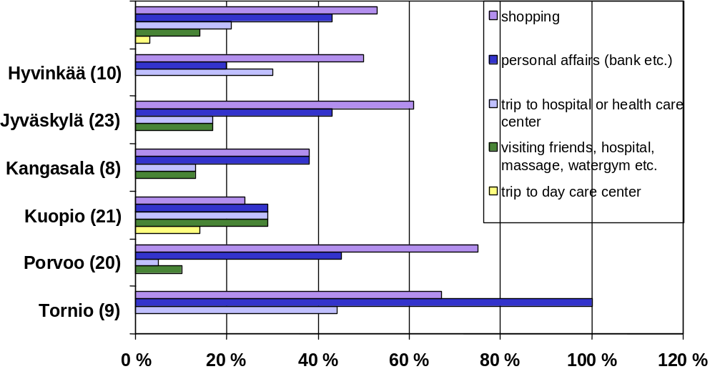

Figure 1: The purpose of the trip

Before the operation of the service lines interviewee used bus or taxi or they walked. 20% of the respondents used bicycle and some had rides from with they relatives or friends. 10% used they own cars. In the town of Jyväskylä most of the passengers used buses before and in the town Kuopio taxis. Cars were used before mainly in smaller towns.
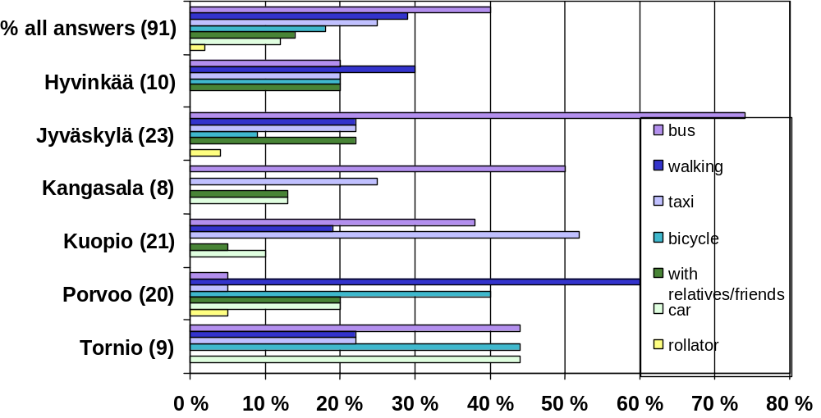

Figure 2: Transportation before service lines

Most of the interviewee’s used service line a couple of times in a week, 20% used service more than three times a week. Many customers use service line as often as they can, because in many residential areas service line bus visit’s only once a week. Those who used the service line less were asked why they didn’t use it more often. Three mentioned that they no need for more and other three where just getting to know service line. A couple of respondents wanted to walk errands. One said that there was too few free trips for him available and another complained that the roads along the course were in bad condition and one interviewee could not travel straight to destination.

Almost 80% of the interviewee’s uses service during they trips. In the towns of Jyväskylä and Kuopio almost one third travels as much as before, because in these two towns the public transport supply is good. Interviewee’s under 60 used other forms of transport as much as service lines, but older used mainly service line.

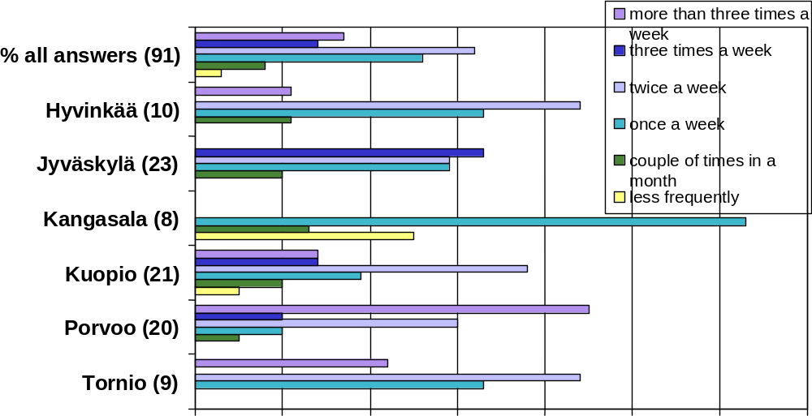
Figure 3: Use of the service – frequency

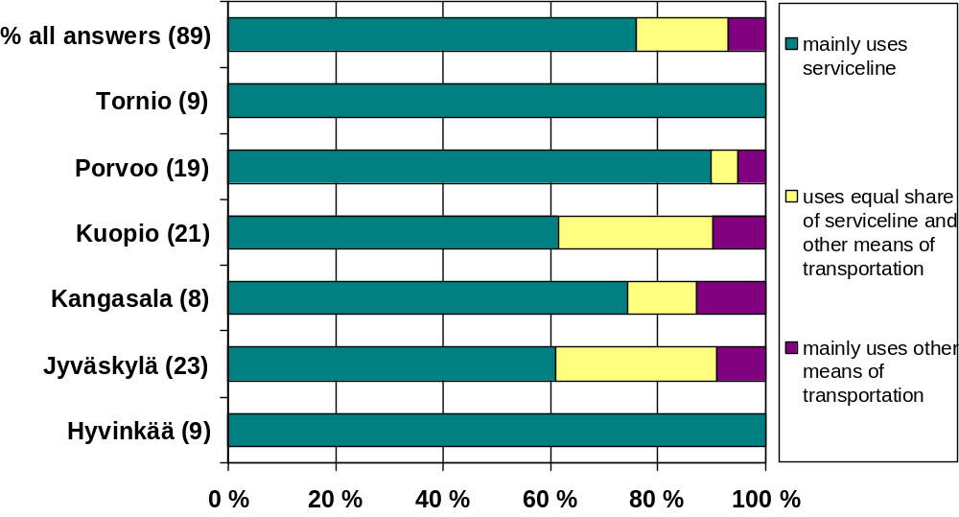
Figure 4: Use of the service – share of all trips

The service of the drivers service was regarded as very good (96%). Passengers were very pleased with the service. In every town the drivers were seen good or excellent. Specially those living in the town of Kuopio emphasised the good service - drivers helped without asking, they carried the bags, helped to get in and out of the bus, they picked up from the front door or even from inside the house, they took the passengers customers where and when the customers wanted, they kept passengers happy and drove smoothly. Some praised drivers personal characteristics, like their ability to listen.

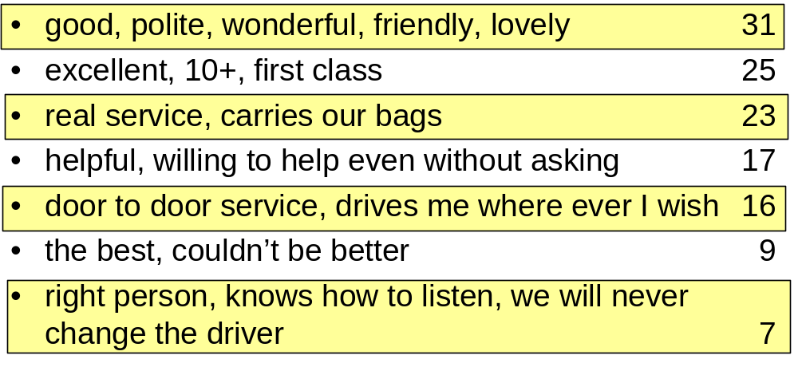
Table 1: Passengers comments on the drivers

96% of the interviewees told that getting in and out of the service bus was easy. The lack of extra step was mentioned to be a disadvantage. Many interviewees told that getting in the service bus was easier than climbing in the regular bus or taxi. Service bus was regarded as cosy and good atmosphere was commended too. However service bus was told to be cramped, when there were several wheelchairs or rollators or for example a lot of schoolchildren on board.

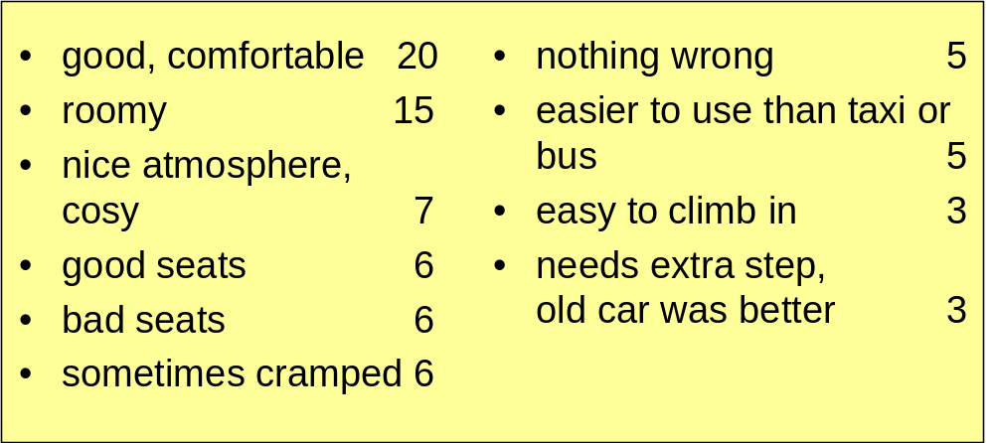
Table 2: Passengers comments on the service bus

Especially in the town of Jyväskylä and in the municipality of Kangasala the interviewees used buses before. Many judged service bus as better alternative, because it is easier to climb in and at the same price the user gets door to door service and pleasant travelling companion. In the towns of Porvoo and Hyvinkää the biggest share of the interviewees used bikes and walked before. For those who are still able to use bicycle the service line has increased alternatives.

Each town and municipality has taken more control over the statutory transports (social transports and transports of the disabled) and for instance the free taxi rides for the social sector customers have been either tightened or abolished in some towns. The service bus is in many cases economically the only possible alternative to travel. Those who are “forced” and those who “voluntary” use service buss are equally satisfied.

When serviceline started in the town of Tornio it was afraid that social sector customers will stop travelling because of increased travelling time compared to taxi. However only four of the customers complained about travelling time. In general the customers were satisfied with travelling time and companion.

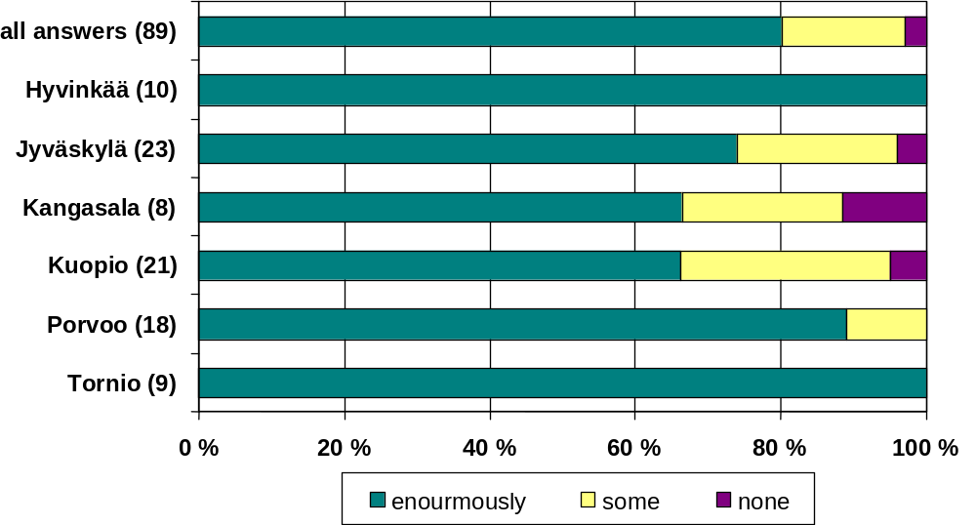
Figure 5: Have service lines eased the mobility

Majority of the passengers told that service bus makes it easier to travel and take care of their errands. Over 50% of the interviewee’s told that service line has increased their mobility, specially passengers aged 61-70 shared this opinion.
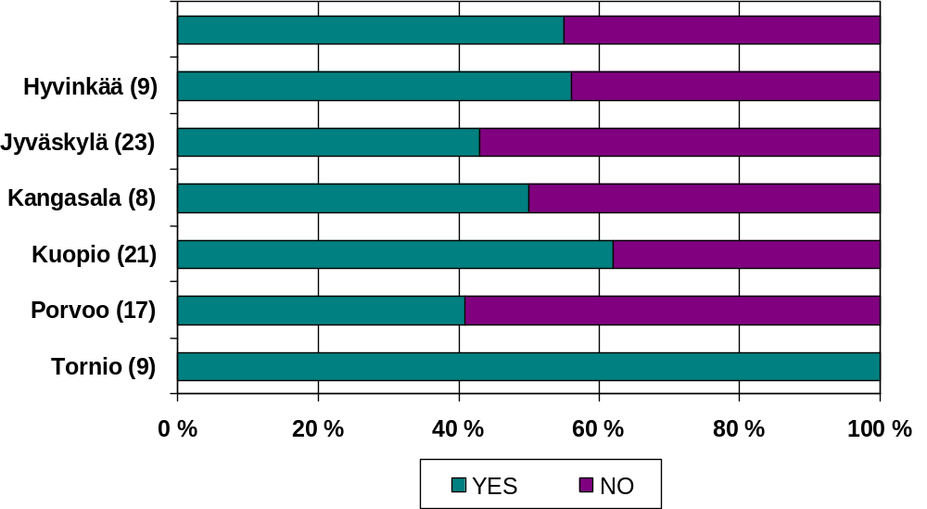
Figure 6: Have service lines increased the mobility?

Majority of the passengers told that service line was either very important (89%) or important (10%) to them. Many of the interviewees spontaneously told that service lines should never discontinued or cut down. Almost everyone told that the service line is important because travelling with the service line is easier than with other modes. 30% of the interviewees told that the low ticket price is important. Social contacts and good atmosphere are essential, when travelling with service bus. Even travelling is pastime.
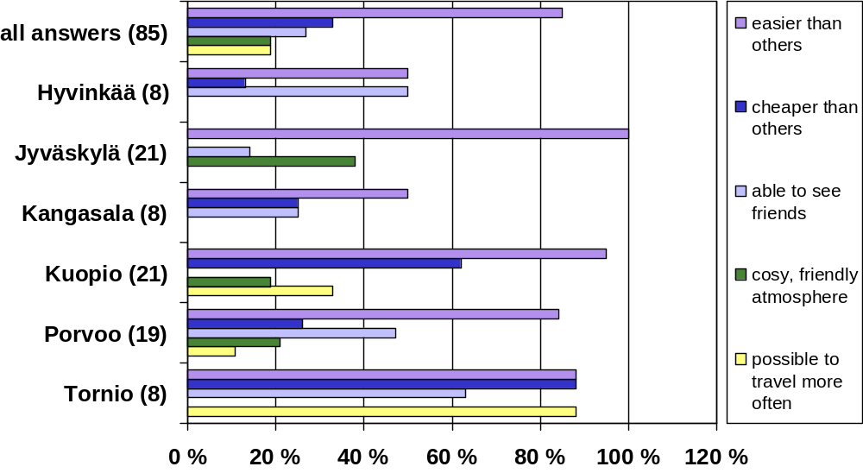

Figure 7: Why is the service line important?

The following tables (Table 3 to Table 6) describe the effects of service lines on different actors.
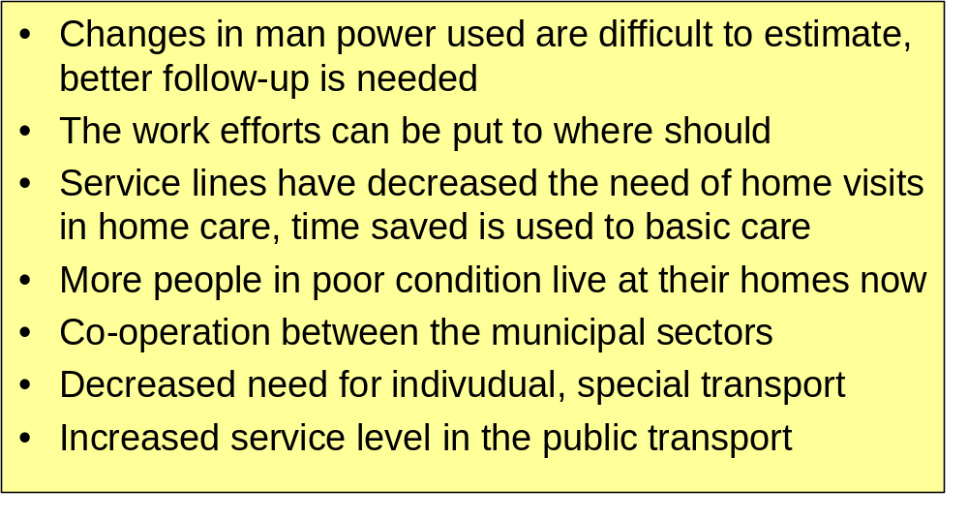
Table 3: Effects on municipalities
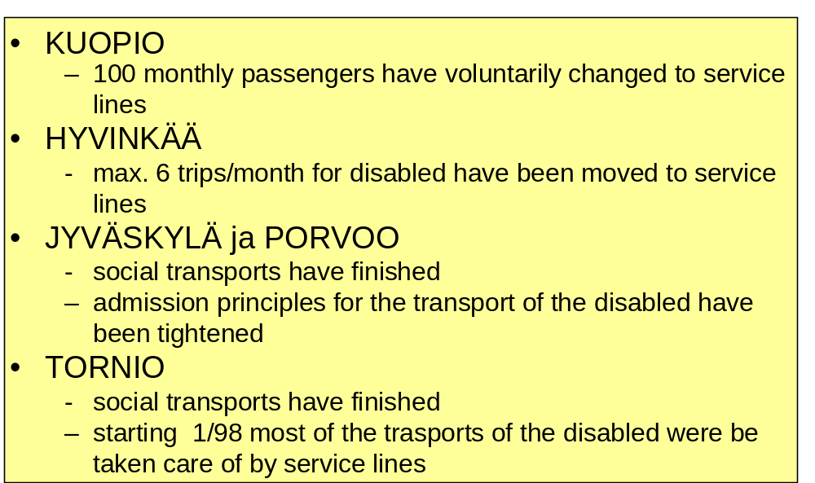
Table 4: Effects on the social transports and transports for the disabled

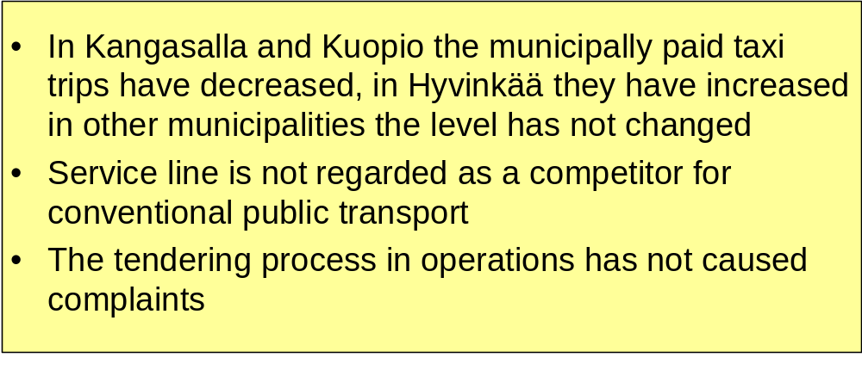
Table 5: Effects on the public transport operators
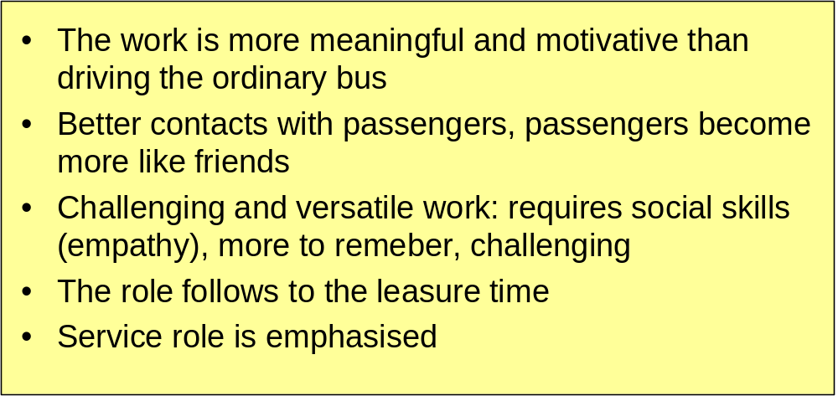

Table 6: Effects on the drivers

The figure 8 describes the passenger amounts in the studied municipalities. Since the municipalities are rather different sized, the passenger amounts vary too.

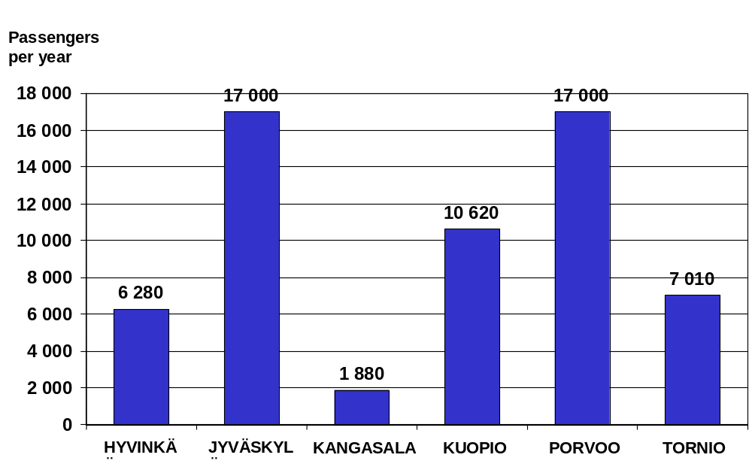

Figure 8: Passenger amounts 1997

The costs and cost shares of the service line per trip is an interesting questions. Even though they vary, they are always lower than the costs of an average taxi trip. Figure 9 shows the costs per trip.

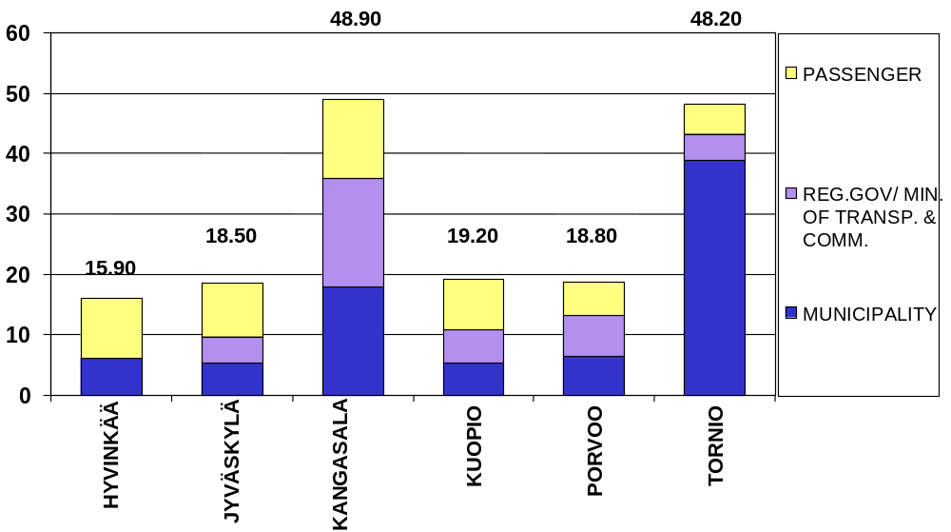
Figure 9: Cost per trip (FIM)

It is also rather interesting to see how many (additional) passengers per trip would be needed to reach the level where the service line can operate commercially profitably. This is described in the Figure 10.

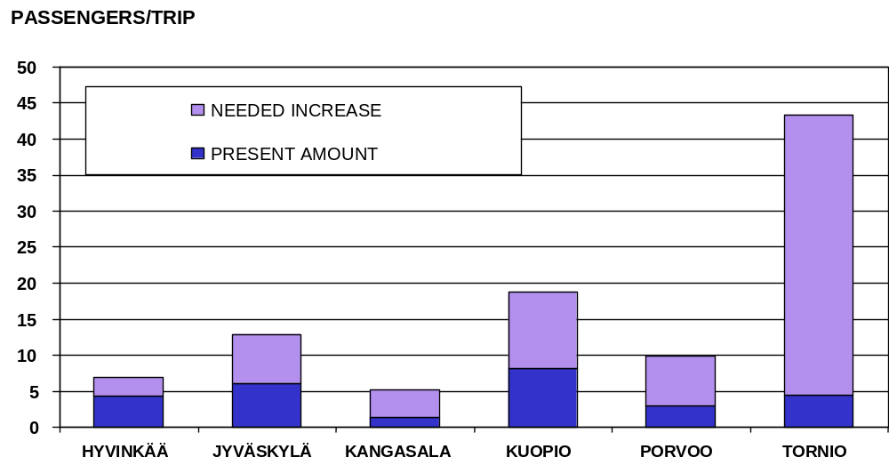
Figure 10: The commercial profitability level

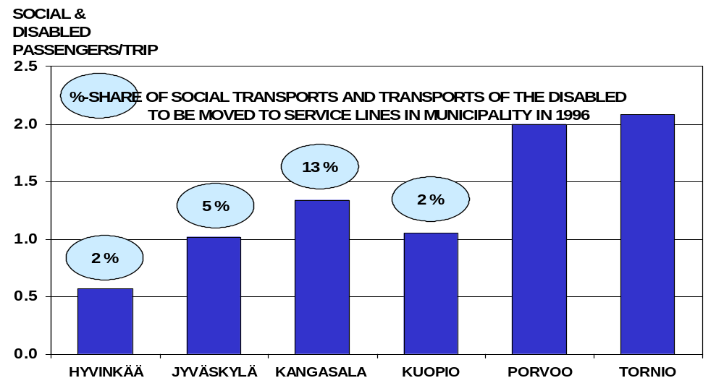
In Figure 11 the bars show how many passengers should move from social and disabled transports to service line to make it profitable. The %-figure shows how big share of social and disabled trips this absolute amount is.

Figure 11: Amount of passengers to make service lines profitable

One of the biggest reasons for not using service lines seems normally to be the lack of information. The users of the service lines were asked in the study, where did they hear about the service lines. The answers are shown in Figure 12. Written material seems to be the main source of information. On the other hand ‘mouth to ear’ information seems to be important.
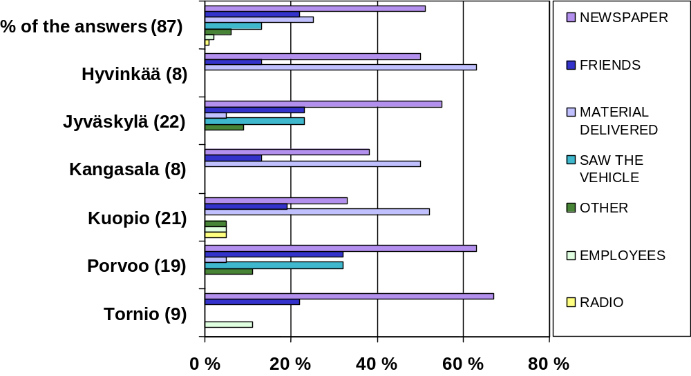

Figure 12: Information sources

As a summary of the Finnish service line study it can be stated that the personal service seems to be very important for the service line passengers. For many of them the service line is the only possibility to move and take care of their own errands and social contacts. The service lines, according to the users, increase the control of one’s own life.

The service lines help the special users such as elderly and disabled to maintain their independence. The service lines also ease and increase the mobility of the users making it for possible several of them to live longer at home, instead being forced to move to of institutional care. Naturally combining several passengers in the same vehicle instead of using several separate taxis or cars is also economical and saves remarkably public money.

To make service lines work properly the following pre-conditions have to be fulfilled:
- enthusiastic and committed responsible persons (drivers are not only drivers but service persons that help the users in many ways)
- proper user needs analysis
- proper planning to meet the needs of the municipalities
- socially oriented and skilled drivers
- effective and continuous information activities
- suitable fleet
- proper marketing

ANNEX D: DRT experiences from Prince William County and cities of Manassas and Manassas Park, USA
DRT Experiences from Prince William County and cities of Manassas and Manassas Park

Background

OmniRide, sponsored by the Potomac and Rappahannock Transportation Commission (PRTC), operates express bus, commuter rail, and ride-matching services, and recently began providing innovative local bus service. This new service is the subject of an operations test, the prime focus of which is to evaluate an integrated, smart vehicle flex-route (route-deviation) service. Service started in 1995 and Intelligent Transportation System (ITS) enhancements were added beginning in October 1997.

The operations test service area, located approximately 25 miles south and west of Washington, DC, includes Prince William County and the Cities of Manassas and Manassas Park, Virginia. PRTC received $3.5 million in Intermodal Surface Transportation Efficiency Act (ISTEA) funds (both Congestion Mitigation and Air Quality (CMAQ) and Surface Transportation Program (STP)) to help offset start-up operating and capital costs to launch the service

Innovative Local Transit Services

Traditional fixed-route transit does not work as well in the suburbs as in cities because populations are not as dense and it is too costly to provide the level of service needed to convince people to get out of their personal automobiles. Additionally, fixed route services require complementary paratransit (door-to-door) services for individuals with disabilities. Recognising these impediments, PRTC began with a blank slate and a desire to provide attractive and efficient public transportation.

The new-start transit service, termed OmniLink, began operation in April of 1995, serving the general public along three flex-route corridors. Three additional flex-route corridors were added in September and 12 peak vehicles are now in service. Flexible routing (within 1.5 mile wide corridors) enables the service to reach a far larger market and negates the need for parallel paratransit services.

Riders can access the service like a fixed route bus if their origin and destination are near OmniLink stops. If bus stops are not convenient, riders can call to arrange for the bus to pick them up in their neighbourhood. ITS enhancements have reduced the minimum lead time from 24 hours to two hours; the goal is to reduce the lead time to a one hour minimum. Standing orders for repeat trips are also accepted.

Upon receiving a trip request not near an existing bus stop, Customer Service Agents establish off-route pickup/drop-off locations that are a reasonable distance from those requested, at points that are efficient to serve and allow the bus to continue making forward progress along the route. A set of pre-determined "standard deviation" points are being developed to make the system easier to use for riders, drivers, and schedulers.

To increase operating efficiency, buses do not have to return to the route at their point of departure. Drivers have the freedom to select the route they drive between stops when deviations are required. Bus stops were installed at locations where the street network requires the vehicle to pass the stop, regardless of the path travelled. As demand patterns emerge additional stops are added, provided they do not minimise the opportunity for route deviation. The fare per one-way trip is $0.75, transfers cost a quarter. Service operates on 45 minute intervals (headways).

The ability to "flex" from a route makes transit more attractive to "choice" riders (those who have another mode of access) and eliminates the need to provide complementary paratransit service required by the Americans with Disabilities Act, thereby mainstreaming individuals with disabilities and reducing operating costs.

Adding Intelligence

Until recently, services have been operated in a manual, non-ITS enhanced mode. ITS technologies are being introduced to improve on-street and in-office efficiencies, enhance vehicle tracking and communications capability, and offer real-time reservation options.

ITS technologies being employed include global positioning satellite-based (GPS) automated vehicle location (AVL) and real-time call intake, scheduling, and dispatching software. The software integrates fixed route, flex-route, and paratransit modes and uses geographic information system (GIS) mapping. Digital dispatching and communication of ridership activity are handled through in-vehicle mobile data terminals (MDT).

With these technologies in place, the software program will allow customer service agents to make real-time reservations and check the schedules, manifests, current vehicle loads, and on-time performance of various services to determine the best trip itinerary. Vehicles will be dispatched via MDTs and drivers can query the system to request routing instructions from their existing location to their next scheduled location, or between two upcoming scheduled points. Voice communication and paperwork will be greatly reduced.

Vehicle tracking through GPS will enhance performance monitoring, reducing the need for, and cost of, on-street time checks. A wealth of historical electronic data will vastly improve service evaluation efforts and highlight needed modifications, such as new bus stops and route and timing changes. ITS technologies will also greatly simplify National Transit Database (formerly Section 15) reporting.

The operation initially includes OmniLink flexroute and rail feeder services. In the future the system could be integrated with the Virginia Railway Express (VRE) commuter rail, human services transportation, commuter bus, and feeder service to park-and-ride lots. Should these services be integrated, the fleet of 24-passenger lift-equipped vehicles will be able to switch between service types on an as-needed basis, allowing the best vehicle to respond to each request in real-time.

This system is expected to provide greater effectiveness and efficiency in serving the public transportation needs of the community than would be the case in a non-ITS enhanced environment. It should serve as a model for other suburban, low density areas wishing to increase transit attractiveness and eliminate the need for operating both fixed route and paratransit services.

Expected Benefits from the Application of ITS Technologies

- Same day reservations for flexroute (route deviation) service - Using the central computer system that tracks reservations and on-street activity (such as vehicle location, on-time performance, passenger boardings and alightings, etc.), Customer Service staff can quickly determine the best times and vehicles to handle requested pick-ups and drop-offs. Same day reservations (two hours advance notice) make OmniLink flex-route service more convenient and attractive to all riders, including "choice" riders (those who have a transportation alternative, such as a car). It permits riders to be more spontaneous in requesting service (formerly trips must be reserved one to two days in advance). While same day reservations currently require a two hour lead time, in the future, PRTC hopes to reduce the advance reservation time to one hour or less.
- Improved customer communication - With the ITS enhancements customers can now make reservations and receive trip details in one phone call for both advanced and same day service. Until recently, reservations had been taken in one phone call, all trips were then scheduled, and customers were then called back with detailed information on their reserved trip. "Real-time" reservation capability also allows Customer Service staff to investigate multiple options (trip time, pick-up and drop-off location, etc.) with the customer to determine the itinerary which best meets their needs and is efficient for PRTC to serve. Inquiries regarding on-time performance will also be improved as each vehicle can be "polled" electronically to determine exact location (via GPS) without driver involvement. This will make it easier for riders to find out whether their vehicle is operating on schedule.
- Improved fleet tracking - Using GPS, the system will compare actual with scheduled performance and automatically notify the dispatcher when vehicles are running late. With this information, the dispatcher can take corrective action to get the vehicle back on schedule by modifying the itinerary, having another vehicle assist or, if available, introducing another vehicle. This enhancement will be particularly important because the dispatcher will always know where vehicles are located and when they are running late, without any verbal communication between the driver or dispatcher. Emergency response is also improved since the GPS signal provides the vehicle’s exact location.
- Increased efficiency and ridership - ITS technologies are improving system ridership. Being able to accept same day reservations allows PRTC to "fill in the holes" by scheduling trips when vehicles have excess time in the schedule. This provides a "win-win" situation both for PRTC and riders with flexible schedules desiring same-day deviation service. The new system also allows PRTC to fill holes created by same day trip cancellations.
- Enhanced operating data and automated collection - With all travel information being captured in the system database, a wealth of historical data will be available. PRTC will be able to quickly and easily track such information as route and bus stop on-time performance and patronage to aid in improving service and making needed route and timing modifications. The database also simplifies National Transit Database (NTD) reporting and can be used to generate billing information for agencies purchasing service from PRTC.
- Improved working environment – Automation has made Customer Service Agents’ jobs easier and less stressful than the cumbersome, time-consuming "paper" process. Since Agents can "negotiate" with clients at the time they make a reservation, they no longer have to deal with individuals who are disappointed because the exact trip they requested was not available. Drivers will be relieved of the requirement of accurately completing paper manifests, since the mobile data terminals will automatically transmit time, location, and mileage data whenever a message is sent. Routing instructions can also be transmitted to the driver, eliminating the need to review maps and/or write down instructions.
- Capability of evaluating multiple travel mode itineraries - The central computer system, the first of its kind to handle flexroute service, also incorporates fixed route (traditional bus service) and paratransit (door-to-door bus service) programs. With this capability, agencies operating multiple service types can examine multiple travel options to meet customers needs and improve the efficiency of the overall operation. For example, an individual requesting to travel at X time from Point A to Point B may best be served by taking a fixed route bus to a convenient point where the rider will transfer to a flexroute bus or paratransit vehicle to complete the trip. PRTC plans to take advantage of the multi-modal capability in the future and will shortly be able to track OmniLink vehicles as they transition between fixed route feeder and flex-route services.

Results

- 1,150 trips per day
- 9.7 riders per revenue hour (range 6.0 to 14.5)
- $3.32 cost per rider (range $2.00 to $6.14)
- Compares favourably to mature peer systems (6.8 riders per hour, $5.72 cost per rider)
- 68% use for work
- 26% formerly drove alone to work
- 6% couldn’t make trip before
- 27% use for education
- 10% couldn’t make trip before
- 18% formerly drove alone to shop
- 83% comfortable with flexible aspect
- Estimated annual savings versus fixed route and paratransit - $560,000, eight vehicles, 62 daily service hours (additional 50% expenditure to operate both systems)
- 83% rider approval rating (excellent/good service)
- 77% of residents said it was "easier to get around" versus 56% two years ago

ANNEX E: References
References

European Commission (1996) Green Paper, The Citizens’ Network

Finn, B (1999) Requirements of Users of DRT Systems, SAMPLUS project. Deliverable D3, ETTS Ltd

Matintupa, R (1999) Analysis of User Requirements for DRT, SIPTS project. Deliverable D3, Provincial Government of Western Finland

Ministry of Transport and Communications (1998) Palveluliikenteen vaikutustutkimus ((Studied Effects of Servicelines). Tampereen Viatel Ltd

OmniRide (1999) PRTC’s Innovative Local Transit Services and Smart Flexroute Integrated Rea-time Enhancement Systems, http://www.omniride.com/its_project.htm.

Transport & Travel Research (1999) Business Plan & Market Projection SAMPLUS project. Deliverable D2.4

University of Newcastle upon Tyne (1999) Results of the Evaluation and Market Assessment of SAMPLUS Technologies

