

CONNECT

Co-ordination of CONcepts for NEw Collective Transport

Updated Business Development Knowledge Base Repository

Deliverable 12
Version 2.2 – Final Version

Status:
Date deliverable due 30/06/05
Document name CONNECT D12
Date last saved 23/11/26
Dissemination level Restricted (final version public)

Contract No. FP6-PLT-506959

The European Commission has financed 100% of this Co-ordination Action within the FP6 Programme

THE CONNECT CONSORTIUM

Co-ordinator:

UNEW University of Newcastle upon Tyne, Transport Operations Research Group, School of Civil Engineering and Geosciences, Newcastle (UK)

Partners:

ATAF ATAF SpA., Mobility Authority, Florence Metropolitan Area (IT)
ATF Angus Transport Forum (UK)
BOKU Institute for Transport Studies, University for Bodenkultur (AT)
D&O Diepens and Okkema (NE)
ETRA Investigación y Desarrollo, s.a. (ES)
ETTS European Transport and Telematics Systems Ltd (IE)
ISDEFE Ingeniería de Sistemas para la Defensa de España s.a. (ES)
LOC Logistik Centrum Väst AB (SE)
MEMEX MemEx S.r.l. (IT)
MSF Mobisoft Oy (FI)
POLIS Polis, (BE)
RAMBOLL Ramboll Management Brussels sa/nv (BE)
RCAUEB Research Centre of the Athens University of Economics and Business (GR)
ROSE ROSE Communications s.l. (ES)
SOFTECO Softeco Sismat SpA (IT)
SZE Department of Transport, Szechenyi Istvan University (H)
TRG Transportation Research Group, University of Southampton (UK)
TRITEL TRITEL NV (BE)
TUC Technical University of Crete (GR)
VO Versio Oy (FI)
VTT Technical Research Centre of Finland (FI)
WSP-LT WSP LT Consultants Ltd (FI)

Technical Officer (EC)

Unit |  | DG-RESEARCH
Name |  | Herbert Thanner

Innovative Solutions and Test Cases
Document Produced By
Responsible Organisation |  | Author(s)

WSP-LT |  | Teemu Sihvola
 |  | Ville Lehmuskoski
in co-operation with
Organisation(s) |  | Author(s)
ETRA  ETTS  RCAUEB |  | Patricia Rodriguez  Brendan Finn  Konstantinos Kozgrafos  Konstantinos Androutsopoulos
APPROVED By
Peer Review 1

Partner |  | UNEW
Name |  | Corinne Mulley

Peer Review 2

Partner |  | TRG
Name |  | Tom Voge

TABLE OF CONTENTS
0 EXECUTIVE SUMMARY 7
1 Introduction 11
1.1 Scope of the project 11
1.2 Scope of WP4: Business Development 12
1.3 Relationship of D12 to D5, D10, D14 14
1.4 Objectives and structure of Deliverable 12 14
2 Validation of the FTS concept Framework 16
2.1 Evolving Domain of Flexible Transport Services 16
2.2 Emerging Issues for Decision-Takers 16
2.3 Decision Taking processes 17
2.4 Ensuring Relevance to current and emerging FTS needs 18
2.5 Concepts and Context 19
2.6 Core Service Concepts for FTS 19
2.7 Developing FTS Options for a Site 21
2.7.1 Site description 21
2.7.2 Concept dimensions 23
2.7.3 Issues outside of the concept description 26
2.7.4 Freight transport 26
3 Selection of the FTS Concept 29
3.1 Assessing FTS Concepts 29
3.2 FTS Concept Screening Process 30
3.3 FTS Concept Assessment Methodology 31
4 Example FTS Sites 38
4.1 Analysed Test Cases 38
4.1.1 Helsinki, Finland 38
4.1.2 Rural Case 1, EU 39
4.2 Areas interested in the FTS implementation 39
4.2.1 Urban Case 2, EU 39
4.2.2 La Sagra, Toledo, Spain 40
4.3 Hypothetic FTS sites 41
4.3.1 Urban Case 3, CIS 41
5 FTS Concept Applicability 44
5.1 FTS Concept Screening Process in practice 44
5.2 Concept identification for the example sites 44
5.2.1 Helsinki, Finland 44
5.2.2 Rural Case 1, EU 46
5.2.3 Urban Case 2, EU 48
5.2.4 La Sagra, Toledo, Spain 50
5.2.5 Urban Case 3, CIS 52
6 Prioritisation of Concepts 54
6.1 FTS concept prioritisation in practice 54
6.2 Example sites 55
6.2.1 Helsinki, Finland 55
6.2.2 Rural Case 1, EU 58
6.2.3 Urban Case 2, EU 59
6.2.4 La Sagra, Toledo, Spain 62
7 Strengths and Weaknesses 65
7.1 Describing the FTS options 65
7.2 The assessment methodology 66
7.3 Potential Concepts 67
8 Conclusions 68
9 Bibliography and References 69
9.1 Business Models 69
9.2 Assessment Methodology 69
9.3 Regulatory Framework 69
9.4 Organisational Issues 69
10 Abbreviations 70
11 Annex A: Example of the pair wise comparisons and concept comparisons 71
12 Annex B: Example of the weights in Concept Assessment Methodology 75

List of Figures
Figure 0-1: The process of assessing FTS concepts. 8
Figure 0-2: The proposed assessment methodology 9
Figure 1-1: WP4 Structure 12
Figure 2-1: Overview of Decision-Taking Process 18
Figure 3-1: The process of assessing FTS concepts. 29
Figure 3-2: The proposed assessment methodology 32
Figure 3-3. Hierarchical decomposition of the evaluation problem. 34
Figure 3-4. Table of pairwise comparisons. 36
Figure 5-1: Permitted options of the example site Helsinki, Finland. 45
Figure 5-2: Feasible concepts of the example site Helsinki, Finland. 46
Figure 5-3: Feasible concepts of the example site La Sagra, Toledo, Spain. 52
Figure 6-1: The categorisation of the feasible concepts of the example site Helsinki, Finland. 56
Figure 6-2: Ranking of the main concepts of the example site Helsinki, Finland. 57
Figure 6-3: AHP Ranking of the 4 concepts for Urban Case 2 62
Figure 6-4: Ranking of concepts of the example site La Sagra, Toledo, Spain. 63
Figure 12-1: The weights of the evaluation criteria at the example case Helsinki, Finland. 75
Figure 12-2: The weights of the indicators of Criterion 2 at the example case Helsinki, Finland. 75
Figure 12-3: The weights of the indicators of Criterion 3 at the example case Helsinki, Finland. 76
Figure 12-4: The weights of the indicators of Criterion 4 at the example case Helsinki, Finland. 76
Figure 12-5: The weights of the indicators of Criterion 5 at the example case Helsinki, Finland. 76
Figure 12-6: The weights of the evaluation criteria at the example case La Sagra, Spain. 77
Figure 12-7: The weights of the indicators of Criterion 2 at the example case La Sagra, Spain. 77
Figure 12-8: The weights of the indicators of Criterion 3 at the example case La Sagra, Spain. 77
Figure 12-9: The weights of the indicators of Criterion 4 at the example case La Sagra, Spain. 77
Figure 12-10: The weights of the indicators of Criterion 5 at the example case La Sagra, Spain. 78
Figure 12-11: The weights of the evaluation criteria at the Urban Case 2, EU. 78
Figure 12-12: The weights of the indicators of Criterion 2 at the Urban Case 2, EU. 78
Figure 12-13: The weights of the indicators of Criterion 3 at the Urban Case 2, EU. 79
Figure 12-14: The weights of the indicators of Criterion 4 at the Urban Case 2, EU. 79
Figure 12-15: The weights of the indicators of Criterion 5 at the Urban Case 2, EU. 79

List of Tables
Table 1-1: Scope of the 4 Deliverables generated within WP4 14
Table 1-2: Structure of Deliverable D12. 15
Table 2-1: Service Concepts for FTS 21
Table 2-2: Dimensions and Options for FTS 25
Table 2-3: Dimensions and Options for Flexible Freight Transport Systems. 28
Table 3-1: The 1-9 AHP ratio scale 36
Table 5-1: Options for Rural Case 1, EU. 47
Table 5-2: Options for Urban Case 2, EU. 48
Table 5-3: Options for La Sagra, Toledo, Spain. 51
Table 5-4: Options for Urban Case 3, CIS 53
Table 6-1. Table of pairwise comparisons for the elements of C2: “Organisational Efficiency”. 55
Table 6-2: Four concepts for Urban Case 2, EU 61
Table 11-1: Example table of the pair wise comparisons from the example site Helsinki, Finland. 72
Table 11-2: Example table of the concept comparisons from the example site Helsinki, Finland. 74

EXECUTIVE SUMMARY
CONNECT Deliverable D10 developed concepts for Flexible Transport Service (FTS). These concepts are intended to describe how to develop a set of feasible FTS solutions, which can be considered, by sites that are interested to implement FTS. Sites can blend the different elements to suit their specific context.
This document is focused on exploring the strengths and weaknesses of the FTS concepts and methodology elements. The definition of the alternative concepts and their prioritisation is demonstrated in the document.
The CONNECT team proposes that there are 7 basic Service Concepts as follows:
- 2 for closed user groups (including special needs)
- 3 for urban/suburban
- 2 for rural areas.
Each Service Concept may have many variations, depending on scale, level of service, vehicle types, actors etc. The set of FTS option could be developed with two stages. First the framework is set by describing the site and its context. Then all possible concept dimensions are considered. For each dimension there will be either a pre-determined approach, or open options. The possible combinations of the open dimensions will form a set of FTS options. The CONNECT team presents the concept description with six business model dimensions, three organisational issues dimensions, three financial dimensions and two operational dimensions. In addition with the FTS dimensions mentioned above, there are other issues that have to be taken into consideration when implementing the FTS. However they are not fitted in the concept description. These issues mentioned above form “the second level of concept dimensions”.
For the practitioner and the stakeholders the greatest interest is how to move from a seemingly infinite list of possible concepts to something practical, which would help the decision making process. The process of assessing concepts is shown in Figure 0-1 below.
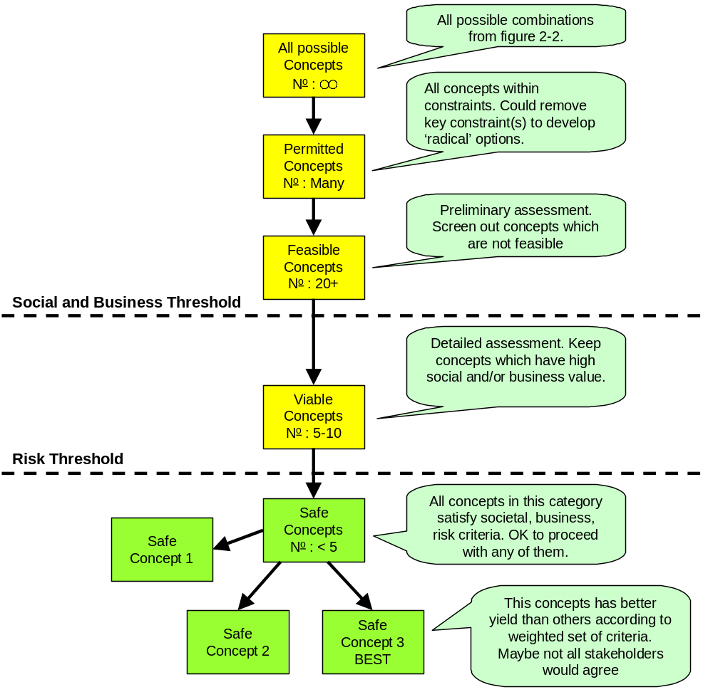
Figure 0-1: The process of assessing FTS concepts.
The process could be divided into two parts:
- The screening process for feasible or viable concepts
- The assessment methodology for safe or best concept.
The screening process begins by assembling the first set of possible concepts using the concept dimensions described earlier. This takes into account the objectives, the context, and any already-agreed aspects. This set is not yet checked for feasibility, but it offers a starting point.
Permitted concepts can be screened with deeper analysis of the context and constraints, especially in relation to the regulatory framework. At this stage, some of the options might not be feasible.
In the feasible concepts phase the illogical and non-feasible options are screened out to the maximum extent possible. If the decision-taker can identify, which among the feasible options satisfy a set of business and societal thresholds, we have the viable concepts. These are the options, which meet the investment criteria and/or the mobility objectives.
The proposed assessment stage for selecting one or more applicable FTS business models involves the prioritisation of a set of feasible and viable business models. The objective of the FTS business model assessment methodology is to assist the decision makers in determining one or more promising FTS business model(s) that align with their vision and business objectives. Given a set of viable FTS business model specified within the Screening stage of the proposed methodological framework, the prioritisation phase involves the identification of the ”best” option. However, it has to be pointed out that the objective of the proposed assessment methodology is to structure the FTS business model selection problem in a way that ranks the competing alternatives.
The selection of the most beneficial business model requires further studies and tests in terms of financial feasibility. However the proposed method constitutes a useful tool for the decision maker in terms of determining the most promising FTS business model configurations that provides the basis for further in depth market and financial analysis.
The proposed assessment methodology is able to incorporate the following evaluation requirements:
- Decompose the evaluation problem to a set of criteria expressing the evaluation objectives of the decision maker(s)
- Rationalise and quantify the decision maker(s)’ beliefs and judgement in order to assign priorities among the evaluation criteria and the performance of the alternative business models under each criterion
- Incorporate different stakeholders’ objectives and judgement providing compromise solutions
- Enable the decision maker to perform sensitivity analysis in order to test the validity of the assessment results.
The major steps of the method are illustrated in Figure 0-2.
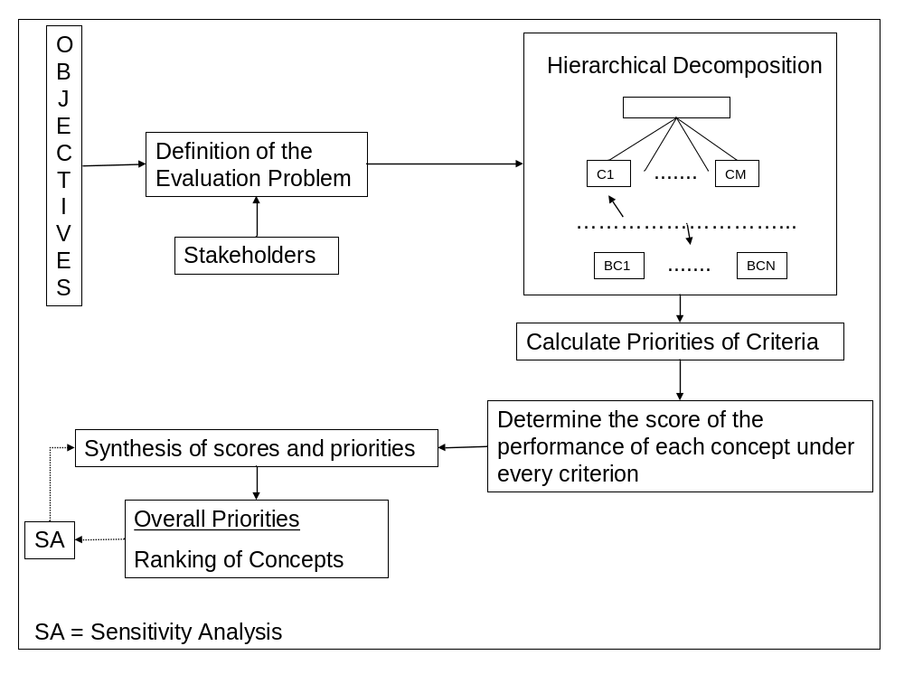
Figure 0-2: The proposed assessment methodology
The prioritisation of the alternative FTS concepts aims to rank the alternatives in terms of the level of attainment of a set of evaluation criteria. This is a complex evaluation problem, which involves multiple tangible and intangible criteria. This fact implies the analysis of the evaluation problem into several levels of homogeneous evaluation elements i.e. criteria, sub-criteria and indicators in order to capture the entire spectrum of evaluation features.
The resulting most beneficial competing FTS business models can be further assessed in terms of their financial viability, system efficiency, effectiveness, and quality. Measuring the efficiency of the FTS will give the involved stakeholders the opportunity to compare the alternative FTS on different aspects.

Introduction

Scope of the project
The scope of CONNECT is Flexible Transport Services (FTS). This term covers the spectrum between (but does not include), on the one hand conventional fixed line transports, and on the other hand own-account non-shared taxi services. This embraces a range of solutions including: local bus routes with some flexibility, Demand Responsive Transport, special users transport services, community transport services, shared taxis and car pooling, car sharing and organised lift giving. Logistics, which could be the ancillary business of the passenger services are included and integrated within the term "user" in this project.
Definition of Flexible transport
Flexible transport means that the service is adapted towards the expressed need of the users for their trip. This means that the mobility service has some degree of freedom in at least one of the three key dimensions: route, timing and vehicle/facility/driver assignment. The service is collective in the sense that it can have multiple users (even if on occasions there may be only one user). The service therefore is capable of taking into account the needs of its diverse users, although for reasons of efficiency or effectiveness it may choose to assign customers to different services. Typically, the service manager aims to optimise the user needs with the resource involved.
Activities of CONNECT-Project
There is a clear need for a rapid escalation of a body of knowledge, targeted research, skill development and appropriate ITS tools to support these new Flexible Transport Services. This is the role of the CONNECT Co-ordination Action. The main activities of CONNECT are:
(i) To set up a common information system, which gathers and manages information on on-going research, the state-of-the-art and good practice in flexible transport and its supporting technologies. This will be achieved by the creation of a continuously updated web-based "Virtual Library", containing information on the different aspects of flexible transport: operation of transport services; legal frameworks and institutional aspects; system architecture, interfaces, data modelling; supporting technologies; business models, contracts, financing; and evaluation methodologies.
(ii) To support the development of skills and best practice in the field of FTS through a number of actions, including: provision of course materials and educational resources; facilitation of exchanges of personnel, experience and knowledge; collection, development and promotion of best practice approaches; and identification and development of research opportunities.
(iii) To provide guidelines and recommendations for supporting business development of FTS. To achieve this, CONNECT will produce knowledge on appropriate business models; organisational issues; and regulatory, legal and policy aspects.
(iv) To organise thematic workshops for the User Communities involved in flexible and responsive forms of transport covering systems and operations; technologies; vehicles and vehicle technologies; and impacts and business cases for FTS.
(v) To increase the awareness of CONNECT among a broader audience by the utilisation of a diversity of channels of dissemination.

Scope of WP4: Business Development
Work package WP4 deals with Business Development. The objective of WP4 is to generate and formalise the necessary knowledge to provide valuable guidelines and recommendations for supporting business development of Flexible Transport Services, from a multidisciplinary point of view. To achieve this, three intermediate objectives will be the target in this work package:
- To produce knowledge on Business Models.
- To produce knowledge on Organisational Issues.
- To produce knowledge on regulatory, legal and policy aspects.
The work to be done within this Business development work package will follow the structure shown in Figure 1-3.
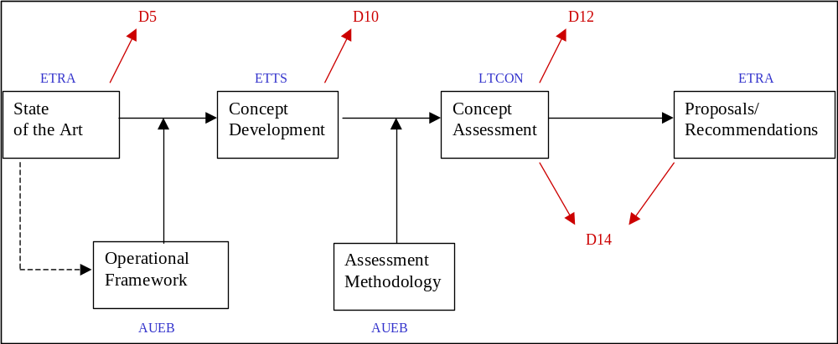
Figure 1-3: WP4 Structure
- The process starts with the state of the art of the different research branches (business models, organisational, legal) that are the object of this work package.
- In parallel with the state of the art and with an impact in the output of this first step, is the Operational Framework phase. This phase will set the scene on the basis of the research carried out in the state of the art phase.
- Once the state of the art has been consolidated, the concept Development phase starts, acting as a concentration tool and encouraging the key players and users to look for innovative approaches starting from the results obtained in the state of the art research.
- Before passing to the Concept Assessment phase, an intermediate module appears to introduce the methodology to be followed in the evaluation of the concepts arisen. It is the Assessment Methodology phase.
- Once these guidelines are produced, the Concept Assessment will be carried out, consisting in the evaluation of a series of applied concepts produced as output of the previous phases in the dedicated Workshop.
- Finally, a series of proposals and recommendations will be produced in order to compile all the knowledge generated in the previous phases.
Three specific tasks have been defined to address the specific objectives described above:
Task 4.1 Excellence Business Models. [Task Leader = RCAUEB] It will rely not only in the compilation of the current best practices and business models but also in the identification of new models and approaches that will be adequately evaluated. Emerging business models and technologies with impact on transport systems will be also considered to envisage new business models of excellence.
Task 4.2. Organisational Issues. [Task Leader = LTCON]. This task will address all the organisational issues, identifying the gaps and proposing new approaches for optimising these kind of transport services. Public-Private-Partnership, Public-Public-Partnership and any other current models of organisations involving public, semi-public and private organisations will be analysed and modelled for its incorporation to the CONNECT Knowledge Repository.
Task 4.3. Regulatory Frameworks. [Task Leader = ETTS]. Transport regulations, legal issues and policy aspects still are heterogeneous across Europe. This task will provide recommendations to advance in the harmonisation and also recommendations to enable the interoperability looking for solutions to by-pass the existing barriers (when possible).
These three tasks have been developed following a common framework structured in 4 main phases and two more phases carried out in parallel.
The development work of WP4 has three core uses:
- The preparation of a Position Paper in early-2005 which will act as a focus for discussion within the industry sector
- Generation of concepts and materials to support the 2nd CONNECT workshop to be held in Cremona, Italy in May 2005
- Production of a set of Deliverables, which report the knowledge, findings and recommendations. These are intended to support practitioners.

Relationship of D12 to D5, D10, D14
Deliverable D12 is the third of four Deliverables generated within Work Package 4, which deal with Business Development for Flexible Transport Services. The four Deliverables report on different stages of the work, and have been designed to make the knowledge more accessible during the life of the project. The structure of four Deliverables also assists in the project management, allowing each phase of the work to be Peer Reviewed and quality assured.
The four Deliverables are shown in Table 1-1 below:
No. | Title | Scope/Role | Due date
D5 | Business Development Knowledge Base Repository | - Describes the three main axes of Business Models, Organisational Frameworks and Legal and Regulatory Frameworks  - Assembles the prior knowledge in the domain  - Identifies the key issues and needed knowledge  - Develops templates for data collection | 08/2004
D10 | Innovative Solutions and Test Cases | - Presents and analyses the knowledge gained from the Test Case sites  - Defines concepts based on the Test Case sites knowledge  - Presents the concept Assessment Methodology for use in D12 | 12/2004
D12 | Updated Business Development Knowledge Base Repository | - Assesses the concepts developed in D10  - Explores the strengths and weaknesses of the various concept and methodology elements  - Demonstrates how to define and prioritise among alternative FTS concepts | 06/2005
D14 | Recommendations for Business Development | - Proposes potentially viable FTS concepts  - Makes recommendations for Business Development for FTS  - Presents the key findings of the 2nd CONNECT workshop | 12/2005
Table 1-1: Scope of the 4 Deliverables generated within WP4
Deliverable D5 provided the platform for the work carried out in the latter Deliverables. Deliverable D10 defined the concepts based on the Test Case sites knowledge and presented the concept assessment methodology for D12. D14 will use the detailed template information as supporting materials for the recommendations.

Objectives and structure of Deliverable 12
Deliverable D12 has three main objectives:
- To assess the concepts developed in D10
- To explore the strengths and weaknesses of the various concepts and methodology elements
- To demonstrate how to define and prioritise among alternative FTS concepts.
Deliverable D12 achieves these objectives through the following structure in Table 1-2:
Ch. | Title | Scope
0 | Executive Summary | Decision-takers synopsis of Deliverable D12
1 | Introduction | Presents CONNECT, WP4 and D12
2 | Validation of the FTS concept Framework | Presents the concept development Framework presented in D10 and validates it
3 | Selection of the FTS concept | Identifies the process of assessing FTS Options. Presents the method for screening possible and permitted concepts and refined FTS concept Assessment Methodology.
4 | Example FTS Sites | Presents the example FTS Sites to which the assessment methodology will be used
5 | FTS concept Applicability | Describes and demonstrates how the candidate concepts can be screened from the suggested FTS concepts for the concept Prioritisation phase
6 | Prioritisation of concept | Demonstrates how to define and prioritise among alternative FTS concepts
7 | Strengths and Weaknesses | Explores the strengths and weaknesses of the various concept and methodology elements
8 | Conclusions | Identifies what the work reported in D12 has achieved
9 | Bibliography and References | References used in this Deliverable
10 | Abbreviations | Explanation of terms used in this Deliverable.
 | Annexes
A | Example of the pair wise comparisons and concept comparisons | Presents the example tables of the pair wise comparisons and concept comparisons from the example site Helsinki, Finland
B | Example of the weights in concept Assessment Methodology | Presents the weights and indicators for concept assessment methodology of the example site Helsinki, Finland
Table 1-2: Structure of Deliverable D12.

Validation of the FTS concept Framework
This chapter does the following:
- Identifies the evolving domain of FTS, and why new approaches are needed.
- Presents the decision-taking process of the stakeholders.
- Presents the main Service Concepts for FTS.
- Presents the elements of an FTS system.
- Shows how these elements can be used to develop options for FTS.

Evolving Domain of Flexible Transport Services
The scope of CONNECT is Flexible Transport Services (FTS). This covers a wide range of mobility offer concepts, although currently Demand Responsive Transport (DRT) is the most common. DRT usually refers to FTS operated with small buses, minibuses and maxi-taxis. DRT can be either for general public use, or can be for closed user groups (e.g. special services for disabled and elderly).
In the mid-1990’s, new forms of DRT were made possible due to the rapid developments in communications, computing and in-vehicle systems. The ability to exploit Intelligent Transport Systems (ITS) overcame key barriers in learning about customer mobility needs, analysing these needs, optimising and allocating work, and handling the dispatching functions. Most importantly, it greatly reduced the time taken for these activities.
In the period 1996-2004, a wave of new DRT services has emerged all over Europe. Most of these are still aimed towards small-scale niche markets such as remote rural areas, groups of disabled users etc. However, some were on a larger scale e.g. special needs service such as the FlexRoute in Gothenburg, Vervoer op Maat in Rotterdam. Others were implemented on small scale but could be readily rolled out on a much larger scale within an extensive organisation e.g. Personal Bus in Florence and Belbus in Flanders.
In the most recent years, there have been further developments that have altered the basic position of FTS within the transportation framework. The FAMS project (20024) has developed the logical and physical platform to support multiple actors on a combined B2C and B2B basis, thus allowing integrated FTS involving many operators and entities. Belbus has been rolled out across much of Belgium, Finland proposes national DRT coverage using a coherent set of Travel Dispatch Centres (TDC), and countries such as France, Ireland, Italy and UK now have many diffuse DRT services in rural areas.
It is clear that FTS – currently in the form of DRT – has moved radically from a niche mobility “offer of last resort” to being a more significant mobility concept that is appearing in many environments. There is a clear need for a rapid escalation of a body of knowledge, targeted research, skill development and appropriate ITS tools to support these new FTS.

Emerging Issues for Decision-Takers
The transformation and emergence of DRT is of particular interest to policy makers, regulators, operators and practitioners. There are already established legal and regulatory frameworks, funding frameworks, authorities and institutions, transport supply industry, and other vested interests. Five significant questions arise:
- Is there a viable Business Case for FTS, and if so, which Business Models offer the greatest potential?
- What organisational and institutional arrangements are best for FTS?
- What is the appropriate Legal and Regulatory frameworks for FTS
- Does FTS face significant barriers within the current frameworks (mostly designed at a time prior to modern DRT)? And if so, do these barriers represent reasonable regulation, or are they either outdated or protectionist?
- How can a site identify relevant options, and choose among them?
Interest is also emerging from the transport operators as entrepreneurs, who see the possibility of generating new business. They must also be viewed as decision-takers, with key decisions such as:
- Is there a viable Business Case for FTS, and if so, which Business Model offers the greatest potential?
- What are the potential returns on investment, and is it a worthwhile investment
- Whether to view FTS as a potential core business area, ancillary business, or a threat
- Which forms of participation are advantageous, and whether to form new alliances or business structures
There are, of course, other decision and other perspectives that must also be taken into account.

Decision Taking processes
The CONNECT project has considered the decisions which are faced by stakeholders, and has developed a methodology to support the decision-takers.
The complete process consists of the following steps, not all of which are within the scope of CONNECT:
- Understand the stakeholders, their values, their context, and their constraints (outside CONNECT)
- Understand the decisions that need to be taken, both individually and collectively, in relation to FTS (outside CONNECT)
- Develop a set of Options which are relevant to the target site(s), which take into account both the objectives and any constraints (this has been developed in Deliverable D10 of CONNECT)
- Carry out an Assessment of the Options (this is developed within this current document)
- Use the result of the Assessment to support the Decision-Taking (this is the task of the site, but CONNECT offers some guidance in this document and in Deliverable D14)
- Implement the Decisions (outside CONNECT)
The steps which are outside of the scope of CONNECT have been taken into account through transfer of knowledge from other projects, and from the Test Case research reported in CONNECT Deliverable D10.
The Logical Process for Decision-Taking can be described in Figure 2-4 below:
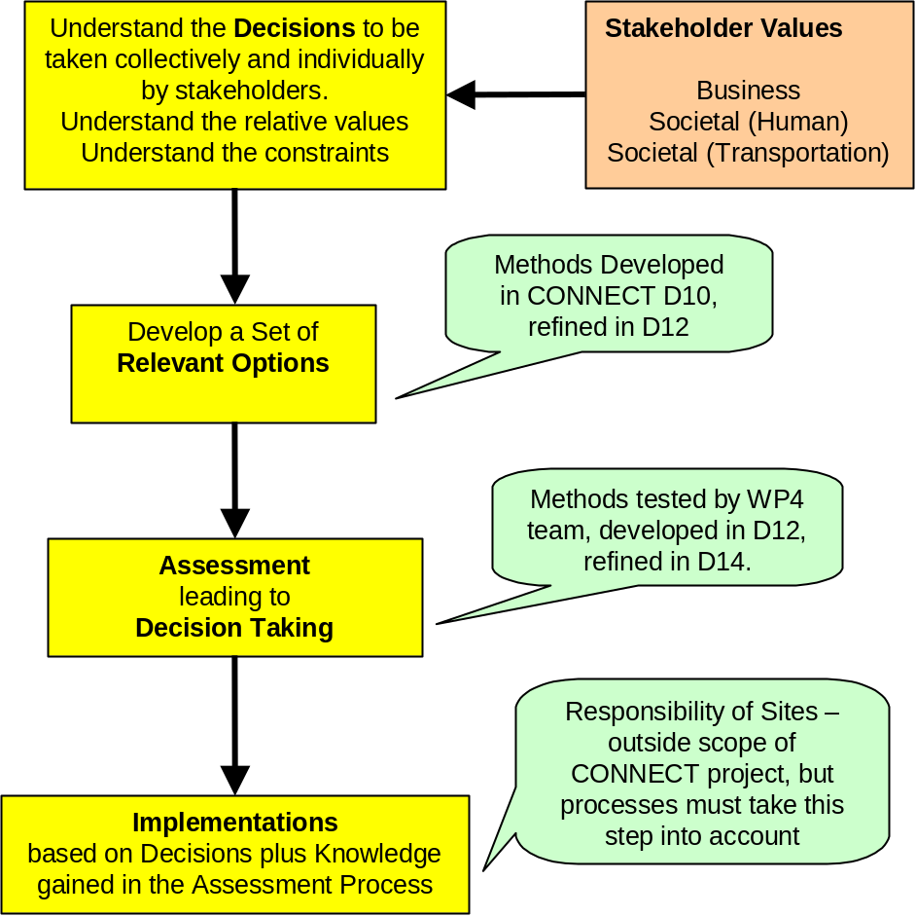
Figure 2-4: Overview of Decision-Taking Process

Ensuring Relevance to current and emerging FTS needs
The CONNECT team decided that the best way to understand the framework and business dimensions for the future FTS was to develop and assess a set of concepts. The concepts would be based on a blend of best current practice in FTS, emerging ideas for the sector, and business concepts from other sectors. It was decided to obtain information on a set of Test Cases, which represented good and innovative practice, with sufficient diversity of location, scale and purpose to give reasonable coverage of the domain. Information for 10 Test Cases in Europe was collected through site visits and direct interview. A further 9 Test Cases in North America were examined through Literature Review.
The Test Cases were researched and analysed according to the three strands:
- Business Models
- Organisational Frameworks
- Legal and Regulatory Frameworks
These were reported in CONNECT Deliverable D10. An initial set of concepts was developed. The work was then extended to a further set of sites. These were rigorously analysed and described using the CONNECT methodology. The feedback from this effort was used to refine the descriptors and approach. The updated version is reported in the remainder of this chapter.

Concepts and Context
CONNECT Deliverable D10 develops concepts for FTS. These concepts are intended to describe how to develop a set of feasible FTS solutions, which can be considered, by sites that are interested to implement FTS. Sites can blend the different elements to suit their specific context.
The intention is to provide information in a ‘toolbox’ fashion rather than to predetermine solutions. This allows practitioners the maximum flexibility in developing options, and harnessing innovation.
Each concept is described by a set of characteristics and/or options. However, each concept is also capable of many variants, since the nature of the participants, the scale, the specific design details must be set locally. Hence the local applications of the same concept can look rather different from one to the next, even though they share fundamental characteristics.
A site which is considering to implement FTS, or to make a major transformation of the existing FTS, can use the concepts as the first step in developing outline options, and can then develop the more promising ones in detail for comparative assessment and prioritisation of detailed options. The assessment approach is presented in Chapter of this report.
However, it is not enough to just consider the concepts. Attention must also be paid to the context. Examination of the Test Cases shows that FTS, which are successful in one location, might not succeed in a seemingly comparable location in some other countries. For example, all right of initiative might be vested in a public authority or monopoly transport operator, so a community or entrepreneurial initiative would not be permitted. Another example could be that the FTS is only possible within the taxi regulations, preventing any solution based on minibuses. Or, the lead actor entrusted to develop the FTS could either lack the core competences or have poor relationships with the other needed actors.
The interested reader is referred to Chapter 6 of Deliverable D10, which deals with these issues in more detail.

Core Service Concepts for FTS
The CONNECT team proposes that there are 7 basic Service Concepts as follows:
- 2 for closed user groups (including special needs)
- 3 for urban/suburban
- 2 for rural areas
The Service Concepts are presented in Table 2-3. Each Service Concept can have many variations, depending on scale, level of service, vehicle types, actors etc.
It is important to note that these concepts are ‘generic’. In other words, they do not exist independently of either their context or their Promoters. The Actors will determine both the Business dimensions of the concept, and will specify the details of the service offer.
Service Concept | Description
Closed services – specific group | Dedicated services for specific groups. Most typically for people with reduced mobility. Special needs services usually are based on a list of registered users, managed by the local authority or other agency.  This concept can also include transport for active groups such as workers, students, conferences, airports etc.
Closed services – single agency | In this concept, all of the closed group services are handled through a single agency. For example, this could cover the different healthcare types, the social ones for elders, perhaps some education, etc. The key difference from the previous concept is that resources are pooled, booking and reservations are combined, and there is greater integration at design, planning, operations, administration and customer support levels.
Urban Periphery | Serving areas of at the urban edge, which until now are served by buses from the city centre or other distant location, and hence are low frequency to the specific area. These FTS have characteristics understood by bus-users, and are integrated – at least at the planning level – with the regular passenger transport. They may be substitutes for unsatisfactory or high-cost fixed-line transport.
Local journeys in urban areas | Services designed for the inner and middle suburbs, to cater for the trips of 1 to 5 km, currently mostly made by car as driver or passenger. Target users include ALL home-based persons, including mothers, pensioners, teleworkers, youth in the Mon-Fri off-peak, and everyone at weekends. Could base on shopping/ activity centres.  These services remain flexible even in the long-term (although the trips might form stable patterns). They are intermediate between bus and taxi, offering the responsiveness of taxi at a price closer to bus tariffs.  The key construct to the user is affordable mobility on demand. The user is unlikely to perceive it as a bus service.
Flexible routes in suburban areas | The FTS are designed to serve non-axis travel, short-mid length journeys. Current public transport options require either long walk at one/both ends of the trip, or taking two buses to complete a relatively short ‘crow-fly’ distance. Current bus users on these trips are highly frustrated. Target groups for these services include workers and students, as well as typical off-peak users.  These FTS services will have some characteristics of bus services, and will be recognised as such by users. There will be integration at least at the planning level, and possibly at the operational level with the regular public transport. Over time, some of these services will convert to regular routes – at least in the peak hours – as the business develops and the demand lines become better understood.
Rural local services | Local FTS services both in the hinterland of the towns, and within the rural communities. Relatively high-frequency in the hinterlands of towns, target users are workers, youth, shoppers, people needing to deal with administration, and leisure.  Moderate to low frequency in more remote areas, providing access to healthcare, administration and shopping services. For remote areas, focus is more typically on overcoming social exclusion.
Rural flexible routes | Short and medium-distance services to towns and transport connection points, ensuring that all inhabitants of the rural areas can make regular travel and can access work, services, and long-distance transport  These FTS have recognisable characteristics of regular passenger transport and are integrated at design, planning and operational levels with the regular PT. They usually also provide planned connections with longer-distance transport.
Table 2-3: Service Concepts for FTS

Developing FTS Options for a Site
Developing a set of FTS options consists of two stages:
- Description of the Site and the context. This sets the framework, and ensures there is a proper understanding of needs, possibilities and constraints
- Consideration of each of the possible concept dimensions. For each dimension there will either be a pre-determined approach, or there will be open options. The possible combinations of the open dimensions will form the set of FTS options

Site description
The site description should include both the background of the FTS site and the context of the site.
Background:
This includes the short description of the background of the FTS site. This could include for example:
- Site location and population
- Current supply of passenger transport
- Motivations for FTS.
The site location specifies where the services are going to be provided. The characteristics of the target area are a key determinant of the type of services to be provided. The vehicle allocation, routing, booking system, etc, may vary if the service is to be provided in rural, urban or semi-urban areas.
Context:
The context should include the following issues:
- Legal and regulatory framework
- The institutions
- Public financing arrangements
- Fare restrictions
- Potential market and market opportunities
- Mobility requirements
- Business and societal objectives.
The Potential Market for mobility services is strongly associated with the characteristics of the target area. The potential market is defined by the socio-economic, demographic and spatial distribution characteristics of the population located in the target area. Furthermore, the spatial distribution of the socio-economic attributes of the target area is also a major determinant of the potential market of a FTS.
The Market Opportunities are defined as subsets of the potential market. These are areas of the market (market segments) with higher potential for existing actors or new entrants to gain new business. They occur due to unmet or poorly-met mobility needs. They can also occur where an actor can offer a (perceived) step change in quality, thus targeting existing business. The set of Market Opportunities is normally background, but it can be influenced by the actors, even in the short term. They can do this through outreach, marketing, and other proactive measures. The potential passenger FTS users can be classified in to the following categories:
- Social groups that have limited access to the existing conventional public transport services or/and private car (elderly, disabled, unemployed, students etc.)
- Residents of areas (rural, urban or sub-urban) where the provision of public transport services is poor inducing undesirable social effects such us social exclusion, economic recession of the area.
- General Public. The objective of the FTS that addresses the general public needs is to replace or complement the existing inefficient conventional public transport services in order to reduce costs and improve the efficiency of the public transport system.
- Concerning the Freight FTS, the major users are the Small and Medium size Enterprises and individuals requiring and providing transportation services.
Legal and regulatory framework, the institutions, public financing arrangements, fare restrictions etc form a framework, that varies across sites, and must be taken into account. The actors cannot easily change this, and even then change is more likely to be in the medium- to long-term. Thus, the Framework forms the core constraints or ‘boundary conditions’ (CONNECT Deliverable D10). Normally, FTS has to exist within the laws and regulations which were designed for conventional buses and taxis, what may distort the FTS offer, forcing the service operators to face a set of constraints, as can be the limitation of the vehicle type and capacity, the acquisition of regular route licence, the lack of freedom in choosing the pick up and set down points or the possibility to compete against self financing regular transport.
In particular, the regulatory framework of a FTS includes to following legislative and institutional issues:
- The regulations that influence the passengers transport market. The emerging market framework includes the specification of the business initiatives, the competition and the degree of deregulation of the market.
- The regulations that determine the level and type of potential involvement of the local/public authorities in the public transport and the constraints and limitations of the public transport operators.
- The regulations addressing the associated transport modes i.e. taxi, bus, FTS
- The legislation related to the minimum level of mobility of the general public or/and special social groups.
The Legal and Regulatory Framework has a very large impact on the freedom of initiative on all of the stakeholders involved in the provision of FTS services. Among other things, it sets the framework for:
- The nature of passenger/freight transport services which can be offered
- Who can offer passenger/freight transport services
- The relationships among the different actors
- Obligations on the provision of mobility services
- Rights of citizens (including specific groups) to mobility services
- Restrictions on services and service types
- Operational and technical requirements
- Financing requirements and subsidies
- Access to the market
- Freedom or restrictions on innovation and entrepreneurship
- Protection for specific market or operator sectors.

Concept dimensions
The concept description consists of following dimensions:
- Business model dimensions
  - Target market
  - Target area
  - Relation to public transport
  - Service typology
  - Tariff system
  - Vehicle type
- Organisational issues dimensions
  - The organisational model
  - The role of the TDC operator
  - Public Control
- Financial dimensions
  - Public Funding
  - Public Funding Payment Basis for TDC
  - Public Funding Payment Basis for Transport Operations
- Operational dimensions
  - Booking system
  - Pricing
Table 2-4 below includes all concept dimensions and options for each dimension.

Concept Dimensions
Business Model Dimensions
A) Target Market | A-1: Disabled people (or other special groups) only |  |  |  | A-2: Passengers with origin or destination in areas with no PT supply |  |  |  |  | A-3: Passengers with PT supply, but which is not well matched to their needs |  |  |  |  |  | A-4: Passengers who are adequately served by other modes |  |  |  |  | A-5: Passengers that want to go to specific events |  |  |  |  |  |  | A-6: Combinations of preceding
B) Target area | B-1: All areas |  |  |  |  |  |  |  |  | B-2: Where public transport supply is lacking or limited |  |  |  |  |  |  |  |  |  |  | B-3: Where public transport exists, but serves only specific needs
C) Relation to public transport | C-1: Stand alone |  |  |  |  | C-2: Integrated (serving different times or different areas) |  |  |  |  |  |  | C-3: Complementary, as feeder |  |  |  |  |  | C-4: Complementary, as equal |  |  |  |  |  |  |  | C-5: Competing (if the regulations allow it)
D) Service typology | D-1: Fixed route and timetable, operated on demand |  |  |  |  | D-2: Routes and possible deviations to serve predefined stops on demand |  |  |  |  |  |  | D-3: Point to point service on demand |  |  |  |  |  | D-4: Door to door service on demand |  |  |  |  |  |  |  | D-5: Combination of door to door service and point to point service
E) Tariff system | E-1: Vouchers or pay per trip |  |  |  |  |  |  |  |  | E-2: Zonal system with special tariff but integrated in the PT-environment |  |  |  |  |  |  |  |  |  |  | E-3: Combination of preceding systems
F) Vehicle type | F-1: Car |  |  | F-2: Minibus |  |  |  |  | F-3: Specially equipped minibus |  |  |  |  | F-4: Minibus with complementary cars |  |  |  | F-5: Specially equipped minibus with complementary cars |  |  |  |  | F-6: Bus |  |  |  |  |  | F-7: Combinations of preceding
Organisational Issues Dimensions
G) The organisational model | G-1: Public body with its own resources operates the FTS |  |  | G-2: The FTS is operated in cooperation with public body and private sector actor |  |  |  |  | G-3: The public body has contracted the TDC and transport operations as a comprehensive service to the one operator |  |  |  |  | G-4: The public body has contracted the TDC and transport operations separately |  |  |  | G-5: The public body has contracted the TDC operations to the one operator. Multiple operators handle the transport operations |  |  |  |  | G-6: FTS operator is private company, but accountable to public bodies and/or community representatives |  |  |  |  |  | G-7: The FTS is operated by private sector actor
H) The role of the TDC operator | H-1: The transport operator operates TDC so that it fulfils its needs for FTS |  |  |  |  |  |  |  |  | H-2: The main occupation is TDC operations, but also own transport capacity for FTS. In addition the subcontractors are used for the transport operations |  |  |  |  |  |  |  |  |  |  | H-3: The TDC operator is not a transport operator
I) Public Control | I-1: The FTS is not controlled by public bodies |  |  |  |  |  |  |  |  | I-2: A single public body controls the FTS |  |  |  |  |  |  |  |  |  |  | I-3: Multiple public bodies are controlling the FTS in cooperation
Financial Dimensions
J) Public Funding | J-1: The FTS is not funded by public bodies |  |  |  |  |  |  |  |  | J-2: A single public body funds the FTS |  |  |  |  |  |  |  |  |  |  | J-3: Multiple public bodies are funding the FTS
K) Public Funding Payment Basis for TDC | K-1: Per vehicle trip | K-2: Per vehicle-kilometre |  |  |  |  | K-3: Per vehicle-hour |  |  |  | K-4: Per passenger trip |  |  |  | K-5: Per passenger-kilometre |  | K-6: Lump Sum |  |  |  |  | K-7 Guaranteed revenue |  |  | K-8 Savings based revenue |  |  |  |  |  | K-9 No Public Funding
L) Public Funding Payment Basis for Transport Operations | L-1: Per vehicle trip |  | L-2: Per vehicle-kilometre |  |  |  |  | L-3: Per vehicle-hour |  |  |  | L-4: Per passenger trip |  |  |  | L-5: Per passenger-kilometre |  |  |  | L-6: Lump Sum |  |  |  | L-7 Guaranteed revenue |  |  |  |  |  | L-8 No Public Funding
Operational Dimensions
M) Booking system | M-1: Call to TDC operator |  | M-2: Call to driver |  |  |  |  | M-3: Automated Phone system |  |  |  | M-4: Internet |  |  |  | M-5: SMS |  |  |  | M-6: Request button at stop or departure point |  |  |  | M-7: Booking by third party (e.g. activity or destination) |  |  |  |  |  | M-8: Combination of preceding systems
N) Pricing | N-1: Flat | N-2: Zonal |  |  |  |  | N-3: Distance |  |  | N-4: Banded |  |  |  |  | N-5: Promotional |  | N-6: Seasonal |  |  |  | N-7: By user type |  |  |  |  | N-8: By usage level |  |  |  |  |  | N-9: By district
Table 2-4: Dimensions and Options for FTS
Dimensions A, E, F and M include an option “Combination of preceding”. With these dimensions one has to consider, if the options are possible to execute together, or if the options are alternatives to each other. In the latter case all options should be marked. If the options form combinations that could be executed together, then one should choose the option “combination of preceding”. If the booking systems possibilities of the FTS are for example calling to TDC operator, Internet and SMS, one should choose them all if they are really alternatives to each other. If the Internet and SMS booking systems are however complementary services to calling, then the option “combination of preceding” should be chosen.

Issues outside of the concept description
In addition of the FTS dimensions mentioned above in the Table 2-4, we have other issues that have to be taken into consideration when implementing the FTS, but are not fitted in the concept description. These issues form “the second level of concept dimensions” and are as following:
- Marketing strategy and communication channels.
- Bonus system / financial penalties based on the delivered level of service.
- Measurements of delivered level of service.
- Customer satisfaction; Methods for collecting customer satisfaction data and how this affects the development of the system.
- Operating times and days.
- Product positioning and branding.
- The level of price relative to bus and taxi fares.
- The rules for booking and operations (are non-prebooked customers accepted? deviation from the route?).
- Usage of community groups to generate business.
- The roles of different shareholders in the business (are taxi firms competitors or do they have some share or stake in the TDC operations?).

Freight transport
FTS does not include only passenger transport, but also freight transports may be executed with flexible transport systems. Table 2-5 below includes concept dimensions and options for Flexible Freight Transport Systems.
The methods presented later in this document for screening and assessing concepts are generic. Therefore, the methods are applicable for freight transport equally as for passenger transports.

Concept Dimensions for Freight Transport
Business Model Dimensions
A) Target Market | A-1: Mail and Parcels  Local to Local |  |  |  | A-2: Catalogue, Internet/TV Shopping, National to Local |  |  |  |  |  | A-3: Food Stuffs and local drug deliveries from chemists Local To Local |  |  |  |  |  | A-4: Refrigerated Goods  Local to Local  National to Local |  |  |  |  |  | A-5: Time Specific Deliveries  Samples for Medical purposes |  |  |  |  |  |  | A-6: Combinations of preceding
B) Target area | B-1: All areas |  |  |  |  |  |  |  |  |  | B-2: Where transport supply is lacking or limited |  |  |  |  |  |  |  |  |  |  |  | B-3: Where transport exists, but serves only specific needs
C) Relation to transport system | C-1: Stand alone |  |  |  |  | C-2: Integrated (serving different times or different areas) |  |  |  |  |  |  |  | C-3: Complementary, as feeder |  |  |  |  |  |  | C-4: Complementary, as equal |  |  |  |  |  |  |  | C-5: Competing (if the regulations allow it)
D) Service typology | D-1: Fixed route and timetable, operated on demand (Time Specific Deliveries Samples for Medical purposes) |  |  |  |  | D-2: Routes and possible deviations to serve predefined stops on demand (Mail) |  |  |  |  |  |  |  | D-3: Point to point service on demand (Foodstuffs, Medicines ETC) |  |  |  |  |  |  | D-4: Door to door service on demand (Mail, Parcels, Refrigerated Goods) |  |  |  |  |  |  |  | D-5: Combination of door to door service and point to point service
E) Tariff system | E-1: Vouchers or pay per item |  |  |  |  |  |  |  |  |  | E-2: Zonal system with special tariff but integrated in the PT-environment |  |  |  |  |  |  |  |  |  |  |  | E-3: Combination of preceding systems
F) Vehicle type | F-1: Car |  |  | F-2: Minibus/Van |  |  |  |  |  | F-3: Specially equipped minibus/Van |  |  |  |  | F-4: Minibus/Van with complementary cars |  |  |  | F-5: Specially equipped minibus/Van with complementary cars |  |  |  |  |  | F-6: Bus/Van/Truck |  |  |  |  |  | F-7: Combinations of preceding
Organisational Issues Dimensions
G) The organisational model | G-1: Public body with its own resources operates the FTS |  |  | G-2: The FTS is operated in cooperation with public body and private sector actor |  |  |  |  |  | G-3: The public body has contracted the TDC and transport operations as a comprehensive service to the one operator |  |  |  |  | G-4: The public body has contracted the TDC and transport operations separately |  |  |  | G-5: The public body has contracted the TDC operations to the one operator. Multiple operators handle the transport operations |  |  |  |  |  | G-6: FTS operator is private company, but accountable to public bodies and/or community representatives |  |  |  |  |  | G-7: The FTS is operated by private sector actor
H) The role of the TDC operator | H-1: The transport operator operates TDC so that it fulfils its needs for FTS |  |  |  |  |  |  |  |  |  | H-2: The main occupation is TDC operations, but also own transport capacity for FTS. In addition the subcontractors are used for the transport operations |  |  |  |  |  |  |  |  |  |  |  | H-3: The TDC operator is not a transport operator
I) Public Control | I-1: The FTS is not controlled by public bodies |  |  |  |  |  |  |  |  |  | I-2: A single public body controls the FTS |  |  |  |  |  |  |  |  |  |  |  | I-3: Multiple public bodies are controlling the FTS in cooperation
Financial Dimensions
J) Public Funding | J-1: The FTS is not funded by public bodies |  |  |  |  |  |  |  |  |  | J-2: A single public body funds the FTS |  |  |  |  |  |  |  |  |  |  |  | J-3: Multiple public bodies are funding the FTS
K) Public Funding Payment Basis for TDC | K-1: Per vehicle trip | K-2: Per vehicle-kilometre |  |  |  |  | K-3: Per vehicle-hour |  |  |  |  | K-4: Per transportation volume unit |  |  |  | K-5: Per  ton-kilometre |  | K-6: Lump Sum |  |  |  |  |  | K-7 Guaranteed revenue |  |  | K-8 Savings based revenue |  |  |  |  |  | K-9 No Public Funding
L) Public Funding Payment Basis for Transport Operations | L-1: Per vehicle trip |  | L-2: Per vehicle-kilometre |  |  |  |  | L-3: Per vehicle-hour |  |  |  |  | L-4: Per transportation volume unit |  |  |  | L-5: Per  ton-kilometre |  |  |  |  | L-6: Lump Sum |  |  |  | L-7 Guaranteed revenue |  |  |  |  |  | L-8 No Public Funding
Operational Dimensions
M) Booking system | M-1: Call to TDC operator |  |  | M-2: Call to driver |  |  |  |  | M-3: Automated Phone system |  |  |  |  |  | M-4: Internet |  |  |  |  | M-5: SMS |  |  |  |  | M-6: Booking by third party (e.g. activity or destination) |  |  |  |  |  | M-7: Combination of preceding systems
N) Pricing | N-1: Flat | N-2: Zonal |  |  |  |  | N-3: Distance |  |  |  | N-4: Banded |  |  |  |  | N-5: Promotional |  | N-6: Seasonal |  |  |  |  | N-7: By user type |  |  |  |  | N-8: By usage level |  |  |  |  |  | N-9: By district
Table 2-5: Dimensions and Options for Flexible Freight Transport Systems.

Selection of the FTS Concept
In this chapter the process of assessing FTS Options is identified. Also the method for screening possible and permitted concepts as well as the refined FTS Concept Assessment Methodology are presented.

Assessing FTS Concepts
With the concept dimensions and options presented in Chapter 2.7.2 we have exactly 7 201 353 600 concept combinations. For the practitioner and the stakeholders, their greatest interest is how to move from a seemingly infinite list to something practical, which helps them to make decisions. The process of assessing concepts is shown in Figure 3-5 below.
Figure 3-5: The process of assessing FTS concepts.
The process could be divided into two parts that are presented in following chapters 3.2 and 3.3. The parts are:
- The screening process for feasible or viable concepts
- The assessment methodology for safe or best concept.

FTS Concept Screening Process
The main steps of the screening process aim to discover:
- Possible concepts
- Permitted concepts
- Feasible concepts
- Viable concepts
Using the concept dimensions in Table 2-4, a first set of possible concepts is assembled. This takes into account the objectives, the context, and any already-agreed aspects. This set is not yet checked for feasibility, but offers a starting point.
Permitted concepts can be screened with a deeper analysis of the context and constraints, especially in relation to the regulatory framework. The exception to this is where one or more constraints are deliberately removed to create a ‘radical’ option. This might be done to test possible outcomes, if FTS moved beyond the current boundaries. Note that at this stage, some of the options might not be feasible.
In the feasible concepts phase the illogical and non-feasible options are screened out to the maximum extent possible. This is important to reduce the effort required in the detailed assessment stage. Not all of the permitted concepts may be applicable since there may be serious conflicts between the options of different elements of the same concept. Furthermore, the issues arising in the FTS context may prevent the simultaneous inclusion of options of different elements e.g. if it is decided that the FTS should be integrated to the existing public transport system, then the FTS should be controlled by a public body thus excluding from consideration any other option. A quick discussion among the stakeholders might decide, for example that from the 48 possible combinations there are only 4−6 combinations that would work in practice and should go forward to the assessment stage.
If the decision-taker can identify, which among the feasible options satisfy a set of business and societal thresholds, we have the viable concepts. These are the options, which meet the investment criteria and/or the mobility objectives
The specifications of the applicable FTS concepts can be implemented by a checklist method where each candidate concept is tested under a set of applicability criteria. The criteria that could be used for example are as following:
- The level of attainment of the stakeholders’ objectives. This criterion examines whether the business incentives of the interested actors (from the FTS context description) are covered by the provided services.
- Economic Feasibility. The objective of the assessment of each concept under this criterion is to determine whether the expected size of the intended market is adequate for establishing the associated FTS.
- Organisational feasibility. This criterion determines whether the organisational model of each of the candidate concepts can be implemented by the interested actors (in the FTS context) of the market area under study and their incentives.
It is pointed out that the assessment of each alternative concept under the aforementioned criteria involves a pass/fail test in terms of covering the associated criteria.
The FTS concepts that fail to satisfy any of the applicability criteria are discarded from the list of alternative concepts. The concepts that cover every applicability criterion are considered as the candidate FTS concepts and they are included in the prioritisation stage of the proposed methodology.

FTS Concept Assessment Methodology
An essential step towards the development of a Flexible Transport System (FTS) is the specification of the associated business model for organising the underlying business system. The selection of the appropriate business model for the development of a FTS pertains to a complex and critical decision making process having the following features:
- It involves multiple objectives. The selection of the most appropriate business model involves several evaluation objectives some of which may be social, economical, or transport integration related.
- It involves a set of business and operational limitations emerging from the relevant legal, institutional, organisational, and market environment.
- It embodies the cooperation and coordination of actors coming from the public and/or the private sector with different and contradicting objectives.
The proposed assessment stage for selecting one or more applicable FTS business models involves the prioritisation of a set of feasible and viable business models. The objective of the FTS business model assessment methodology is to assist the decision makers in determining one or more promising FTS business model(s) that align with their vision and business objectives. Given a set of viable FTS business model specified within the Screening stage of the proposed methodological framework the prioritisation phase involves the identification of the ”best” option. However, it should be pointed out that the objective of the proposed assessment methodology is to structure the FTS business model selection problem in such a way as to rank the competing alternatives. The outcome that is derived from the application of the methodology to a site is the determination of the relative weights of the alternating FTS business models in terms of their performance by taking into account all the identified assessment criteria. The ranking of the alternative FTS business models is achieved through putting the associated relative weights to descending order i.e. the alternative with the highest weight is the most beneficial, the alternative with the second higher weight is the second most beneficial etc.
The selection of the most beneficial business model requires further studies and tests in terms of financial feasibility. However the proposed method constitutes a useful tool for the decision maker in terms of determining the most promising FTS business model configurations that provides the basis for further in depth market and financial analysis.
The FTS Business Model Screening Process described in section 3.2 results to a set of applicable FTS business models. The objective of this section is to present the assessment methodology for ranking alternative applicable FTS business models. The proposed methodology achieves to incorporate the following evaluation requirements:
- Decompose the evaluation problem to criteria expressing the evaluation objectives of the decision maker(s)
- Rationalise and quantify the decision maker(s)’ beliefs and judgement in order to assign priorities among the evaluation criteria and the performance of the alternative business models under each criterion
- Incorporate different stakeholders’ objectives and judgement providing compromise solutions
- Enable the decision maker to perform sensitivity analysis in order to test the validity of the assessment results.
The proposed assessment methodology covers the aforementioned requirements while it aims to provide the user with a decision making tool for the comparative assessment of the alternative FTS business models. In particular the outcome of the application of the proposed methodology is the ranking of the alternative FTS business models in terms of the decision makers’ preferences. The major steps of the method are illustrated in Figure 3-6.
Figure 3-6: The proposed assessment methodology
The prioritisation of the alternative FTS concepts aims to rank the alternatives in terms of the level of attainment of a set of evaluation criteria. This is a complex evaluation problem, which involves multiple tangible and intangible criteria. This fact implies the analysis of the evaluation problem into several levels of homogeneous evaluation elements i.e. criteria, sub-criteria and indicators in order to capture the entire spectrum of evaluation features. The evaluation problem at hand can be decomposed to the following criteria:
C1. Expected System Performance. The objective of this criterion is to assess the expected performance of intended FTS in terms of effectiveness and efficiency. Measures for both types of the system performance assessment may be found in the next subsection. The associated indicators are as follows:
I1.1: Expected system effectiveness
C2. Organisational Efficiency. A major feature of the implementation of an FTS business model is the organisational structure of the intended FTS. This feature affects significantly the level of coordination and co-operation of the involved stakeholders and therefore plays a key role in the FTS business models assessment. In particular this criterion is expressed by the following indicators:
I2.1: Degree of coordination of the stakeholders
I2.2: Contribution to the degree of transport integration
C3. Financial Feasibility. This criterion aims to assess the alternative FTS business models in terms of the expected financial benefits derived from their implementation. It involves the following indicators:
I3.1: Expected investment and start up costs
I3.2: Expected Management Costs
I3.3: Expected system revenues
I3.4: Cash-flow and first year performance
C4. Transport Level of Service. This criterion refers to the impacts of the FTS implementation in the transport network performance. Under this perspective, the transport efficiency is expressed by the following indicators:
I4.1: Increase of comfort
I4.2: Improvement of transport reliability
I4.3: Improve geographical coverage of transport services
I4.4: Improve customisation of services
I4.5: Increase of duration of system availability
C5. Societal Impacts which refers to the potential improvements on the quality of life of the people that could use the FTS services offered. The Societal Impacts may be further decomposed to the following indicators:
I5.1 : Improvement of personal mobility among target groups
I5.2 : Impact on the traffic level of the target area
I5.3 : Recovery/Improvement of the local economy
I5.4 : Mitigation of Environmental Impacts (e.g. air pollution)
I5.5 : Increase transport safety
Figure 3-7 provides the hierarchy of criteria and indicators emerging from the decomposition of the evaluation problem. The next two steps of the proposed methodology refer to the quantification of the decision-makers preferences to a set of priorities/weights concerning the relative importance of the criteria/indicators and alternative FTS business models and the synthesis of these weights in order to determine the overall score (priority) of each alternative. The proposed prioritisation scheme may be achieved by using either a simple scoring model or more sophisticated multi-criteria decision making method (e.g. Analytic Hierarchy Process).

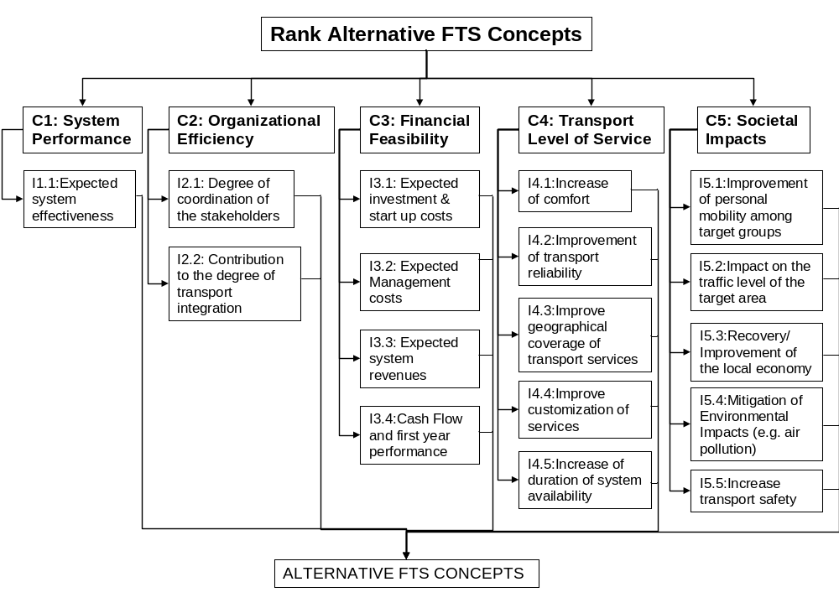
Figure 3-7. Hierarchical decomposition of the evaluation problem.

A major issue in applying the proposed methodology is the determination of the overall priorities of the alternative applicable FTS business models. In this context, the AHP mathematical model aims to calculate the priorities of the alternative FTS business models that express the relative importance of each alternative in achieving the overall evaluation goal (i.e. rank the alternatives in terms of their contribution to achieving the site specific objectives of the intended FTS).
The major features of AHP are the following:
- It incorporates multiple criteria
- It deals with multiple stakeholders
- It uses experts measurements (however it can use objective measurements too)
- It synthesizes opposite and contradicting judgments providing compromise solutions
- It specifies the degree of inconsistency of the experts judgments
- It allows the performance of sensitivity analysis
It is apparent that the aforementioned features fulfil the basic requirements of the evaluation problem at hand.
The AHP is based on the hierarchical decomposition of the evaluation problem into several levels of homogeneous evaluation elements i.e. criteria, sub-criteria and indicators. The constituent elements of each level of the hierarchy are assigned weights, which express the relative importance between these elements with respect to the associated parent element of the preceding level. The priorities of the elements are specified based on a set of pairwise comparisons in terms of their importance with respect to the associated parent element of the hierarchy [Saaty et al, 1991]. The synthesis of these weights provides the overall priorities of the alternative FTS concepts. The ranking of the concepts in terms of the priorities’ descending order implies the FTS concept prioritisation.
The implementation of the AHP involves the following methodological steps:
- Problem definition
- Hierarchical Decomposition of the problem
- Determination of the pairwise comparisons
- Synthesis
Steps 1 and 2 of the associated process have already been addressed within the proposed assessment methodology. In particular the hierarchical decomposition of the problem has been already introduced in Figure 2-4. The overall weights of the alternative FTS business models will be produced through the implementation of the AHP mathematical model. According to this model a set of weights is determined for the elements at each level of the hierarchy based on a set of pairwise comparisons of the elements of each level with respect to every parent element in the hierarchy. The collection of the pairwise comparisons of the elements in level Lk that are associated with the element x of level Lk-1 is achieved through the completion of the upper triangular matrix presented in Figure 3-8.
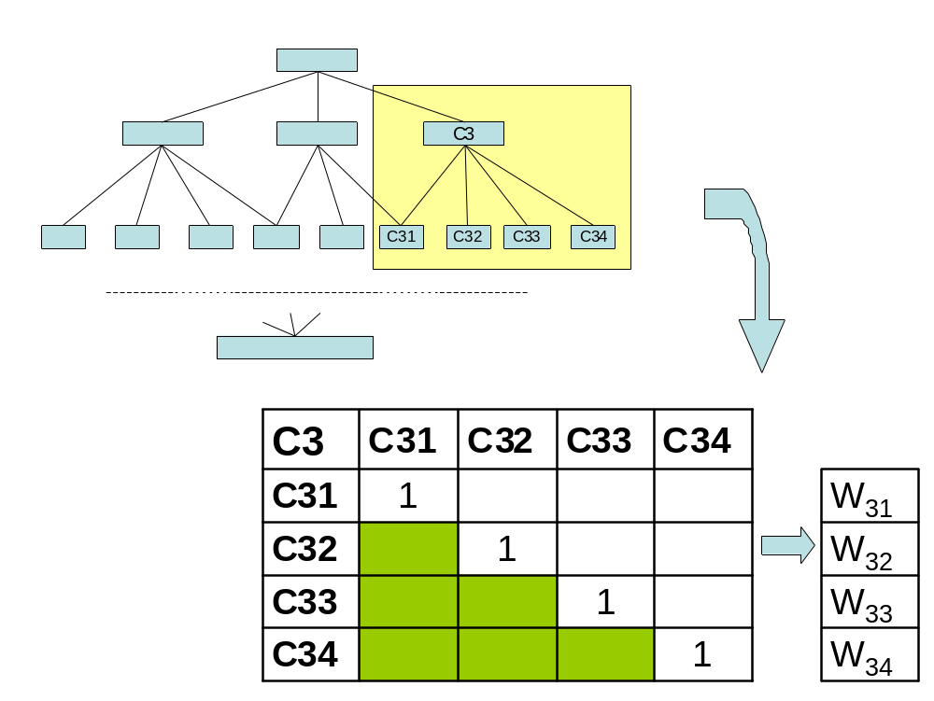
Figure 3-8. Table of pairwise comparisons.
Each of the empty non-shaded cells should be completed by performing the comparison of the type: “How mach important is element C3i from C3j (j>i) with respect to C3?”. The outcome of this type of comparison may take the values presented in Table 3-6 [Saaty, 1990]. For example, considering the hierarchy presented in Figure 3-7 the completion of the table of pairwise comparisons that relates to the indicators stemming out of criterion C2 ‘Organisational Efficiency’ (i.e. I21 and I22) involves only the following comparison: ‘How much more important is I21 ‘Degree of coordination of the stakeholders’ as compared to I22 ‘Contribution to the degree of transport integration ’ in achieving ‘Organisational Efficiency?’.
Intensity of Importance | Definition
1 | Equal importance
3 | Moderate importance of one over another
5 | Essential or strong importance
7 | Very strong importance
9 | Extreme importance
2,4,6,8 | Intermediate values between the two adjacent judgments
Reciprocals | When element i compared to j is assigned one of the above numbers, then activity j compared to i is assigned its reciprocal
Table 3-6: The 1-9 AHP ratio scale
A set of guidelines for applying the AHP is provided in section 6.1.
A set of weights is calculated for each table of pairwise comparisons that express the relative importance of the corresponding elements of the hierarchy with respect to the relevant parent element. The synthesis of all the emerging sets of relative weights results to the overall priorities of the alternative FTS business models. Furthermore, the AHP mathematical model enables the performance of sensitivity analysis i.e. determination of the changes on the overall priorities given specific minor changes to the relative weights of the elements of the hierarchy. This process aims to investigate the robustness of the emerging ranking of the alternative FTS business models under minor changes to the relative weights of the elements of the hierarchy.
The resulting most beneficial competing FTS business models can be further assessed in terms of their financial viability, system efficiency, effectiveness, and quality. Measuring the efficiency of the FTS will give the involved stakeholders the opportunity to compare the alternative FTS on different aspects. The following efficiency measures can be considered:
- Average number of passengers per vehicle
- Average number of passenger-kilometres per vehicle
- Average operating speed (km’s/hour)
- Average percentage waiting time
- Average percentage unloaded km’s
- Costs of intake, planning and dispatch per trip
- Costs of intake, planning and dispatch per trip related to operating costs
- Percentage overhead costs related to total costs
Furthermore, measuring the effectiveness gives answers on the usage of the transport system, which can be related to the efforts made and the money spend on the system. The following relevant effectiveness measures have been identified:
- Number of passenger trips per year
- Number of passenger-kilometres per year
- Number of passenger trips per inhabitant
- Number of passenger trips per person in a target group
All quality aspects that are defined and measured during the design of the FTS can measure the quality of the system. The following quality measures can be considered:
- Image
- Customer satisfaction
- Percentage trips in time / within quality parameters

Example FTS Sites
This chapter presents the example FTS sites, which are used as an example where the business model development process of this Deliverable is gone through. The example FTS sites give the reader an overview on how the methods presented in the Deliverable operate in practise. The example FTS sites presented in the Deliverable are as three different types:
- Analysed test cases
- Areas interested in the FTS implementation
- Hypothetical FTS sites.
The analysed test cases are the cases that are presented in CONNECT Deliverables D5 and D10. The background and context of the test cases are described based on the earlier Deliverables and used for analyses.
The areas interested in the FTS implementation are real sites that are interested to implements FTS In the near future.
The hypothetical FTS sites are fictitious sites that are interesting cases for the analysis. For example real life test case could be transformed into hypothetical FTS site by changing the context of the site from the original. For example the affects of changing the regulations to the business models could be analysed.
The example FTS Sites are presented with the site description format presented in Chapter 2.7.1. The site description of the real life examples can be described more detailed than with the hypothetical cases.

Analysed Test Cases

Helsinki, Finland
The City of Helsinki is one of the case studies described in the CONNECT Deliverable D10.
Background:
The City of Helsinki is the capital of Finland and has about 560.000 inhabitants. The City area is about 186 square kilometres. The level of service of public transport system in Helsinki is one of the highest in Europe. There are over 15 open for all service lines that are designed especially for the elderly and disabled people. The vehicles are low-floor easy-to-access mid-sized buses.
The City of Helsinki has its obligation to provide services based on the Disability Act in Finland. The disabled people are entitled to make 18 parallel spare time trips per month free of cost (Customer's excess must be comparative to the public transport fee). The number of disabled people entitled to have Disability Act services is 13.000.
The primary target of the City of Helsinki is to 1) provide good enough level of service and 2) make cost savings compared to normal taxi system.
Context:
The Disability Act services must be operated 24 hours a day, 7 days a week, 52 weeks a year.
Transmation Helsinki Ltd has operated HTDC since 2001. The operator takes care of the TDC as well as the transports. The operator has around 80 minibuses equipped with machinery needed for handicapped. Some trips are dispatched to open taxi system too. Clients (the disabled) have also free access to public transport. Current contract with the operator ends after 2005 and the City of Helsinki has started the new tendering process for the TDC.
The City of Helsinki could in principle operate the TDC with its own resources as a part of the City organisation. In practice the outsourcing of the operations is the only option in the City as large as Helsinki.

Rural Case 1, EU
Rural Case 1 currently operates limited FTS services. It wants to extend the scale and style of FTS services.
Background:
The FTS is operated by a private company, with governance by community representatives. The scheme is one many schemes receiving funding support through a national program to support rural transport. It currently operates DRT on 13 rural routes in its area of coverage. It has a TDC with an ITS-based booking, assignment and dispatch system. It currently uses three minibuses. For the first two years it contracted in the operations, but in 2004 changed over to direct operation.
The existing services operate on either 1 or 2 days per week, and operate 2-3 trips on each day. The primary target is overcoming social exclusion, and the main initial objective was to give people at least one opportunity a week to access shops, services and social/community activities. Although intended for all users, the majority of customers are elderly or mobility impaired.
The company now wants to implement frequent daily services, so that mobility is available to all users. They have decided to focus on the hinterland of a local town of about 5.000 people, which has a full range of services and amenities, and served by long-distance transport.
The main idea is that people of all ages and categories without a car in rural areas will have broadly comparable opportunities as their counterparts in the town.
Context:
The operator already operates FTS, with a TDC located within the area, and using an ITS-based booking, assignment and dispatch system.
It is not expected that any licences are needed for the foreseen services. However, if they provide local transport services within the town, or if they pick-up and set-down along the existing regular bus lines (mostly express services) there would certainly be a complaint and possibly a legal challenge.

Areas interested in the FTS implementation

Urban Case 2, EU
This City does not currently have any FTS. It has identified that there are unmet mobility needs, and wants to understand whether FTS is a suitable solution. If so, the City will need to take policy decisions on the nature and the organisational framework of the FTS.
Background:
Urban Case 2 is a medium-sized city. The municipal authority does not have responsibility for public transport. Funding and licensing of public transport is under the aegis of the national Department of Transport. There is a public sector company that is the de facto monopoly provider of passenger transport services in the city and its hinterland.
The City has a progressive policy of managing traffic, and has been willing to implement bus lanes and other priority measures. Although the public sector company has made some improvements to their services, some of the suburban areas and some of the hinterland areas do not have adequate passenger transport services. The City wants to improve the situation, and considers that FTS might offer a good solution.
The City will launch a detailed Feasibility Study during 2005. For the moment, there is a very open starting point.
Context:
The public sector company operates all of the bus services serving the city and the hinterland, as well as most of the regional and long-distance services serving the City. Some private operators also operate regional and long-distance services.
The City has recently become directly involved in passenger transport operations. During 2004 it established itself as a competent operator, obtaining the equivalent of a PSV licence. It has established the first of a series of Park’n’Ride sites, and wished to provide free shuttle bus services from the P’n’R site to the city centre. It planned the services, obtained a licence for it, offered it to competitive tender, and then concluded contracts with the winner. The public sector company won the tender and is now operating under contract to the City.
The quasi-monopoly public sector operator accepted to participate in an open tender and operate services under contract. This implies that they accept the principle that the City can gain route licences and offer them to tender. The central government transport department – who issued the licence – also seems to accept the principle.
The City believes that they could use a similar mechanism for DRT, if the Feasibility Study is positive. However, it could still face three issues:
- Whether a licence can be granted for a flexible route
- If not, whether they can offer such services in an unconstrained way, or would be forced to operate it as a taxi/hackney style service
- Whether the public sector company or the Department of Transport would try – openly or covertly - to prevent the establishment of a fare-paying service, which would be competition to regular transport services (even if the current ones are weak)
In addition, the City needs to understand which FTS options offer the greatest potential, and what would be the transportation and financing impacts.

La Sagra, Toledo, Spain
Background:
La Sagra Region is a rural area located in the province of Toledo. The low density of population of the municipalities in the Region and the geographical situation generates a dependency on Toledo, the capital of the province, for the main services, especially health services. The access to the services in the capital is made by public transport, but the frequency is not enough, normally one day per week to access the hospital. On the other hand, due to the proximity of this municipality to Madrid, there is an emerging trend to move to the Spanish capital to cover the basic services as the public transport facilities to access Madrid are better than those offered to access Toledo.
The Toledo Government would like to provide a solution to this migration of users to Madrid and they are thinking about the possibility of implementing a Demand Responsive Transport system. The first step would be to facilitate access to the hospital.
The main idea is that in a future, this service will be extended to all people willing to access all kind of services available in Toledo.
Context:
The service would be based on a fleet of taxis that would act as feeders to the regular public transport service. A step forward would be to combine taxis with special vehicles for disabled.
The TDC could be offered by the taxi agency, combined with the taxi call centre, or subcontracted to a TDC agency dedicated only to the DRT services.
The ticketing system will use passenger smart cards that will differentiate between the use of a taxi service and the use of DRT service (combination of taxi and public regular transport). In this last case, a special tariff will be applied in the moment the passenger passes the smart card through the reader in the bus.
The taxi will be reimbursed by the Administration according to a previous agreement.
The users of the service will have to be registered and will have to own a smartcard. Both the taxis and the buses will have to be equipped with the smart-card reader devices.
It is expected that the service will operate under the taxi legislation. However, if the service is extended to special vehicles for disabled or minibuses there could be some conflicts.
A second possibility would be that the regular bus public transport deviates from the fixed route to serve a set of pre-defined on-demand stops. In this case the TDC would be subcontracted and smart cards would not be used. The tariff system will consist on a fixed supplement added to the regular transport rates.
In both cases, there are no legal constraints, as the system would act under the umbrella of the taxi and bus regulations respectively.

Hypothetic FTS sites

Urban Case 3, CIS
Urban Case 3 is presented as a sample hypothetical case. The City is one of many cities in this CIS country of greater than 250.000 inhabitants, which currently have extensive minibus operations. This hypothetical case is needed to identify which options are practical, and among these options, which would be the best to bring forward to policy-makers. It is worth noting that the similarity of conditions throughout the CIS mean that this case has widespread applicability.
Background:
Urban Case 3 is a medium-sized city, which has experienced substantial population growth in the past decade, and is likely to experience significant further growth. This is due to a national policy decision to transfer many functions to the city. This will place substantial pressure on all urban services, including transportation. It also means that travel patterns will change significantly and perhaps in unforeseen ways.
In both the Soviet and the Independence eras, public transport has been the main means of mobility. Although there is a rapidly increasing car ownership and corresponding car usership, passenger transport will remain the main mode for the foreseeable future. Nonetheless, the increasing level of car use will lead to congestion and deterioration of the conditions for the urban transport. Passenger transport needs to re-establish itself as a mode of choice. It needs to offer policy makers a real alternative to the car.
Passenger transport consists of bus, minibus and trolleybus. All operate on fixed routes. A series of reforms in the past decade has transferred many of the public sector companies to private ownership, and allowed new entrants. A second wave of reforms meant that all routes are operated on the basis of a contract of 35 years, awarded following competitive tender. There are no subsidies and tariffs are fixed by the municipality. As most places in the CIS, minibus tariffs are higher than those for large buses and trolleybuses.
The number of minibuses increased dramatically in the mid- and late-90’s due to two factors (this was typical throughout the CIS) – the degradation of the big bus fleet which led to market openings, and the affordability of minibuses as a means for entrepreneurs to enter the market. During the worst years, minibuses established themselves as an acceptable alternative to unreliable and overcrowded big buses.
However, the minibuses were not ideal. Where they gain on speed and frequency, they lose out on being cramped and not always professionally run. Both the city authorities and many passengers prefer that bigger vehicles are used. On the one hand, this is for operational and comfort reasons. On the other, there is a feeling that cities should have ‘proper’ services. In the most recent years, it has again been possible for operators to acquire big buses. Services are now operated at 100% of the plan, and are fairly reliable. In the City, many of the buses are new and comfortable (e.g. Scania, MAN).
A big question arises on what to do with the minibuses. The current thinking is that they will be squeezed out by the big buses, operating only on the lesser routes, and perhaps pushed out altogether. Since they have a relatively short life, they could disappear within 3-5 years (perhaps transferring to small cities and towns).
A radical alternative would be to adapt them to FTS. Currently they are called marshrutki ‘route taxis’ but they operate fixed route, fixed price. Taxi fares are usually 8-10 times higher, and there is still the widespread practice of flagging down private car drivers and negotiating a lift with them for a little less than the equivalent taxi fare.
The question is whether this market could become the domain of the flexible ‘route taxi’, at tariffs closer to bus tariffs than flag-down prices.
Context:
Minibus services are already operated extensively, but they are fixed route services under contract to the city following competitive tender.
It is unclear whether the law has provision for flexible transport.
Taxi services are permitted, both as formal taxis with plates, and on an informal flag-down basis of any private car. It is unclear whether there is any legal basis for the latter, and whether there are insurance issues. At present, officials do not mention this practice as a problem or something they would like to eliminate.
Transformation of fixed-route minibus to FTS would impact on three sets of people:
- Existing taxi drivers, who could lose a significant part of their business. It would be necessary to engage with them, possibly to ensure that some work from the TDC comes to them, and possibly to retrain some as minibus drivers
- Car drivers who give flag-down lifts on a regular basis. It is clear that some drivers just cruise the city as unofficial taxis. There is no legal basis on which they could complain, but they are likely to agitate against FTS.
- Car drivers who give flag-down lifts on an opportunistic basis. They will lose out on opportunities to earn ‘petrol money’, but are unlikely to complain too much. In any case, they can continue to operate and there will always be people who need a vehicle immediately or don’t bother to book the FTS.
It is less clear how the FTS would impact on big bus services. Currently the tariff is about 0,13 euro for a bus ride and 0,16 euro for a minibus ride. A comparable flag-down journey would be 0,901,30 euro, and a taxi trip 1,301,90 euro.
If the FTS price is set somewhere in the range of 0,200,30 euro, it provides a sufficient differential that people will make a conscious choice between bus and FTS, and between FTS and taxi.
The other area of potential heavy resistance is the city officials. They are focussed on mass rapid transit solutions and high quality big buses. To their opinion, minibuses are suitable only for provincial towns, and lower the image of their city. It will be necessary to position FTS as a new and modern mode, which in turn will have implications for the vehicles and service quality. It will also be necessary to be very clear about how and by whom the business will be run.

FTS Concept Applicability

FTS Concept Screening Process in practice
FTS Concept Screening Process begins with a deep analysis of the site description. With the constraints and guidelines gained from the background and context the possible Service Concept (or concepts) is chosen. After this, the main tool in concept screening is the concept dimensions table (Table 2-4).
All dimensions in the table are examined through with experts, who have a good understanding about the background and context. All permitted options within each dimension are marked so that they form all possible combinations. This takes into account the objectives, the context, and any already-agreed aspects. Some dimensions include the option “Combination of preceding”. With these dimensions one has to consider if the options are possible to execute together, or if the options are alternatives to each other. In the latter case all the options should be marked. If the options form combinations that could be executed together, then one should choose the option “combination of preceding”.
Next step is to screen out illogical and non-feasible options. This includes the following:
- Overlapped options: Some dimensions have multiple permitted options that differ from each other, but in practise formulate only one option, because they can not be implemented alone. In this case the options are merged.
- Non-feasible combinations: Two options in different dimensions can be separately permitted. However if the other is chosen the other is not permitted. In this case the non-feasible combinations are removed.
If there are still more than 10 feasible concept combinations after the overlapped options are merged and non-feasible combinations are removed, there are two options to follow:
- The concepts should be categorised so that they form main concepts and lower class concepts. There should be no more than ten main concepts. The main concepts should include the dimensions that experts think have the most effect on FTS implementation.
- Experts should analyse the feasible concept combinations more deeply so that the number of combinations could be limited down to no more than ten concepts. This is only possible if the there is evidently weaker concepts within feasible combinations so that the experts could find them.
If the concepts are categorised to the main concepts and lower class concepts, then the main concepts are first assessed with the methodology. After that the methodology is used to assess the lower levels of the one or two best main concepts.
If the experts could screen out the concept combinations so that there are no more than ten combinations left, then they should proceed to the prioritisation phase with them.

Concept identification for the example sites

Helsinki, Finland
The Service Concept in Helsinki is Closed services – specific group. In the future the Service Concept could be Closed services – single agency, if dispatching of other transports of City of Helsinki are attached to the HTDC.

All the concept dimensions in Table 2-4 and options were examined by the CONNECT experts, who have a good knowledge about the background and context of the case of City of Helsinki. The dimensions and options were screened so that the permitted options were marked. The permitted options (see Figure 5-9) form a total of 360 concepts. The current business model used in Helsinki is marked with bright green colour and other options with tan.

Concept Dimension
Business Model Dimensions
A) Target Market | A-1 |  |  |  | A-2 |  |  |  |  | A-3 |  |  |  |  | A-4 |  |  |  |  | A-5 |  |  |  |  | A-6
B) Target area | B-1 |  |  |  |  |  |  |  |  | B-2 |  |  |  |  |  |  |  |  |  | B-3
C) Relation to public transport | C-1 |  |  |  |  | C-2 |  |  |  |  |  | C-3 |  |  |  |  |  | C-4 |  |  |  |  |  | C-5
D) Service typology | D-1 |  |  |  |  | D-2 |  |  |  |  |  | D-3 |  |  |  |  |  | D-4 |  |  |  |  |  | D-5
E) Tariff system | E-1 |  |  |  |  |  |  |  |  | E-2 |  |  |  |  |  |  |  |  |  | E-3
F) Vehicle type | F-1 |  |  | F-2 |  |  |  |  | F-3 |  |  |  | F-4 |  |  |  | F-5 |  |  |  | F-6 |  |  |  |  | F-7
Organisational Model Dimensions
G) The organisational model | G-1 |  |  | G-2 |  |  |  |  | G-3 |  |  |  | G-4 |  |  |  | G-5 |  |  |  | G-6 |  |  |  |  | G-7
H) The role of the TDC operator | H-1 |  |  |  |  |  |  |  |  | H-2 |  |  |  |  |  |  |  |  |  | H-3
I) Public Control | I-1 |  |  |  |  |  |  |  |  | I-2 |  |  |  |  |  |  |  |  |  | I-3
Financial Dimensions
J) Public Funding | J-1 |  |  |  |  |  |  |  |  | J-2 |  |  |  |  |  |  |  |  |  | J-3
K Public Funding Payment Basis for TDC | K-1 | K-2 |  |  |  |  | K-3 |  |  | K-4 |  |  |  | K-5 |  | K-6 |  |  |  | K-7 |  |  | K-8 |  |  |  |  | K-9
L Public Funding Payment Basis for Transport Operations | L-1 |  | L-2 |  |  |  |  | L-3 |  |  | L-4 |  |  |  | L-5 |  |  |  | L-6 |  |  | L-7 |  |  |  |  | L-8
Operational Dimensions
M Booking system | M1 |  | M-2 |  |  |  |  | M-3 |  |  | M-4 |  |  |  | M-5 |  |  |  | M-6 |  |  | M-7 |  |  |  |  | M-8
N Pricing | N-1 | N-2 |  |  |  |  | N-3 |  |  | N-4 |  |  |  | N-5 |  | N-6 |  |  |  | N-7 |  |  | N-8 |  |  |  |  | N-9
Figure 5-9: Permitted options of the example site Helsinki, Finland.
All the combinations that the permitted options form are not feasible ones. Also there are some dimensions where possible options differ from each other, but in practise formulate only one option. For example in dimension C) “Relation to public transport” the options “C-1: Stand alone” and “C-4: Complementary, as equal” are both viable options, but cannot be implemented alone. After the overlapped options are screened there is total of 90 possible concepts. These combinations come from
- Three different organisational models
- Two different possible roles of TDC operators
- Three possible public funding payment basis for TDC operator
- Five possible public funding payment basis for transport operator.

The feasibility of those 90 concepts are analysed and based on following reasons the number of feasible concepts is limited to 18 feasible concepts:
- If the comprehensive service is used, then there is no difference for the contractor if the TDC operator is a transport operator or not. In both cases there is a need for subcontractors that complement the vehicle capacity.
- If the TDC and transport operations are contracted separately, then the TDC operator shouldn’t be transport operator.
- If the comprehensive service is used, then the operator should be paid based on the amount of ordered trips or with lump sum.
- If the transport operator is contracted separately from the TDC operations, then the transport operator should not be paid based on the amount of ordered trips or with a lump sum.
These concepts are presented in the figure below.
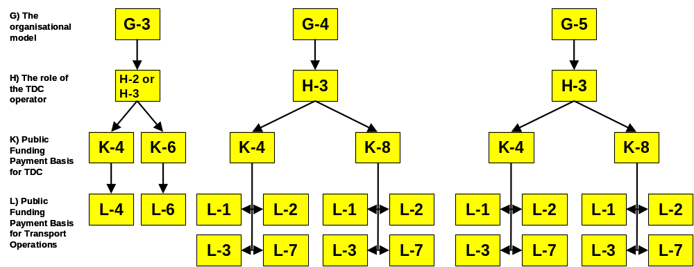

Figure 5-10: Feasible concepts of the example site Helsinki, Finland.

Rural Case 1, EU
The Service Concept is likely to be Rural Local Transport, although Rural Flexible Route is a possibility. The question is whether the travel patterns will be sufficiently regular, or whether this would lose too much flexibility. For planned connections, it would require the co-operation of the public sector long-distance bus operator.
The next section described the details, and Table 5-7 presents them according to the CONNECT format.
Concept Dimension
Business Model Dimensions
A) Target Market | A-1 |  |  |  | A-2 |  |  |  |  | A-3 |  |  |  |  | A-4 |  |  |  |  | A-5 |  |  |  |  | A-6
B) Target area | B-1 |  |  |  |  |  |  |  |  | B-2 |  |  |  |  |  |  |  |  |  | B-3
C) Relation to public transport | C-1 |  |  |  |  | C-2 |  |  |  |  |  | C-3 |  |  |  |  |  | C-4 |  |  |  |  |  | C-5
D) Service typology | D-1 |  |  |  |  | D-2 |  |  |  |  |  | D-3 |  |  |  |  |  | D-4 |  |  |  |  |  | D-5
E) Tariff system | E-1 |  |  |  |  |  |  |  |  | E-2 |  |  |  |  |  |  |  |  |  | E-3
F) Vehicle type | F-1 |  |  | F-2 |  |  |  |  | F-3 |  |  |  | F-4 |  |  |  | F-5 |  |  |  | F-6 |  |  |  |  | F-7
Organisational Model Dimensions
G) The organisational model | G-1 |  |  | G-2 |  |  |  |  | G-3 |  |  |  | G-4 |  |  |  | G-5 |  |  |  | G-6 |  |  |  |  | G-7
H) The role of the TDC operator | H-1 |  |  |  |  |  |  |  |  | H-2 |  |  |  |  |  |  |  |  |  | H-3
I) Public Control | I-1 |  |  |  |  |  |  |  |  | I-2 |  |  |  |  |  |  |  |  |  | I-3
Financial Dimensions
J) Public Funding | J-1 |  |  |  |  |  |  |  |  | J-2 |  |  |  |  |  |  |  |  |  | J-3
K Public Funding Payment Basis for TDC | K-1 | K-2 |  |  |  |  | K-3 |  |  | K-4 |  |  |  | K-5 |  | K-6 |  |  |  | K-7 |  |  | K-8 |  |  |  |  | K-9
L Public Funding Payment Basis for Transport Operations | L-1 |  | L-2 |  |  |  |  | L-3 |  |  | L-4 |  |  |  | L-5 |  |  |  | L-6 |  |  | L-7 |  |  |  |  | L-8
Operational Dimensions
M Booking system | M1 |  | M-2 |  |  |  |  | M-3 |  |  | M-4 |  |  |  | M-5 |  |  |  | M-6 |  |  | M-7 |  |  |  |  | M-8
N Pricing | N-1 | N-2 |  |  |  |  | N-3 |  |  | N-4 |  |  |  | N-5 |  | N-6 |  |  |  | N-7 |  |  | N-8 |  |  |  |  | N-9
Table 5-7: Options for Rural Case 1, EU.
There are some issues, which are not covered by the option dimensions, but which need to be resolved:
- Whether to operate the services directly, or to sub-contract them
- Whether to operate just as many service as possible around a single driver’s shift and meal breaks, or to determine the service level according to need, and then find the staffing/buses to meet this
- How much baseline service should one guarantee, regardless of demand?
- What constraints to set on whether to operate a trip: run the trip, do a large deviation for only one person?
- Decide on the operating times – start/finish times, whether to operate on Sundays?
- Marketing strategy and communication channels
- Product positioning and branding
- Usage of community groups to generate business
Some of these items are probably common to all options, and can therefore be considered as implementation issues. It was a little difficult to rationalise why some items of choice were considered as part of the business model, and others were not.

Urban Case 2, EU
The Service Concept will be Urban. All three Urban Service Concepts are open at present.
There are three major questions:
- Is FTS appropriate to the City, and if so, what type(s) of service offers the best opportunities? What are the likely transportation and social impacts?
- How should the FTS be organised in Business, organisational and institutional terms, and what are the likely fiscal dimensions?
- Should the City take the lead role, or should they just try to encourage others to make the FTS happen (either public sector or market)
Table 5-8 presents the issues for the City study site.
Concept Dimension
Business Model Dimensions
A) Target Market | A-1 |  |  |  | A-2 |  |  |  |  | A-3 |  |  |  |  | A-4 |  |  |  |  | A-5 |  |  |  |  | A-6
B) Target area | B-1 |  |  |  |  |  |  |  |  | B-2 |  |  |  |  |  |  |  |  |  | B-3
C) Relation to public transport | C-1 |  |  |  |  | C-2 |  |  |  |  |  | C-3 |  |  |  |  |  | C-4 |  |  |  |  |  | C-5
D) Service typology | D-1 |  |  |  |  | D-2 |  |  |  |  |  | D-3 |  |  |  |  |  | D-4 |  |  |  |  |  | D-5
E) Tariff system | E-1 |  |  |  |  |  |  |  |  | E-2 |  |  |  |  |  |  |  |  |  | E-3
F) Vehicle type | F-1 |  |  | F-2 |  |  |  |  | F-3 |  |  |  | F-4 |  |  |  | F-5 |  |  |  | F-6 |  |  |  |  | F-7
Organisational Model Dimensions
G) The organisational model | G-1 |  |  | G-2 |  |  |  |  | G-3 |  |  |  | G-4 |  |  |  | G-5 |  |  |  | G-6 |  |  |  |  | G-7
H) The role of the TDC operator | H-1 |  |  |  |  |  |  |  |  | H-2 |  |  |  |  |  |  |  |  |  | H-3
I) Public Control | I-1 |  |  |  |  |  |  |  |  | I-2 |  |  |  |  |  |  |  |  |  | I-3
Financial Dimensions
J) Public Funding | J-1 |  |  |  |  |  |  |  |  | J-2 |  |  |  |  |  |  |  |  |  | J-3
K Public Funding Payment Basis for TDC | K-1 | K-2 |  |  |  |  | K-3 |  |  | K-4 |  |  |  | K-5 |  | K-6 |  |  |  | K-7 |  |  | K-8 |  |  |  |  | K-9
L Public Funding Payment Basis for Transport Operations | L-1 |  | L-2 |  |  |  |  | L-3 |  |  | L-4 |  |  |  | L-5 |  |  |  | L-6 |  |  | L-7 |  |  |  |  | L-8
Operational Dimensions
M Booking system | M1 |  | M-2 |  |  |  |  | M-3 |  |  | M-4 |  |  |  | M-5 |  |  |  | M-6 |  |  | M-7 |  |  |  |  | M-8
N Pricing | N-1 | N-2 |  |  |  |  | N-3 |  |  | N-4 |  |  |  | N-5 |  | N-6 |  |  |  | N-7 |  |  | N-8 |  |  |  |  | N-9
Table 5-8: Options for Urban Case 2, EU.
There are some issues not covered by the options table:
- Where should the price relative to bus and taxi fares be positioned?
- What role the taxi firms will play – will they be competitors, or should they be brought within the scheme?
- If within, how should this be achieved, and should the taxi-owners have some share or stake in the TDC?
Common with Rural Case 1:
- How much baseline service should be guaranteed, regardless of demand
- Operating times – start/finish times? Operate on Sundays?
- Marketing strategy and communication channels
- Product positioning and branding
For Urban Case 2, it is still at the conceptual stage, so more options can be considered.
The number of open options is:
A: 2
B: 2
C: 3
D: 4
E: -
F: 2
G: 5
H: 3
I: -
J: 2
K: 4
L: 1 (+3 complementary)
M: 3
This gives a notional set of 138.240 possible combinations. Obviously this is impractical. Further, it is not so practical to try to reduce this set by logical elimination. We will need to consider the most effective way to structure options from such a diverse set of possibilities.
For the purposes of the May 2005 exercise, a set of 4 options has been created to represent the practical range of interest. This will be sufficient to test both the option development and the ability of AHP to support a logical ranking. However, it should be clear that if the number of comparisons increases with the number of options in an exponential or other escalating manner, then the analysis burden would be extremely heavy. This would either create severe workloads, or lead to potentially interesting options being dropped in the pre-analysis phase, perhaps without appreciating their significance.
For the purpose of this exercise, the following are the pivotal decisions:
- Whether to serve only target groups and areas that have poor/no public transport supply, or whether to consider all areas on their merit (A, B)
- Whether the FTS should be ‘subservient’ in its role, or whether it can offer services where PT already exists (not as head-to-head competitor) (C, D)
- Whether to position FTS as a ‘premium product’ which is attractive and appropriately priced, or as a ‘social product’ (D, L, M)
- Whether the City is the central player, or stimulates the operator sector (G, H, I)
- Whether the City takes on the fiscal burden for the services, or just provides stimulatory funding
Four options are set out below to reflect this key decision areas. It is obvious that more than four options are needed to properly explore these questions, let alone the finer variations among them. Nonetheless, the four options should help test the processes and tools.
It should be noted that the business dimensions set out above are not reflected here.

La Sagra, Toledo, Spain
The Service Concept in La Sagra is Rural Local Services, FTS services in rural communities - low frequency of regular public transport and providing access to healthcare services. The taxis act as a feeder service and the combination with regular public transport is mandatory. The public-private partnership is a key characteristic to take into account when analysing the services provided.

The concepts dimensions summarised in Table 2-4 have been studied and analysed by the CONNECT experts that have an in depth knowledge of the context and background of the service to be provided in La Sagra. The different dimensions and options were screened so that the permitted options were marked

Concept Dimension
Business Model Dimensions
A) Target Market | A-1 |  |  |  | A-2 |  |  |  |  | A-3 |  |  |  |  | A-4 |  |  |  |  | A-5 |  |  |  |  | A-6
B) Target area | B-1 |  |  |  |  |  |  |  |  | B-2 |  |  |  |  |  |  |  |  |  | B-3
C) Relation to public transport | C-1 |  |  |  |  | C-2 |  |  |  |  |  | C-3 |  |  |  |  |  | C-4 |  |  |  |  |  | C-5
D) Service typology | D-1 |  |  |  |  | D-2 |  |  |  |  |  | D-3 |  |  |  |  |  | D-4 |  |  |  |  |  | D-5
E) Tariff system | E-1 |  |  |  |  |  |  |  |  | E-2 |  |  |  |  |  |  |  |  |  | E-3
F) Vehicle type | F-1 |  |  | F-2 |  |  |  |  | F-3 |  |  |  | F-4 |  |  |  | F-5 |  |  |  | F-6 |  |  |  |  | F-7
Organisational Model Dimensions
G) The organisational model | G-1 |  |  | G-2 |  |  |  |  | G-3 |  |  |  | G-4 |  |  |  | G-5 |  |  |  | G-6 |  |  |  |  | G-7
H) The role of the TDC operator | H-1 |  |  |  |  |  |  |  |  | H-2 |  |  |  |  |  |  |  |  |  | H-3
I) Public Control | I-1 |  |  |  |  |  |  |  |  | I-2 |  |  |  |  |  |  |  |  |  | I-3
Financial Dimensions
J) Public Funding | J-1 |  |  |  |  |  |  |  |  | J-2 |  |  |  |  |  |  |  |  |  | J-3
K Public Funding Payment Basis for TDC | K-1 | K-2 |  |  |  |  | K-3 |  |  | K-4 |  |  |  | K-5 |  | K-6 |  |  |  | K-7 |  |  | K-8 |  |  |  |  | K-9
L Public Funding Payment Basis for Transport Operations | L-1 |  | L-2 |  |  |  |  | L-3 |  |  | L-4 |  |  |  | L-5 |  |  |  | L-6 |  |  | L-7 |  |  |  |  | L-8
Operational Dimensions
M Booking system | M1 |  | M-2 |  |  |  |  | M-3 |  |  | M-4 |  |  |  | M-5 |  |  |  | M-6 |  |  | M-7 |  |  |  |  | M-8
N Pricing | N-1 | N-2 |  |  |  |  | N-3 |  |  | N-4 |  |  |  | N-5 |  | N-6 |  |  |  | N-7 |  |  | N-8 |  |  |  |  | N-9
Table 5-9: Options for La Sagra, Toledo, Spain.
A total of 384 possible concepts arise from the concept description (table above). There is however some dimensions where possible options differ from each other, but in practise formulate only one option depending on the concrete services to be implemented or, for example in dimension G) “Organisational model” the options “G-3: The public body has contracted the TDC and transport operations as a comprehensive service to the one operator” and “G-4: The public body has contracted the TDC and transport operations separately” are both viable options, but the context establishes that the taxi acting as a feeder will use G3 and the bus example will use G-4. After applying the context, the different options are screened and there are a total of 8 possible concepts. These combinations come from
- Two different types of services
- Two different types of tariff system
- Two different types of pricing.
However, in the case of La Sagra the different options are quite determined by the context, and it limits the number of feasible concepts. For example, in the case of deviations of the regular bus to serve predefined stops on demand, since it is part of the regular bus system, the tariff system remains the same, i.e. payment per trip, and the pricing has to be adapted to the payment per trip by a flat rate added.
The rest of options are specific to the two possible services provided: deviations of the bus service from the fixed route to serve predefined stops on demand and a feeder service performed by taxis.
Taking into account these considerations, a total of 4 potential feasible concepts have been identified and are presented in the figure below.
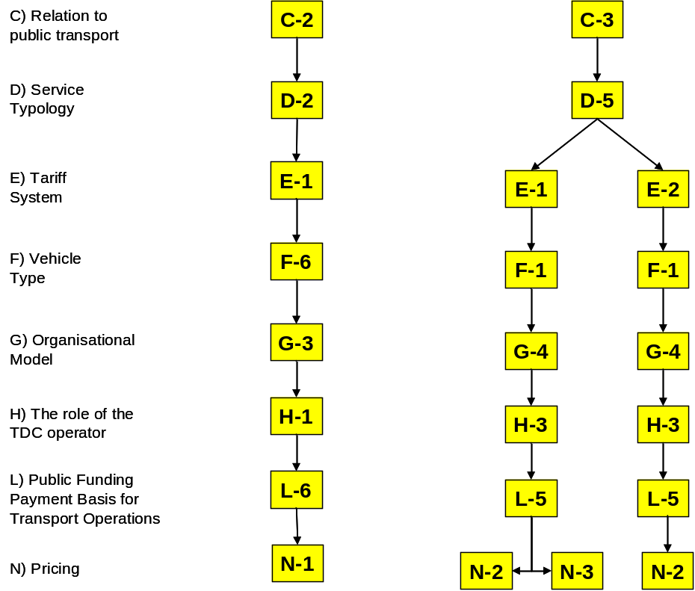
Figure 5-11: Feasible concepts of the example site La Sagra, Toledo, Spain.

Urban Case 3, CIS
The Service Concept will be Urban, but all options are open at present. The following section and Table 5-10 presents the possible combinations for Urban Case 3. As with Urban Case 2, it is still pre-feasibility, and they don’t run any FTS yet. However, they do have extensive minibus operations. Thus a system could be mobilised very quickly, if there was a positive business case and a consensus to act.

Concept Dimension
Business Model Dimensions
A) Target Market | A-1 |  |  |  | A-2 |  |  |  |  | A-3 |  |  |  |  | A-4 |  |  |  |  | A-5 |  |  |  |  | A-6
B) Target area | B-1 |  |  |  |  |  |  |  |  | B-2 |  |  |  |  |  |  |  |  |  | B-3
C) Relation to public transport | C-1 |  |  |  |  | C-2 |  |  |  |  |  | C-3 |  |  |  |  |  | C-4 |  |  |  |  |  | C-5
D) Service typology | D-1 |  |  |  |  | D-2 |  |  |  |  |  | D-3 |  |  |  |  |  | D-4 |  |  |  |  |  | D-5
E) Tariff system | E-1 |  |  |  |  |  |  |  |  | E-2 |  |  |  |  |  |  |  |  |  | E-3
F) Vehicle type | F-1 |  |  | F-2 |  |  |  |  | F-3 |  |  |  | F-4 |  |  |  | F-5 |  |  |  | F-6 |  |  |  |  | F-7
Organisational Model Dimensions
G) The organisational model | G-1 |  |  | G-2 |  |  |  |  | G-3 |  |  |  | G-4 |  |  |  | G-5 |  |  |  | G-6 |  |  |  |  | G-7
H) The role of the TDC operator | H-1 |  |  |  |  |  |  |  |  | H-2 |  |  |  |  |  |  |  |  |  | H-3
I) Public Control | I-1 |  |  |  |  |  |  |  |  | I-2 |  |  |  |  |  |  |  |  |  | I-3
Financial Dimensions
J) Public Funding | J-1 |  |  |  |  |  |  |  |  | J-2 |  |  |  |  |  |  |  |  |  | J-3
K Public Funding Payment Basis for TDC | K-1 | K-2 |  |  |  |  | K-3 |  |  | K-4 |  |  |  | K-5 |  | K-6 |  |  |  | K-7 |  |  | K-8 |  |  |  |  | K-9
L Public Funding Payment Basis for Transport Operations | L-1 |  | L-2 |  |  |  |  | L-3 |  |  | L-4 |  |  |  | L-5 |  |  |  | L-6 |  |  | L-7 |  |  |  |  | L-8
Operational Dimensions
M Booking system | M1 |  | M-2 |  |  |  |  | M-3 |  |  | M-4 |  |  |  | M-5 |  |  |  | M-6 |  |  | M-7 |  |  |  |  | M-8
N Pricing | N-1 | N-2 |  |  |  |  | N-3 |  |  | N-4 |  |  |  | N-5 |  | N-6 |  |  |  | N-7 |  |  | N-8 |  |  |  |  | N-9
Table 5-10: Options for Urban Case 3, CIS
The following issues, which are not covered by the table above, and which need to be resolved:
- Where should the price relative to bus and taxi fares be positioned?
- What role the taxi firms will play – will they be competitors, or should they be brought within the scheme?
- If within, how should this be achieved, and should be taxi-owners have some share or stake in the TDC?
- Will non-pre-booked customers be accepted?
- Marketing strategy and communication channels
- Product positioning and branding
The other significant issue is whether the FTS is seen as a coherent unity, or are there multiple competing FTS services, networks, associations etc.
The four options open are:
- The transport authority establishes and operates a single FTS – this is most likely to occur if the private operators cannot work as a single body
- The transport authority establishes the FTS and contracts it out to a private entity – this is to either ensure neutrality or to have direct control of the outcome
- The transport authority persuades the operators to form a single body for FTS operation (e.g. co-operative, association, JSC) and authorises this body as the sole TDC operator for the City – with or without conditions on what it does
- The transport authority allow more than one TDC to be established, and offer either area-based or directly competing FTS services
Note that the services do not currently receive subsidy. If services are ‘contracted’ to the transport authority, it is in the current sense of a permit to operate the route/area.

Prioritisation of Concepts

FTS concept prioritisation in practice
The prioritisation of the alternative applicable FTS business models is based on the application of the AHP for the calculation of the overall priorities of the alternatives. The overall priorities express the relative importance of each alternative in contributing to the establishment of a viable and cost-effective FTS within a specific site. The application of the AHP mathematical model to the evaluation problem at hand involves the following methodological steps:
- Definition of the alternative FTS Business models. This step uses the outcome of the screening process of the assessment methodology, which leads to the feasible and viable alternative FTS business models. In this step a comprehensive and systematic definition of each business model is produced in order to accommodate the collection of experts judgements.
- Development of pairwise comparisons. The calculation of the overall priorities is based on the completion of a set of tables of pairwise comparisons. Given the hierarchical decomposition of the evaluation problem, one table of pairwise comparison is required for each element of the hierarchy apart from the elements of the bottom level (i.e. alternative FTS business models). The construction of each table of pairwise comparison can be thoroughly presented through the following coherent description of the corresponding table of the ith element placed at the jth level of the hierarchy. Assuming there are k elements at the j+1 level of the hierarchy that are directly connected to the (ith, jth) element under consideration (i.e. the element under consideration is decomposed to these k elements), the dimension of the emerging table of parwise comparison would be (k+1) x (k+1). The element (1,1) of the table is left blank. The remaining cells of both the first row and first column are filled with the corresponding k elements of the jth level of the hierarchy. It is imperative to place these elements in the same order in both the first row and column. The remaining cells of the table are completed with the pairwise comparisons that are described in the next step.
- Completion of the tables of pairwise comparisons. Each cell (m,n) of the table of pairwise comparisons is filled with the result of the following type of comparison: “How much more important is element m as compared to element n with respect to element (ith, jth) under consideration?”. The outcome of this type of comparison is placed on a 1-9 ratio scale that was presented in Table 3-6 of section 3.3. In case that element n is more important than element m then the reciprocal of the score is placed in the corresponding cell. It should be noted than the cells that form the diagonal of the table express the comparison of each element with itself and therefore the resulting score of the comparison is always unity (1). Furthermore, the scores placed in cells symmetrical to the diagonal (i.e. (m, n) and (n, m) elements) are reciprocal. It is therefore sufficient for the completion of the table of pairwise comparisons to fill in only the upper triangle part of the table. Table 6-11 presents the table of pairwise comparisons that is derived for the child-elements of C2: “Organisational Efficiency”.
 | I21 | I22
I21 | 1
I22 |  | 1
Table 6-11. Table of pairwise comparisons for the elements of C2: “Organisational Efficiency”.
It is evident that only cell (2,3) should be filled.
- Application of the AHP mathematical model. This step involves the use a software package in order to determine the overall priorities of the alternative FTS business models based on the tables of pairwise comparisons. The AHP mathematical model takes as input the hierarchy and the relevant tables of pairwise comparisons and provides the following results:
  - The inconsistency ratio, which constitutes a measure of the logical consistency of the provided pairwise comparisons. If this measure exceeds 0.1 in one of the tables then the corresponding pairwise comparisons should be reconsidered in order to guarantee the transitivity of the comparisons.
  - The overall priorities of the alternative FTS business models. These priorities are non-negative and sum up to unity. The ranking of the alternatives is achieved by putting the emerging overall priorities to descending order.
  - The weights of the criteria, sub-criteria, and indicators. These weights express the relative importance of the criteria, sub-criteria and indicators based on the experts’ judgment.
Furthermore, sensitivity analysis may be performed in order to verify the validity and the robustness of the resulting prioritisation of the alternative FTS business models. This task involves the determination of the changes of the overall priorities to minor changes to the weights of the criteria, sub-criteria and indicators.
In theory, there is no limit in the number of alternative FTS business models that can be placed at the bottom level of the hierarchy. However, there is a limit in the number of alternative options that can be compared by human intelligence (7+/- 2) [Saaty, 1991]. This constraint in the capability of humans in performing comparisons sets a practical upper bound at the number alternative FTS business models equal to 9. It is apparent that this constraint in the number of alternative FTS business model creates an impediment in the application of the methodology when the resulting applicable FTS business models exceed nine. However this problem can be resolved through aggregating the alternative business models to major business model categories thus decreasing the number of alternatives below nine. Then the prioritisation process can be applied at two levels: 1) in level 1 the prioritisation of the categories of business models is aimed, and 2) at the second level the elements of the most beneficial category of FTS business models are prioritised. A comprehensive application of this approach is provided in the Helsinki case study that is presented in the following section.
It should be pointed out though that in case the indicators identified in the hierarchy are measured objectively on an absolute scale quantitative or qualitative scale, there aforementioned practical limit is not valid. In this case the number of alternatives in unbounded.

Example sites

Helsinki, Finland
As mentioned in Chapter 5.2.1, the concept screening produced 18 feasible concepts for the assessment phase. Therefore the 18 concepts are categorised in six main concepts (four of them have four lower class concepts). The assessment procedure is done so that first the six main concepts are assessed. After that the four lower class concepts are assessed, if the best main class concept has lower levels. The categorisation of concepts can be seen from the Figure 6-12 below.
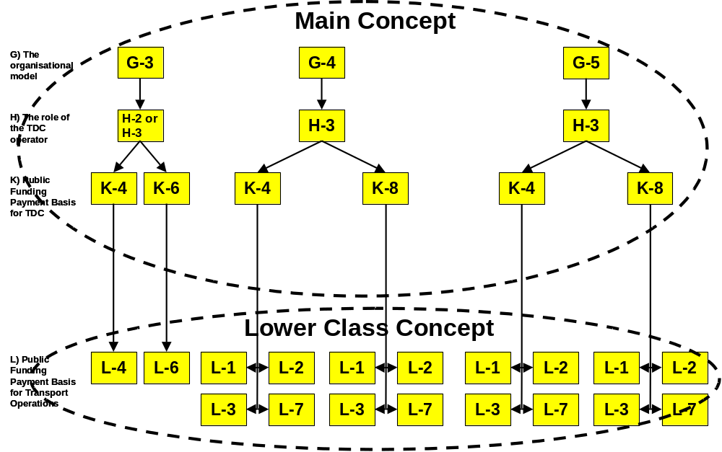
Figure 6-12: The categorisation of the feasible concepts of the example site Helsinki, Finland.
The six main concepts are summarised below (only the dimensions that differentiate one concept from another are included).
Main Concept 1:
G) The organisational model | TDC and transport operations are contracted as a comprehensive service to the one operator.
H) The role of the TDC operator | The TDC operator could be also transport operator or not because in the tendering process the role is not limited.
K) Public funding payment basis for TDC | The TDC operator is paid based on the number of passenger trips.
Main Concept 2:
G) The organisational model | TDC and transport operations are contracted as a comprehensive service to the one operator.
H) The role of the TDC operator | The TDC operator could be also transport operator or not because in the tendering process the role is not limited.
K) Public funding payment basis for TDC | The TDC operator is paid based with the lump sum.
Main Concept 3:
G) The organisational model | TDC and transport operations are contracted separately and there is only one transport operator who handles transports.
H) The role of the TDC operator | The TDC operator is not a transport operator
K) Public funding payment basis for TDC | The TDC operator is paid based on the number of passenger trips.
Main Concept 4:
G) The organisational model | TDC and transport operations are contracted separately and there is only one transport operator who handles transports.
H) The role of the TDC operator | The TDC operator is not a transport operator
K) Public funding payment basis for TDC | The revenue of the TDC operator is based on the savings that the FTS produces from the transports.
Main Concept 5:
G) The organisational model | TDC and transport operations are contracted separately. Multiple transport operators handle the transport operations.
H) The role of the TDC operator | The TDC operator is not a transport operator
K) Public funding payment basis for TDC | The TDC operator is paid based on the number of passenger trips.
Main Concept 6:
G) The organisational model | TDC and transport operations are contracted separately. Multiple transport operators handle the transport operations.
H) The role of the TDC operator | The TDC operator is not a transport operator
K) Public funding payment basis for TDC | The revenue of the TDC operator is based on the savings that the FTS produces from the transports.
The main concepts were processed with the assessment methodology. Annex A presents how the tables of pair wise comparisons and concept comparisons were filled. The AHP calculations based on the tables were done with the software Expert Choice (EC). It is a multi-objective decision support tool based on the AHP.
Results of the assessment can be seen from the figure below. The weights of the evaluations criteria and indicators of the criteria are presented in Annex B.
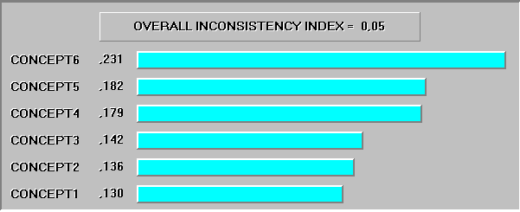
Figure 6-13: Ranking of the main concepts of the example site Helsinki, Finland.
Main concept 6 was ranked as a best concept with quite clear margin. It has four lower class concepts that could be assessed with the same methodology as main concepts. As the public funding basis for transport operations is the only dimension that separates the lower class concepts, the evaluation could be done also without the methodology. Possible options for the public funding basis for transport operations are as follows:
- Per vehicle trip
- Per vehicle-kilometre
- Per vehicle-hour
- Per passenger trip.
Since the TDC and transport operations are contracted separately, the transport operators have no influence on arrangements of transports. On the basis of this the payment per vehicle trip and per passenger trip are not as good as payment per vehicle-kilometre or per vehicle hour.
Additional use of the assessment methodology is not needed as the two quite similar variations of the main concept 6 can be taken into deeper analysis without respectable alternatives.

Rural Case 1, EU
In the Rural Case 1 example, there is already a quite determined view of the FTS scheme. This has happened for two reasons:
- The Company already operates FTS services. It is not practical to consider that they will radically change the organisational framework.
- The Company has already gone through the process of considering the basic nature of the service to be offered in the target area. Given the understanding of both the Company’s societal mission and the needs of the people in the area, many characteristics of the proposed are considered to be self-evident
As will be seen below, this has two impacts:
- Many of the features are already fixed. The number of options is not very large, and the variation (within the terms of the CONNECT framework) appear to be relatively small.
- The focus is on the business dimensions. These are not well covered by the framework.
Within the CONNECT framework, the only parameters with open options are M and N. For parameters A, D and L, there is one definite solution and there are options that may be offered as supplemental.
By contrast, there are four main issues, which the Company must consider, and which are important to the viability of the FTS service:
- Whether to direct operate or to sub-contract. [There are both cost and funding support implications of each]
- Whether to operate a full customer day (07.30–19.30), which will require at least two drivers, or to operate whatever is possible with one driver. [Longer day will substantially increase the cost. The big issue is what will it do both to the revenue and the mobility of the key target groups]
- Whether to charge a flat fare regardless of distance travelled, or a differentiated fare; and whether to offer discounts for frequent travel. [There is the normal set of issues such as equity, customer understanding, fare collection equipment, and convenience. There is also the background issue that separate fares moves the FTS into a formal route, which requires a licence. But, there is no mechanism to grant a licence to a flexible route]
- Whether to accept concessionary passes if there is not an explicit reimbursement. [If they accept the passes, it is unlikely that they will be reimbursed, and they will lose any leverage to get such reimbursement. It could have devastating impact on revenues and costs].
Parameters G and H are not really designed to cater for sub-contracting specific services while continuing to direct operate all other services.
In this particular case, we appear to have reached limitations in the ability of CONNECT framework and assessment methodology to support practical choices, even if it is good for supporting conceptual choices.
Nonetheless, the stakeholders at Rural Case 1 site have found the process useful, and it has given them material for future reflection.

Urban Case 2, EU
For the purpose of this exercise, the following are the pivotal decisions:
- Whether to serve only target groups and areas that have poor/no public transport supply, or whether to consider all areas on their merit (A, B)
- Whether the FTS should be ‘subservient’ in its role, or whether it can offer services where PT already exists (not as head-to-head competitor) (C, D)
- Whether to position FTS as a ‘premium product’ which is attractive and appropriately priced, or as a ‘social product’ (D, L, M)
- Whether the City is the central player, or stimulates the operator sector (G, H, I)
- Whether the City takes on the fiscal burden for the services, or just provides stimulatory funding
Four options are set out in Table 6-12 to reflect these key decision areas. It is obvious that more than four options are needed to properly explore these questions, let alone the finer variations among them. Nonetheless, the four options should help test the processes and tools.
It should be noted that the business dimensions set out above are not reflected here.

Parameter | Option A | Option B | Option C | Option D | Comment
Target Area | Western suburbs of the City and hinterland beyond the City boundary
Service Concept | Local Journeys in Urban Areas | Urban Periphery | Flexible Routes in Suburban Area | Local Journeys in Urban Areas
Business Model Dimensions
A) Target Market | A-3: Passengers with PT supply, but which is not well matched to their needs | A-3: Passengers with PT supply, but which is not well matched to their needs | A-3: Passengers with PT supply, but which is not well matched to their needs | A-4: Passengers who are adequately served by other modes | Options A , B and C are complementary to the conventional transport.  Option D does not go head-to-head with conventional transport, but neither is it constrained by it.
B) Target area | B-3: Where public transport exists, but serves only specific needs | B-3: Where public transport exists, but serves only specific needs | B-3: Where public transport exists, but serves only specific needs | B-1: All areas
C) Relation to public transport | C-1: Stand alone | C-3: Complementary, as feeder | C-1: Stand alone | C-4: Complementary, as equal
D) Service typology | D-3: Point to point service on demand | D-2: Routes and possible deviations to serve predefined stops on demand | D-2: Routes and possible deviations to serve predefined stops on demand | D-3: Point to point service on demand | Options B and C are understood by users as being like bus routes. Options A and D are more person-customised
E) Tariff system | E-1: Vouchers or pay per trip |  |  |  | In the short term, it is not practical to think of integrating with the conventional transport tariff system.
F) Vehicle type | F-2: Minibus |  |  |  | Options B and C might need buses as the service develops
Organisational Model Dimensions
G) The organisational model | G-3: The public body has contracted the TDC and transport operations as a comprehensive service to the one operator | G-5: The public body has contracted the TDC operations to the one operator. Multiple operators handle the transport operations | G-4: The public body has contracted the TDC and transport operations separately | G-5: The public body has contracted the TDC operations to the one operator. Multiple operators handle the transport operations | The City will not be the TDC Operator, but they will contract it out and control it.
H) The role of the TDC operator | H-2: The main occupation is TDC operations, but also own transport capacity for FTS. In addition the subcontractors are used for the transport operations | H-2: The main occupation is TDC operations, but also own transport capacity for FTS. In addition the subcontractors are used for the transport operations | H-3: The TDC operator is not a transport operator | H-3: The TDC operator is not a transport operator | For Options C and D, the TDC Operator must be neutral relative to the operators. It is not so important for Option B. Option A is a turnkey contract.
I) Public Control | I-2: A single public body controls the FTS |  |  |  | In reality, this may not be true, but for this exercise the City takes the initiative.
Financial Dimensions
J) Public Funding | J-2: A single public body funds the FTS |  |  |  | Again, for this exercise, the City carried the financial burden.
K) Public Funding Payment Basis for TDC | K-6: Lump Sum |  |  |  | No knowledge on which to base an alternative.
L) Public Funding Payment Basis for Transport Operations | L-3: Per vehicle-hour | L-2: Per vehicle-kilometre | L-7 Guaranteed revenue | L-4: Per passenger trip | Basis selected to provide best incentives for service type.
Operational Dimensions
M) Booking system | M-1: Call to TDC operator | M-8: Combination of preceding systems | M-8: Combination of preceding systems | M-8: Combination of preceding systems | Option A is phone only. Other options will accept SMS and Internet bookings as well.
N) Pricing | N-1: Flat | N-3: Distance | N-3: Distance | N-1: Flat | Options A and D expect to be short trips, Options B and C could be much longer.
Table 6-12: Four concepts for Urban Case 2, EU
The four concepts were evaluated using AHP. The weights of the evaluation criteria and indicators were obtained from a single expert. This would clearly be insufficient and unsafe for a real-life application leading to decision taking. However, it is deemed fit for purpose to test the usability and soundness of the outcome. The weighting values are presented in Annex B.
The results of the AHP ranking of the four concepts are shown in Figure 6-14 below:
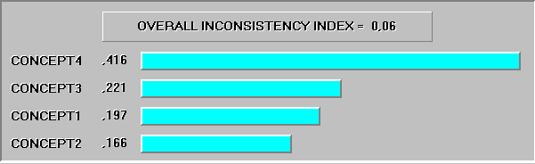
Figure 6-14: AHP Ranking of the 4 concepts for Urban Case 2
This shows that Concept 4 is very clearly preferred over the other three concepts. Concepts 1, 2, and 3 have visible but moderate differences in the overall score.
However, three very strong cautions have been made by the expert:
- The experts should have a very clear understanding of the characteristics and practical aspects of the concepts before applying the weightings. It would be best that all the participating experts discuss the concepts. Otherwise, it carries a very strong risk of bias for and against certain options, perhaps based on a misunderstanding of the concept.
- A clearer definition of the indicators is needed.
- Estimates of the patronage levels, costs, revenues and other key impacts are needed, particular for the Indicators in Criteria C and E. Otherwise, it is purely guesswork, which again may bring a systematic bias into the relative weightings.
These cautions should not be interpreted to mean that Concept 4 would not be the preferred option in a broader exercise.
The key strengths of Concept 4 are the positioning of the FTS service as a transport mode in its own right, free to develop its business and not prevented from competing with other public transport modes (although not seeking to take their business either). This offers the highest potential usage and best alignment with user needs. However, these same characteristics also make it the most likely concept to be challenged and possibly blocked by the regulatory framework or other less visible influences.

La Sagra, Toledo, Spain
As mentioned in Chapter 5.2.4, the concept screening produced 4 feasible concepts for the assessment phase. In the case of La Sagra, the concepts are very influenced by the context and the background, and the result is that only 4 feasible concepts have been selected, what means that the assessment methodology can be directly applied to these concepts without the need of a previous categorisation: the experts can easily manage to consider the four options. These four concepts are summarised below (only the dimensions that differentiate one concept from another are included).
Concept 1:
C) Relation to public transport | Complementary, as a feeder.
D) Service typology | Combination of door-to-door service and point-to-point service.
E) Tariff system | Pay per trip
E) Pricing | Based on the distance
Concept 2:
C) Relation to public transport | Complementary, as a feeder.
D) Service typology | Combination of door-to-door service and point-to-point service.
E) Tariff system | Pay per trip
E) Pricing | Zonal
Concept 3:
C) Relation to public transport | Complementary, as a feeder.
D) Service typology | Combination of door-to-door service and point-to-point service.
E) Tariff system | Zonal system with special tariff but integrated in the PT-environment
E) Pricing | Zonal
Concept 4:
C) Relation to public transport | Integrated
D) Service typology | Routes and possible deviations to serve predefined stops on demand
E) Tariff system | Pay per trip
E) Pricing | Flat

These concepts were processed using the assessment methodology and the results are shown in figure below. The weights of the evaluation criteria and indicators of the criteria are presented in Annex B.

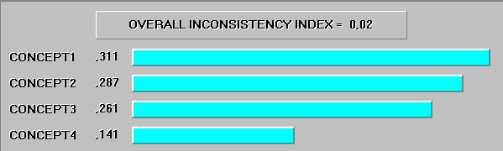
Figure 6-15: Ranking of concepts of the example site La Sagra, Toledo, Spain.
As we can see, Concept 1 is ranked as the best concept with quite clear margin over concepts 2, 3 and 4. The difference in the ranking of concepts 1−2 and 2−3 is not so big. However, the difference between the ranking of the three first concepts and concept 4 is even more than 50%. These results are quite logical. There are two main conclusions that arise from them:
- The experts consider that, from a business development point of view, and in the case of La Sagra, the taxi acting as a feeder of the regular public transport service is better option than the public transport deviating from the regular route to serve predefined stops on demand.
- The three concepts emerging from the feeder door to point service have been evaluated and compared from the tariff system and pricing perspectives, and the experts have concluded that the pay per trip tariff system, in the case of La Sagra, is better than the zonal system and that the pricing based on the distance covered by the taxi is better than a zonal pricing system.

Strengths and Weaknesses
The CONNECT team has gained experiences from the use of concept description, concept screening and prioritisation during the build-up of D12. The methods developed during the build-up were also presented in the Cremona Work Shop for experts around from Europe outside the CONNECT consortium. The discussion concerning the topics is presented in this chapter.
Figure 2-4 presents the decision-taking process. At the top of the process there could be a phase for the problem definition. This phase could take into consideration what should be done and who has to make the decision. The phase could also discuss the objectives that have to be achieved.
The decision-making process is difficult if one is working in a mature environment. There can be vested interests, lack of knowledge and difficulties to benchmark. Also, if the idea is visionary, the situation can face a different set of difficulties. A lot of time could be spent getting a potential decision-maker to understand the issues, and then they move on and the process has to begin again.
To make the assessment effective, one must understand what it is assessing. Therefore, enough time should be spent for exploring and explaining. This leads to question of what is the role of the decision-taker and what is the role of the analysts. Often the analysts become the effective decision-takers by screening out so much in advance and presenting the decision-takers with their choices. Equally, sometimes the decision-takers become too much the analysts. The roles should be clear before going to the actual decision-making process. The information and knowledge flow should be described.

Describing the FTS options
One of the problems leading to getting a good decision made is the lack of knowledge of alternatives. The concept description table is quite helpful tool for the beginning. With it one can get answer to questions:
- What options do we have and what problems should we solve?
- What do we take forward?
- What do we leave behind (it is possible to come back and look at later)?
The concept description table has proved to be easy to use. With a little effort the interesting issues can be raised for the discussion. The stakeholder, who is planning to implement FTS, has to go through all dimensions and options. Therefore the stakeholder may discover new possibilities for the implementation that would not have occurred without the concept description table.
When the experts go through the dimensions and options of the concept description table they should have a good understanding about the background and context of the FTS site. The more details we get from the context and background, the easier will be the methodology application since the number of feasible concepts will decrease. The knowledge about the context is not however completely guaranteed so the use of the concept description might deepen the understanding of the context and its background.
The table can be used with different approaches. A potential FTS site could have no clue on possible FTS concepts. With the table the FTS can formulate all possible concepts for its needs. In another case a FTS site could have more knowledge about the FTS and its applicability to the site. In that case the table is used for choosing the permitted options. In the third case the FTS site could have implemented FTS earlier, but it wants to compare it with other possibilities. The table could be used for setting up couple of alternative concepts. The concept description table could also be used in the tendering process as a good checklist.
One of the biggest limitations of the concept description table is that it does not show interdependences of the dimensions and options. Two options could be permitted separately, but not together. The experts who use the table should notice the interdependences themselves as well as the possible combinations. This is not always an easy task.
The result of the concept screening process might be something from 1 to 100 possible concepts. After that it is quite hard to decide what concepts should be taken into concept prioritisation phase.
It has been noted that in the table there could be dimensions that cover the legal dimensions as tendering and contracting. This should be taken into account in order to avoid the risk of “going to the court” and having unexpected external decision takers coming into the decision-making process. The legal dimensions are however dealt in the context description so that the legal constraints are considered within each concept dimension and option. Also one could argue that the legal dimensions are common to all options at the site. This also applies to some dimensions concerning marketing and others.
In the financial dimension it might be useful to include different options considering the cost recovery ratio. There is also a problem of terminology as for an example; it is not clear for all what the service typology means. There is a need to a standardisation of the used terminology.

The assessment methodology
The definition and terminology of the criteria to assess FTS options must be very clear. Otherwise, for example the indicators C1 and C2 will inevitably be very light compared to the others, whereas in fact they are quite important.
Almost all indicators concerning the level of service are mentioned with positive effects such as “increase, improve” – but the result could also be negative. The terminology should be more open, including negative effects, or state the impacts without presuming the direction.
As a first impression the Analytic Hierarchy Process (AHP) used in the assessment methodology is a little bit too theoretical and complicated. In SAMPO project a simple matrix of stakeholders was used with good results. Comments coming from who have already used AHP are however that they have found it easy to use once they understand what they are trying to do. A key stage is getting the experts to understand what the options are. It has to be noted and understood that AHP is intended for a specific phase of the work. It is not the end-to-end solution. It can be used to rank and select options. It is a screening tool that allows comparing alternatives without measuring them in absolute values.
There are not a specific optimum number of experts that should be used in the concept assessment. The optimum depends very much on the problem. However, there should be enough experts to cover the main stakeholder viewpoints. A significant statistical sample is not needed. If important viewpoints are not covered, it won’t be so effective. Also if all the experts have a similar view, there will not be the same necessity to use the tradeoffs.
The prioritisation process has to be carried out by actual experts in order to get valuable results. A problem raised is the way to test whether the expert really is an ‘expert’. The AHP can be useful in this respect because it is possible to test the consistency of the rankings. On one side, there is a risk that a person is not really an expert. On the other hand they bring with them an overt or latent bias towards a specific option. The AHP checks for (in)consistency, and this can reveal less than reliable experts. As other decision making tools the sensitivity analysis is quite important in order to understand the weight of the different criteria.
The indicators in the assessment methodology do not cover well the business generation effectiveness. The indicators I3.1 and I3.2 are two profitability elements and are linked so that the comparison between them is not very practical in most cases.
When the potential concepts are compared there is a question does one rate the concepts in advance of having the information needed to do so. For some items one can guess. For many, one would need a mix of fiscal analysis, travel pattern assessment, and practical measurements. This is particularly the case for C3.
The experts should have very clear understanding of the characteristics and practical aspects of the concepts before applying the weightings. It would be best that all the participating experts discuss the concepts. Otherwise, it carries a very strong risk of bias for and against certain options, perhaps based on a misunderstanding of the concept.
The results obtained with the assessment methodology are easily understood and they provide not only the ranking of feasible concepts but also relevant information on the experts’ answers consistency (inconsistency ratio, overall inconsistency index). The concept description does not include any financial data. Therefore, once the best-ranked concepts will be identified the deeper analysis should be performed.

Potential Concepts
This deliverable has demonstrated that the applicability of the concept depends crucially on the context and background and therefore the development of a generic or a number of possible concepts would be inappropriate. This can be easily understood if we have a look to the table that summarises all existing dimensions. Although not all the combinations of the dimensions and options are feasible, we have proven with the examples where the assessment methodology has been applied that there are multiple options depending on the context and the background of the concrete case.
What is developed is a toolbox for identifying which are the potential FTS concepts, from a business development point of view, for a given context and a given background. The toolbox will help decision-takers to choose among the different options available when a FTS service is to be implemented, extended or modified.

Conclusions
The work reported in Deliverable D12 has produced tools for exploring the strengths and weaknesses of various concept and methodology elements. The tools are meant for the use of practitioners and therefore, the Deliverable D12 is quite much in a manual like format. All the relevant chapters include sections for examples and presented methods are described as simple as possible.
The concept description table and the concept screening and prioritisation methods are now ready from the point of view of the CONNECT project. These can be used directly by either CONNECT partners or external people. What comes to next steps of the CONNECT project, the next Deliverable D14 will give more detailed analyses for the potentially viable FTS concepts and make recommendations for Business Development for FTS.
Now it would be good to get the knowledge gained working with D12 into the hands of practitioners. In a long term the ideas from the practitioners could be used for a further development of the FTS concepts.

Bibliography and References

Business Models
Ambrosino, G, Nelson, J D and Romanazzo, M (Eds) (2003) “Demand Responsive Transport Services: Towards the Flexible Mobility Agency”, Rome: ENEA.

CONNECT Consortium (2004a) “Business Development Knowledge Base Repository”, IST Programme Project No FP6-PLT-506959 Deliverable No. 5. Commission of the European Communities, Bruxelles, October 2004.

CONNECT Consortium (2004b) “CONNECT Training Module E: Business development”, IST Programme Project No FP6-PLT-506959 Commission of the European Communities, Bruxelles, 2004.

CONNECT Consortium (2005a) “Innovative Solutions and Test Cases concerning Business Development”, IST Programme Project No FP6-PLT-506959 Deliverable No. 10. Commission of the European Communities, Bruxelles, March 2005.

CONNECT Consortium (2005b). “Position Paper on Flexible Transport Systems Business Models”, reported in IST Programme Project No FP6-PLT-506959 Deliverable No. 11. “Workshop Report: Impacts and Business Case”, Commission of the European Communities, Bruxelles, 2005.

FAMS Consortium (2003) “Comparative Evaluation and Business Case Assessment”, IST Programme Project No IST-2001-34347 Contract Report 7. Commission of the European Communities, Bruxelles, August.

Assessment Methodology
Saaty L.T., L.G. Vargas. (1991). The Logic of Priorities. The Analytic Hierarchy Process Series Vol. III (1991), RWS Publications, Pittsburgh, USA.

Saaty L.T. (1990). The Analytic Hierarchy Process: Planning, Priority Setting, Resource Allocation. The Analytic Hierarchy Process Series Vol. I (1990). RWS Publications, Pittsburgh, USA.

Regulatory Framework
CONNECT Consortium (2004c) “CONNECT Training Module A: Systems and Operations of FTS”, IST Programme Project No FP6-PLT-506959 Commission of the European Communities, Bruxelles, 2004.

Berechman, J (1993) “Public Transit Economics and Deregulation Policy”, Amsterdam.

Organisational Issues

Sihvola T. (2003) “Conceptual development of Integrated Multiservice Transportation Centres”, Masters Thesis, Helsinki University of Technology.

Abbreviations

Abbreviation | Description
AHP | Analytic Hierarchy Process
B2B | Business to Business
B2C | Business to Customer
CONNECT | Co-ordination of CONcepts for New Collective Transport – EU supported knowledge network with focus on FTS
DART | Dial-a-Ride Transport – FTS service operated in rural parts of Angus, Scotland.
DRT | Demand Responsive Transport
Dx (e.g. D5, D10) | Deliverable of the CONNECT project, D = Deliverable, x = sequential production number. The current document is D12.
EU | European Union
FAMS | Flexible Agency for Mobility Services. Key EU research project (2002-4) in DRT and FTS which developed B2B/B2C platform for DRT.
FTS | Flexible Transport Service
ITS | Intelligent Transport Systems (also known as ‘Telematics’)
KAN | Kommune Arnhem-Nijmegen – local and passenger transport authority for region of Arnhem-Nijmegen, Netherlands
KBR | Knowledge Base Repository
NEXUS | Passenger Transport Authority in Newcastle-upon-Tyne, UK. Operator of FTS services Ucall and Phone’n’Go.
NLA | Former small FTS operator in Rotterdam, section of RET, which has subsequently been restructured as RMC, current operator of VVM
PSV | Public Service Vehicle – especially in UK “PSV Licence”
(U)PT | (Urban) Public Transport
RET | Rotterdam Electric Traction – public sector monopoly passenger transport provider in Rotterdam, Netherlands
RMC | Rotterdam Mobility Centre – operator of VVM in Rotterdam, joint venture owned by RET and RMT, Rotterdam’s leading taxi operator.
RTI | Rural Transport Initiative – program of Department of Transport in Ireland, initiated 2002, which currently supports 34 rural community FTS organisations.
SAMPO, SAMPLUS | EU sponsored projects of 4th FP in 1996-7 and 1998-9 respectively in which ITS for DRT was developed and demonstrated in European sites
SMS | Short Message Service
TDC | Travel Dispatch Centre
TEC | Transport en Commun - public sector monopoly passenger transport service provider in Wallonia, Belgium.
VVM | Vervoer op Maat – FTS service for registered special needs users operated in Rotterdam, Netherlands

Annex A: Example of the pair wise comparisons and concept comparisons
Reader should note that the following tables are generated based on the earlier version of the assessment methodology than presented in this Deliverable. Therefore, some indicators of the hierarchical decomposition may be missing in tables.

Tables of pair wise comparisons
Figure 3-8 presents the table of pairwise comparisons. Each of the empty non-shaded cells should be completed by performing the comparison of the type: “How much important is element C3i from C3j (j>i) with respect to C3?”. The outcome of this type of comparison may take the values presented in Table 3-6.

The example of the complete set of tables of pairwise comparisons is provided below. Each expert will fill own tables that are processed with the AHP software. First the criteria and then the indicators described in the Figure 3-7 are compared based on the importance.

C1: System Performance | 9 | 8 | 7 | 6 | 5 | 4 | 3 | 2 | 1 | 2 | 3 | 4 | 5 | 6 | 7 | 8 | 9 | C2: Organisational Efficiency
C1: System Performance | 9 | 8 | 7 | 6 | 5 | 4 | 3 | 2 | 1 | 2 | 3 | 4 | 5 | 6 | 7 | 8 | 9 | C3: Financial Viability
C1: System Performance | 9 | 8 | 7 | 6 | 5 | 4 | 3 | 2 | 1 | 2 | 3 | 4 | 5 | 6 | 7 | 8 | 9 | C4: Level of Transport Service
C1: System Performance | 9 | 8 | 7 | 6 | 5 | 4 | 3 | 2 | 1 | 2 | 3 | 4 | 5 | 6 | 7 | 8 | 9 | C5: Societal Impacts
C2: Organisational Efficiency | 9 | 8 | 7 | 6 | 5 | 4 | 3 | 2 | 1 | 2 | 3 | 4 | 5 | 6 | 7 | 8 | 9 | C3: Financial Viability
C2: Organisational Efficiency | 9 | 8 | 7 | 6 | 5 | 4 | 3 | 2 | 1 | 2 | 3 | 4 | 5 | 6 | 7 | 8 | 9 | C4: Level of Transport Service
C2: Organisational Efficiency | 9 | 8 | 7 | 6 | 5 | 4 | 3 | 2 | 1 | 2 | 3 | 4 | 5 | 6 | 7 | 8 | 9 | C5: Societal Impacts
C3: Financial Viability | 9 | 8 | 7 | 6 | 5 | 4 | 3 | 2 | 1 | 2 | 3 | 4 | 5 | 6 | 7 | 8 | 9 | C4: Level of Transport Service
C3: Financial Viability | 9 | 8 | 7 | 6 | 5 | 4 | 3 | 2 | 1 | 2 | 3 | 4 | 5 | 6 | 7 | 8 | 9 | C5: Societal Impacts
C4: Level of Transport Service | 9 | 8 | 7 | 6 | 5 | 4 | 3 | 2 | 1 | 2 | 3 | 4 | 5 | 6 | 7 | 8 | 9 | C5: Societal Impacts

Degree of coordination of the stakeholders | 9 | 8 | 7 | 6 | 5 | 4 | 3 | 2 | 1 | 2 | 3 | 4 | 5 | 6 | 7 | 8 | 9 | Contribution to the degree of transport integration
Expected system cost | 9 | 8 | 7 | 6 | 5 | 4 | 3 | 2 | 1 | 2 | 3 | 4 | 5 | 6 | 7 | 8 | 9 | Expected System Revenue
Expected system cost | 9 | 8 | 7 | 6 | 5 | 4 | 3 | 2 | 1 | 2 | 3 | 4 | 5 | 6 | 7 | 8 | 9 | Cash Flow and first year performance
Expected System Revenue | 9 | 8 | 7 | 6 | 5 | 4 | 3 | 2 | 1 | 2 | 3 | 4 | 5 | 6 | 7 | 8 | 9 | Cash Flow and first year performance
Increase of comfort | 9 | 8 | 7 | 6 | 5 | 4 | 3 | 2 | 1 | 2 | 3 | 4 | 5 | 6 | 7 | 8 | 9 | Improvement of transport reliability
Increase of comfort | 9 | 8 | 7 | 6 | 5 | 4 | 3 | 2 | 1 | 2 | 3 | 4 | 5 | 6 | 7 | 8 | 9 | Improve geographical coverage of transport services
Increase of comfort | 9 | 8 | 7 | 6 | 5 | 4 | 3 | 2 | 1 | 2 | 3 | 4 | 5 | 6 | 7 | 8 | 9 | Improve customization of services
Improvement of transport reliability | 9 | 8 | 7 | 6 | 5 | 4 | 3 | 2 | 1 | 2 | 3 | 4 | 5 | 6 | 7 | 8 | 9 | Improve geographical coverage of transport services
Improvement of transport reliability | 9 | 8 | 7 | 6 | 5 | 4 | 3 | 2 | 1 | 2 | 3 | 4 | 5 | 6 | 7 | 8 | 9 | Improve customization of services
Improve geographical coverage of transport services | 9 | 8 | 7 | 6 | 5 | 4 | 3 | 2 | 1 | 2 | 3 | 4 | 5 | 6 | 7 | 8 | 9 | Improve customization of services
Improvement of personal mobility among target groups | 9 | 8 | 7 | 6 | 5 | 4 | 3 | 2 | 1 | 2 | 3 | 4 | 5 | 6 | 7 | 8 | 9 | Impact on the traffic level of the target area
Improvement of personal mobility among target groups | 9 | 8 | 7 | 6 | 5 | 4 | 3 | 2 | 1 | 2 | 3 | 4 | 5 | 6 | 7 | 8 | 9 | Recovery/Improvement of the local economy
Improvement of personal mobility among target groups | 9 | 8 | 7 | 6 | 5 | 4 | 3 | 2 | 1 | 2 | 3 | 4 | 5 | 6 | 7 | 8 | 9 | Mitigation of Environmental Impacts
Improvement of personal mobility among target groups | 9 | 8 | 7 | 6 | 5 | 4 | 3 | 2 | 1 | 2 | 3 | 4 | 5 | 6 | 7 | 8 | 9 | Increase transport safety
Impact on the traffic level of the target area | 9 | 8 | 7 | 6 | 5 | 4 | 3 | 2 | 1 | 2 | 3 | 4 | 5 | 6 | 7 | 8 | 9 | Recovery/Improvement of the local economy
Impact on the traffic level of the target area | 9 | 8 | 7 | 6 | 5 | 4 | 3 | 2 | 1 | 2 | 3 | 4 | 5 | 6 | 7 | 8 | 9 | Mitigation of Environmental Impacts
Impact on the traffic level of the target area | 9 | 8 | 7 | 6 | 5 | 4 | 3 | 2 | 1 | 2 | 3 | 4 | 5 | 6 | 7 | 8 | 9 | Increase transport safety
Recovery/Improvement of the local economy | 9 | 8 | 7 | 6 | 5 | 4 | 3 | 2 | 1 | 2 | 3 | 4 | 5 | 6 | 7 | 8 | 9 | Mitigation of Environmental Impacts
Recovery/Improvement of the local economy | 9 | 8 | 7 | 6 | 5 | 4 | 3 | 2 | 1 | 2 | 3 | 4 | 5 | 6 | 7 | 8 | 9 | Increase transport safety
Mitigation of Environmental Impacts | 9 | 8 | 7 | 6 | 5 | 4 | 3 | 2 | 1 | 2 | 3 | 4 | 5 | 6 | 7 | 8 | 9 | Increase transport safety
Table 11-13: Example table of the pair wise comparisons from the example site Helsinki, Finland.
Comparison of Concepts
The second step is the assessment of the alternative FTS concepts based on the judgments of a set of experts on the performance of each concept under the evaluation indicators. Following table presents the example of the concept comparison table at the example case Helsinki, Finland under the first two indicators “I1.1: Expected System efficiency” and “I2.1: Degree of coordination of the stakeholders”.

 | Expected System efficiency
Concept 1 | 9 | 8 | 7 | 6 | 5 | 4 | 3 | 2 | 1 | 2 | 3 | 4 | 5 | 6 | 7 | 8 | 9 | Concept 2
Concept 1 | 9 | 8 | 7 | 6 | 5 | 4 | 3 | 2 | 1 | 2 | 3 | 4 | 5 | 6 | 7 | 8 | 9 | Concept 3
Concept 1 | 9 | 8 | 7 | 6 | 5 | 4 | 3 | 2 | 1 | 2 | 3 | 4 | 5 | 6 | 7 | 8 | 9 | Concept 4
Concept 1 | 9 | 8 | 7 | 6 | 5 | 4 | 3 | 2 | 1 | 2 | 3 | 4 | 5 | 6 | 7 | 8 | 9 | Concept 5
Concept 1 | 9 | 8 | 7 | 6 | 5 | 4 | 3 | 2 | 1 | 2 | 3 | 4 | 5 | 6 | 7 | 8 | 9 | Concept 6
Concept 2 | 9 | 8 | 7 | 6 | 5 | 4 | 3 | 2 | 1 | 2 | 3 | 4 | 5 | 6 | 7 | 8 | 9 | Concept 3
Concept 2 | 9 | 8 | 7 | 6 | 5 | 4 | 3 | 2 | 1 | 2 | 3 | 4 | 5 | 6 | 7 | 8 | 9 | Concept 4
Concept 2 | 9 | 8 | 7 | 6 | 5 | 4 | 3 | 2 | 1 | 2 | 3 | 4 | 5 | 6 | 7 | 8 | 9 | Concept 5
Concept 2 | 9 | 8 | 7 | 6 | 5 | 4 | 3 | 2 | 1 | 2 | 3 | 4 | 5 | 6 | 7 | 8 | 9 | Concept 6
Concept 3 | 9 | 8 | 7 | 6 | 5 | 4 | 3 | 2 | 1 | 2 | 3 | 4 | 5 | 6 | 7 | 8 | 9 | Concept 4
Concept 3 | 9 | 8 | 7 | 6 | 5 | 4 | 3 | 2 | 1 | 2 | 3 | 4 | 5 | 6 | 7 | 8 | 9 | Concept 5
Concept 3 | 9 | 8 | 7 | 6 | 5 | 4 | 3 | 2 | 1 | 2 | 3 | 4 | 5 | 6 | 7 | 8 | 9 | Concept 6
Concept 4 | 9 | 8 | 7 | 6 | 5 | 4 | 3 | 2 | 1 | 2 | 3 | 4 | 5 | 6 | 7 | 8 | 9 | Concept 5
Concept 4 | 9 | 8 | 7 | 6 | 5 | 4 | 3 | 2 | 1 | 2 | 3 | 4 | 5 | 6 | 7 | 8 | 9 | Concept 6
Concept 5 | 9 | 8 | 7 | 6 | 5 | 4 | 3 | 2 | 1 | 2 | 3 | 4 | 5 | 6 | 7 | 8 | 9 | Concept 6
 | Degree of coordination of the stakeholders
Concept 1 | 9 | 8 | 7 | 6 | 5 | 4 | 3 | 2 | 1 | 2 | 3 | 4 | 5 | 6 | 7 | 8 | 9 | Concept 2
Concept 1 | 9 | 8 | 7 | 6 | 5 | 4 | 3 | 2 | 1 | 2 | 3 | 4 | 5 | 6 | 7 | 8 | 9 | Concept 3
Concept 1 | 9 | 8 | 7 | 6 | 5 | 4 | 3 | 2 | 1 | 2 | 3 | 4 | 5 | 6 | 7 | 8 | 9 | Concept 4
Concept 1 | 9 | 8 | 7 | 6 | 5 | 4 | 3 | 2 | 1 | 2 | 3 | 4 | 5 | 6 | 7 | 8 | 9 | Concept 5
Concept 1 | 9 | 8 | 7 | 6 | 5 | 4 | 3 | 2 | 1 | 2 | 3 | 4 | 5 | 6 | 7 | 8 | 9 | Concept 6
Concept 2 | 9 | 8 | 7 | 6 | 5 | 4 | 3 | 2 | 1 | 2 | 3 | 4 | 5 | 6 | 7 | 8 | 9 | Concept 3
Concept 2 | 9 | 8 | 7 | 6 | 5 | 4 | 3 | 2 | 1 | 2 | 3 | 4 | 5 | 6 | 7 | 8 | 9 | Concept 4
Concept 2 | 9 | 8 | 7 | 6 | 5 | 4 | 3 | 2 | 1 | 2 | 3 | 4 | 5 | 6 | 7 | 8 | 9 | Concept 5
Concept 2 | 9 | 8 | 7 | 6 | 5 | 4 | 3 | 2 | 1 | 2 | 3 | 4 | 5 | 6 | 7 | 8 | 9 | Concept 6
Concept 3 | 9 | 8 | 7 | 6 | 5 | 4 | 3 | 2 | 1 | 2 | 3 | 4 | 5 | 6 | 7 | 8 | 9 | Concept 4
Concept 3 | 9 | 8 | 7 | 6 | 5 | 4 | 3 | 2 | 1 | 2 | 3 | 4 | 5 | 6 | 7 | 8 | 9 | Concept 5
Concept 3 | 9 | 8 | 7 | 6 | 5 | 4 | 3 | 2 | 1 | 2 | 3 | 4 | 5 | 6 | 7 | 8 | 9 | Concept 6
Concept 4 | 9 | 8 | 7 | 6 | 5 | 4 | 3 | 2 | 1 | 2 | 3 | 4 | 5 | 6 | 7 | 8 | 9 | Concept 5
Concept 4 | 9 | 8 | 7 | 6 | 5 | 4 | 3 | 2 | 1 | 2 | 3 | 4 | 5 | 6 | 7 | 8 | 9 | Concept 6
Concept 5 | 9 | 8 | 7 | 6 | 5 | 4 | 3 | 2 | 1 | 2 | 3 | 4 | 5 | 6 | 7 | 8 | 9 | Concept 6
Table 11-14: Example table of the concept comparisons from the example site Helsinki, Finland.

Annex B: Example of the weights in Concept Assessment Methodology
Reader should note that some of the following results are obtained with the earlier version of the assessment methodology than presented in this Deliverable. Therefore, some indicators of the hierarchical decomposition may be missing in figures.
The AHP calculations in this document have been done with the software Expert Choice (EC). It is a multi-objective decision support tool based on the AHP.
Example case Helsinki, Finland
The following figure shows the weights of the evaluation criteria at the example case Helsinki, Finland. As can be seen, the experts have valued the Financial Feasibility (Criterion C3) and Transport Level of Service (Criterion C4) to be clearly more important than other three criteria.

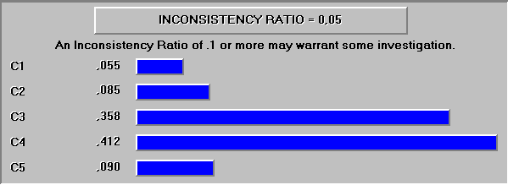
Figure 12-16: The weights of the evaluation criteria at the example case Helsinki, Finland.
Figures 11-2 to 11-5 show the weights of the indicators within criteria 2 to 5. In the criterion 1 there is only one indicator.

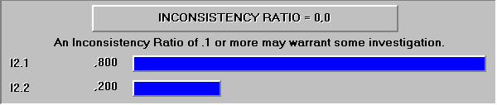
Figure 12-17: The weights of the indicators of Criterion 2 at the example case Helsinki, Finland.

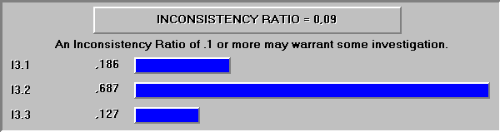
Figure 12-18: The weights of the indicators of Criterion 3 at the example case Helsinki, Finland.

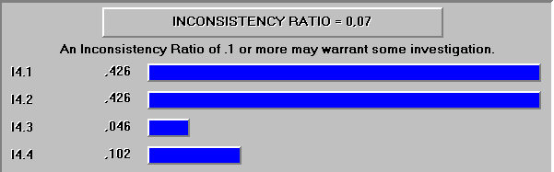
Figure 12-19: The weights of the indicators of Criterion 4 at the example case Helsinki, Finland.

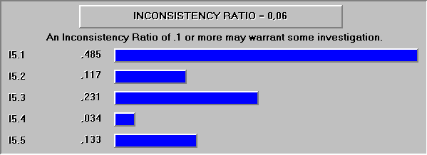

Figure 12-20: The weights of the indicators of Criterion 5 at the example case Helsinki, Finland.

Example case La Sagra, Spain
The following figure shows the weights of the evaluation criteria at the example case La Sagra, Spain. As can be seen, the experts have valued the System Performance (Criterion C1) and Organisational efficiency (Criterion C4) to be more important than other three criteria.
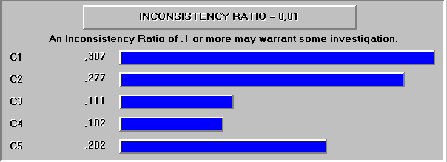
Figure 12-21: The weights of the evaluation criteria at the example case La Sagra, Spain.
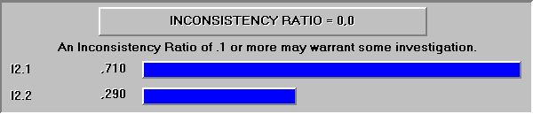
Figure 12-22: The weights of the indicators of Criterion 2 at the example case La Sagra, Spain.

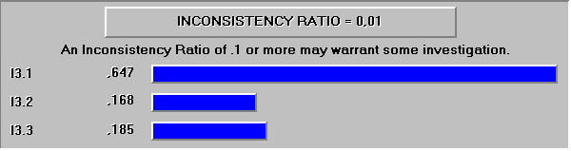
Figure 12-23: The weights of the indicators of Criterion 3 at the example case La Sagra, Spain.

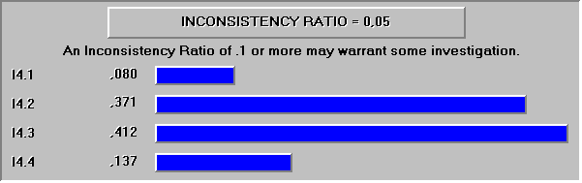
Figure 12-24: The weights of the indicators of Criterion 4 at the example case La Sagra, Spain.

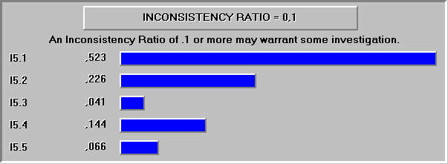
Figure 12-25: The weights of the indicators of Criterion 5 at the example case La Sagra, Spain.

Example case Urban Case 2, EU
The following figure shows the weights of the evaluation criteria at the Urban example Case 2, EU. As can be seen, the experts have valued the Societal Impacts (Criterion C5) to be the most important criteria. The second most important criterion is Organisational Efficiency (Criterion C4).

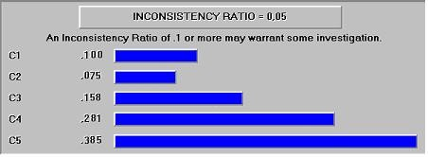
Figure 12-26: The weights of the evaluation criteria at the Urban Case 2, EU.

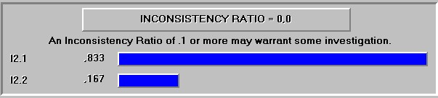
Figure 12-27: The weights of the indicators of Criterion 2 at the Urban Case 2, EU.

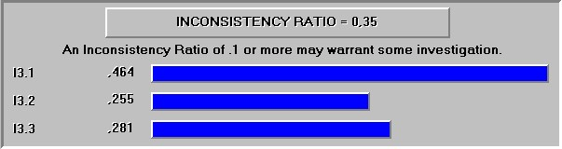
Figure 12-28: The weights of the indicators of Criterion 3 at the Urban Case 2, EU.

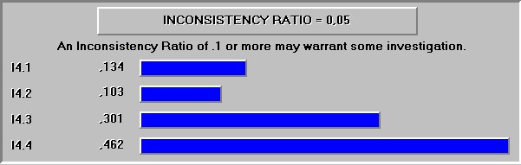
Figure 12-29: The weights of the indicators of Criterion 4 at the Urban Case 2, EU.

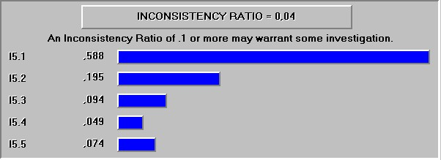
Figure 12-30: The weights of the indicators of Criterion 5 at the Urban Case 2, EU.

End Page

